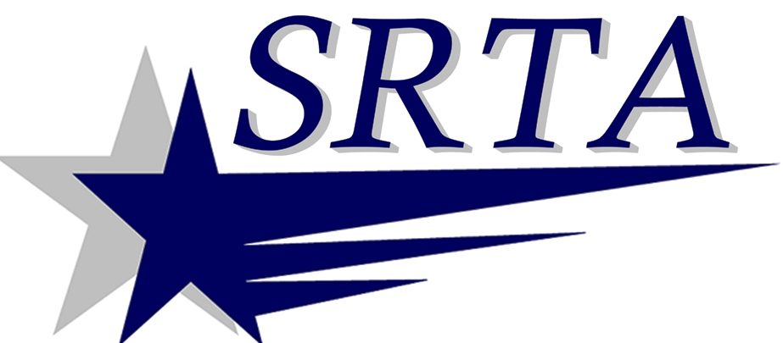

ATTENTION!!!
STARTING JANUARY 1, 2014
THE DEMAND RESPONSE FARE STRUCTURE WILL BE AS INDICATED BELOW
Demand Response Fare Structure
 | 2013 | 2014 | 2015
One Zone Fare* | $1.75 | $2.25 | $3.00
Regular Fare | $3.00 | $3.00 | $3.00
10 Ride Pass ($2.50 a trip) | $25.00 | $25.00 | $25.00
Trips outside 2 mile radius of fixed route | add $1.00 | add $1.00 | add $1.00
*Trips that would have been calculated as one zone ($1.25 fare) as of December 2012.

REMINDER: 10 one way tickets books are $25.00
Tickets available at the:
SRTA Administration Office
700 Pleasant St., Suite 320
New Bedford, MA 02740
New Bedford Terminal
134 Elm St.
New Bedford, MA 02740
Louis D. Pettine Transportation Center
118 4th Street
Fall River, MA 02721

