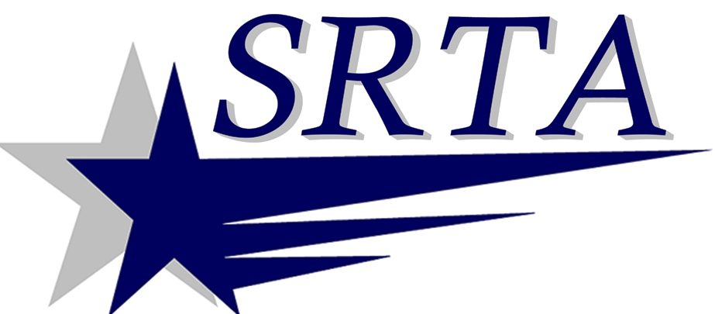

700 Pleasant St., Suite 320
New Bedford, MA 02740
Srtabus.com
Phone: 508-997-6767
Fax 508-993-9196

ATTENTION

ACCESS PASS USERS, SENIORS AND DEMAND RESPONSE USERS WHO WISH TO
OBTAIN PICTURES ID’S

PICTURES CAN NOW BE PROCESSED AT THE FALL RIVER TERMINAL EFFECTIVE:

October 22, 2014

Tuesday, Wednesday and Thursday from 9:30am to 3:00pm

The cost is $5.00.

You must show your approval from SRTA Administrative Office,
A postcard or letter from SRTA Offices
Medicare Card,
Veterans VA Card that shows minimum 70% disability,
Senior ID from our member Councils on Aging.

Any questions you may call 508 997-6767, ext 3309

