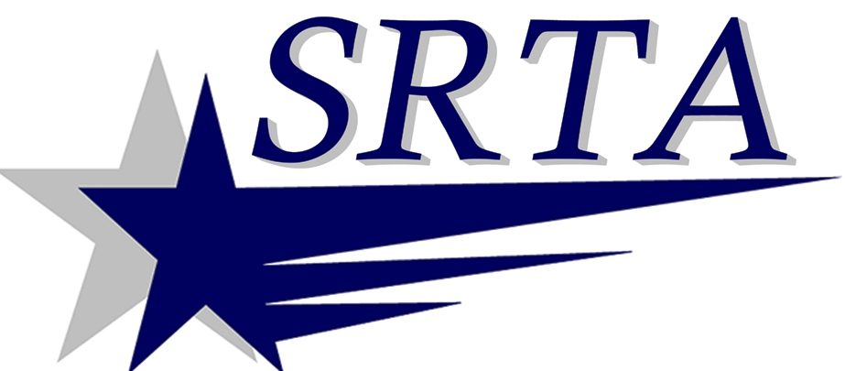

MARTIN LUTHER KING DAY
HOLIDAY SERVICE
MONDAY, JANUARY 20, 2014

The Southeastern Regional Transit Authority will provide Holiday Service for the entire SRTA service area on January 20, 2014 this will include both the FIXED ROUTE AND DEMAND RESPONSE BUSES.

This service will be exactly the same as the “Saturday Service” in our published schedules.

Any questions may be directed to bus information:
N. B. (508)-999-5211 x 1122
F.R. (508) 672-6071 OR www.SRTABUS.COM

