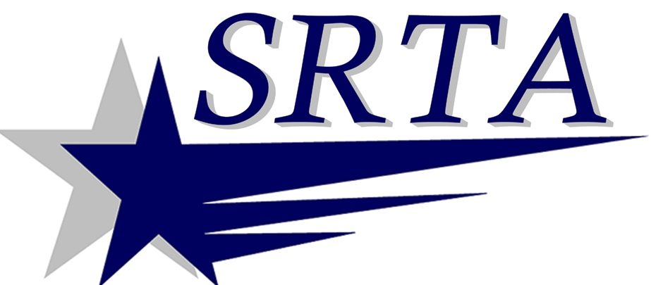
NOTICE
TO THE PUBLIC

DATE: March 26, 2014

RE: Process for placing topics for discussion at the SRTA Advisory Board meetings
In an effort to serve you better, Southeastern Regional Transit Authority is implementing the following process, effective immediately:
On occasion, the public may wish to bring an issue to the SRTA Advisory Board’s attention for investigation and discussion. Questions or topics should be submitted to the Authority at least one week prior to a published board meeting date in order to be placed on the agenda, under Public Comment. This will allow the Authority time to post the question or topic and develop a response. Requests must be in writing and sent to the address below, or via email to info@srtabus.com .
SRTA
700 Pleasant St, Ste 320
New Bedford, MA 02740

Information on Advisory Board meeting dates can be found on SRTA’s website, www.srtabus.com

As always, general questions, comments or concerns may be submitted using the customer service hotline, (508) 997-6767 x 3309.

