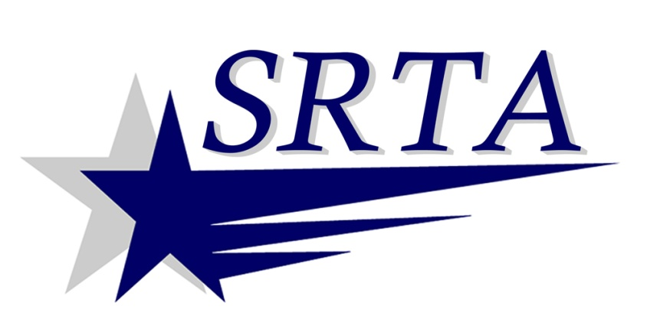
2014 Holiday Bus Service
SRTA will run holiday fixed route bus service
(Saturday service in published schedules)
on the following holidays in 2014:
Monday, Jan 20th | Martin Luther King Day
Monday, Feb 17th | President’s Day
Monday, April 21st | Patriot’s Day
Monday, May 26th | Memorial Day
Friday, July 4th | Independence Day
Monday, Sept 1st | Labor Day
Monday, Oct 13th | Columbus Day
Tuesday, Nov 11th | Veterans Day
SRTA will provide Demand Response service ONLY on: Thanksgiving Day (Thursday, November 27th) and Christmas Day (Thursday, December 25th). There will be NO fixed route service on those holidays.
For more information call SRTA at 508-999-5211 or visit www.SRTAbus.com

