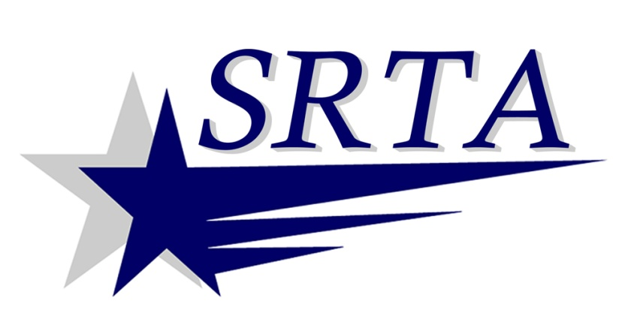
2015
Holiday Bus Service
SRTA will run holiday fixed route bus service
(Saturday service in published schedules)
on the following holidays in 2015:
Thursday, January 1 | New Years Day
Monday, January 19 | Birthday of Martin Luther King, Jr.
Monday, February 16 | Washington’s Birthday
Monday, April 20 | Patriot’s Day
Monday, May 25 | Memorial Day
Saturday, July 4 | Independence Day
Monday, September 7 | Labor Day
Monday, October 12 | Columbus Day
Wednesday, November 11 | Veterans Day

SRTA will provide Demand Response service ONLY on Thanksgiving Day (Thursday, November 26) and Christmas Day (Friday, December 25). There will be NO fixed route service on those holidays.

For more information call SRTA at 508-997-6767 or visit www.SRTAbus.com

