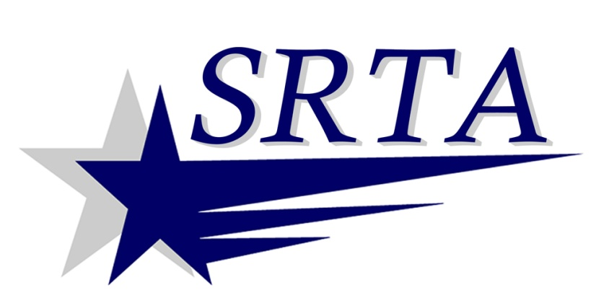
2017
Holiday Bus Service
SRTA will run holiday fixed route bus service
(Saturday service in published schedules)
on the following holidays in 2017:
Monday, January 16 | Martin Luther King, Jr. Day
Monday, February 20 | Washington’s Birthday
Monday, April 17 | Patriot’s Day
Monday, May 29 | Memorial Day
Tuesday, July 4 | Independence Day
Monday, September 4 | Labor Day
Monday, October 9 | Columbus Day
Friday, November 10 | Veterans Day Observed
Monday, January 1, 2018 | New Year’s Day
PLEASE NOTE
SRTA will provide Demand Response service ONLY on
Thanksgiving Day (Thursday, November 23) and
Christmas Day (Monday, December 25).
There will be NO fixed route service on those holidays.
For more information call SRTA at 508-999-5211 or visit www.SRTAbus.com

