DELAY IN SERVICE EXPECTED DUE TO SANTA SIGHTINGS RACE
On Saturday, December 7, 2013 downtown New Bedford will experience service disruption between 10:30AM and 1:00PM.
We will do our best to stay on schedule during this time, but please be aware of possible delays.
The race completely blocks off access to the New Bedford Terminal, so we have assigned each route a pick up and drop off point outside the terminal area. There will be no dropping off or picking up at the New Bedford Terminal from 10:30AM-1:00PM. Please use the designated areas listed below for each route.
Route #1 - Fort Rodman will be laying over on Spring St. between Pleasant St. & Sixth St.
Route #2 – Lund’s Corner will be laying over on Acushnet Ave @ Hillman St. Extension (then using Herman Melville Blvd – North Front St – Regular Route)
Route #3 – Dartmouth St. will be laying over on Orchard St. between Union St. & Arnold St. ( then using right on Arnold St. – right on Cottage St. – left on Union St. to Regular Route)
Route #4 – Ashley Blvd will be laying over on Franklin St. between Pleasant St. & Purchase St. ( in order for buses to get to Franklin St. they will be taking a right onto Merrimac St. then left on Pleasant St. then left on Franklin St. leaving Franklin St. all busses will take left onto Purchase to Regular Route )
Route #5 - Rivet St. will be laying over on Madison St. between So. Second St. and Acushnet Ave
Route #6 – Shawmut Ave will be laying over on Summer St. between Kempton St. & Mill St.
Route #8 – Mt. Pleasant St. will be laying over on Summer St. between Kempton St. & Mill St.
Route #9 – Fall River will be laying over on Summer St. between Kempton St. & Mill St.
Route #10 – Dartmouth Mall will be laying over on Summer St. between Kempton St. & Mill St.
Route #11 – Fairhaven will be laying over on Acushnet Ave @ Hillman St. Extension (on the inbound they will be taking a right onto Wamsutta St. then a left onto Acushnet Ave to Pick up at Hillman St. Ext.)
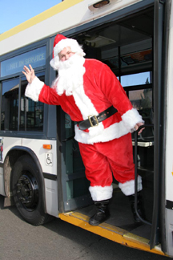
FOR MORE INFORMATION PLEASE CALL (508) 999-5211 X 1122

