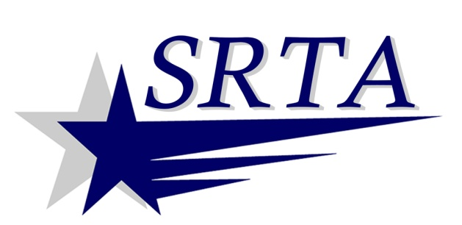

Suburban Shuttle Public Hearings

The Southeastern Regional Transit Authority is holding public hearings and a public comment period to receive comments regarding proposed cuts of the:
Somerset Shuttle
Swansea Shuttle
Acushnet/Fairhaven Shuttle
Fairhaven/Mattapoisett Shuttles

Wednesday, November 6, 2013 at 1:00 PM
Eugene Murphy Village, Somerset
Community Room

Tuesday, November 12, 2013 at 1:00 PM
Fairhaven Council on Aging

If you cannot attend the public hearings, you may send your comments to:

SRTA
700 Pleasant St., 3rd Floor
New Bedford, MA 02740-6263
508-997-6767
info@srtabus.com

Comments will be accepted until close of business on Wednesday, November 20, 2013.

Both meeting rooms are accessible. Transportation to the meetings is available by fixed route bus or Demand Response service (for those that qualify). Please call 508-997-6767 or visit www.srtabus.com for more information.

