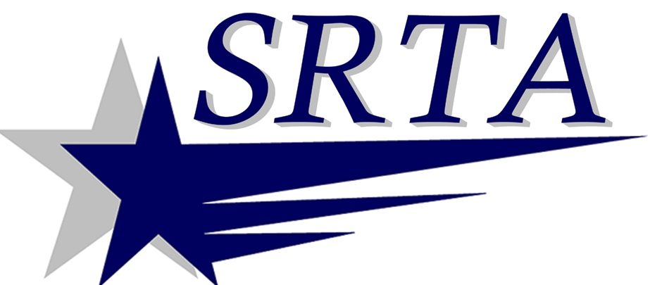

THANKSGIVING DAY
HOLIDAY SERVICE
NOVEMBER 27, 2014

THE SOUTHEASTERN REGIONAL TRANSIT AUTHORITY WILL PROVIDE HOLIDAY SERVICE FOR DEMAND RESPONSE ONLY ON
THURSDAY, NOVEMBER 27, 2014.

THIS SERVICE WILL BE EXACTLY THE SAME AS THE “SATURDAY SERVICE” FOR DEMAND RESPONSE HOURS.

ANY QUESTIONS MAY BE DIRECTED TO BUS INFORMATION:
N. B. (508)-999-5211 x 1122
F.R. (508) 672-6071 OR www.SRTABUS.COM

