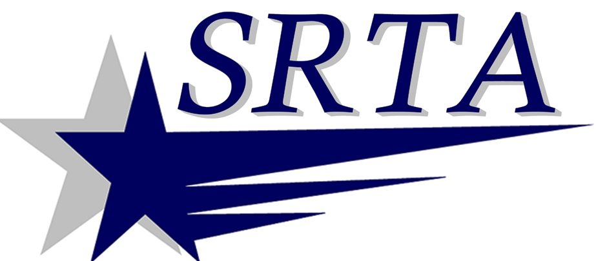

CHRISTMAS and NEW YEAR’S DAY
HOLIDAY SERVICE on
DECEMBER 25th and JANUARY 1, 2014

THE SOUTHEASTERN REGIONAL TRANSIT AUTHORITY WILL PROVIDE HOLIDAY SERVICE FOR DEMAND RESPONSE ONLY ON DECEMBER 25th and January 1, 2014.

THIS SERVICE WILL BE EXACTLY THE SAME AS THE “SATURDAY SERVICE” FOR DEMAND RESPONSE HOURS.

ANY QUESTIONS MAY BE DIRECTED TO BUS INFORMATION:
N. B. (508)-999-5211 x 1122
F.R. (508) 672-6071 OR www.SRTABUS.COM

