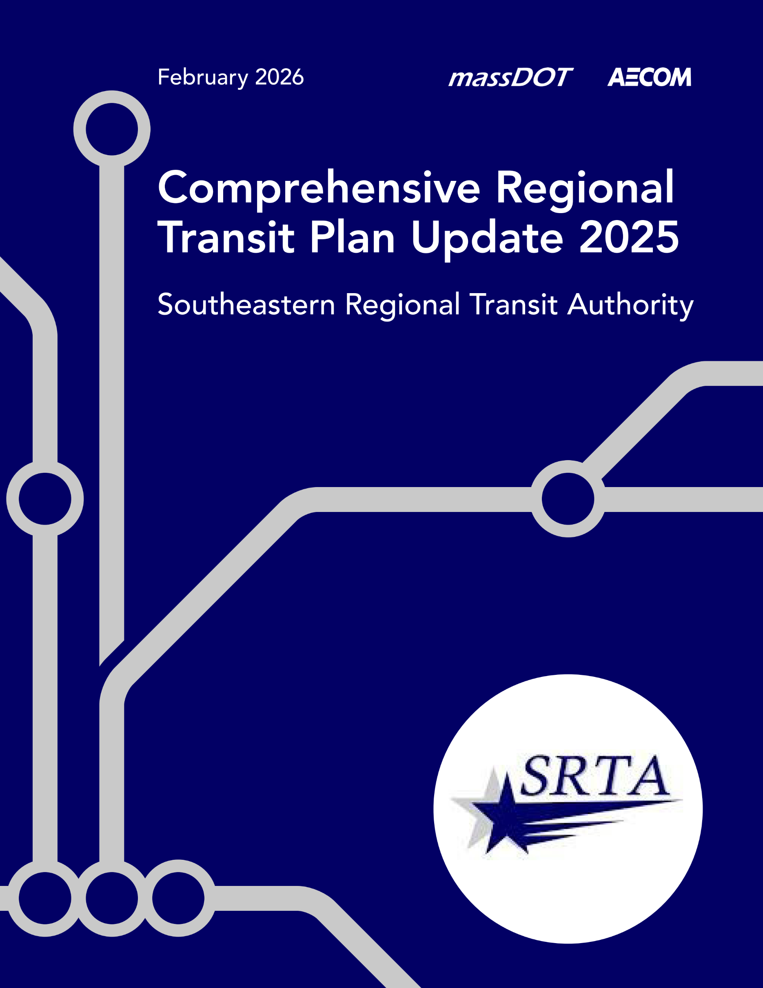

Table of Contents
1 Executive Summary 1
1.1 Changes Since the 2020 Comprehensive Regional Transit Plan 1
1.2 Planning Process 2
1.3 Recommendations 2
2 Background and Context 5
2.1 Overview of SRTA Services 5
2.2 Purpose 6
3 Needs and Goals 8
3.1 Statewide Policies and Goals 8
3.2 Agency Mission 8
3.3 Identified Needs 8
3.4 Goals and Objectives 9
4 Existing Conditions 11
4.1 Transit Service Overview 11
4.1.1 Service Descriptions 14
4.1.2 Provided Services 17
4.1.3 Transit Service Performance 18
4.1.4 Funding 21
4.2 Ridership and Service Operations 23
4.2.1 Fixed Route Ridership 26
4.2.2 Fixed Route Effectiveness 30
4.2.3 Demand Response Ridership and Effectiveness 32
4.2.4 On-Time Performance 34
4.2.5 Customer Service 36
4.3 Regional Connections and Partnerships 37
4.4 Asset Management 37
4.4.1 Maintenance 37
4.4.2 Vehicles 39
4.4.3 Facilities 40
4.4.4 Technology 40
4.5 Policies and Procedures 41
4.6 Peer Agency Analysis 45
5 Market Evaluation 48
5.1 Demographic Analysis 50
5.1.1 Population Density 50
5.1.2 Older Adult Population 52
5.1.3 Youth Population 52
5.1.4 Median Household Income 52
5.1.5 Low-Income Population 52
5.1.6 Zero-Vehicle Households 52
5.1.7 Population Other Than Non-Hispanic White 52
5.1.8 Adult Disabled Population 59
5.1.9 Title VI Population 59
5.1.10 Job Density 59
5.2 Transit Score 63
5.3 Public and Stakeholder Engagement 65
5.3.1 Board Meeting 65
5.3.2 Pop-Up Events 66
5.3.3 Employee Survey Effort 67
5.3.4 Public Survey Effort 67
5.3.5 2024 SRTA Rider Survey 74
6 Performance Measures 76
6.1 MassDOT Performance Management Program 76
6.1.1 Ridership 77
6.1.2 Financial 77
6.1.3 Customer Service and Satisfaction 78
6.1.4 Asset Management 78
6.1.5 Safety 79
6.1.6 Annual Performance 79
6.2 Additional Measures 80
7 Trends and Uncertainties 81
7.1 Future Uncertainties 81
7.1.1 Population and Demographics 81
7.1.2 Affordability 83
7.1.3 Technology 84
7.1.4 Funding for Transit 85
7.2 2020 Alternative Scenarios 87
7.3 Looking Ahead: 2025 to 2030 Scenario Planning 88
7.3.1 Lower Ridership 88
7.3.2 Medium Ridership 88
7.3.3 High Ridership 89
7.4 Future Opportunities 89
8 Recommendations 91
8.1 Changes Since the 2020 Comprehensive Regional Transit Plan 91
8.2 Planning for an Uncertain Future 91
8.3 Identified Needs 92
8.4 Recommendations 93
8.4.1 Service Recommendations 94
8.4.2 Capital Recommendations 95
8.4.3 Performance Recommendations 96
8.4.4 Policy Recommendations 96
8.4.5 Coordination Recommendations 97
8.4.6 Recommendations for Additional Studies 98
9 References 99
Appendix A Fares 103
Appendix B Environmental Policy 110
Appendix C Survey Comments 114

Figures
Figure 1. SRTA Fall River Terminal 1
Figure 2. Map of Massachusetts RTA Service Areas 6
Figure 3. Fall River Fixed Route System Map 12
Figure 4. New Bedford Fixed Route System Map 13
Figure 5. MicroConnector Zone Map 14
Figure 6. Annual Operating Cost by Mode (FY 2020–FY 2024) 23
Figure 7. Annual System Ridership (FY 2020–FY 2024) 24
Figure 8. Ridership Breakdown by Service Type (FY 2024) 24
Figure 9. Monthly Ridership Trends (2022–2024) 25
Figure 10. Overall Scheduled Trips Operated by Mode (FY 2020–FY 2024) 25
Figure 11. Fixed Route Annual Ridership (FY 2020–FY 2024) 26
Figure 12. Ridership by Fixed Route (FY 2024) 27
Figure 13. Weekday Average Ridership by Route (FY 2024) 28
Figure 14. Saturday Average Ridership by Route (FY 2024) 29
Figure 15. Sunday Average Ridership by Route (FY 2024) 30
Figure 16. Passengers per Hour per Route (FY 2024) 31
Figure 17. Demand Response Annual Ridership (FY 2020–FY 2024) 32
Figure 18. On-Time Performance - Fixed Route (FY 2024) 34
Figure 19. On-Time Performance by Fixed Route (FY 2024) 35
Figure 20. On-Time Performance - Demand Response (FY 2024) 36
Figure 21. Valid Complaints per 100,000 Passenger Trips: All Services (FY 2020 – FY 2024) 36
Figure 22. Miles Between Road Calls (FY 2020 – FY 2024) 38
Figure 23. Preventive Maintenance Performed On-Time (FY 2020 – FY 2024) 38
Figure 24. Mean Miles Between Major Mechanical Failures (FY 2020 – FY 2024) 39
Figure 25. Number of Preventable Accidents per 100,000 Vehicle Revenue Miles (FY 2020 – FY 2024) 42
Figure 26. Number of Fatalities per Million Vehicle Revenue Miles (FY 2020 – FY 2023) 43
Figure 27. Number of Injuries per Million Vehicle Revenue Miles (FY 2020 – FY 2023) 44
Figure 28. Number of Safety Events per Million Vehicle Revenue Miles (FY 2020 – FY 2023) 45
Figure 29. Overview of SRTA Service Area 49
Figure 30. Population Density 51
Figure 31. Older Adult Population 53
Figure 32. Youth Population 54
Figure 33. Median Household Income 55
Figure 34. Low-Income Population 56
Figure 35. Zero-Vehicle Households 57
Figure 36. Population Other Than Non-Hispanic White 58
Figure 37. Adult Disabled Population 60
Figure 38. Title VI Population 61
Figure 39. Job Density 62
Figure 40. Transit Score in the SRTA Service Area 64
Figure 41. Pop-up tables at New Bedford (left) and Fall River (right) terminals. 66
Figure 42. SRTA Social media post 68
Figure 43. Where do you want to go that SRTA doesn't go (choose all that apply)? 69
Figure 44. What is the biggest improvement that SRTA should make over the next 5 years? 69
Figure 45. Do you prefer bus routes that come more often or run earlier in the morning/later at night? 70
Figure 46. Would you prefer fare-free service to continue or return to paid service? 71
Figure 47. Would you like to see the Fort Rodman bus route renamed Fort Taber? 71
Figure 48. What is your primary mode of transportation? 72
Figure 49. What is your race/ethnicity (select all that apply)? 73
Figure 50. What language(s) do you speak most often at home (select all that apply)? 73
Figure 51. What is your yearly household income? 74
Figure 52. Long-term Population Projections for Massachusetts (2000-2050) 82
Figure 53. Bristol County Housing and Transportation Costs as a Percentage of Residents’ Income 84
Figure 54. Inadequate Charging Infrastructure is the Leading Obstacle to Fleet Modernization 85
Figure 55. Record of Extensions for the Last Six Federal Transportation Funding Laws 86
Figure 56. State Funding for Massachusetts’ RTAs from FY 2007 to FY 2025 87
Figure 57. SRTA Annual System Ridership (FY 2019–FY 2024) 88

Tables
Table 1. Recommendations 2
Table 2. Statistics by Service (FY 2024) 11
Table 3. Fall River Fixed Routes 14
Table 4. New Bedford Fixed Routes 16
Table 5. Fall River Service Offerings 17
Table 6. New Bedford Service Offerings 18
Table 7. Annual Fixed Route Operating Statistics (FY 2020–FY 2024) 19
Table 8. Annual Demand Response Operating Statistics (FY 2020–FY 2024) 19
Table 9. Service Effectiveness (FY 2020-FY 2024) 20
Table 10. Fixed Route Financial Efficiency (FY 2020–FY 2024) 21
Table 11. Demand Response Financial Efficiency (FY 2020–FY 2024) 21
Table 12. Capital Expenses Funding Sources (FY 2022-FY 2024) 22
Table 13. Operating Expenses Funding Sources (FY 2022-FY 2024) 22
Table 14. Operating Statistics by Route (FY 2024) 31
Table 15. Demand Response Operating Statistics (FY 2020–FY 2024) 33
Table 16. Demand Response Metrics (FY 2020-FY 2024) 33
Table 17. Active Equipment Inventory Summary (FY 2024) 39
Table 18. Revenue Vehicle Spare Ratio (FY 2024) 40
Table 19. Facility Inventory Summary 40
Table 20. Peer Systems Census Data (FY 2024) 45
Table 21. Peer Systems Operating Data (FY 2024) 46
Table 22. Peer System Comparison Metrics (FY 2024) 47
Table 23. Performance Measures Overview 76
Table 24. Ridership Metrics and Targets (FY 2026) 77
Table 25. Financial Metrics and Targets (FY 2026) 77
Table 26. Customer Service and Satisfaction Metrics and Targets (FY 2026) 78
Table 27. Asset Management Metrics and Targets (FY 2025) 78
Table 28. Safety Metrics and Targets 79
Table 29. Fleet Composition by Fuel Type and External Partnership Annual Performance Metrics (FY 2026) 79
Table 30. Opportunities by Ridership Scenario 89
Table 31. Identified Needs 92
Table 32. Recommendations Categories 94
Table 33. Service Recommendations 94
Table 34. Capital Recommendations 96
Table 35. Performance Recommendations 96
Table 36. Policy Recommendations 97
Table 37. Coordination Recommendations 97
Table 38. Recommendations for Additional Studies 98
Table 39. Fixed Route Fare Policy 104
Table 40. ADA and Senior Van Service Fare Policy 105

Acronyms
ACS American Community Survey
ADA Americans with Disabilities Act
APC Automatic Passenger Counting
AVL Automatic Vehicle Location
BAT Brockton Area Transit Authority
BCC Bristol Community College
BEB Battery Electric Bus
CAD Computer Aided Dispatch
COA Council on Aging
CRTP Comprehensive Regional Transit Plan
DDS Disability Determination Services
DMH Department of Mental Health
FTA Federal Transit Administration
GATRA Greater Attleboro Taunton Regional Transit Authority
IIJA Infrastructure Investment and Jobs Act
LEHD Longitudinal Employer-Household Dynamics
MassDOT Massachusetts Department of Transportation
MBTA Massachusetts Bay Transportation Authority
MCB Massachusetts Commission for the Blind
MOU Memorandum of Understanding
MPO Metropolitan Planning Organization
MRC Massachusetts Rehabilitation Commission
NTD National Transit Database
PTASP Public Transportation Agency Safety Plan
RIPTA Rhode Island Public Transit Authority
RMV Registry of Motor Vehicles
RTA Regional Transit Authority
RTD Rail & Transit Division
SMMPO Southeastern Massachusetts Metropolitan Planning Organization
SRPEDD Southeastern Regional Planning and Economic Development District
SRTA Southeastern Regional Transit Authority
TAM Transit Asset Management
TERM Transit Economic Requirements Model
TVM Ticket Vending Machine
UMass University of Massachusetts

Glossary
Access: The opportunity to reach a given destination within a certain timeframe or without significant physical, social, or economic barriers.
Accessible Vehicle: A public transportation vehicle that does not restrict access, is usable, and provides allocated space and/or priority seating for individuals who use mobility devices.
Americans with Disabilities Act (ADA): Passed in July 1991, gave direction to local transit agencies to ensure full access to transportation for persons with disabilities
Boarding: The total number of passengers getting on a transit vehicle during a specified period of time.
Capital Cost: The cost of equipment and facilities required to support transportation systems, including vehicles, radios, shelters, software, etc.
Central Transfer Point: A central meeting place where routes or zonal demand response buses intersect so that passengers may transfer. Routes are often timed to facilitate transferring and depart once passengers have had time to transfer. Strategic placement of the transfer point can attract riders to the system and may provide an opportunity for joint marketing promotions with local merchants.
Commuter Bus Service: Transportation designed for daily, round-trip service, which accommodates a typical 8-hour, daytime work shift (e.g., an outbound trip arriving at an employment center by 8 AM, with the return trip departing after 5 PM).
Computer Aided Dispatch/ Automatic Vehicle Location: A computer technology with advanced dispatching capabilities combined with automatic vehicle location, ensuring that vehicles are where they need to be when required.
Coordination: Pooling the transportation resources and activities of several agencies. The owners of transportation assets talk to each other to find ways to mutually benefit their agencies and their customers. Coordination models can range in scope from sharing information, to sharing equipment and facilities, to integrated scheduling and dispatching of services, to the provision of services by only one transportation provider (with other former providers now purchasing services). Coordination may involve human service agencies working with each other or with public transit operations.
Cost per Boarding: The total operating expenditures of a route or service divided by the number of total boardings. Boardings are often presented as unlinked passenger trips.
Cost per Revenue Mile or Hour: The total operating expenditures of a route or service divided by the number of revenue miles or revenue hours.
Cutaway Vehicle: A smaller bus built on a modified van or truck chassis with the rear section removed, allowing a bus shell to be added by a second manufacturer, creating a customizable mini-bus or shuttle for services like parantransit, local routes, or demand response.
Demand Response Service: Service to individuals that is activated based on passenger requests. Usually involves curb-to-curb or door-to-door service. Trips may be scheduled on an advance reservation basis or in “real-time.” Usually smaller vehicles are used to provide demand response service. This type of service usually provides the highest level of service to the passenger but is the most expensive for the transit system to operate in terms of cost per trip. In rural areas with relatively high populations of elderly persons and persons with disabilities, demand response service is sometimes the most appropriate type of service.
Dial-a-Ride Service: A name that is commonly used for demand response service. It is helpful in marketing the service to the community, as the meaning of “dial-a-ride” may be more self-explanatory than “demand response” to someone unfamiliar with transportation terms.
Express Bus Service: Direct service from a limited number of origins to a limited number of destinations with no intermediate stops. Typically, express bus service is fixed route/fixed schedule and is used for longer distance commuter trips. The term may also refer to a bus that makes a limited number of stops, while a local bus makes many stops along the same route but as a result takes much longer.
Fair Share Amendment: A 4 percent Massachusetts surtax on income above $1 million annually approved by Massachusetts voters in 2022. The revenue generated by the surtax is constitutionally dedicated to funding public education and transportation.
Fare: Revenue from cash, tickets, and pass receipts given by passengers as payment for public transit rides.
Fare-Free Transit: Any transit service that does not require a passenger fare to ride.
Farebox Recovery Ratio: The percentage of operating costs covered by revenue from fares and contract revenue (total fare revenue and total contract revenue divided by the total operating cost).
Fixed Route: Transportation service operated over a set route or network of routes on a regular time schedule.
Headway: The length of time between vehicles moving in the same direction on a route. Headways are called short if the time between vehicles is short and long if the time between them is long. When headways are short, the service is said to be operating at a high frequency; if headways are long, service is operating at a low frequency.
Intercity Bus Service: Regularly scheduled bus service for the public that operates with limited stops over fixed routes connecting two or more urban areas not near, that has the capacity for transporting baggage carried by passengers, and that makes meaningful connections with scheduled intercity bus service to more distant points, if such service is available. Intercity bus service may include local and regional feeder services, if those services are designed expressly to connect to the broader intercity bus network.
Memorandum of Understanding: A formal, non-binding document that outlines the framework for cooperation, roles, responsibilities, and objectives between multiple agencies or jurisdictions involved in providing transit services.
Metropolitan Planning Organization (MPO): The policy board of an organization created and designated to carry out the metropolitan transportation planning process. MPOs are required to represent localities in all urbanized areas with populations over 50,000.
Microtransit: A form of demand response service, open to the general public, that requires some type of "reservation," typically made via an app-based system. Typically, microtransit uses software algorithms to completely automate the scheduling of the trip, the fare collection (if any), and the route the driver will utilize (communicating with the driver via some type of mobile data terminals).
National Transit Database (NTD): The United States government’s main repository of data about the financial, operating, and asset conditions of American transit systems.
Non-Revenue Vehicle: Any vehicle used by a public transit organization that is not used for passenger service but is essential to support transit operations and safety, such as service trucks, supervisor cars, and utility vehicles.
Operating Expenditure: The recurring cost of providing transit service (wages, salaries, fuel, oil, taxes, maintenance, insurance, marketing, etc.).
Operating Revenue: The total revenue earned by a transit agency through its transit operations. It includes passenger fares, advertising, and other revenues.
Paratransit Service: The transportation of passengers by motor vehicle or other means of conveyance by persons operating on a regular and continuing basis and the transportation or delivery of packages in conjunction with an operation having the transportation of passengers as its primary and predominant purpose and activity but excluding regular route transit. Paratransit includes transportation by carpool and commuter van, point deviation and route deviation services, shared-ride taxi service, dial-a-ride service, and other similar services.
Passengers per Mile or Hour: Productivity measure that takes the total passengers and divides by the miles and/or hours operated. The passengers may be presented as unlinked passenger trips and hours and/or miles may be presented as either total vehicle miles or hours or as revenue miles or hours.
Performance Indicator: A metric that provides meaningful information about the condition or performance of the transportation system but is neither managed nor used to evaluate the effectiveness of policies, strategies, or investments.
Performance Measure: A metric that measures progress toward a goal, outcome, or objective. This definition covers metrics used to make decisions or evaluate the effectiveness or adequacy of a policy, strategy, or investment.
Performance Target: A specific performance level representing the achievement of a goal, outcome, or objective.
Public Transportation: Transportation service that is available to any person upon payment of the fare either directly, subsidized by public policy, or through some contractual arrangement, and that cannot be reserved for the private or exclusive use of one individual or group. “Public” in this sense refers to the access to the service, not to the ownership of the system that provides the service.
Public Transportation Agency Safety Plan (PTASP): A plan published by a public transit agency containing processes and procedures that define a comprehensive, collaborative, and systematic approach to managing safety. All public transportation systems that receive federal funds under the FTA Urbanized Area Formula Grants are required to have a Public Transportation Agency Safety Plan.
Revenue Hour: The number of transit vehicle hours when passengers are being transported. Calculated by taking the total time when a vehicle is available to the public with the expectation of carrying passengers. Excludes deadhead hours, when buses are positioning but not carrying passengers, but includes recovery/layover time.
Revenue Mile: The number of transit vehicle miles when passengers are being transported. Calculated by taking the total mileage operated when a vehicle is available to the public with the expectation of carrying passengers. Excludes deadhead mileage, when buses are moving but not carrying passengers.
Revenue Vehicle: Any vehicle, such as a bus, train, or railcar, used to actively carry passengers or operating on a scheduled route to pick up or drop off passengers.
Ridership: The total of all unlinked passenger trips, including transfers. One trip that includes a transfer would be counted as two unlinked passenger trips.
Ridesharing: A form of transportation, other than public transit, in which more than one person shares the use of a vehicle, such as a van or car, to make a trip. Variations include carpooling or vanpooling.
Service Area: The geographic area that coincides with a transit system’s legal operating limits (city limits, county boundary, etc.).
Service Gap: When certain geographic segments cannot be covered by transportation services. This term can also refer to instances where service delivery is not available to a certain group of riders, or at a specific time.
Service Span: The duration of time that service is made available or operated during the service day (e.g., 6 AM to 10 PM on weekdays).
Spare Ratio: The percentage/number of vehicles that an operator purchases in excess of the number of vehicles required to provide the maximum level of service. The spares are required so that some vehicles may cycle through a preventive maintenance regimen while the full level of planned service can still be provided.
Standard: A recommendation that leads or directs a course of action to achieve a certain goal. A standard is the expected outcome for the measure that will allow a service to be evaluated. There are two sets of transit standards.
- Service design and operating standards: Guidelines for the design of new and improved services and the operation of the transit system.
- Service performance standards: The evaluation of the performance of the existing transit system and of alternative service improvements using performance measures.
State Contract Assistance: The program through which the RTAs receive state operating funding for transit at the discretion of the Massachusetts Legislature via the state budget process annually. The total amount of state contract assistance funding provided in the state budget is allocated to the RTAs via a formula developed with RTA input.
State of Good Repair: The condition of physical assets used in public transit, such as vehicles, stations, and signals, that permits their full designed performance level, ensuring safe, reliable, and efficient use through regular maintenance and timely replacement.
Title VI: Title VI of the Civil Rights Act of 1964, which requires that “No person in the United States shall, on the grounds of race, color, or national origin, be excluded from participation in, be denied the benefits of, or be subjected to discrimination under any program or activity receiving federal financial assistance.”
Total Operating Cost: The total of all operating costs incurred during the transit system calendar year, excluding expenses associated with capital grants.
Transfer: Passengers arrive on one bus and leave on another (totally separate) bus to continue their trip. The boarding of the second vehicle is counted as an unlinked passenger trip.
Transit Asset Management Plan: A strategic document that helps transit agencies systematically manage their capital assets, such as vehicles, facilities, and other equipment, over their entire lifecycle and to ensure they are safe, reliable, and cost-effective. Transit agencies that own, operate, and manage capital assets and receive funding from FTA are required to adopt a Transit Asset Management Plan.
Transit Dependent: A population or person who does not have immediate access to a private vehicle, or because of age or health reasons cannot drive and must rely on others for transportation.
Transit Economic Requirements Model: A computer application published by FTA that is designed to estimate transit capital investment needs over an extended time horizon, helping transit agencies assess current asset conditions and adopt an asset management strategy that achieves state of good repair.
Transit Subsidy: The operating costs not covered by revenue from fares or contracts.
Transportation Network Company: Private sector companies that provide software routing, scheduling, and payment services to independent contractor drivers for a fee; these drivers then utilize their own vehicles to provide a (typically) curb-to-curb transportation service, sometimes to sole riders and sometimes to pooled groups.
Trip Denial: Occurs when a trip is requested by a passenger, but the transportation provider cannot provide the service. Trip denial may happen because capacity is not available at the requested time. For ADA paratransit, a capacity denial is specifically defined as occurring if a trip cannot be accommodated within the negotiated pick-up window. Even if a trip is provided, if it is scheduled outside the pick-up window, it is considered a denial. If the passenger refused to accept a trip offered within the pick-up window, it is considered a refusal, not a capacity denial.
Unlinked Passenger Trip: Typically, one passenger trip recorded any time a passenger boards a transportation vehicle or other conveyance used to provide transportation. “Unlinked” means that one trip is recorded each time a passenger boards a vehicle, no matter how many vehicles that passenger uses to travel from their origin to their destination.
Useful Life Benchmark: The expected service life for a capital asset, like a bus or utility vehicle, before major overhaul or replacement. Standards for useful life benchmarks for different vehicle classes are defined by FTA.
Zero Emission Vehicle: A vehicle that produces no tailpipe pollutants or greenhouse gases during operation, primarly through electric power from batteries.

Executive Summary
This 2025 update of the Comprehensive Regional Transit Plan (CRTP) for the Southeastern Regional Transit Authority (SRTA) will shape and guide the region's transit priorities and improvements over the next five years. The recommendations in this plan emerged from a data-informed process that incorporated historical operational data, stakeholder feedback, industry standards, local policy, statewide objectives, and SRTA priorities. They establish a framework for advancing strategic service adjustments, capital improvements, and policy initiatives, and make significant progress toward improving mobility for residents across the region.
Figure 1. SRTA Fall River Terminal
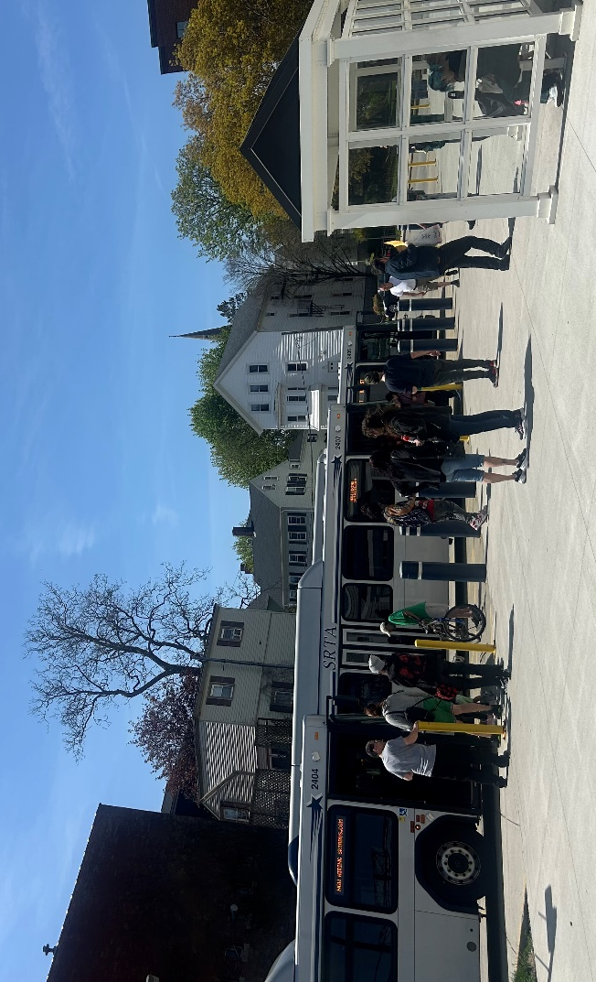
Source: AECOM 2025

Changes Since the 2020 Comprehensive Regional Transit Plan
The 2020 CRTP featured a range of recommendations including service enhancements and capital investments. In the last five years, there has been a significant infusion of state and federal funding supporting expanded transit service. Some of the investments that SRTA has made over the past five years include:
- Implemented Sunday service with a schedule matching Saturday operations.
- Implemented a microtransit pilot program serving the region’s new Massachusetts Bay Transportation Authority (MBTA) stations in Fall River and New Bedford.
- Replaced an aging fleet with the procurement of 40 diesel/electric hybrid buses and four battery electric buses (BEB).
- Implemented fare-free service on all fixed routes and demand response.

Planning Process
The planning process for the CRTP was a collaborative effort in which SRTA engaged with key stakeholders, such as SRTA board members, employees, and the public. Input from these groups, along with guidance from statewide and regional transportation plans, was used to establish goals and objectives for this plan.
SRTA used both quantitative and qualitative input when developing recommendations for future system improvements. An evaluation of SRTA’s current transit operations, including existing service levels, ridership patterns, and overall system performance, helped to identify baseline efficiencies and opportunities. It should be noted that the data in this plan were largely gathered between April and October 2025 to analyze existing conditions and provide a foundation for later elements. Therefore, the data referenced are largely from FY 2020 to FY 2024—the plan’s five-year reporting period. Service enhancements and ridership changes beyond this timeframe, while sometimes discussed in the narrative, are largely not fully captured in the data represented.
Additionally, a market analysis was carried out to contextualize the region's demographic and socioeconomic characteristics. The analysis included factors such as population trends, job locations, and transit demand to pinpoint areas with the most critical needs.
In parallel, a robust outreach campaign was conducted, utilizing both in-person gatherings and virtual sessions to ensure input from a diverse group of stakeholders. Key outreach activities included multiple target online surveys, an employee survey, pop-up events, and updates at an SRTA board meeting, as well as social media promotions of survey links.

Recommendations
SRTA developed 21 recommendations that address the needs identified through the CRTP planning process (Table 1). These recommendations will guide efforts over the next five years and provide a flexible approach to pursuing strategic improvements in mobility depending on how the future unfolds. For instance, significant changes in ridership demand or propulsion technology could change how certain recommendations are prioritized.
The recommendations are grouped into seven primary categories: service, capital, policy, performance, coordination, additional studies, and other (for those recommendations that do not fit elsewhere). The recommendations are not presented as a prioritized list and are only numbered for reference to the recommendations in Chapter 8.
Table 1. Recommendations
ID | Category | Recommendation
1 | Service, Policy | Build from prior planning studies; define actionable next steps for service changes
2 | Service, Additional Studies | Assess costs and operational impacts of running later fixed route service and determine future plans for implementation
3 | Service, Additional Studies | Assess costs, operational impacts, and implementation strategies for increasing fixed route service frequency, with a goal of half hour headways systemwide
4 | Service, Policy | Continue to offer fare-free fixed route services subject to sustained state funding
5 | Service, Policy | Evaluate local assessment impacts on expanding fixed route service
6 | Service | Maintain Sunday service
7 | Service, Coordination | Enhance communication with the public about services and policies
8 | Service, Capital, Policy, Performance | Strategize how to accommodate increased ridership demand for demand response services, including capital needs, staff resources, and service eligibility and application process
9 | Service | Focus on increasing microtransit service use through targeted advertising and marketing in the community
10 | Service, Coordination | Assess how microtransit connections to South Coast Rail stations affect ridership; explore expanded service zones and increased connections to South Coast Rail stations especially with growth of transit oriented development in the SRTA service area
11 | Service | Explore the potential to expand service to new locations within the region
12 | Service, Coordination | Assess ways to match service with transit ridership potential in coordination with UMass Dartmouth
13 | Service, Additional Studies | Explore strategies for mitigating difficulties associated with short trips in terms of maintaining headways
14 | Service | Refresh list of bus stops identified for updates based on previously developed guidelines and secured funding
15 | Service, Capital, Additional Studies | Evaluate potential for added capacity at existing transit hubs and opportunities for additional locations
16 | Capital | Continue capital bus replacement plan to maintain a state of good repair
17 | Capital, Additional Studies | Assess the benefits and drawbacks of alternatives to current maintenance facilities configuration, including transit operations and Title VI analyses, environmental review and permitting, and conceptual through final design
18 | Capital, Coordination | Continue collaborating with utility company to meet the needs of the current and future fleet
19 | Policy, Performance | Use ridership reports as educational tools to highlight key accomplishments and benefits of increased investment in service
20 | Policy, Performance | Continue providing security and increasing public safety at terminals
21 | Policy | Continue to advocate for sustainable funding and seek opportunities for additional sources
22 | Policy, Performance | Look for opportunities to form and maintain partnerships with other RTAs and technical schools to grow the labor pool for operators and maintenance staff

Background and Context
SRTA, alongside the Commonwealth of Massachusetts’ 14 other Regional Transit Authorities (RTAs), plays a crucial role in providing essential mobility options and lifeline services to millions of residents across the Commonwealth. Demonstrating its commitment to continuous improvement, SRTA updates its CRTP every five years. This document represents the 2025 update of the SRTA CRTP covering the years 2020 to 2025.
The chapters of the plan include:
- Needs and Goals: Overview of identified needs and goals of SRTA that provide the foundation for recommendations over the next five years.
- Existing Conditions: Review of SRTA performance information.
- Market Evaluation: Assessment of transit demand through demographic analysis and engagement feedback results.
- Performance Measures: Review of performance measures used by SRTA to assess service.
- Trends and Uncertainties: Assessment of key uncertainties facing SRTA over the next five years and how those may impact implementation of recommendations.
- Recommendations: Listing of specific recommendations to guide SRTA priorities over the next five years.
Additionally, the CRTP contains appendices reviewing fare and environmental considerations based on the broader statewide and national context, as well as documenting all comments on outreach surveys.

Overview of SRTA Services
SRTA is headquartered in New Bedford, Massachusetts, and is one of the 15 RTAs that, along with MBTA, operates public transportation in the Commonwealth (Figure 2). SRTA provides fixed route and demand response services to residents of the 10 communities within its service area. SRTA’s fixed route services operate around the two urban centers within the region: Fall River and New Bedford. SRTA operates demand response service as federally required by the Americans with Disabilities Act (ADA) to provide complementary service to individuals unable to use fixed route buses. SRTA also offers the Boston Hospital Shuttle, which is a twice weekly shuttle to Boston-area hospitals.
Since the 2020 CRTP, SRTA has made new investments both in capital procurements as well as day-to-day operations. Additional information on those investments, as well as an overview of 2020 recommendations implementation, can be found in Chapter 8.
Figure 2. Map of Massachusetts RTA Service Areas
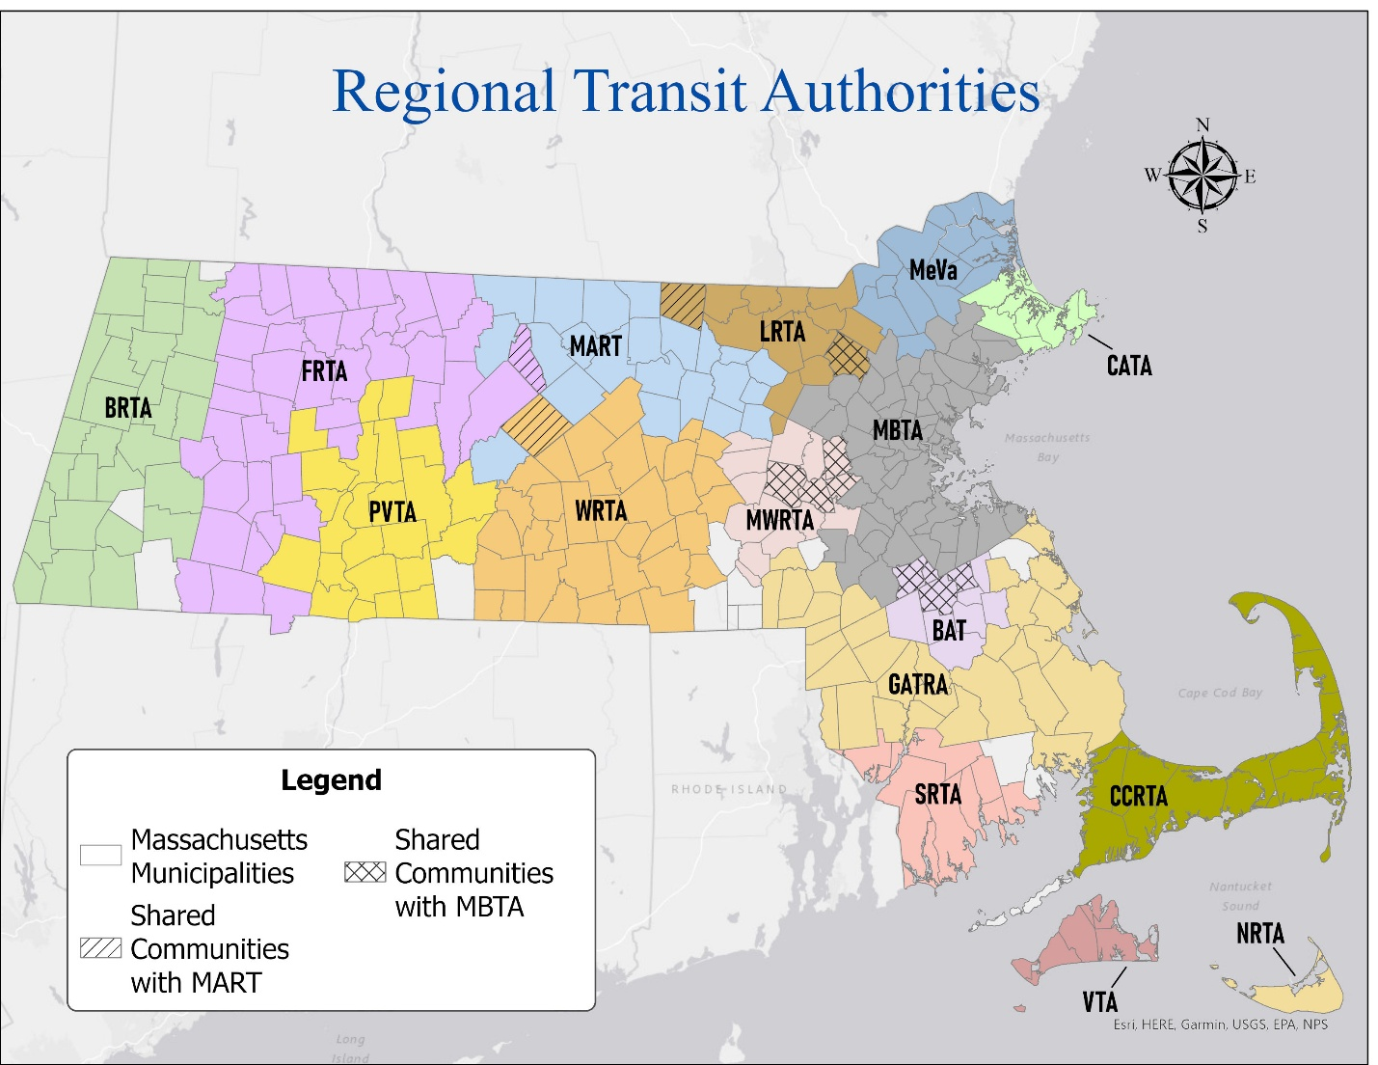
Source: Massachusetts Department of Transportation (MassDOT)

Purpose
The CRTP serves as a policy-level document and roadmap for future action outlining SRTA’s vision and priorities for the next five years. Supported by the Commonwealth as part of a statewide effort, it complements other statewide and regional plans such as the Beyond Mobility Massachusetts 2050 Transportation Plan and Report of the Task Force on RTA Performance and Funding (refer to Chapter 3 for a complete list of relevant plans).
The Task Force report, in particular, recommends that “[a]ll state contract assistance will be connected to performance targets via a Memorandum of Understanding (MOU). MOUs will be bilaterally negotiated between MassDOT Rail & Transit Division (RTD) and each RTA and will identify performance targets in the following categories: ridership; customer service and satisfaction; asset management; and financial performance (incorporating a number of factors including farebox recovery ratio).” Based on this recommendation, the Massachusetts State Legislature has included language in the annual state budget since FY 2020 on the collection of performance data and the distribution of state funding in accordance with the most recently established MOU. As such, MassDOT RTD and the RTAs undergo a biennial bilateral negotiation process to establish an agreed upon MOU that includes performance targets in the above-mentioned categories. Also included in the MOU is a commitment by the RTA to prepare a long-range CRTP as a mechanism to inform and support data-driven decisions, to work with local partners, and to communicate and discuss with MassDOT RTD on unmet needs or priorities and the potential for additional resources or support, if available.
Developed alongside these other plans, the CRTP provides guidance to SRTA state and local partners as they develop their own plans. The CRTP can also serve as a valuable tool for helping the public gain a clearer understanding of how SRTA operates, the value it provides, and opportunities for improvements in the future.
Over the next five years, this document will serve as a resource, offering strategic guidance to inform policy decisions that shape the region’s transportation future. Acting as a roadmap for data-driven decision-making that can inform more detailed capital and operational planning, the CRTP plays a dual role: it is both a product of ongoing discussions on public transportation in the state and region and a catalyst for future dialogue and action.

Needs and Goals
Over the next five years, SRTA seeks to address critical needs within the agency and the communities it serves. As part of SRTA’s CRTP, goals and objectives for this timeframe were identified that align with the agency’s mission. The goals set forth include developing actionable next steps, improving interconnectivity, and continuing to deliver exceptional service.

Statewide Policies and Goals
Over the last six years, the Commonwealth of Massachusetts has developed the following statewide planning and policy documents that are relevant to SRTA’s CRTP update and goal setting:
- Beyond Mobility Massachusetts 2050 Transportation Plan (2024)
- Regional Bus Network Assessment (2024)
- Benefits of Regional Mobility Managers Plan (2023)
- Clean Energy and Climate Plan for 2050 (2022)
- Massachusetts State Plan on Aging (2021)
- Massachusetts 2050 Decarbonization Roadmap (2020)
- Report of the Task Force on RTA Performance and Funding (2019)
Together, the documents highlight a number of robust goals and action steps that are relevant for all Commonwealth RTAs. Common goal themes as noted in the statewide documents that help inform the development of SRTA-specific needs and goals for its 2025 CRTP include:
- Implementing zero emission fleets and pursuing opportunities for fleet transition and sustainability
- Promoting cross-RTA coordination and interconnectivity among services, where feasible
- Delivering fare-free transit service
- Supporting and growing transit ridership
- Exploring and maximizing innovative funding sources
- Ensuring Council on Aging (COA) services prioritize access for older adults and persons with disabilities
As detailed further in this chapter, the overarching goals for the SRTA CRTP are aligned with many of these statewide goals.

Agency Mission
It is the mission for SRTA to provide safe, convenient, and economical transportation opportunities for people that support economic development and improved quality of life for residents of Massachusetts’ south coast.

Identified Needs
Through review and discussion of existing transportation challenges, past community feedback received, the findings from the 2020 CRTP, and regional, state, and federal priorities, SRTA identified the following needs to address in its 2025 CRTP, in no particular order of priority:
- Expand access to transit
- Increase ridership across all services
- Support current and new services
- Present transit as a convenient option for SRTA service area residents and visitors
- Make data-driven decisions to improve current service and when implementing new service
- Move forward with SRTA’s established goals
- Position SRTA for future funding opportunities
- Reduce greenhouse gas emissions

Goals and Objectives
Starting with the 2020 CRTP, an evaluation was conducted of the previous goals, objectives, needs, and recommendations. This information served as the basis for SRTA staff to identify priorities, opportunities, and any potential barriers for the 2025 CRTP. To identify goals and objectives, SRTA focused on its priorities and its community and stakeholders. Additional consideration was given to regional goals, such as those of the metropolitan planning organization (MPO) and of major regional partners such as in housing and economic development. The discussion also focused on the broader context, including Commonwealth policies and goals and federal considerations.
The overarching goals identified for SRTA’s 2025 CRTP include developing actionable next steps, pursuing opportunities for additional funding, delivering exceptional service, and continuing to transition to zero emission technology, which are reflective of the agency’s needs and opportunities. The objectives associated with each of these five goals are as follows, in no particular order of priority:
- Goal 1: Develop Actionable Next Steps
- Objective 1: Building from prior planning studies, define actionable next steps for service changes.
- Objective 2: Implement bus stop updates based on previously developed guidelines and secured funding.
- Objective 3: Increase staff resources by filling open positions.
- Goal 2: Pursue Additional Funding Opportunities to Support Existing and New Services
- Objective 1: Continue to offer fixed route services fare free.
- Objective 2: Update local assessment evaluations to support expanding fixed route services.
- Objective 3: Continue capital bus replacement plan to maintain a state of good repair.
- Goal 3: Deliver Exceptional Service
- Objective 1: Explore extending hours of service.
- Objective 2: Maintain Sunday service.
- Objective 3: Enhance communication with the public about services and policies.
- Objective 4: Continue and increase existing security at terminals.
- Goal 4: Explore Opportunities for Interconnectivity
- Objective 1: Continue to coordinate with other RTAs to explore opportunities for collaboration.
- Objective 2: Improve connections for education.
- Objective 3: Utilize microtransit to pilot new services and connections within the SRTA service area.
- Goal 5: Explore Innovative Technologies
- Objective 1: Continue collaborating with utility company to meet the needs of the current and future fleet.
- Objective 2: More clearly understand maintenance facility approach after completing the Maintenance Facility Feasibility Study.
These goals and objectives were assessed against progress since the last CRTP in an effort to identify opportunities to meet SRTA’s identified needs. Additionally, a detailed data assessment of SRTA’s system from the last five years, combined with input from stakeholder engagement efforts, was used to inform this CRTP’s recommendations.

Existing Conditions
To support the development of informed future recommendations, a comprehensive assessment of existing conditions was performed. This chapter documents SRTA’s current services, ridership, operations, asset management, and more.

Transit Service Overview
SRTA was incorporated under Massachusetts General Law 161B in 1974 and provides fixed route and demand response service to the southeastern Massachusetts communities of Acushnet, Dartmouth, Fairhaven, Fall River, Freetown, Mattapoisett, New Bedford, Somerset, Swansea, and Westport. SRTA’s fixed route service operates 26 routes concentrated around the two urban centers within the region: Fall River and New Bedford. Each city serves as a hub for fixed route service, which originates or terminates at the terminal within that city (Figure 3 and Figure 4). The two systems are connected via service along US Route 6 and I-195. On an annual basis, SRTA carries nearly 2.9 million passengers, traveling approximately 2.4 million miles and operating over 180,000 revenue hours, with an operating budget of over $26.3 million (Table 2).
Table 2. Statistics by Service (FY 2024)
FY 2024 Data | Fixed Route | Percentage of Total | Demand Response | Percentage of Total | Total
Ridership | 2,783,971 | 96.4% | 104,788 | 3.6% | 2,888,759
Revenue Miles | 1,575,682 | 66.0% | 811,226 | 34.0% | 2,386,908
Revenue Hours | 129,144 | 71.7% | 50,983 | 28.3% | 180,127
Operating Cost | $18,976,171 | 72.0% | $7,396,951 | 28.0% | $26,373,122
Source: MassDOT
SRTA operates ADA demand response service for disabled persons in an expanded service area beyond the required ¾ mile paratransit buffer and covers the entirety of all 10 communities within its service area. To be eligible for the service, potential riders must complete an application with a qualified medical professional and be certified by SRTA to be authorized for the service. Additionally, SRTA offers the Boston Hospital Shuttle, which is a twice weekly shuttle to Boston-area hospitals, serving New Bedford on Tuesday and Fall River on Thursday. The service prioritizes older adults, veterans, and persons with disabilities with remaining seats available to the general public; reservations are required.
In March 2025, SRTA launched its new microtransit service, MicroConnector, to connect riders to the new South Coast Rail service. MicroConnector is a new on-demand transportation service where riders request a ride via a smart phone app or by telephone to transport them to or from a South Coast Rail station. At the time of this report, SRTA offers MicroConnector in three zones (Figure 5): New Bedford North Zone, New Bedford South Zone, and Fall River Zone. The MicroConnector is available Monday through Friday from 4:00 AM to 9:30 AM for the morning trains and from 5:30 PM to 11:00 PM for the evening trains. The current cost to ride the service is $1.00 for riders age 12 and older and $0.50 for riders age six to 11 years old and riders age 65 and older. Children under six years old may ride for free.
Figure 3. Fall River Fixed Route System Map
Source: SRTA
Figure 4. New Bedford Fixed Route System Map
Source: SRTA
Figure 5. MicroConnector Zone Map
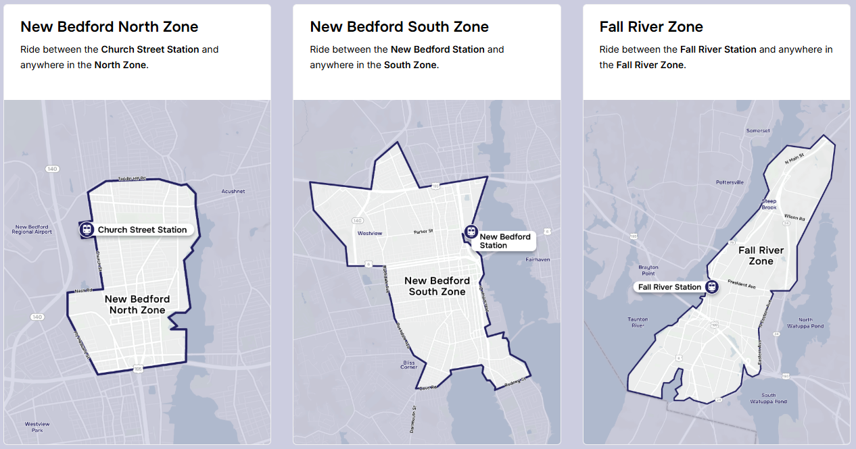
Source: SRTA

Service Descriptions
In general, SRTA services connect outlying communities with the two main cities in the service area (New Bedford and Fall River). SRTA also provides a connection between the two cities via the New Bedford to Fall River Intercity Route, which offers both local and express service.
SRTA offers its riders a tool to help them navigate trips: the SRTA Bustracker app. Launched in spring 2022, the SRTA Bustracker is a free app that provides real-time bus tracking and schedule information for riders, available directly on their personal smartphones. The app puts real-time information directly into the hands of its riders.

Fall River Services
Fall River is served by 11 regular fixed routes, plus the Boston Hospital Shuttle, as seen in Table 3.
Table 3. Fall River Fixed Routes
Route Number | Route Name | Service Type | Service Destinations
9, 9X | Intercity ª | Fixed Route | Fall River Terminal, UMass Dartmouth, Dartmouth Mall, New Bedford Terminal. Includes Route 199 Intercity Tripper serving Durfee High School.  The 9X route is the express Route 9 service that runs every hour.
101 | South Main Street | Fixed Route | South Main and Hall Street, Shove Street and Broad Street
102 | North Main Street | Fixed Route | North Main Street Shaw’s, Four Winds
103 | Laurel Street | Fixed Route | Globe Street and Vale Street, Fall River Shopping Plaza, Amity Street and McMahon Street
104 | Robeson Street | Fixed Route | Truesdale Clinic, Highland Apartments, Catholic Memorial Home
105 | Stafford Road | Fixed Route | Pleasant Street and Second Street, Seabra Market, Southcoast Marketplace
106 | Pleasant Street | Fixed Route | Route discontinued in August FY 2024
107 | Bay Street | Fixed Route | Bay Street and Bradford Street, Gold Medal Bakery, Bay Street Turnaround
108 | BCC & Durfee High School | Fixed Route | Charlton Memorial Hospital, Durfee High School, BCC
109 | Bedford Street | Fixed Route | Bedford Street and 17th Street, County Street and Pleasant Street
110 | Rodman Street | Fixed Route | Rodman Street and Brayton Avenue, Fall River Walmart
114 | Swansea Mall | Fixed Route | Commonwealth Landing, Somerset Stop & Shop, Swansea Walmart
— | Boston Hospital Shuttle ª | Demand Response | Various Boston hospitals
Source: SRTA
ª Serves both Fall River and New Bedford

New Bedford Services
New Bedford is served by 11 fixed routes, plus the Boston Hospital Shuttle, as seen in Table 4.
Table 4. New Bedford Fixed Routes
Route Number | Route Name | Service Type | Service Destinations
9, 9X | Intercity ª | Fixed Route | Fall River Terminal, UMass Dartmouth, Dartmouth Mall, New Bedford Terminal. Includes Route 199 Intercity Tripper.  The 9X route is the express Route 9 service that runs every hour.
201 | Fort Rodman | Fixed Route | Howland Green Library, Brock Avenue and Portland Street, Rodney French Boulevard and Welcome Street, Portland Street and Coral Street
202 | Lund's Corner | Fixed Route | Market Basket, Acushnet Avenue and Belleville Road, Lund's Corner
203 | Dartmouth Street | Fixed Route | St Luke's Hospital, Dartmouth Street Stop & Shop, Tripp Tower, Big Value Plaza
204 | Ashley Boulevard | Fixed Route | Ashley Boulevard and Sawyer Street, Ashley Boulevard and Daniel Street, Trucchi's
205 | South Central | Fixed Route | MacArthur Drive and South Street
206 | Shawmut Avenue | Fixed Route | Shawmut Avenue and Mt Vernon Street, Rockway Street and Carriage Drive
208 | Mt Pleasant Street | Fixed Route | Mt Pleasant Street and Nauset Street, Stop & Shop
210 | Dartmouth Mall | Fixed Route | Dartmouth Mall, Hawthorn Medical
211 | Fairhaven | Fixed Route | Market Basket, Fairhaven Walmart, Stop & Shop
221 | North End Shuttle | Fixed Route | Stop & Shop, Lund's Corner, Church Street and Amanda Avenue
— | Boston Hospital Shuttle ª | Demand Response | Various Boston hospitals
Source: SRTA
ª Serves both Fall River and New Bedford

Provided Services
SRTA operates on a consistent schedule all year, with most services operating seven days a week, as seen in Table 5 and Table 6.
Table 5. Fall River Service Offerings
Route Number | Weekday Service Hours | Weekend Service Hours | Weekday Headway (Minutes) | Weekend Headway (Minutes) | Days Operated
9, 9X ª | 6:00 AM - 10:10 PM | 8:00 AM –  8:10 PM | 20 | 20 | 7 Days
101 | 6:10 AM - 8:52 PM | 6:10 AM –  5:37 PM | 30 | 30 | 7 Days
102 | 6:00 AM - 9:24 PM | 6:30 AM –  7:24 PM | 30 | 30 | 7 Days
103 | 6:20 AM - 5:50 PM | 7:30 AM –  6:00 PM | 30 | 30 | 7 Days
104 | 5:59 AM - 5:57 PM | 6:28 AM –  6:25 PM | 30 | 60 | 7 Days
105 | 6:10 AM - 8:19 PM | 6:45 AM –  5:57 PM | 30 | 30 | 7 Days
106 | Discontinued in August of FY 2024 | N/A | N/A | N/A | N/A
107 | 6:10 AM - 6:06 PM | 6:40 AM –  5:16 PM | 60 | 60 | 7 Days
108 | 6:35 AM - 8:40 PM | 7:20 AM –  5:50 PM | 30 | 60 | 7 Days
109 | 6:05 AM - 5:19 PM | 6:50 AM –  6:02 PM | 30 | 60 | 7 Days
110 | 6:33 AM - 5:49 PM | 6:55 AM –  6:06 PM | 30 | 30 | 7 Days
114 | 8:30 AM - 9:29 PM | 8:30 AM –  6:24 PM | 60 | 60 | 7 Days
Boston Hospital Shuttle | 8:30 AM–2:30 PM (return trip leaves from Boston) | N/A | Thursdays only | N/A | N/A
ADA Demand Response | 5:20 AM - 10:10 PM | 6:10 AM –  8:05 PM | N/A | N/A | N/A
Source: SRTA
ª Serves both Fall River and New Bedford
N/A = Not Applicable
Table 6. New Bedford Service Offerings
Route Number | Weekday Service Hours | Weekend Service Hours | Weekday Headway (Minutes) | Weekend Headway (Minutes) | Days Operated
9, 9X ª | 6:00 AM – 10:10 PM | 8:00 AM –  8:10 PM | 15 | 15 | 7 Days
201 | 5:20 AM – 10:00 PM | 6:45 AM –  6:03 PM | 20 | 30 | 7 Days
202 | 5:20 AM – 9:42 PM | 6:55 AM –  6:44 PM | 20 | 30 | 7 Days
203 | 6:30 AM – 9:23 PM | 7:40 AM –  5:32 PM | 30 | 60 | 7 Days
204 | 5:35 AM – 8:56 PM | 7:45 AM –  5:59 PM | 30 | 30 | 7 Days
205 | 7:00 AM – 5:15 PM | 8:00 AM –  5:17 PM | 60 | 60 | 7 Days
206 | 6:15 AM –5:52 PM | 7:20 AM –  4:54 PM | 60 | 60 | 7 Days
208 | 6:44 AM – 6:05 PM | 8:05 AM –  5:11 PM | 40 | 40 | 7 Days
210 | 5:45 AM – 6:46 PM | 9:30 AM –  6:32 PM | 60 | 60 | 7 Days
211 | 6:05 AM – 6:38 PM | 8:05 AM –  5:33 PM | 30 | 30 | 7 Days
221 | 9:05 AM – 5:02 PM | 9:03 AM –  4:53 PM | 40 | 40 | 7 Days
Boston Hospital Shuttle | 8:30 AM – 2:30 PM (return trip leaves from Boston) | N/A | Tuesdays only | N/A | 7 Days
ADA Demand Response | 5:20 AM – 10:10 PM | 6:10 AM –  8:05 PM | N/A | N/A | N/A
Source: SRTA
ª Serves both Fall River and New Bedford
N/A = Not Applicable

Transit Service Performance
This section provides information on SRTA systemwide performance trends for fixed route and demand response services from FY 2020 to FY 2024. Transit service performance is evaluated in two categories: service effectiveness and financial performance. A comparison with peer transit systems across Massachusetts and the nation is also provided.
SRTA’s annual fixed route operating statistics are shown in Table 7. Following the decrease in system metrics in FY 2021 due to the COVID-19 pandemic, ridership and revenue hours increased from FY 2021 to FY 2024.
Table 7. Annual Fixed Route Operating Statistics (FY 2020–FY 2024)
Statistic | FY 2020 | FY 2021 | FY 2022 | FY 2023 | FY 2024
Ridership | 2,225,259 | 1,665,868 | 2,016,128 | 2,278,886 | 2,783,971
Revenue Hours | 113,581 | 122,073 | 126,725 | 124,058 | 129,144
Revenue Miles | 1,438,774 | 1,621,177 | 1,661,461 | 1,566,913 | 1,575,682
Operating Costs | $15,193,408 | $16,089,181 | $17,051,605 | $17,693,595 | $18,976,171
Source: SRTA, MassDOT
SRTA’s annual demand operating statistics are shown in Table 8. As with fixed route service, all metrics increased from FY 2021 to FY 2024.
Table 8. Annual Demand Response Operating Statistics (FY 2020–FY 2024)
Statistic | FY 2020 | FY 2021 | FY 2022 | FY 2023 | FY 2024
Ridership | 79,524 | 73,408 | 83,014 | 89,663 | 104,788
Revenue Hours | 36,985 | 37,435 | 40,613 | 44,229 | 50,983
Revenue Miles | 558,229 | 558,240 | 596,637 | 677,467 | 811,226
Operating Costs | $4,923,531 | $4,953,866 | $5,455,462 | $6,222,068 | $7,396,951
Source: SRTA, MassDOT

Service Effectiveness
Service effectiveness describes the amount of transit service utilized per unit amount of transit service that is provided. Service effectiveness is measured using two indicators: passengers per mile and passengers per hour.
- Passengers per mile measures the average number of unlinked passenger trips taken for every vehicle revenue mile provided. Though passengers per mile indicator is a strong measure of system efficiency, it is also influenced by the length of passenger trips. Smaller values likely represent longer trips where passengers are travelling greater distances, or a poorly performing system. Larger values likely represent shorter trips where passengers are traveling smaller distances, or a high-performing system.
- Passengers per hour measures the average number of unlinked passenger trips taken for every vehicle revenue hour provided. Passengers per hour is influenced by the geographic area and the average operating speed of a route. Higher values indicate a more efficient system.
Service effectiveness for SRTA fixed route and demand response services from 2020 to 2024 are illustrated in Table 9. From FY 2020 to FY 2024 SRTA increased fixed route passengers per mile. In FY 2024 SRTA was above the FY 2024 Massachusetts average for both fixed route passengers per mile and passengers per hour. From FY 2020 to FY 2024 demand response passengers per mile remained steady at around 0.14 passengers per mile. In FY 2024 SRTA was at the national average of 0.13 demand response passengers per mile and above the national average for demand response passengers per hour.
Table 9. Service Effectiveness (FY 2020-FY 2024)
Fiscal Year | Fixed Route Passengers/Mile | Fixed Route Passengers/Hour | Demand Response Passengers/Mile | Demand Response Passengers/Hour
FY 2020 | 1.55 | 19.59 | 0.14 | 2.15
FY 2021 | 1.03 | 13.65 | 0.13 | 1.96
FY 2022 | 1.21 | 15.91 | 0.14 | 2.04
FY 2023 | 1.45 | 18.37 | 0.13 | 2.03
FY 2024 | 1.49 | 20.24 | 0.13 | 2.06
FY 2024 Massachusetts Average ª | 1.25 | 17.87 | 0.12 | 1.95
FY 2024 National Average | 1.92 | 23.06 | 0.13 | 1.92
Source: National Transit Database (NTD)
ª Massachusetts average excludes MBTA.

Financial Performance
Cost effectiveness is a measure of a transit system’s financial performance, indicating how efficiently funds are used to deliver the service. Many variables influence the financial efficiency of a transit agency, including the geographic area, ridership, the cost of labor, and more. Cost effectiveness indicators are cost per mile, cost per hour, and cost per passenger.
- Cost per mile measures the overall expense of providing a transit service divided by the vehicle revenue miles provided by the service. A smaller value indicates more financially efficient system and/or faster operating speeds.
- Cost per hour measures the overall expense of providing a service divided by the number of vehicle revenue hours provided by the service. A smaller value indicates a more financially efficient system and/or faster operating speeds.
- Cost per passenger measures the overall expenses required to operate the transit service divided by the number of unlinked passenger trips that were taken on the service. A smaller value indicates a financially efficient system and/or a mode with high ridership.

Fixed Route Financial Performance
Table 10 illustrates the cost effectiveness of SRTA fixed route services from FY 2020 to FY 2024. SRTA’s fixed route services increased in cost per mile (14 percent) and cost per hour (10 percent) from FY 2020 to FY 2024. SRTA’s cost per passenger for fixed route services increased in FY 2021 by about $3.00 but decreased to $6.82 in FY 2024. The increased cost is attributed to the agency response to the COVID-19 pandemic. Service was reduced for five months and restored to a full schedule in fall 2020; ridership did not start to recover until well into 2021. SRTA’s FY 2024 fixed route cost per mile, cost per hour, and cost per passenger are all below the FY 2024 national averages.
Table 10. Fixed Route Financial Efficiency (FY 2020–FY 2024)
Fiscal Year | Cost/Mile | Cost/Hour | Cost/Passenger
FY 2020 | $10.56 | $133.77 | $6.83
FY 2021 | $9.92 | $131.80 | $9.66
FY 2022 | $10.26 | $134.56 | $8.46
FY 2023 | $11.29 | $142.62 | $7.76
FY 2024 | $12.04 | $146.94 | $6.82
FY 2024 Massachusetts Average ª | $9.88 | $141.70 | $7.93
FY 2024 National Average | $15.80 | $189.95 | $8.24
Source: NTD
ª Massachusetts average excludes MBTA.

Demand Response Financial Performance
Table 11 illustrates the cost effectiveness of SRTA’s demand response services from 2020 to 2024. From FY 2020 to FY 2024 SRTA’s cost per mile, cost per hour, and cost per passenger increased for demand response services, underperforming both state and national averages.
Table 11. Demand Response Financial Efficiency (FY 2020–FY 2024)
Fiscal Year | Cost/Mile | Cost/Hour | Cost/Passenger
FY 2020 | $8.82 | $133.12 | $61.91
FY 2021 | $8.87 | $132.33 | $67.48
FY 2022 | $9.14 | $134.33 | $65.72
FY 2023 | $9.18 | $140.68 | $69.39
FY 2024 | $9.12 | $145.09 | $70.59
FY 2024 Massachusetts Average ª | $5.43 | $87.07 | $44.76
FY 2024 National Average | $6.32 | $97.27 | $50.57
Source: NTD
ª Massachusetts average excludes MBTA.

Funding
Until FY 2024 the largest source of SRTA’s capital funding was provided by the federal government as shown in Table 12. In FY 2024, the largest source of SRTA’s capital funds came from state funding (59.7 percent). From FY 2023 to FY 2024 the amount of state funding for capital increased nearly $2 million. Overall, total capital funding grew from $3.1 million in FY 2022 to $5.9 million in FY 2024. The capital funds were mostly directed to the vehicle replacement program, which replaced diesel buses past their usable life benchmarks with diesel/electric hybrid drive buses. Capital funds were used to a lesser extent for facility improvements and maintenance equipment procurements.
Table 12. Capital Expenses Funding Sources (FY 2022-FY 2024)
Funding Source | FY 2022 | Percentage of FY 2022 Total | FY 2023 | Percentage of FY 2023 Total | FY 2024 | Percentage of FY 2024 Total
Federal | $2,402,103 | 78.6% | $4,319,529 | 72.8% | $2,360,153 | 40.3%
State | $652,409 | 21.4% | $1,569,971 | 26.5% | $3,495,561 | 59.7%
Local | $0 | 0.0% | $0 | 0.0% | $0 | 0.0%
Farebox | $0 | 0.0% | $41,606 | 0.7% | $0 | 0.0%
Other | $0 | 0.0% | $0 | 0.0% | $0 | 0.0%
TOTAL | $3,054,512 | 100.00% | $5,931,106 | 100.00% | $5,855,714 | 100.00%
Source: SRTA
The largest source of SRTA’s operating funds in FY 2024 came from state funding (49.7 percent), which is a change from years past when the largest source of SRTA’s funding was provided by the federal government, as shown in Table 13. SRTA also previously received COVID-era federal funding in the form of Coronavirus Aid, Relief, and Economic Security Act (which had to be obligated by May 11, 2023), Coronavirus Response and Relief Supplemental Appropriations (obligated by September 30, 2023), and American Rescue Plan Act funding (which had to be obligated by September 30, 2024), which SRTA has fully utilized. These fund sources could be used by SRTA for both capital and operating expenses. From FY 2023 to FY 2024, the amount of state funding increased from $7 million to $13 million through a combination of discretionary grant funds and an increase in state operating formula funds. Overall total funding sources grew from $22.5 million in FY 2022 to $26.4 million in FY 2024, largely due to an increase in funding from the state.
The amount of funding from fareboxes has decreased over time due to SRTA offering fare-free service for its fixed routes and complementary ADA funded by a state grant, Try Transit, that replaced revenue lost by removing fare collection. The Try Transit grants had been available in the past for short duration fare-free operations for the Christmas season. In FY 2024, funds were extended for longer periods determined by the RTAs; SRTA used FY 2024 Try Transit funds to operate fare free from January 1 to June 30, 2024. Try Transit funds were again available in FY 2025 and provided funding for a full year of fare-free operation. In FY 2026, fare-free operations were mandated by state legislation and funded accordingly.
Table 13. Operating Expenses Funding Sources (FY 2022-FY 2024)
Funding Source | FY 2022 | Percentage of FY 2022 Total | FY 2023 | Percentage of FY 2023 Total | FY 2024 | Percentage of FY 2024 Total
Federal | $9,742,719 | 43.3% | $11,282,227 | 47.2% | $8,277,892 | 31.4%
State | $7,175,334 | 31.9% | $6,957,548 | 29.1% | $13,112,136 | 49.7%
Local | $3,614,280 | 16.1% | $3,704,637 | 15.5% | $3,797,250 | 14.4%
Farebox | $1,678,052 | 7.5% | $1,858,230 | 7.8% | $1,032,967 | 3.9%
Other | $296,682 | 1.3% | $113,021 | 0.5% | $152,877 | 0.6%
TOTAL | $22,507,067 | 100.0% | $23,915,663 | 100.0% | $26,373,122 | 100.0%
Source: SRTA
SRTA maintains several revenue-producing agreements. In FY 2020, SRTA entered an advertising contract with a new vendor that produced substantial increases in revenue compared with the previous contract. SRTA also generates revenue through a partnership with the Greater Attleboro Taunton Regional Transit Authority (GATRA) in which SRTA operates the agencies’ joint service, the New Bedford-Wareham Shuttle. Additionally, prior to implementing fare-free service in January 2024, SRTA had a partnership with University of Massachusetts (UMass) Dartmouth in which, the university reimbursed SRTA at a rate of $0.75 per trip and was invoiced monthly; the goal of the partnership was to be cost and revenue neutral and generate ridership.
Figure 6 shows the annual operating cost from both fixed route and demand response services from FY 2020 to FY 2024. Operating costs increased from FY 2020 to FY 2024 by $3.8 million for fixed route and $2.5 million for demand response. Fixed route operating costs increased with the introduction of Sunday service. Demand response operating costs have been impacted by the introduction of Sunday service and fare-free service. Additionally, SRTA introduced a 5.5 percent attendance incentive pay for all union employees.
Figure 6. Annual Operating Cost by Mode (FY 2020–FY 2024)

Source: SRTA

Ridership and Service Operations
SRTA’s overall system ridership (inclusive of both fixed route and demand response) experienced a decrease in ridership from FY 2020 to FY 2021 due to the COVID-19 pandemic. Since the initial drop, ridership steadily increased from FY 2021 to FY 2024 (Figure 7). FY 2024 ridership reached nearly 2.9 million, a 25 percent increase from FY 2020’s ridership and slightly more than the steady pre-COVID annual overall system ridership. Ridership numbers from FY 2015 to FY 2019 were consistently between 2.7 million and 2.8 million, as documented in SRTA’s 2020 CRTP Update (SRTA 2021).
Figure 7. Annual System Ridership (FY 2020–FY 2024)

Source: SRTA, MassDOT
SRTA provided the majority of its trips on traditional fixed route buses, with only 4 percent of trips taken on demand response services, as shown in Figure 8. From a financial efficiency perspective, this is preferable, as fixed route trips are much less expensive to operate than door-to-door service (SRTA 2021).
Figure 8. Ridership Breakdown by Service Type (FY 2024)

Source: MassDOT
Monthly ridership trends from calendar year 2022 to calendar year 2024 show that there is a decrease in ridership during the summer months of June, July, and August (Figure 9). Many students use SRTA services as transportation to and from school, and to after-school jobs and activities. School being out of session during summer vacation contributes to the decrease in ridership during summer months.
Figure 9. Monthly Ridership Trends (2022–2024)

Source: MassDOT
As shown in Figure 10, SRTA had a nearly 100 percent scheduled trips operated rate. SRTA did not report any capacity issues or denied scheduled trips to customers between FY 2020 and FY 2024.
Figure 10. Overall Scheduled Trips Operated by Mode (FY 2020–FY 2024)

Source: SRTA

Fixed Route Ridership
Fixed route ridership experienced a low in FY 2021 with ridership numbers just under 1.7 million as shown in Figure 11. Since FY 2021, ridership has been increasing with a peak in ridership of nearly 2.8 million in FY 2024. The increase in ridership can be attributed to both fare-free service and the introduction of Sunday service; both were implemented in January 2024. This is approximately 500,000 more riders than the FY 2024 fixed route ridership target of 2,291,623.
Figure 11. Fixed Route Annual Ridership (FY 2020–FY 2024)

Source: SRTA, MassDOT
As shown in Figure 12, Route 202, Route 201, and Route 9 have the highest ridership in the SRTA system, the latter connecting the Fall River system with the New Bedford system while serving the Dartmouth Mall and the UMass Dartmouth campus. Route 205 has among the lowest riderhip, partly because the route operates hourly with few destinations on the route. Analysis conducted by SRTA suggests that route elimination would not yeild significant savings in the operating budget. A similar analysis of Route 221 showed that, despite having the lowest ridership, it had the most consistent ridership of any route with very little variance month to month. Route 106 is not included in the graph since service was discontued in FY 2024.
Figure 12. Ridership by Fixed Route (FY 2024)

Source: SRTA
As shown in Figure 13, Route 202, Route 201, and Route 9 have the highest average weekday ridership in the system, which is consistent with them having the highest annual ridership by route. Routes 201 and 202 average ridership are attributed to the amount of service to these routes. Both routes have the most frequent headways and the longest span of service in the SRTA system. Route 205 and Route 221 also have very low average weekday ridership, which is consistent with low annual ridership.
Route 106 is not included in the graph since service was discontinued in FY 2024.
Figure 13. Weekday Average Ridership by Route (FY 2024)

Source: SRTA
Similar to trends in weekday average ridership, Figure 14 and Figure 15 show that the routes with the highest ridership on both Saturdays and Sundays are Route 201, Route 202, and Route 9. Route 221 and Route 205 have the lowest ridership on both Saturdays and Sundays. SRTA operates the same schedule on Saturday and Sunday, which for some routes like Route 9, Route 201, and Route 202 means less frequency, and for all routes means a shorter span. Sunday service is a new addition demonstrated by the latent demand for service in the community. The consistency between Saturday and Sunday ridership shows how quickly the service was adopted by riders.
Route 106 is not included in the graph since service was discontinued in FY 2024.
Figure 14. Saturday Average Ridership by Route (FY 2024)

Source: SRTA
Figure 15. Sunday Average Ridership by Route (FY 2024)

Source: SRTA

Fixed Route Effectiveness
SRTA’s fixed route operations remained steady with a system average of over 20 passengers per hour during FY 2024. While the system average was 20.24 passengers per hour, many routes exceeded the average, such as Route 103, Route 108, and Route 9, which carried around 26 passengers per hour (Figure 16). Routes 103 and 108 serve dense areas of Fall River, connecting downtown to multiple shopping centers, hospitals, schools, and employment centers. Route 9 links both the Fall River and New Bedford systems with UMass Dartmouth and the Dartmouth Mall. Conversely, Route 114, Route 205, and Route 221 have the lowest passengers per hour rates for FY 2024. Routes 114 and 221 serve low density areas on the peripheries of the Fall River and New Bedford urban areas, respectively. Route 205, one of SRTA’s shortest routes, runs between the New Bedford terminal and the Price Rite Marketplace just south of downtown New Bedford. A portion of this route is also served by Route 201.
Figure 16. Passengers per Hour per Route (FY 2024)

Source: SRTA
Table 14 shows SRTA operating statistics by route in FY 2024.
Table 14. Operating Statistics by Route (FY 2024)
Route | Ridership | Revenue Hours | Passenger Trips/ Hour | Revenue Miles | Passenger Trips/ Mile
9 | 340,251 | 13,492 | 25.22 | 238,838 | 1.42
101 | 119,584 | 5,026 | 23.79 | 53,552 | 2.23
102 | 171,908 | 8,151 | 21.09 | 159,700 | 1.08
103 | 126,451 | 4,801 | 26.34 | 45,912 | 2.75
104 | 100,222 | 4,993 | 20.07 | 63,725 | 1.57
105 | 139,511 | 6,431 | 21.69 | 76,381 | 1.83
106ª | 4,162 | 269 | 15.47 | 2,468 | 1.69
107 | 48,869 | 2,478 | 19.72 | 30,023 | 1.63
108 | 126,992 | 4,750 | 26.74 | 62,786 | 2.02
109 | 62,677 | 3,430 | 18.27 | 39,541 | 1.59
110 | 90,323 | 3,645 | 24.78 | 41,990 | 2.15
114 | 29,292 | 3,645 | 8.04 | 76,158 | 0.38
201 | 226,579 | 9,140 | 24.79 | 98,591 | 2.30
202 | 263,441 | 11,648 | 22.62 | 121,844 | 2.16
203 | 89,376 | 6,603 | 13.54 | 82,003 | 1.09
204 | 151,410 | 7,348 | 20.61 | 104,427 | 1.45
205 | 7,605 | 735 | 10.35 | 9,574 | 0.79
206 | 38,869 | 3,184 | 12.21 | 36,153 | 1.08
208 | 69,535 | 3,197 | 21.75 | 40,293 | 1.73
210 | 54,735 | 4,203 | 13.02 | 59,129 | 0.93
211 | 98,827 | 7,589 | 13.02 | 100,263 | 0.99
221 | 10,694 | 2,380 | 4.49 | 47,186 | 0.23
Source: SRTA, MassDOT
Note: Data discrepancies between the sum values for route level data and total systemwide data are caused by separate reporting systems used to produce the sums. Systemwide fixed route data are adjusted by the reporting system to account for data discarded by the reporting software business rules; route level data are reported without adjustment.
ª Route 106 was discontinued in August 2024

Demand Response Ridership and Effectiveness
SRTA provides ADA demand response service to its 10 member communities. While the ADA requires service to be provided only within ¾ mile of fixed route service, SRTA provides ADA service community-wide to the 10 member communities. Demand response service is provided above and beyond minimum requirements; however, it remains a small proportion of overall SRTA ridership. Ridership figures represent the total of ADA required service, additional service outside the ADA buffer, and Boston Hospital Shuttle ridership.
Demand response annual ridership experienced a dip in FY 2021 but continued to increase from FY 2021 to FY 2024. SRTA exceeded the FY 2024 annual ridership target of 89,450, with a FY 2024 annul ridership of 104,788 (Figure 17).
Figure 17. Demand Response Annual Ridership (FY 2020–FY 2024)

Source: SRTA, MassDOT
Table 15 shows SRTA’s operating statistics for demand response from FY 2020 to FY 2024. Revenue hours, revenue miles, and operating costs all increased as ridership increased following the dip in ridership from FY 2020 to FY 2021 due to the pandemic.
Table 15. Demand Response Operating Statistics (FY 2020–FY 2024)
Statistic | FY 2020 | FY 2021 | FY 2022 | FY 2023 | FY 2024
Ridership | 79,524 | 73,408 | 83,014 | 89,663 | 104,788
Revenue Hours | 36,985 | 37,435 | 40,613 | 44,229 | 50,983
Revenue Miles | 558,229 | 558,240 | 596,637 | 677,467 | 811,226
Operating Costs | $4,923,531 | $4,953,866 | $5,455,462 | $6,222,068 | $7,396,951
Source: SRTA, MassDOT
SRTA’s demand response service tracks the number of denied trips, missed trips, no-shows, late cancellations, and same-day cancellations SRTA uses the following definitions for missed trips, no-shows, late cancellations, and same-day cancellations:
- No show: Customer did not show for ride
- Missed trip: Arrived after pick-up window
- Late cancellation: Customer cancelled trip at door
- Same-day cancellation: Customer cancelled trip same day
It is notable that SRTA did not deny any demand response trips from FY 2020 to FY 2024 as shown in Table 16. From FY 2021 to FY 2024 there was an increase in the number of trips per passenger, which was calculated by dividing total demand response ridership by the number of unique passengers, suggesting that the increase in ridership is caused by more trips taken by the same or similar number of passengers. The introduction of fare-free service has increased the number of trips taken by an individual passenger as well as attracted more passengers to the demand response system.
Table 16. Demand Response Metrics (FY 2020-FY 2024)
Metric | FY 2020 | FY 2021 | FY 2022 | FY 2023 | FY 2024
Average Trips/Passenger | 42.92 | 40.25 | 46.12 | 49.70 | 53.99
% Denied Trips | 0.00% | 0.00% | 0.00% | 0.00% | 0.00%
% Missed Trips | 0.03% | 0.02% | 0.03% | 0.01% | 0.02%
% No-show | 1.06% | 1.27% | 1.37% | 1.06% | 1.05%
% Late Cancellation | 1.05% | 1.09% | 0.87% | 1.07% | 1.15%
% Same Day Cancellation | 9.18% | 9.76% | 10.15% | 9.47% | 7.51%
Source: SRTA

On-Time Performance
SRTA defines on-time performance for fixed route trips as trips that fall within a 6-minute pickup window (−1 minute, +5 minutes) of the scheduled departure from the first stop on the trip. As shown in Figure 18, SRTA’s FY 2024 target for all trips was to have 85 percent of trips on-time. In FY 2024 SRTA exceeded this goal as 89 percent of weekday trips, 90 percent of Saturday trips, and 95 percent of Sunday trips were on time.
Figure 18. On-Time Performance - Fixed Route (FY 2024)

Source: SRTA
Figure 19 shows on-time performance broken down to the route level. Systemwide, on average, 90 percent of fixed route trips are on time. At the route level, 18 out of 21 routes exceeded the target of operating at least 85 percent of trips on time. Only three routes, Route 110, Route 202, and Route 211, fell below the target for on-time performance. However, these three routes only missed the target by 1 or 2 percent.
Figure 19. On-Time Performance by Fixed Route (FY 2024)

Source: SRTA
For demand response trips, on-time performance is defined as trips that fall within a 20-minute pickup window (5 minutes before and 15 minutes after) of the scheduled pick-up time. Figure 20 shows how demand response has the same target as fixed route, at 85 percent of trips on time. Both weekday and Saturday demand response trips missed this target, operating 68 percent and 79 percent of trips on time, respectively. Sunday exceeds the on-time target, with an average of 89 percent of demand response trips on time. Early arrivals are the primary reason demand response on-time performance fell below the target. Customers are not expected to board more than 5 minutes before their scheduled trip time; however, for those that do, the trip is recorded as early.
Figure 20. On-Time Performance - Demand Response (FY 2024)

Source: SRTA

Customer Service
Transit providers typically have a target number for complaints per 100,000 passenger trips to normalize complaints across fluctuating ridership. SRTA saw a peak in complaints per 100,000 trips in FY 2020, with the lowest number of complaints in FY 2022 (Figure 21).
Figure 21. Valid Complaints per 100,000 Passenger Trips: All Services (FY 2020 – FY 2024)

Source: SRTA

Regional Connections and Partnerships
SRTA provides connections to other public transportation services and has limited service to Rhode Island. SRTA and GATRA jointly operate the Wareham-New Bedford Connection, which connects SRTA customers to GATRA services at several transit hubs in the GATRA network. SRTA has a terminal use agreement with Rhode Island Public Transit Authority (RIPTA) that enables RIPTA’s Route 24X (which travels to Newport and Providence) to serve SRTA’s Fall River Terminal.
In March 2025, SRTA began the MicroConnector to provide service to South Coast Rail stations. This service is an app based on-demand transit service that runs from 4:00 AM to 9:30 AM and 5:30 PM to 11:00 PM. The goal of this service is to fill the gaps in time where SRTA routes are not in service to provide connections to the South Coast Rail stations. South Coast Rail service, called the Fall River / New Bedford Line on the MBTA’s Commuter Rail system, connects the region to Boston via various stops along the rail route (MBTA 2025).
In July 2025, SRTA, GATRA, and Brockton Area Transit Authority (BAT) began a new partnership to offer the Gateway Link. The Gateway Link connects terminals in Fall River, Taunton, and Brockton with minimal stops in between. This service operates as a cross between a commuter and regular fixed route and runs more frequently than a commuter route.

Asset Management
SRTA manages transit operations out of two facilities: Fall River Maintenance and New Bedford Maintenance and operates its fixed route and demand response services with a fleet of 70 fixed route buses and 44 demand response vehicles. This section highlights the data SRTA tracks and the targets it sets related to the condition, maintenance, and performance of its assets, as well as any implemented or planned technology upgrades to support operations. Each RTA has a Transit Asset Management (TAM) Plan that lays out the condition of facilities and priorities for capital improvements (SRTA 2023a). The performance targets are submitted to the NTD annually, whereas the full TAM Plan is updated at least every four years per federal requirements.

Maintenance
As of FY 2019 SRTA classifies road calls using the following definitions, the last of which is used to measure miles between road calls:
- Road Call (Farebox): Any road call due to an issue related to farebox.
- Road Call (Other): Any on-the-road issue that is (1) not related to farebox and (2) does not require a non-revenue (i.e., maintenance) vehicle to assist the bus or van.
- Road Call (Major Mechanical): Any on-the-road issue that requires a non-revenue (i.e., maintenance) vehicle to assist the bus or van. This would be a direct impediment to service, meaning that the next scheduled trip would be missed or canceled.
Miles between road calls decreased significantly in FY 2021 and increased in FY 2022 and again slightly in FY 2024 (Figure 22). It is notable that there were 11 major mechanical failures in FY 2021, which then decreased to 2 in FY 2022 and 2 in FY 2023.
Figure 22. Miles Between Road Calls (FY 2020 – FY 2024)

Source: SRTA
The Federal Transit Administration (FTA) standard for preventive maintenance is that revenue vehicles undergo regular maintenance service according to a schedule based on vehicle miles. The minimum percentage of preventive maintenance completed on time is 80 percent, meaning 80 percent of vehicles have received preventive maintenance service within the scheduled mileage, as shown in Figure 23. SRTA continued to exceed this minimum from FY 2020 to FY 2024, with 96 percent of preventive maintenance performed on-time in FY 2024.
Figure 23. Preventive Maintenance Performed On-Time (FY 2020 – FY 2024)

Source: SRTA
SRTA sets targets for mean miles between major mechanical failures for both demand response and fixed route. The FY 2024 target for fixed route was 35,000 miles and the demand response target was 250,000 miles. As there were no major mechanical failures in FY 2024 (Figure 24), SRTA met these targets.
Figure 24. Mean Miles Between Major Mechanical Failures (FY 2020 – FY 2024)

Source: SRTA

Vehicles
Table 17 displays SRTA’s active revenue vehicle inventory summary as of FY 2024. In total, SRTA has 114 active service vehicles.
Table 17. Active Equipment Inventory Summary (FY 2024)
Vehicle Type | Active Vehicles | Average Age (years) | Average Mileage | Useful Life Benchmark | % at or past Useful Life Benchmark
Bus (35 feet, 40 feet) | 70 | 5.3 | 160,267 | 12 | 15.6%
Demand Response Van | 44 | 4.2 | 104,062 | 4 | 54.5%
Source: SRTA
Table 18 outlines SRTA’s revenue vehicle spare ratios. The majority of SRTA’s vehicles are active, as only 17 buses are inactive. SRTA meets FTA guidance for spare ratio by mode.

Table 18. Revenue Vehicle Spare Ratio (FY 2024)
Vehicle Type | Total Number | Active | Inactive | Maximum in Service | Spare Ratio
Fixed Route | 87 | 70 | 17 | 51 | 37%
Demand Response | 44 | 44 | 0 | 28 | 57%
Source: SRTA

Facilities
SRTA has maintenance facilities in Fall River and New Bedford (Table 19). The Fall River maintenance facility’s Transit Economic Requirements Model (TERM) rating is 2, on a scale of 1 (lowest) to 5 (highest), indicating the building is not considered to be in a state of good repair. This standard of reporting is required by FTA. The Fall River maintenance facility is more than 50 years old; it is undersized for the current operations and has features (below grade maintenance pits) considered hazardous and outdated. SRTA is actively evaluating options to replace the facility. The New Bedford maintenance facility has a TERM rating of 3.
SRTA also owns two public-facing bus terminals, one located in Fall River and one in New Bedford. The Fall River Terminal (also known as the Louis D. Pettine Transportation Center) opened in 2013. The Fall River Terminal’s TERM rating is 5, indicating it is considered to be at the highest state of good repair. The New Bedford bus terminal has a TERM rating of 3.
Table 19. Facility Inventory Summary
Facility Name | Type | Location | Landowner the Facility is on | Direct Capital Responsibility | TERM Rating
New Bedford Terminal | Passenger - Bus transfer center | 134 Elm Street, New Bedford, MA 02740 | SRTA | SRTA | 3
New Bedford Maintenance Facility | General purpose maintenance facility/depot | 65 Potomska Street, New Bedford, MA 02740 | SRTA | SRTA | 3
Fall River Terminal | Passenger - Bus transfer center | 118 4th Street, Fall River, MA 02721 | SRTA | SRTA | 5
Fall River Maintenance Facility | General purpose maintenance facility/depot | 601 Brayton Avenue, Fall River, MA 02721 | SRTA | SRTA | 2
Source: MassDOT, SRTA

Technology
In addition to the vehicles and facilities previously noted, SRTA also has the following technology assets:
- Clever Devices Ltd. automatic passenger counting (APC) technology
- Clever Devices Ltd. computer aided dispatch/automatic vehicle location (CAD/AVL) technology
- TripSpark Technologies Novus demand response trip booking software
- Enghouse Transportation Sched21 Lite and Clever Devices Cleverworks fixed route scheduling software
- Upcoming QR codes on signs directing to bus information
- Seon and REI cameras on-board fixed route and demand response vehicles
- AssetWorks Maintenance Management Software
- S&A Systems Inc. Fleetwatch Fuel Management System
- Microsoft Dynamics Great Plains Financial Management System
- Real-time bus information screens in terminals
- Bustracker app
- Via Transportation, Inc. Microtransit

Policies and Procedures
SRTA’s Rules of Conduct are posted on the Authority’s website and give drivers authority to ensure the safety and comfort of all passengers; prohibit rude, loud, or abusive language; and give SRTA “the right to refuse transportation to any persons under the influence of intoxicating beverages or drugs or to a person whose conduct or personal hygiene is such or likely to be such as to make them objectionable to other passengers” (SRTA 2025).
SRTA bans smoking, food and drinks, and loud music without headphones. SRTA requires passengers to sit down if possible, and for the front seats to be reserved for persons with disabilities.
SRTA is focused on safety of passengers, staff, and the community. Figure 25 illustrates the rate of preventable accidents since FY 2020. Preventable accidents per 100,000 vehicle revenue miles increased since FY 2021, though it is important to note that this increase is by fewer than one preventable accident per 100,000 vehicle revenue miles.
Figure 25. Number of Preventable Accidents per 100,000 Vehicle Revenue Miles (FY 2020 – FY 2024)

Source: SRTA
SRTA has a target of zero fatalities per million vehicle revenue miles for both demand response and fixed route. SRTA met this target in each fiscal year from FY 2021 to FY 2023 except for FY 2022 when there was unfortunately a service-related accident resulting in a fatality on a fixed route service (Figure 26).
Figure 26. Number of Fatalities per Million Vehicle Revenue Miles (FY 2020 – FY 2023)

Source: SRTA
SRTA sets targets for injuries per million vehicle revenue miles for both demand response and fixed route services. The target for demand response was 1.9 injuries per million vehicle revenue miles, while the target for fixed route was 5.2 injuries per million vehicle revenue miles. As shown in Figure 27, SRTA met both targets in all years of review.
Figure 27. Number of Injuries per Million Vehicle Revenue Miles (FY 2020 – FY 2023)

Source: SRTA
SRTA sets targets for the number of safety events per million vehicle revenue miles for both demand response and fixed route services. For the purposes of this analysis, documented safety events, as reported to FTA, have been measured against SRTA’s preventable accidents targets. A safety event is defined by FTA as “all safety events meeting an NTD major event threshold (events reported on the S&S-40 form)” (FTA 2020). The target for demand response was 1.9 safety events per million vehicle revenue miles, while the target for fixed route was 5.2 safety events per million vehicle revenue miles. As shown in Figure 28, SRTA met both targets in all four years of review.
Figure 28. Number of Safety Events per Million Vehicle Revenue Miles (FY 2020 – FY 2023)

Source: SRTA

Peer Agency Analysis
As part of this plan, a peer review was prepared to gain an understanding of how similar systems operate transit services. This peer review explores four transit services that operate in similar conditions. Although each transit system and its routes are unique, the general similarities provide useful insight into how transit service is provided and operated throughout the country and how SRTA compares. SRTA previously developed a group of peer agencies for performance reporting and policy review as part of 2020 CRTP. Peers were chosen based on similarity in service area size, service area population density, and size of their fixed route vehicle fleet. These same peers were used again for this 2025 CRTP update for continued comparison. FY 2024 peer data are sourced from the 2019-2023 American Community Survey (ACS) 5-year estimates (US Census Bureau 2024).
Table 20 shows Census data from FY 2024 from the ACS dataset and the four peer agencies. SRTA serves a total population near the average of its peers, though the population density is relatively lower and percent poverty is relatively higher in comparison,
Table 20. Peer Systems Census Data (FY 2024)
System | Town | State | Population | Population Density (Population / Square Mile) | Percent Poverty
Eastern Contra Costa Transit Authority | Antioch | CA | 324,612 | 3,864 | 11.0%
Santa Clarita Transit | Santa Clarita | CA | 273,145 | 2,946 | 5.3%
Kanawha Valley Regional Transportation Authority | Charleston | WV | 178,198 | 198 | 16.1%
Denton County Transportation Authority | Lewisville | TX | 945,644 | 1,076 | 7.0%
Southeastern Regional Transit Authority | New Bedford | MA | 321,201 | 1,159 | 16.4%
Source: 2024 ACS 5-Year Estimates
Table 21 displays operating data for SRTA and the four peer agencies. Data are from FY 2024 NTD transit agency reports (NTD 2024a, 2024b, 2024c, 2024d, 2024e). Ridership for SRTA is near the top of the selected peers, while operating expenses, vehicle revenue miles, and vehicle revenue hours are all near or below average. This suggests a relatively high efficiency of operations, even as ridership for SRTA has grown beyond pre-pandemic levels unlike most of its peers.
Table 21. Peer Systems Operating Data (FY 2024)
System | Ridership (Unlinked Passenger Trips) | Percentage of Service Miles Demand Response | Operating Expenses | Revenue Miles Operated | Revenue Hours Operated | Farebox Revenue
Eastern Contra Costa Transit Authority | 1,411,611 | 21.33% | $33,431,858 | 3,371,903 | 241,508 | $1,830,675
Santa Clarita Transit | 2,066,662 | 6.07% | $27,251,236 | 2,726,081 | 168,273 | $1,543,693
Kanawha Valley Regional Transportation Authority | 1,092,102 | 5.19% | $15,032,440 | 2,454,718 | 135,892 | $1,207,761
Denton County Transportation Authority | 3,198,901 | 28.14% | $42,526,100 | 7,411,898 | 363,490 | $7,017,013
Southeastern Regional Transit Authority | 2,926,800 | 3.58% | $26,276,041 | 2,381,148 | 179,935 | $1,032,967
Source: NTD
Table 22 highlights how SRTA compares with the four peer agencies in different operational metrics. SRTA operates more trips with more passengers per mile (1.23) and more passengers per hour (16.27) than any of its peer systems. SRTA also operates at the lowest subsidy per passenger at $8.62 per passenger. This again reflects the operational efficiency of SRTA service.
Table 22. Peer System Comparison Metrics (FY 2024)
System | Passengers per Mile | Passengers per Hour | Cost per Hour | Operating Cost per Passenger | Subsidy per Passenger | Farebox Recovery
Eastern Contra Costa Transit Authority | 0.42 | 5.84 | $138 | $24 | $22.39 | 5.48%
Santa Clarita Transit | 0.76 | 12.28 | $162 | $13 | $12.44 | 5.66%
Kanawha Valley Regional Transportation Authority | 0.44 | 18.06 | $111 | $6 | $12.66 | 8.03%
Denton County Transportation Authority | 0.43 | 8.80 | $117 | $13 | $11.10 | 16.50%
Southeastern Regional Transit Authority | 1.23 | 16.27 | $146 | $9 | $8.62 | 3.93%
Source: NTD

Market Evaluation
This chapter includes an overview of the existing demographic and socioeconomic characteristics for the SRTA service area (Figure 29). A market evaluation can identify areas for existing and future connectivity based on population, job, and transit demand factors. This market evaluation utilizes the latest data available from US Census Bureau’s 2018-2022 ACS 5-year estimates (US Census Bureau 2023) and the Longitudinal Employer-Household Dynamics (LEHD) 2022 dataset (US Census Bureau 2025b) for the demographic data used in this market evaluation analysis, and Replica data (Replica 2024) for the number of transit trips taken.
SRTA has 10 communities in its service area. Its fixed route service focuses on the two urban centers, Fall River and New Bedford, each of which serves as a hub for fixed route services, as highlighted in Figure 29. The two systems are connected by US Route 6 and I-195.
Figure 29. Overview of SRTA Service Area
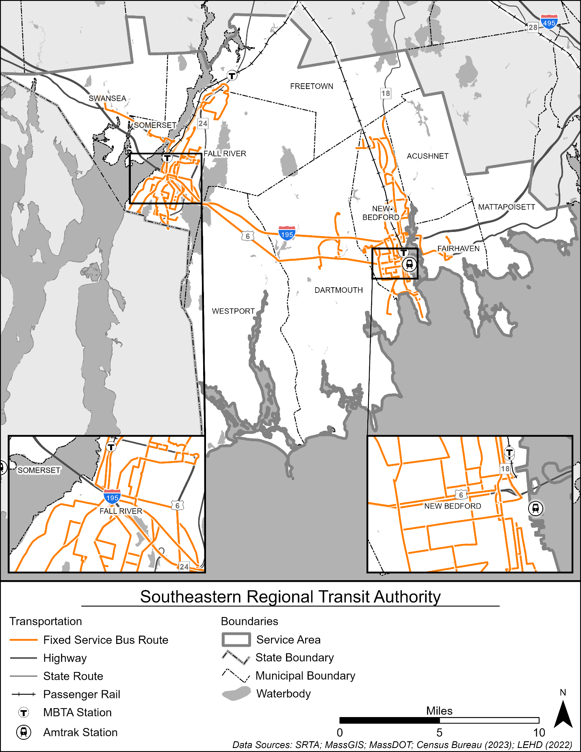
Source: AECOM (2025)

Demographic Analysis
The demographic analysis considers several key population indicators of transit use and demand to guide SRTA’s transit service planning. This includes:
- Population density is often a key determinant of transit use, as transit offers a more efficient way to move many people in a constrained area than personal vehicles. Knowing the population density can help transit agencies identify and plan for the most suitable types of transit to offer people in areas of different density.
- Older adult population includes those residents 65 years of age or older. As people age, their ability to safely operate a personal vehicle often becomes limited, making transit or other shared transportation a vital part of maintaining mobility and accessing shops, medical resources, and entertainment.
- Youth population includes people under the age of 18 years old. Many children and teenagers rely on transit to reach school, activities, and sports, for example, often at times when their caregivers or school-sponsored transportation is unavailable.
- Median household income and low-income population are important measures to understand the potential for transit demand, as low-income individuals and households are more likely to rely on transit.
- Zero-vehicle households are more likely to rely on transit service as a reliable source of transportation to meet their mobility needs.
- Populations other than non-Hispanic White is an important metric to consider to comply with federal regulations and agency goals to ensure service for majority-minority communities.
- Population with disabilities shows the concentration of people who, by some measure of physical or mental disability, cannot readily operate a personal vehicle and often rely on transit use, especially paratransit services.
- Title VI of the Civil Rights Act of 1964 prohibits discrimination based on race, color, national origin, sex, age, or disability in federally assisted programs. Title VI indicators include low-income and populations other than non-Hispanic white (as previously described) and are used to guide Title VI planning efforts.
- Job density, like population density, indicates a concentration of trip generators that may be well-served by transit, especially at shift changes, that may result in many people commuting to or from work at the same time.
Together, these enable SRTA to better contextualize their existing service and best meet the unmet needs of different segments of the community. The following sections illustrate the distribution of each demographic indicator throughout SRTA’s service area.

Population Density
The population density, or population per square mile, in the SRTA service area is shown in Figure 30. Population density is highest in the Fall River and New Bedford areas, which are the two major urban centers and therefore the two hearts of the SRTA service area.
Figure 30. Population Density
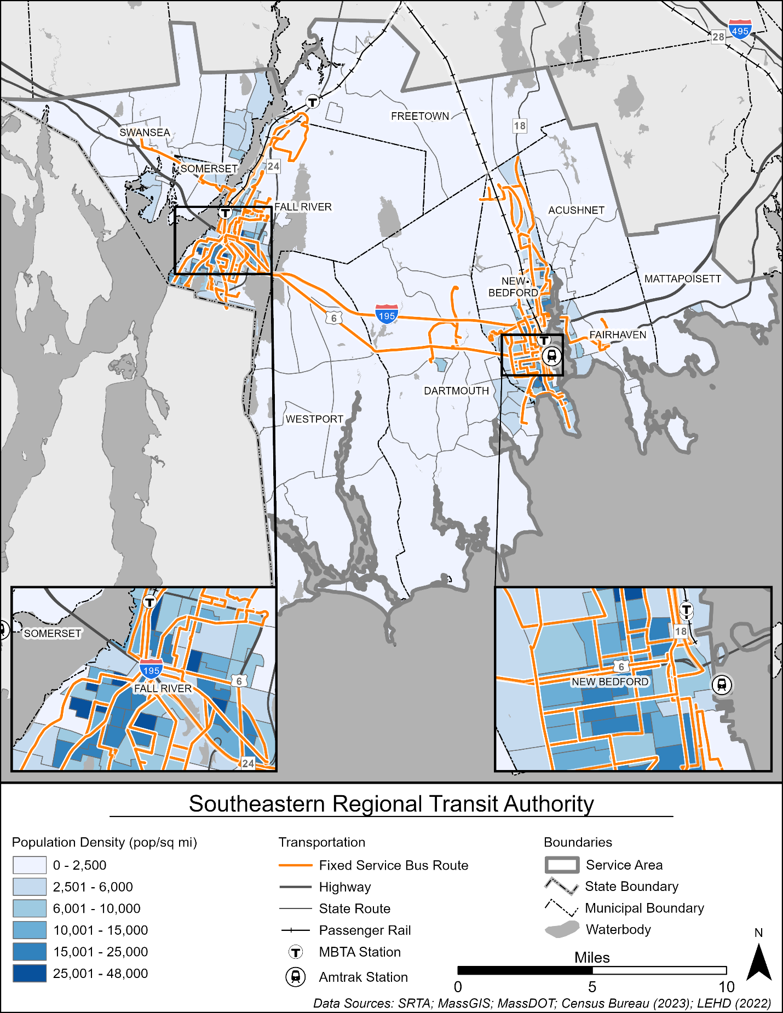
Source: AECOM (2025)

Older Adult Population
Older adults, defined as people 65 years of age or older, are likely to be transit dependent and/or prefer utilizing transit to maintain their independence to access medical appointments, grocery stores, and recreation activities. As shown in Figure 31, the population over 65 is varies across the SRTA service area, with high concentrations in coastal areas of the Towns of Westport, Dartmouth, Fairhaven, and Mattapoisett except for some areas of Dartmouth, which have low concentrations of older adults. The Cities of New Bedford and Fall River have relatively low concentrations of older adults. For older adults who may no longer be able to access fixed route transit, SRTA offers ADA demand response services as well as the Boston Hospital Shuttle, which connects the SRTA service area to Boston-area hospitals.

Youth Population
The youth population, defined as the percentage of the population under the age of 18, is shown in Figure 32. Youths are likely to utilize transit as a reliable and convenient form of transportation, in lieu of car ownership. Many students use SRTA buses, specifically Route 299, as their mode of transport to and from school and to after-school activities and jobs. The youth population is generally evenly distributed between the urban and rural parts of the service area, though there are pockets of high concentrations in the urban centers of Fall River and New Bedford.

Median Household Income
As shown in Figure 33, the lowest income households are concentrated in the cities of Fall River and New Bedford. High median household incomes are generally spread evenly across the rest of the SRTA service area.

Low-Income Population
SRTA defines low-income households as those earning less than 100 percent of the federal poverty rate. For SRTA, this means block groups with a larger than average low-income population, or approximately 14.5 percent. Figure 34 shows the low-income population in the SRTA service area. There are high concentrations of low-income households in both New Bedford and Fall River. This is consistent with other socioeconomic factors observed in the areas, including high concentrations of youth and a low median household income.

Zero-Vehicle Households
The highest concentrations of households without access to a personal vehicle are in Fall River and New Bedford as shown in Figure 35, particularly in neighborhoods near the New Bedford and Fall River Terminals.

Population Other Than Non-Hispanic White
Figure 36 shows the concentration of demographic groups other than non-Hispanic white. These populations are concentrated in New Bedford, Fall River, and Dartmouth.

Figure 31. Older Adult Population
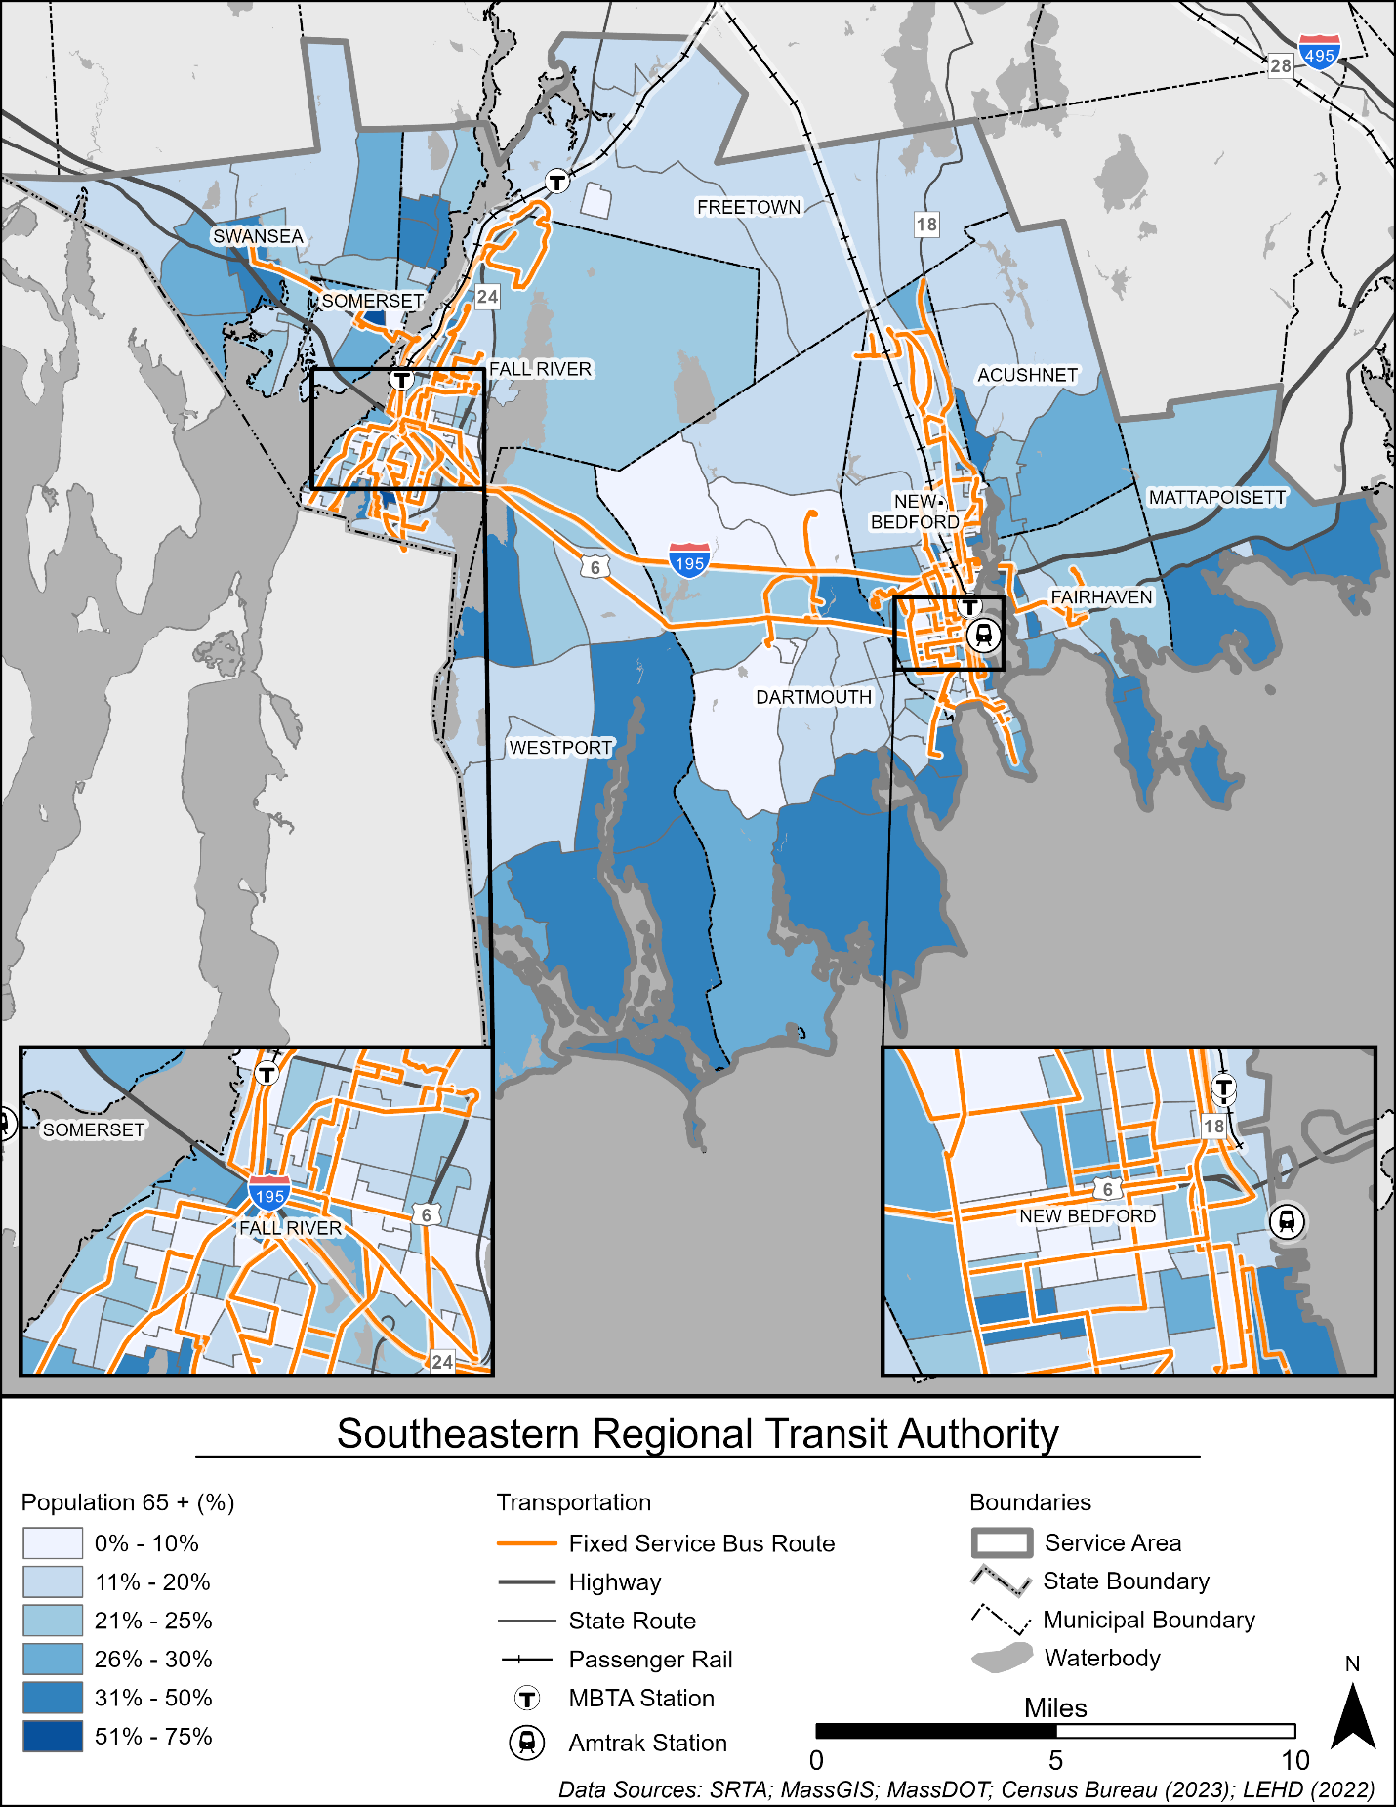
Source: AECOM (2025)
Figure 32. Youth Population
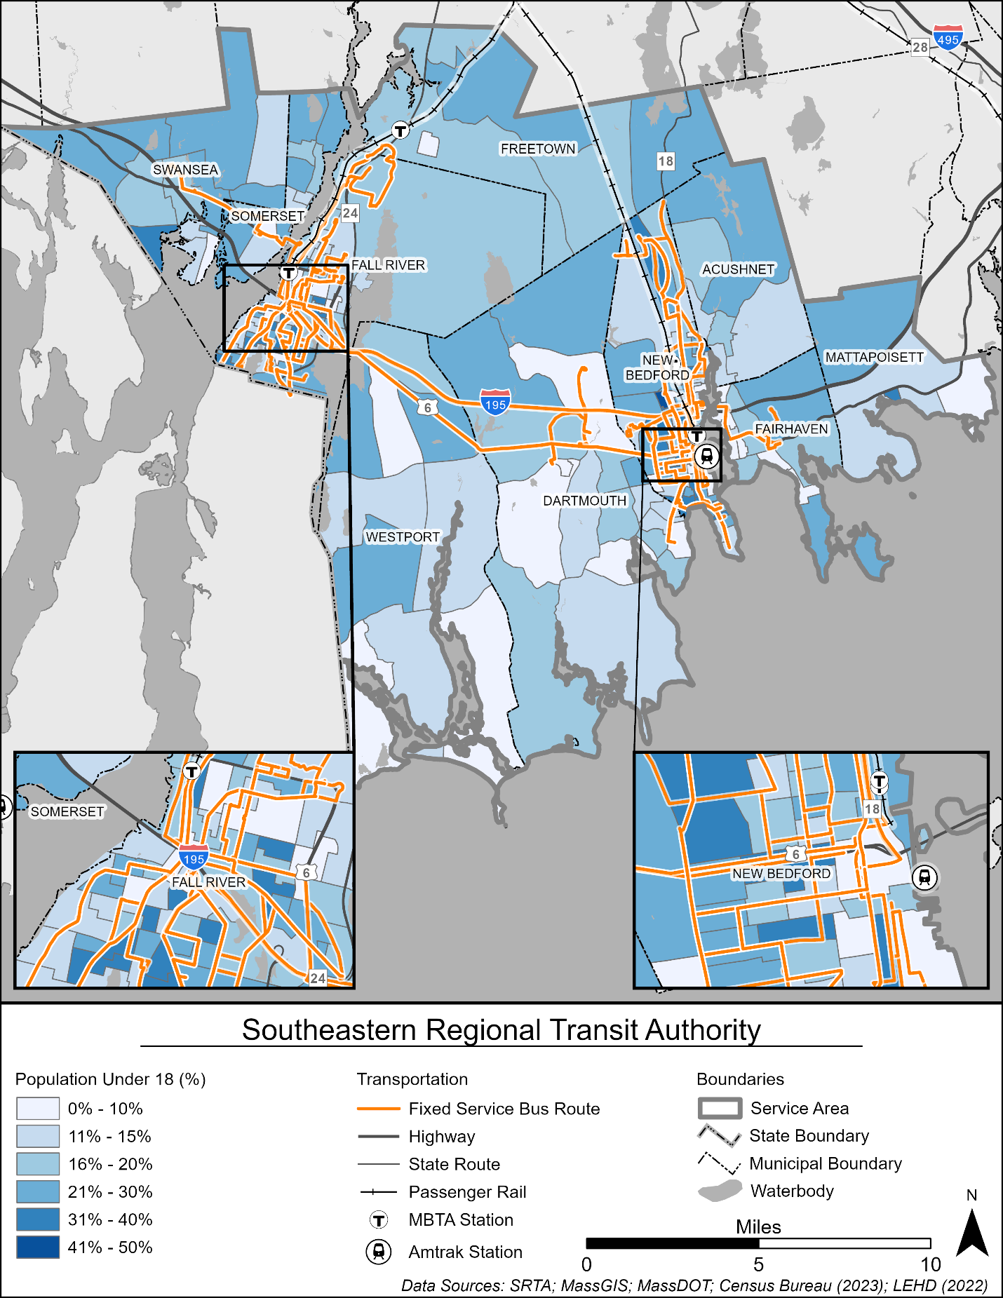
Source: AECOM (2025)
Figure 33. Median Household Income
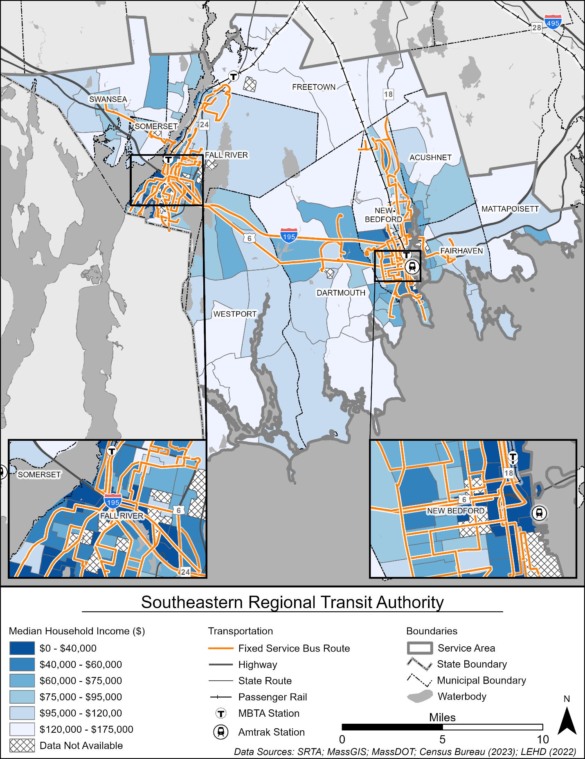
Source: AECOM (2025)

Figure 34. Low-Income Population
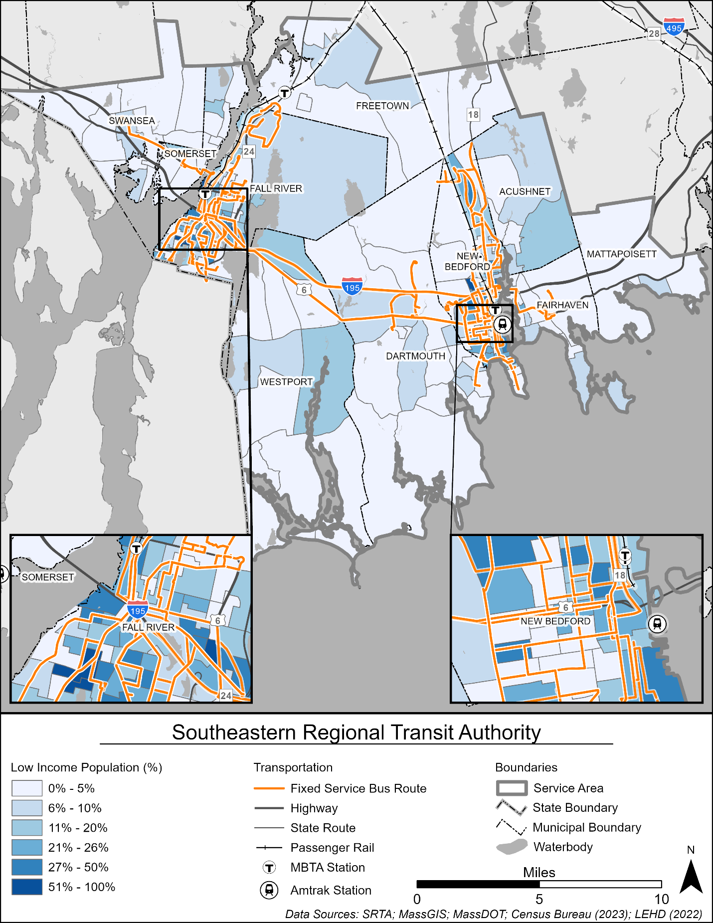
Source: AECOM (2025)
Figure 35. Zero-Vehicle Households
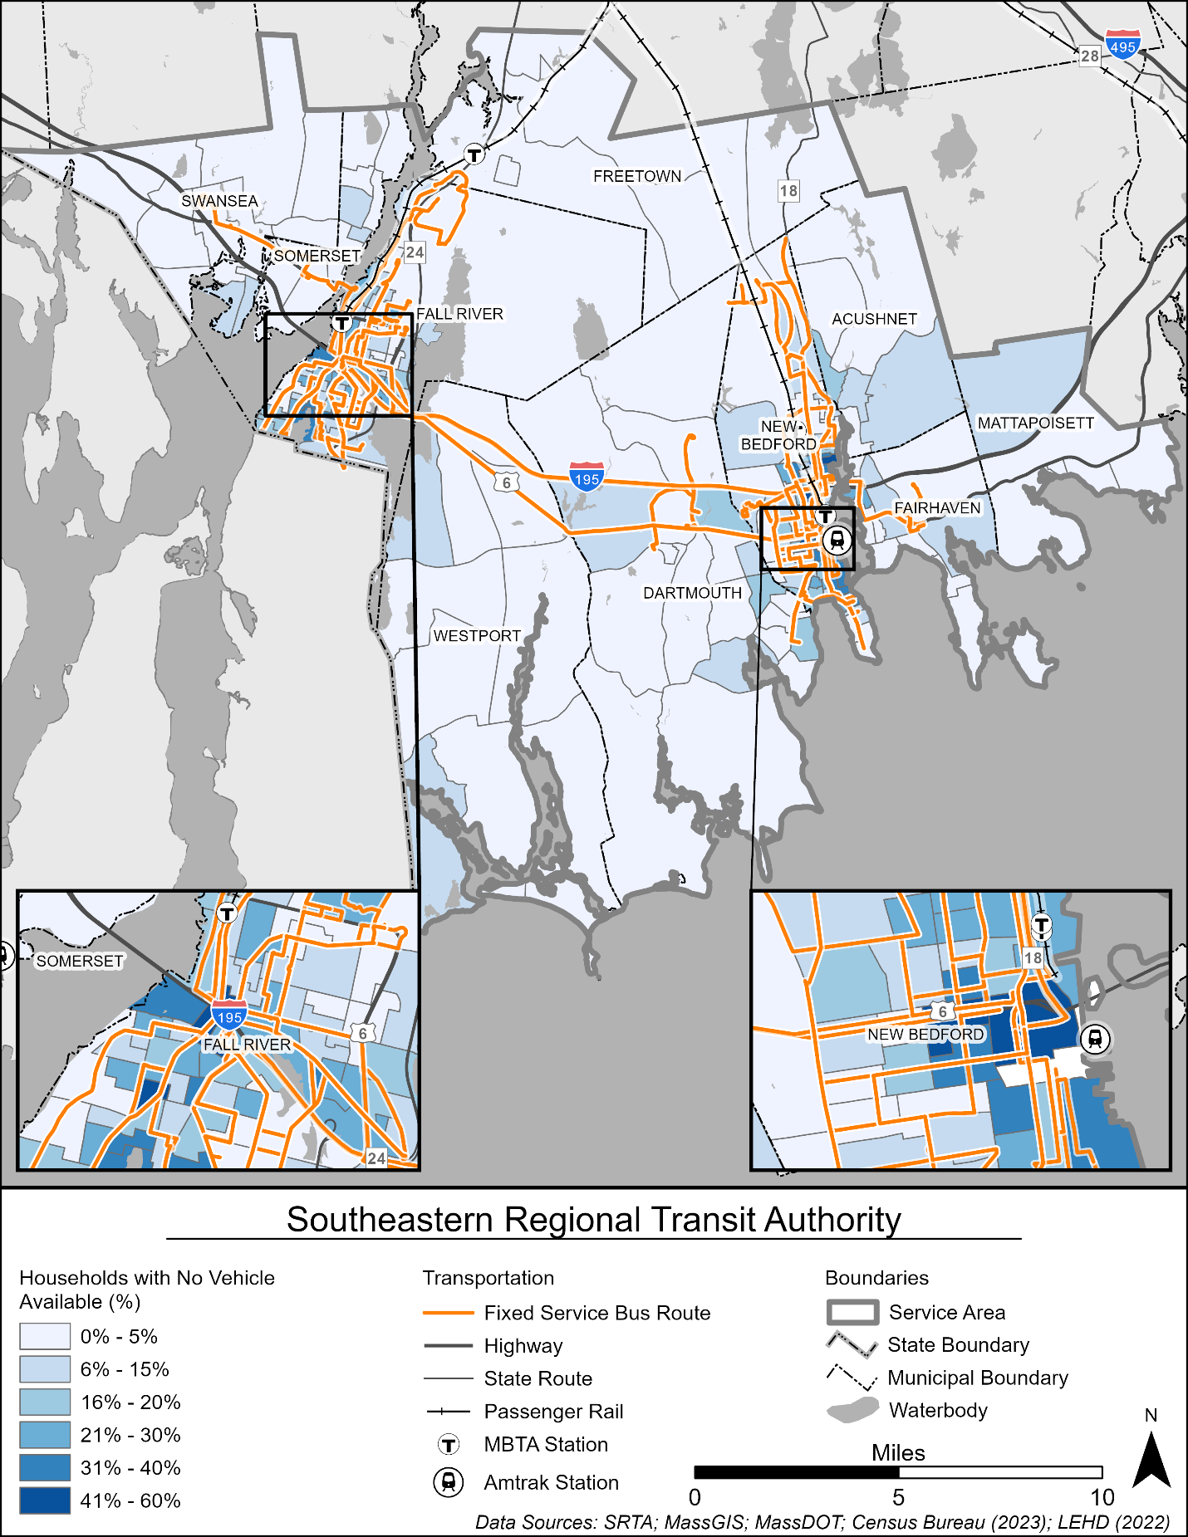
Source: AECOM (2025)
Figure 36. Population Other Than Non-Hispanic White
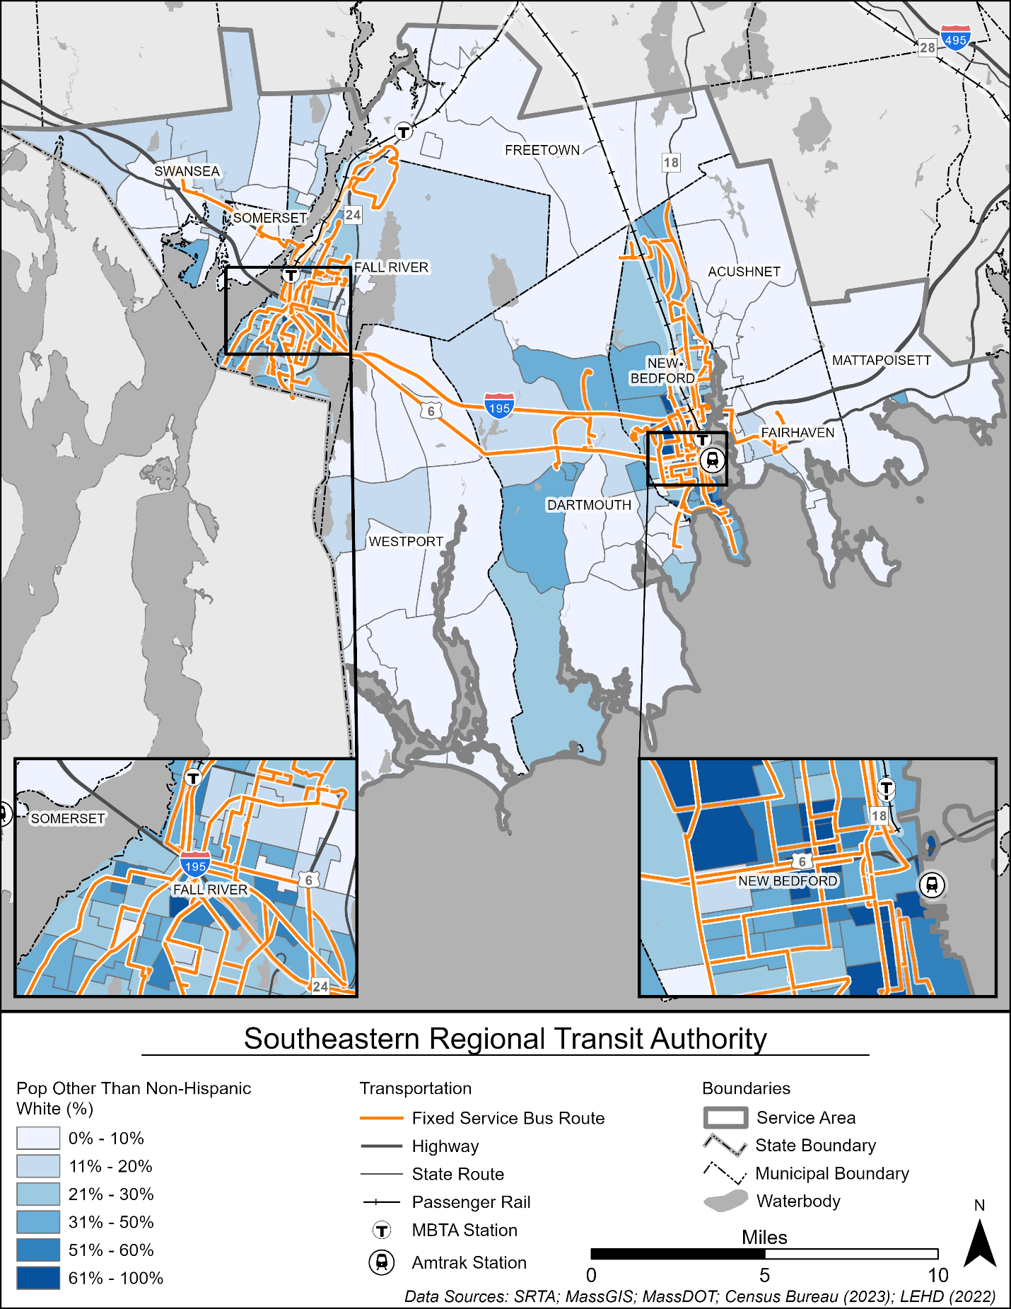
Source: AECOM (2025)

Adult Disabled Population
MassDOT and SRTA utilize data on older adults, persons with disabilities, and low-income populations to identify opportunities to improve mobility across the service area. The adult disabled population, defined as adults who are identified as having difficulty with six functional areas: hearing, vision, cognitive function, walking, self-care, or independent living, is shown in Figure 37. Generally, the population of adults with a disability is evenly distributed across the SRTA service area. High concentrations of adults with disabilities are in the cities of New Bedford and Fall River as well as in the towns of Dartmouth and Westport, particularly along the I-195 and US Route 6 corridors.

Title VI Population
As a transit authority, and recipient of federal funds, SRTA is required to comply with Title VI requirements. For Title VI reporting, SRTA defines minority as a block group with a larger than average minority threshold, which is approximately 26.7 percent. Title VI indicators include two factors: low income and population other than non-Hispanic white. Figure 38 shows the two factors as previously described and highlights communities where the population is both low income and non-Hispanic white. New Bedford and Fall River have the highest concentrations of both low-income populations and populations other than non-Hispanic white. Additionally, Dartmouth, near US Route 6, is home to populations other than non-Hispanic white. Low-income communities are located in Westport near I-195. As SRTA modifies any fixed route service or introduces new fixed route service, the Title VI market evaluation can help inform program modifications and long-term engagement strategies.

Job Density
Job density is highest in New Bedford and Fall River, specifically concentrated along SRTA bus routes around the two hubs, as shown in Figure 39. Major industries in the service area include healthcare, manufacturing, retail, and construction.

Figure 37. Adult Disabled Population
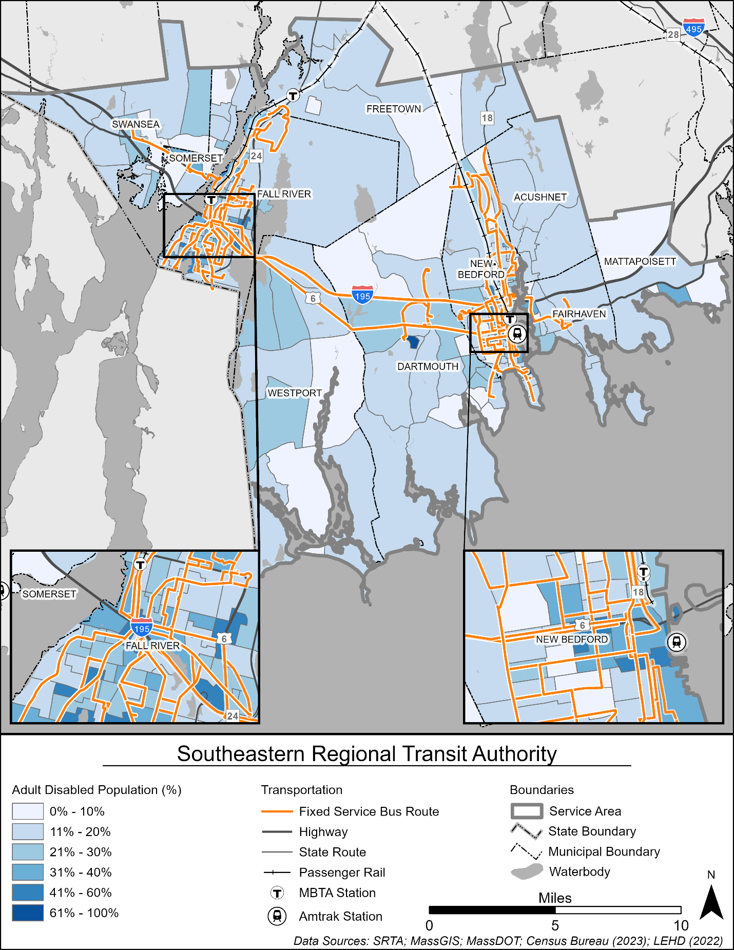
Source: AECOM (2025)

Figure 38. Title VI Population
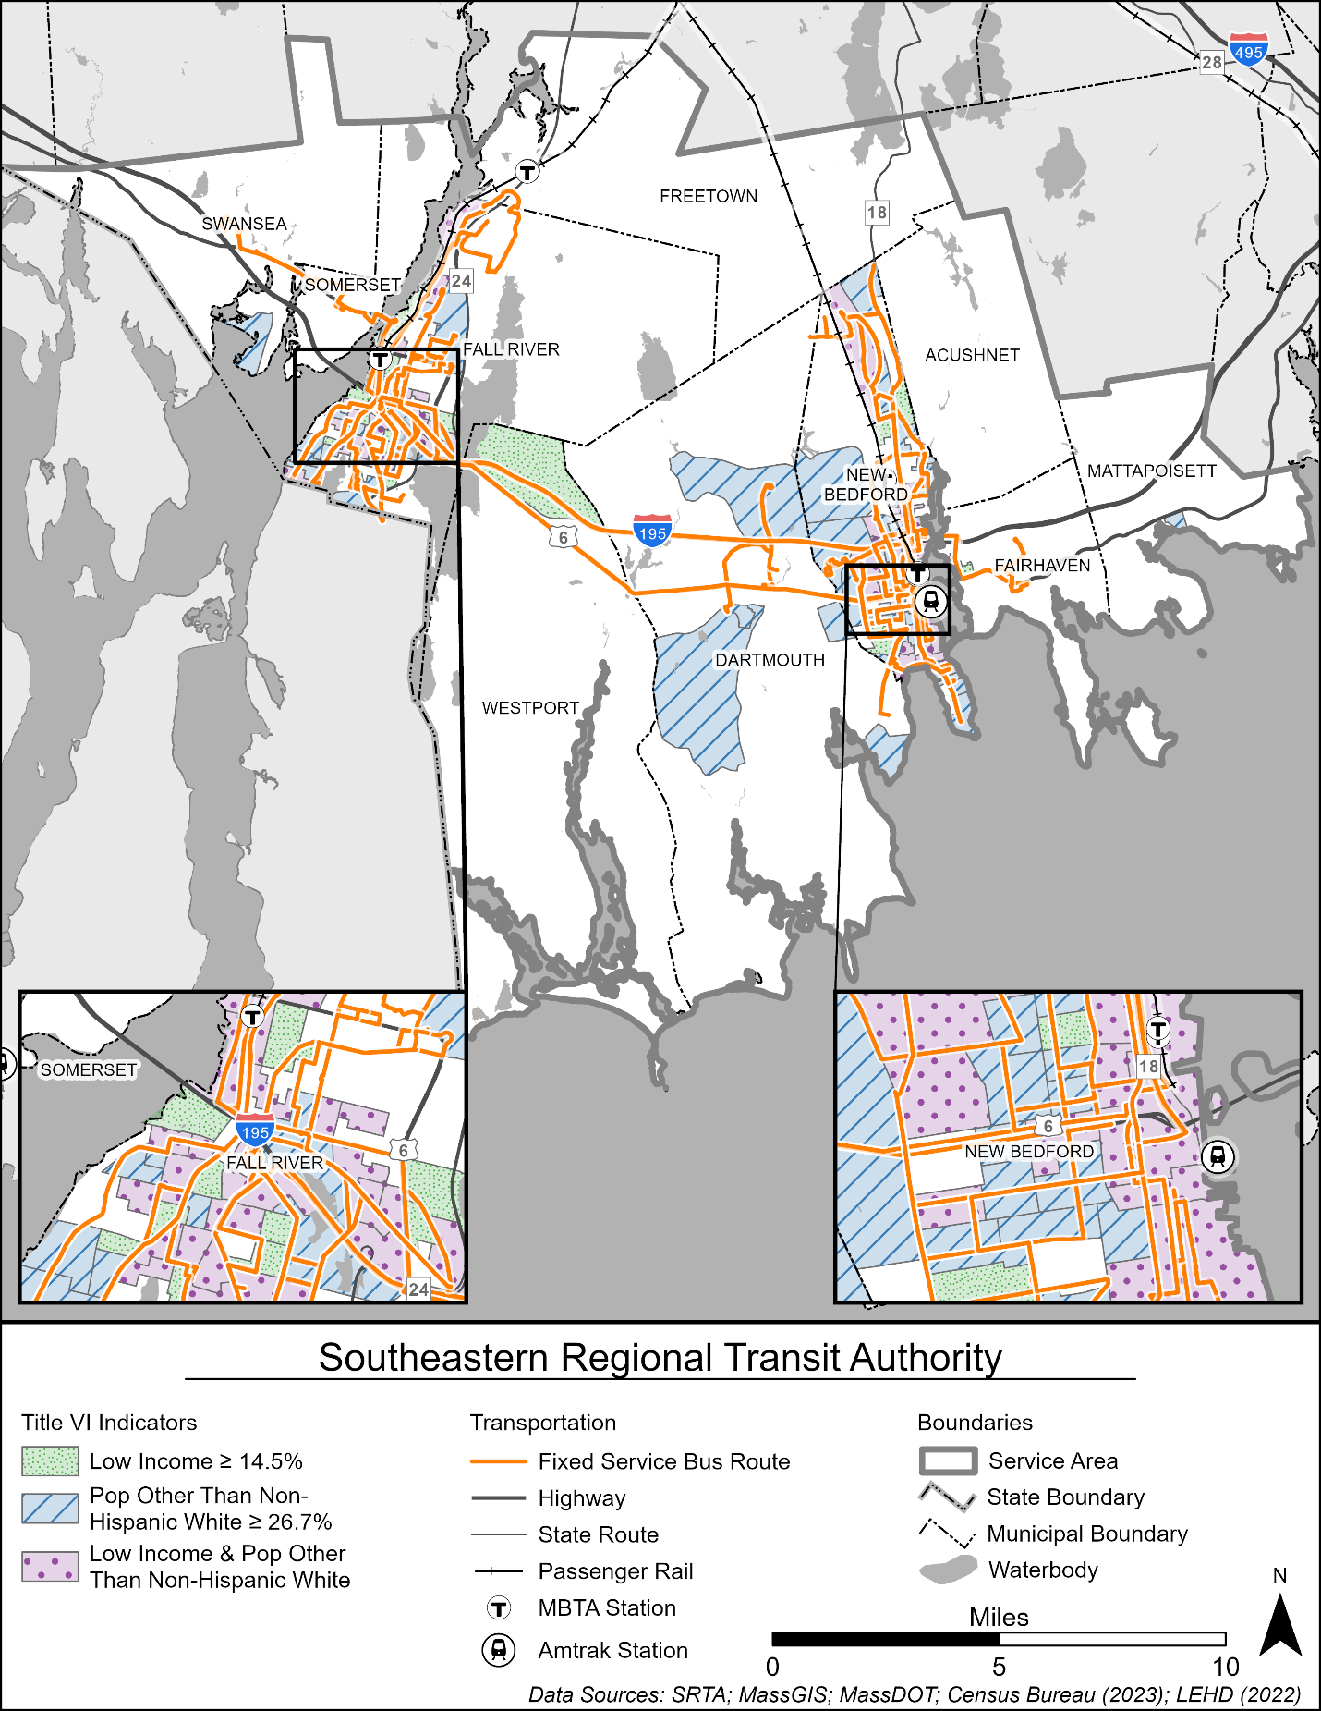
Source: AECOM (2025)
Figure 39. Job Density
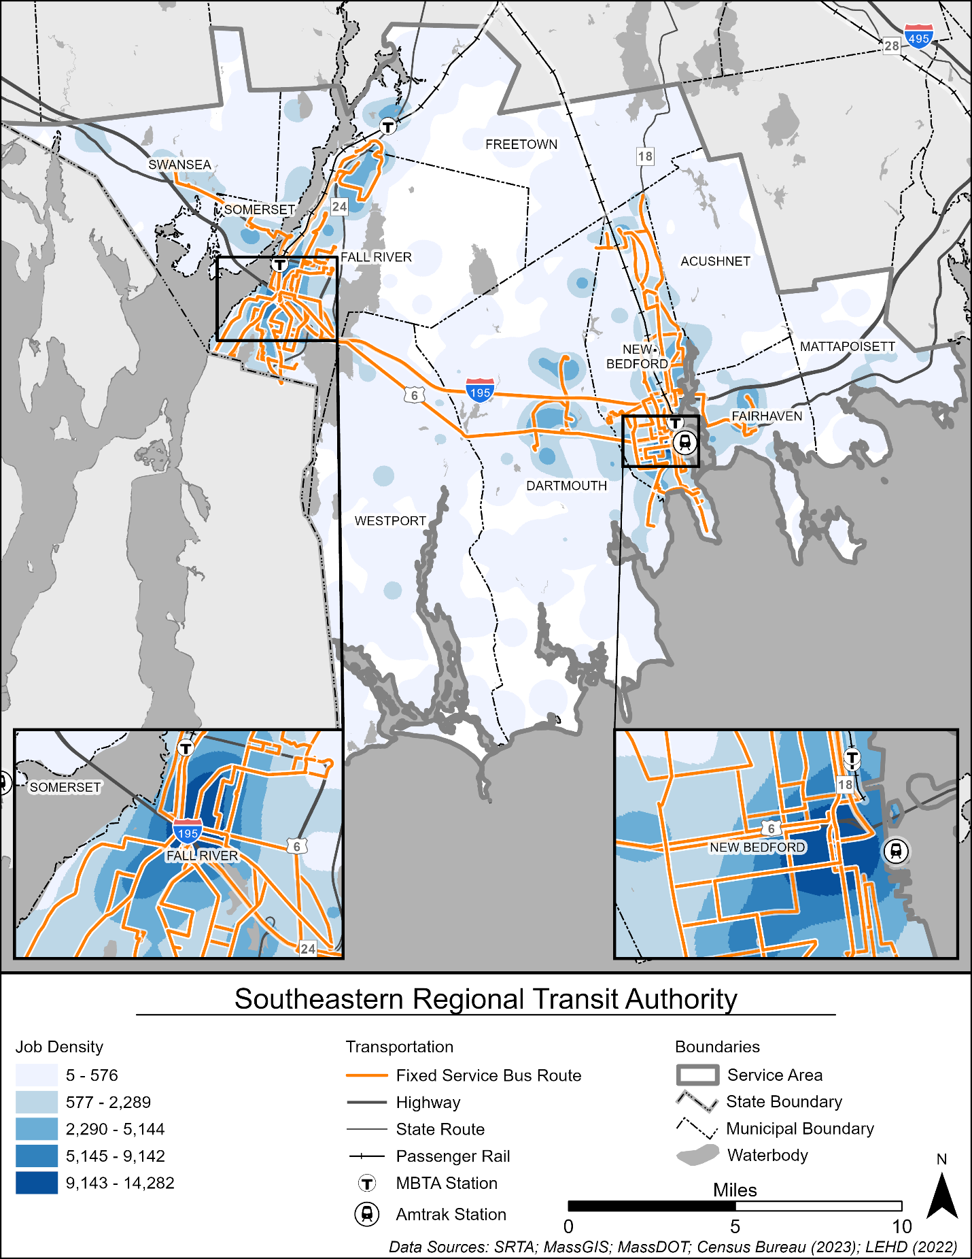
Source: AECOM (2025)

Transit Score
The transit score map is created to spatially analyze several transit-oriented demographic and socioeconomic characteristics at the same time (the characteristics discussed individually in this chapter so far). The transit score is a relative measure of how successful a fixed route transit system is expected to be in a particular region. It can be used to evaluate existing services and to identify areas of potential demand.
Demographic and socioeconomic information was collected from the US Census Bureau for this region divided into small geographic units such as tracts, block groups, or blocks. Block groups and census tracts were used for this analysis. Transit-oriented variables used for the analysis include:
- Overall population density
- Overall job density
- Density of the population under the age of 18
- Density of the population over the age of 65
- Median household income
- Percentage of the population living below the poverty level
- Percentage of zero-car households
- Percentage of the population other than non-Hispanic White
- Percentage of the population with disabilities
- Number of transit trips taken
Figure 40 illustrates the transit score in the SRTA service area. As shown in the figure, transit scores are very high in the communities that are served by many SRTA bus routes and MBTA rail service. The communities with very high transit scores are concentrated in New Bedford and Fall River, whereas more rural areas not currently served by SRTA bus routes have very low transit scores.
Figure 40. Transit Score in the SRTA Service Area
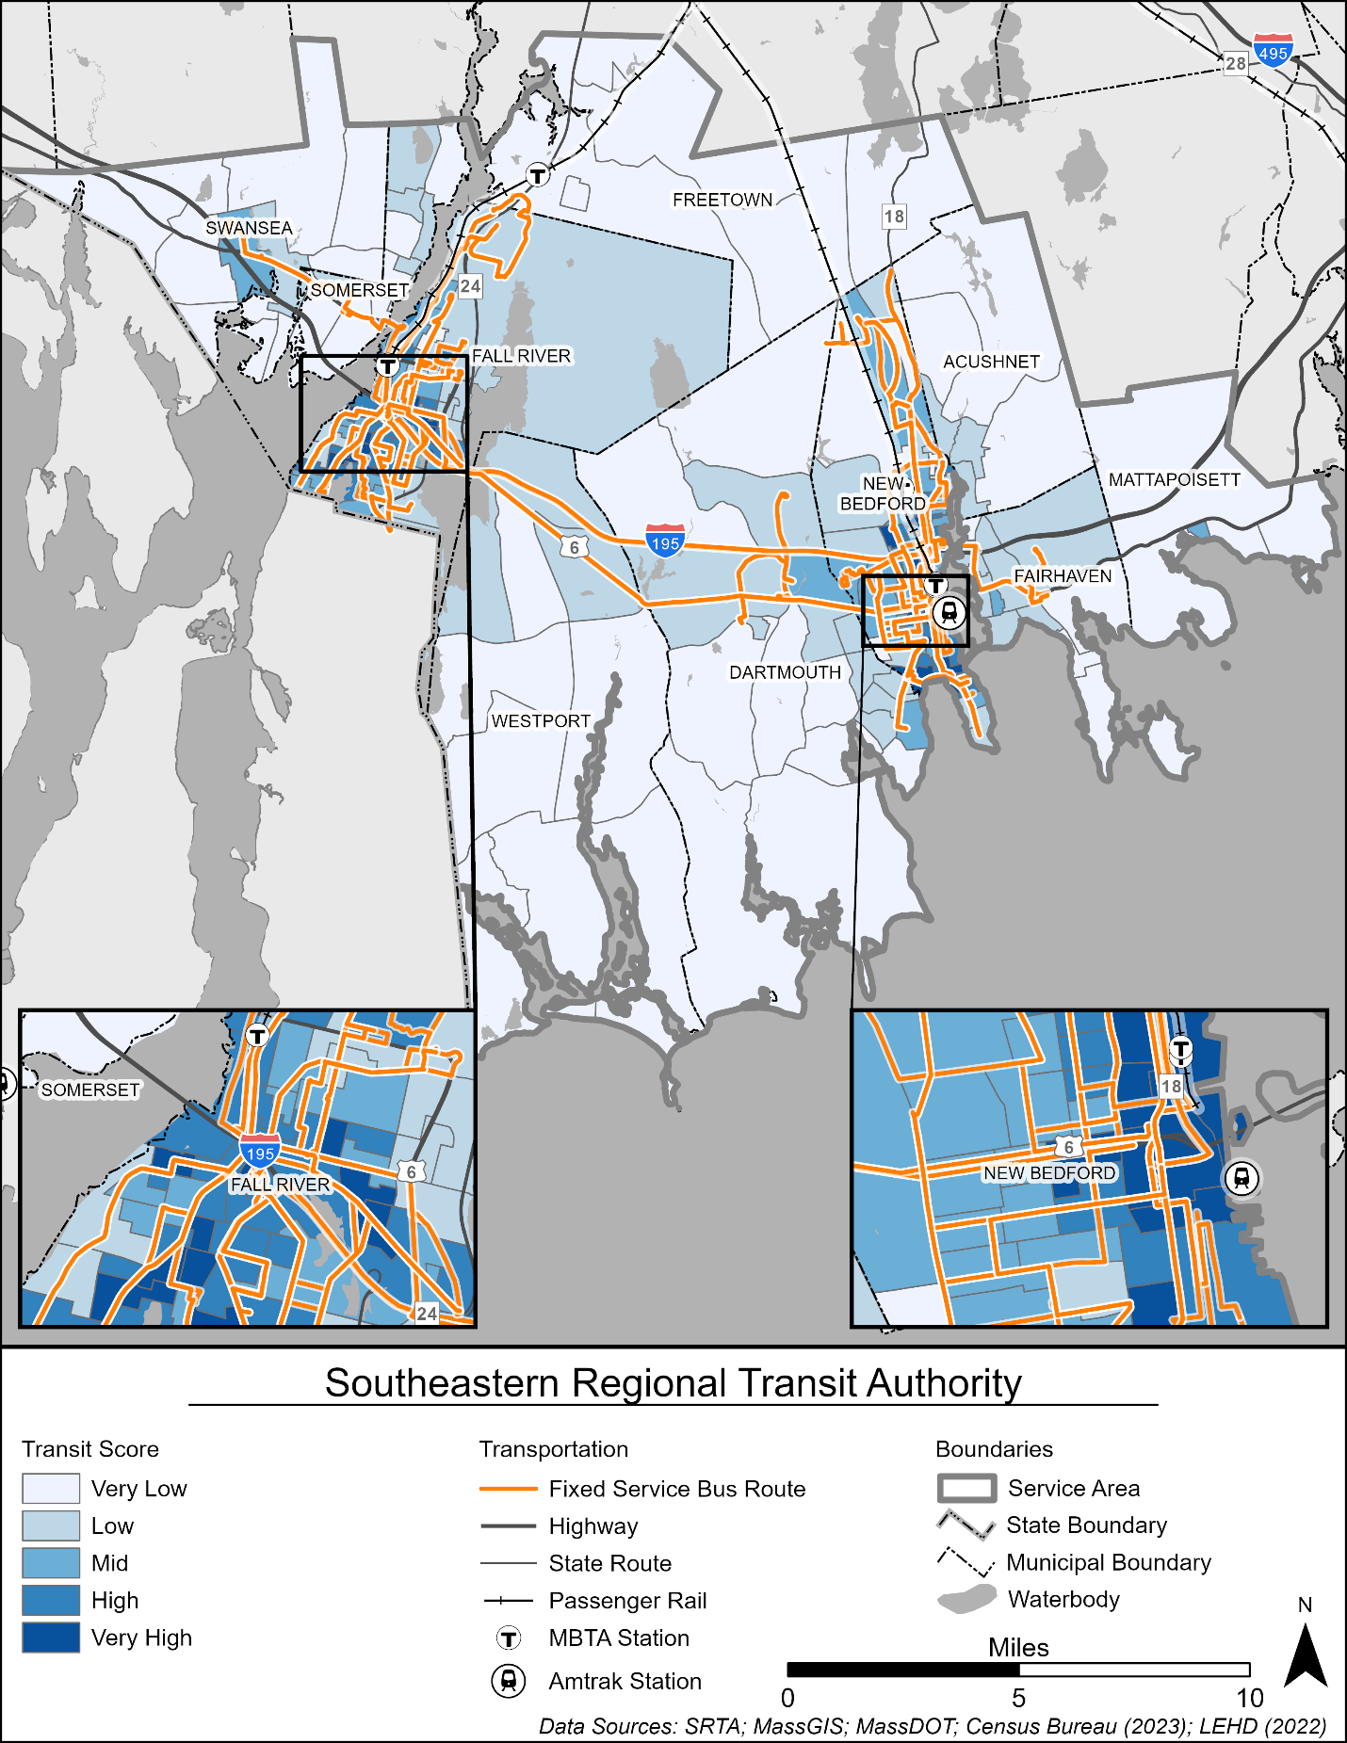
Source: AECOM (2025)

Public and Stakeholder Engagement
SRTA conducted extensive outreach and engagement to better understand public and stakeholder needs and suggestions for service improvements. Input received through meetings and surveys helped to inform the list of needs and recommendations included in Chapter 8.
Outreach and engagement for SRTA’s CRTP were undertaken through multiple targeted online surveys and an employee survey. Additional outreach activities included updates at an SRTA board meeting, a pop-up event, and social media promotion of survey links. The activities were carried out in 2025, and a diverse range of voices and perspectives was captured to support CRTP development.
Key takeaways from these combined efforts include support for the following:
- SRTA services. The majority of riders said they do not have cars or driver’s licenses and that SRTA services are their primary mode of transportation. They use SRTA service daily or a few times a week for shopping/errands, work, and medical appointments.
- Fare-free service. Riders and survey respondents showed strong support for fare-free service, though some said crowding on buses due to increased ridership has become an issue.
- Improvements to the rider experience and safety. Riders expressed concerns about cleanliness, safety, and the need for improvements at bus stops and at the New Bedford and Fall River Terminals. Riders requested better shelters, benches, and bus terminal upgrades.
- Extended and increased service: Riders affirmed that extended service hours are needed, especially at night; more frequent buses along current routes are also desired, to allow for less wait time if one is missed.
- Expanded service locations. Stakeholders and riders showed interest in expanding SRTA services to new areas, with Horseneck Beach, Buttonwood Park, and Taunton as the most-requested destinations.
Subsequent sections detail feedback collected during all of SRTA’s engagement efforts.

Board Meeting
SRTA held a board meeting with board members to provide the SRTA 2025 CRTP update and to get feedback.
- Topic: Comprehensive Regional Transit Plan
- Date and time: September 25, 2025, 2:00 PM
- Location: Virtually, through Microsoft Teams

Attendees
SRTA staff, as well as SRTA board members or designees from Fairhaven, New Bedford, Swansea, Fall River, and Mattapoisett, were in attendance.

Agenda
- SRTA Regular Board Meeting Business and Updates
- CRTP Update
- Open to Comments from Board/Attendees

Comments from Board/Attendees
- Board attendees were open to sharing survey information with their communities.
- Advisory Board Member Designee Jennifer Clarke from New Bedford asked for information about CRTP outreach and survey efforts for other Massachesetts RTAs, particularly GATRA.

Key Takeaways
- Board attendees were generally supportive, looked forward to seeing the results of the plan, and were open to sharing the survey in their communities.

Pop-Up Events
SRTA held two in-person pop-up events to distribute information, advertise its survey, and seek public feedback (Figure 41).
- SRTA Downtown Fall River Bus Terminal (Louis D. Pettine Transportation Center) in Fall River, August 19, 2025, 10:00 AM to 1:00 PM
- SRTA Downtown New Bedford Bus Terminal in New Bedford, August 25, 2025, 10:00 AM to 1:00 PM
A total of 49 riders (29 in Fall River and 20 in New Bedford) filled out paper surveys. At both terminals, riders were engaged at the bus pick-up/drop-off area and inside the terminal. Spanish, Haitian-Creole, and Portuguese translations of the survey and survey flyer were provided during the events.
Figure 41. Pop-up tables at New Bedford (left) and Fall River (right) terminals.
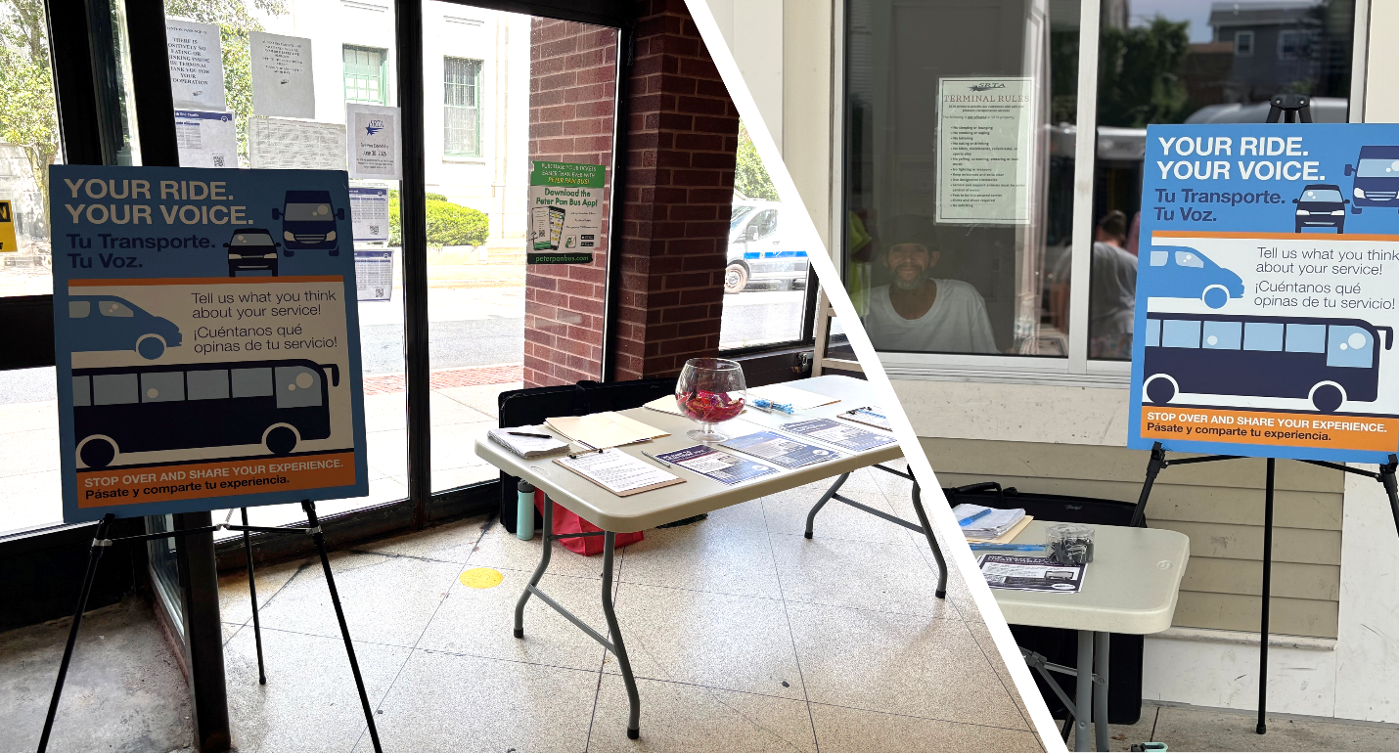
The following are the key takeaways from the pop-up events.
- SRTA riders were generally positive about fare-free service in both Fall River and New Bedford. Some said they have noticed crowding due to more riders, and that some riders are now using the bus for just one stop, adding net time to trips.
- Riders said some drivers drive too fast or skip stops (or the rider not knowing when to request a stop).
- Station security and maintenance were a concern for some riders.
- Later service for workers was a common request.

Employee Survey Effort
SRTA staff developed a short online survey to gather employee input and get a better understanding of what employees observe and hear from riders. The results of the survey helped shape SRTA’s approach to collecting feedback directly from riders.
The employee survey asked the following two questions:
Question 1: What feedback have SRTA riders and the public given about places they want to travel to but can't with current SRTA services?
Question 2: What would you say is the biggest improvement riders want to see SRTA make over the next five years?
In answer to the first question, multiple employees mentioned connections within the region, specifically to Horseneck beach and Seekonk. In answers to question two, multiple employees mentioned continuing fare-free service and continued increase to security at terminals. For a full list of answers to the employee survey refer to Appendix C

Public Survey Effort
As a primary tool to gather feedback from current riders, SRTA staff developed an online survey. The purpose of the survey was to get a better understanding of stakeholder preferences regarding current services and gather feedback about the desire for potential improvements or changes.

Survey Outreach
To promote participation in the online survey, SRTA shared it through multiple channels:
- The survey link was posted on SRTA’s website, and promoted through social media posts and ads (Figure 42).
- On August 19 and 25, 2025, SRTA hosted pop-up events, where staff distributed flyers featuring the survey link and QR code.
- Paper copies of the survey were provided at the in-person SRTA pop-up events.
- Posters featuring the survey link and QR code were displayed on SRTA buses and at stations.
The survey was designed to be mobile-friendly. The survey link was accompanied by a QR code to enable a quick scan using a smart phone to immediately direct users to the survey.
Figure 42. SRTA Social media post
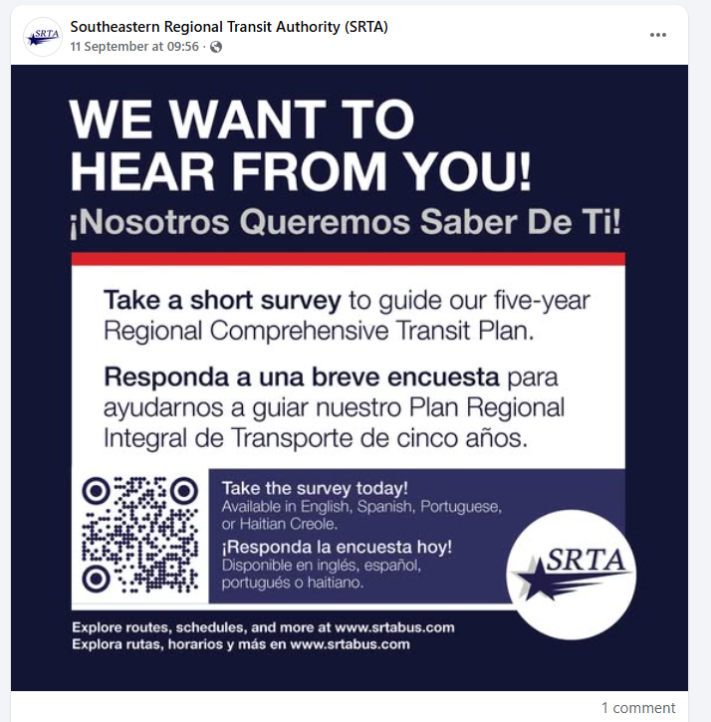

Survey Results Summary
SRTA’s online survey opened to the public August 4, 2025, and closed October 5, 2025. The survey, which was hosted on Microsoft Forms, was available online in English, Spanish, Haitian/Creole, and Portuguese.
Of the 142 responses collected using online and paper surveys, 134 people, or 94 percent of survey respondents, responded in English, 7 people (5 percent) responded in Spanish, and 1 person (1 percent) responded in Haitian/Creole.
When asked to choose all options to where riders would like to go that SRTA currently doesn’t serve, 22 percent of respondents said Horseneck Beach, 19 percent said Buttonwood Park, 18 percent said Taunton, 17 percent said Seekonk, 12 percent said Somerset, and 13 percent selected “other” (Figure 43). Refer to Appendix C for a full list of other locations respondents said they would like the bus to go.
Figure 43. Where do you want to go that SRTA doesn't go (choose all that apply)?

Expanding the span of service, connecting to new destinations, and increasing frequency were the top priorities for survey respondents. Responses indicated that the biggest improvement SRTA should make over the next five years is to increase service late at night and early in the morning, with 40 percent of respondents choosing that option. Eighteen percent of respondents chose connecting to more places outside of Fall River and New Bedford as the biggest improvement, 13 percent chose to increase bus frequency, 13 percent chose increase weekend service, 9 percent chose bus stop improvements, and 7 percent chose improved accuracy for the SRTA Bustracker app (Figure 44).
Figure 44. What is the biggest improvement that SRTA should make over the next 5 years?

When examining which types of improvements to existing service were important, frequency and later schedules were the most popular. Responses indicated that, in terms of preferences on bus routes coming more often or running earlier or later, 46 percent of respondents chose bus routes that come more often, 38 percent chose bus routes that run later at night, and 16 percent chose bus routes that run earlier in the morning (Figure 45).
Figure 45. Do you prefer bus routes that come more often or run earlier in the morning/later at night?

Respondents were also asked about locations where they would like to see bus stop improvements, including benches, bus shelters, and other items, and to specify what and which station. For a full list of responses, refer to Appendix C.
Fare-free service has remained a popular implementation for SRTA. Responses indicated that 79 percent of respondents would prefer fare-free service to continue, 14 percent would prefer a return to paid service, and 7 percent said they did not know what they preferred (Figure 46).
Figure 46. Would you prefer fare-free service to continue or return to paid service?

Survey respondents were asked for their opinion about changing a specific service name, reflecting the entire Fort Taber Park instead of the Fort Rodman structure within the park. Responses indicated that, in terms of renaming the Fort Rodman bus to Fort Taber, 58 percent of respondents had no preference, 30 percent said yes, and 12 percent said no (Figure 47).
Figure 47. Would you like to see the Fort Rodman bus route renamed Fort Taber?

When asked about their primary mode of transportation, the majority (75 percent) of respondents said they use SRTA bus or other SRTA services (Figure 48). Other responses included walking (9 percent), driving in their car (5 percent), the MBTA Fall River/New Bedford Line (4 percent), Uber/Lyft (2 percent), and carpooling/getting a ride (1 percent). Four percent responded “other,” and no one selected taxi or bicycle.
Figure 48. What is your primary mode of transportation?

In terms of race/ethnicity, when asked to select from all choices that apply, 54 percent of respondents identified as White (Non-Hispanic), 20 percent as Hispanic or Latino, 9 percent as Black or African American, 7 percent as Cape Verdean, 5 percent as “other,” 3 percent as American Indian or Alaska Native (Figure 49). Fifteen percent preferred not to answer, and no one selected Guatemalan Mayan or Native Hawaiian/Pacific Islander.
Figure 49. What is your race/ethnicity (select all that apply)?

Responses indicate that, when asked to select from all choices that apply, 91 percent of respondents speak English most often at home, while 15 percent speak Spanish. Additionally, 1 percent reported speaking Portuguese, 1 percent Haitian Creole, 4 percent selected “other,” and 2 percent preferred not to answer (Figure 50).
Figure 50. What language(s) do you speak most often at home (select all that apply)?

Respondents indicated that, while yearly household income was spread among multiple ranges, the majority of responses skewed below $50,000. While 28 percent of respondents preferred not to answer, 27 percent said their yearly household income is under $10,000, 20 percent said it is between 10,001 and $25,000, 14 percent said it is between $25,001 and $50,000, 6 percent said it is between $50,001 and $75,000, and 5 percent it is more than $75,000 (Figure 51).
Figure 51. What is your yearly household income?

Key Takeaways
The following are key takeaways from the public survey.
- Desire for extended service: Riders made it very clear that extended service hours, especially at night, are needed
- Desire for increased service: Riders asked for more frequent buses along current routes to allow for less wait time if one is missed.
- Desire for bus stop upgrades and improvements: Many riders weighed in about a number of locations, asking for benches and bus shelters and noting that they are expecially important for older adults. Walmart and Stop & Shop were noted frequently.
- Fare-free service is greatly appreciated: 79 percent of riders prefered that fare-free service remain in place.

2024 SRTA Rider Survey
In the fall of 2024, SRTA conducted rider surveys onboard SRTA’s 21 fixed bus routes to gather information about demographics and travel patterns. Results were taken from 1,063 surveys.

Summary Results of Travel Patterns
Travel patterns are summarized below.
- When asked “Where did you get on the bus you are riding right now?” the top five answers for were New Bedford Terminal (25.3 percent), Fall River Terminal (21.6 percent), Market Basket (3.9 percent), Stop & Shop (3.1 percent), and Walmart (2.9 percent).
- When asked “Where did you get off the bus you are riding right now?” the top five answers for were New Bedford Terminal (18.5 percent), Fall River Terminal (12.9 percent), Walmart (5.3 percent), Market Basket (3.6 percent), and Ashley Boulevard (3.5 percent).
- When asked “How did you get to the bus stop for this trip?” 91 percent said they walked, 5 percent said by bus, 2 percent got a ride, 1 percent biked, 1 percent got a taxi/Uber, and less than 1 percent drove themselves.
- When asked “How will you travel after you get off the bus for this trip?” 87 percent said they walked, 9 percent said by bus, 2 percent said they would get a ride, 1 percent said by bike, less than 1 percent said via taxi/Uber, and less than 1 percent said they would drive themselves.
- When asked “Why are you riding the bus on this trip?” 41 percent said shopping or errands, 20 percent said going to work, 9 percent said medical appointments, 9 percent said returning home, 8 percent said visiting family or friends, 7 percent said going to school, and 6 percent said for fun/recreation or worship.
- Forty-nine percent said they ride SRTA buses every day, and 39 percent said they ride a few times a week.
- Seventy-three percent of respondents said they do not have a driver’s license.
- The top answers for “If you didn’t take the bus for this trip, how would you get to your destination?” were walk (43 percent), use a taxi/rideshare (40 percent), and get a ride from someone (38 percent).
- Sixty-one percent said they did not have cars or other motor vehicles in their household.

Key Takeaways
The following are key takeaways from the rider survey.
- A majority of riders do not have cars or driver’s licenses and most (43 percent) would walk if they did not take the bus.
- Walking predominantly makes up SRTA bus riders’ first and last mile portions of their trips.
- Shopping/errands, work, and medical appointments were the top three reason riders said they were making their bus trips (making up 70 percent of the responses).

Performance Measures
Performance measurement is a foundational component of enhancing operational efficiency, improving customer experience, ensuring safety, and meeting the numerous other goals that a transit agency may have by supporting and driving data-based decision-making. This chapter outlines the performance measures and targets defined and selected by SRTA. Data examining performance from FY 2020 through FY 2024 can be found in Chapter 4.

MassDOT Performance Management Program
SRTA reports performance data on a quarterly basis across a variety of metrics as outlined below. The targets are reviewed and/or updated annually as mutually agreed upon by SRTA and MassDOT for the FY 2026 through FY 2027 time period. Where an RTA is performing well, there is an opportunity to share best practices with other RTAs in the Commonwealth. Where an RTA is not meeting these targets, this is an opportunity to assess avenues for potential improvements. A summary of performance measures is provided in Table 23.
Table 23. Performance Measures Overview
Category | Metric | Definition | Desired Direction
Ridership | Unlinked passenger trips | Number of boardings on public transportation vehicles | Higher
Ridership | Unlinked passenger trips per vehicle revenue mile | Unlinked passenger trips divided by total miles operated while vehicles are in service (revenue miles) | Higher
Ridership | Unlinked passenger trips per vehicle revenue hour | Unlinked passenger trips divided by total hours operated while vehicles are in service (revenue hours) | Higher
Financial | Operating expenses per vehicle revenue mile | Total fully allocated operating expense divided by revenue miles | Lower
Financial | Operating expenses per vehicle revenue hour | Total fully allocated operating expense divided by revenue hours | Lower
Financial | Operating expenses per unlinked passenger trip | Total fully allocated operating expense divided by revenue unlinked passenger trips | Lower
Financial | Farebox recovery ratio | Total fully allocated operating expense divided by farebox revenue | Higher
Customer Service and Satisfaction | On-time performance | Vehicle departures that meet the RTA definition of “on-time” (refer to Section 6.1.3) | Higher
Customer Service and Satisfaction | Scheduled trips operated | Proportion of scheduled trips that are operated (i.e., not “dropped”) | Higher
Asset Management | State of Good Repair | Proportion of capital assets not meeting state of good repair goals (refer to Section 6.1.4) | Lower
Safety | Multiple safety metrics | Progress on meeting safety goals (refer to Section 6.1.5) | Varies

Ridership
Ridership is reported as unlinked passenger trips. Each boarding is counted and summed toward the overall unlinked passenger trip metric. This metric is also normalized by vehicle revenue miles and vehicle revenue hours to better understand how ridership compares to the level of service provided. SRTA ridership metrics and targets are shown in Table 24. Monthly data are submitted quarterly and compared to annual targets set by SRTA.
Table 24. Ridership Metrics and Targets (FY 2026)
Metric | Fixed Route | Demand Response
Unlinked passenger trips | 4,000,000 | 130,000
Unlinked passenger trips per vehicle revenue mile | 2.20 | 0.13
Unlinked passenger trips per vehicle revenue hour | 27.01 | 1.99
Source: MassDOT

Financial
Each RTA differs in the level of service, geographic area, modes operated, and other aspects of its operation, and as such, financial metrics are normalized by revenue miles, revenue hours, and unlinked passenger trips. SRTA financial metrics and targets are displayed in Table 25. Typically, each RTA verifies its financial data annually through an end-of-year audit. Data are submitted as the raw operating cost and farebox revenue collection, then normalized for comparison against performance targets. Here, operating expenses are measured in units of vehicle revenue miles, vehicle revenue hours, and unlinked passenger trips.
Farebox recovery ratio is a measure of revenue collected through fares as a ratio to operating expenses. As of FY 2026, all RTAs will operate fare-free fixed route service and fare-free ADA demand response (though “premium” service beyond federal ADA requirements may still charge fares). As such, the target all RTAs use for fixed route farebox recovery ratio is 0 percent. Demand response target is reflective of the farebox recovery ratio for these premium services.
Table 25. Financial Metrics and Targets (FY 2026)
Metric | Fixed Route | Demand Response
Operating expenses per vehicle revenue mile | $14.06 | $10.87
Operating expenses per vehicle revenue hour | $172.35 | $165.47
Operating expenses per unlinked passenger trip | $6.38 | $82.69
Farebox recovery ratio | 0.00% | 0.00%
Source: MassDOT

Customer Service and Satisfaction
Reliability of service is an important element when providing transit that meets customer needs. Therefore, customer service and satisfaction are measured through the on-time performance of fixed route and demand response modes. The definitions of on-time performance for each mode are:
- Fixed Route: Trips that depart within a 6-minute pickup window (1 minute before and up to 5 minutes after) of scheduled departure from the first stop on the trip.
- Demand Response: Trips that depart within a 20-minute pickup window (5 minutes before and up to 15 minutes after) of the scheduled pick-up time.
The metric for scheduled trips operated serves as a measure of service reliability, as "dropped" trips often highlight issues such as labor shortages, equipment failures, or other operational challenges. From the customer’s perspective, they are waiting for a bus that does not arrive, which is especially challenging for routes with less frequent service. As shown in Table 26, SRTA operates nearly 100 percent of scheduled trips and has an on-time performance target of 85 percent for fixed route service and 92 percent for demand response service.
Monthly data are submitted quarterly and compared against the annual target.
Table 26. Customer Service and Satisfaction Metrics and Targets (FY 2026)
Metric | Fixed Route | Demand Response
On-time performance | 85.00% | 92.00%
Scheduled trips operated | 98.00% | 98.00%
Source: MassDOT

Asset Management
The state of good repair for capital assets is a priority of MassDOT, FTA, and SRTA. Equipment in poor condition can result in reliability issues, safety risks, poor customer perceptions, and other problems that impede successful transit operation. Each RTA has a TAM Plan that lays out the condition of assets and facilities with priorities for capital improvements. The RTA-specific performance targets are updated annually, while the full TAM Plan is updated at least once every four years. The targets listed in Table 27 represent the percentage of each asset class that is expected to be beyond useful life at the close of FY 2025.
Table 27. Asset Management Metrics and Targets (FY 2025)
Metric | Target
Bus | 25%
Cutaway Bus | 25%
Automobile | 50%
Trucks and Other Rubber Tire Vehicles | 50%
Passenger and Parking Facilities | 0%
Admin and Maintenance Facilities | 0%
Source: MassDOT

Safety
Safety is the number one priority when delivering transit service. As an urban system, SRTA develops a Public Transportation Agency Safety Plan (PTASP) that defines specific safety goals for the authority. These are updated annually in coordination with Southeastern Massachusetts Metropolitan Planning Organization (SMMPO) and MassDOT. Performance data are submitted annually to the NTD, and performance targets are reviewed annually and updated as part of PTASP updates. Safety events are only tracked per 1 million vehicle revenue miles, as shown in Table 28.
Table 28. Safety Metrics and Targets
Metric | Fixed Route Target | Fixed Route Target per 1 million Vehicle Revenue Miles | Demand Response Target | Demand Response Target per 1 million Vehicle Revenue Miles
Fatalities | 0 | 0.00 | 0 | 0.00
Injuries | 8 | 5.20 | 1 | 1.90
Safety Events | 8 | 5.20 | 1 | 1.90
Source: MassDOT

Annual Performance
Two annual performance metrics reported to MassDOT vary by RTA. As part of the bilateral MOU negotiation process, each RTA identifies and reports a metric and target of their choosing, and a second metric is chosen based on prioritized recommendations included in the CRTP. For the FY 2026 MOU period, the metric is tied to the 2020 CRTP. The two metrics for SRTA are:
- RTA-Choice Metric: Cost per unlinked passenger trips to collect fares
- RTA-Choice Metric Tied to CRTP: Cash fare paid at the farebox
Other annual performance metrics are external partnerships and fleet composition by fuel type as shown in Table 29. Both are reported annually and are not compared against an annual target.
Table 29. Fleet Composition by Fuel Type and External Partnership Annual Performance Metrics (FY 2026)
Metric | Fixed Route | Demand Response
Percent Fleet Composition- Electric | 5% | 0%
Percent Fleet Composition- Hybrid | 54% | 0%
Percent Fleet Composition- Compressed Natural Gas | 0% | 0%
Percent Fleet Composition- Diesel | 41% | 0%
Percent Fleet Composition- Gasoline | 0% | 100%
Number of external partnerships | 4 | 14
Source: MassDOT

Additional Measures
At the time of this report, SRTA is exploring ways to implement additional performance measures beyond the ones required by MassDOT. These additional performance measures would be included in the annual ridership reports published on the SRTA website (SRTA 2025a).

Trends and Uncertainties
SRTA held an alternatives workshop to explore future market trends and uncertainties that could potentially impact transit over the next five years. During this exercise, SRTA examined how these trends might influence ridership levels and identified how it may respond to each scenario. In developing this CRTP, it is essential that the final recommendations align with operational, policy, and financial realities over time. The recommendations are informed by ridership scenarios, enabling SRTA to identify which recommendations are most applicable based on current conditions. Key topics and solutions that arose during the scenario discussions for SRTA to consider in the future are presented below.

Future Uncertainties
As SRTA prepares for the next five years, it is important to recognize and plan for trends that are both highly impactful and deeply uncertain. These uncertainties may define the operating circumstances of SRTA, possibly influencing factors such as public expectations of transit, service models, funding sources, transit technologies and infrastructure, and ultimately ridership demand. The following section outlines critical uncertainties that were explored during the workshop due to their potential to plausibly shape the future of SRTA’s operations.

Population and Demographics

General Population Trends
Massachusetts has experienced consistent population growth throughout the twenty-first century and at a pace that exceeds neighboring New England states. This is particularly true in most recent years, as Massachusetts recorded the largest annual percentage increase in population in over a decade from 2023 to 2024 (UMass Donahue Institute 2025). However, as seen in Figure 52, the population of Massachusetts is projected to plateau with little to no growth from 2025 to 2035 and then decline from 2035 to 2050 (Renski 2015; UMass Donahue Institute 2025). A slow down and eventual decline in population is largely attributed to two factors: domestic out-migration and international migration uncertainty. First, multiple migration measures, such as the U-Haul Growth Index, indicate very large rates of domestic migration out of the state (U-Haul 2025). In 2022, Massachusetts lost an estimated 24,000 working-age adults and 54,000 residents total through migration to other states. Second, international migration—one of the largest and most consistent sources of new residents to the Commonwealth—is highly uncertain and subject to significant changes in the future.
Figure 52. Long-term Population Projections for Massachusetts (2000-2050)

Source: UMass Donahue Institute 2025
Population and demographic trends have a defining influence on transportation needs, the quality of transit service, and the cultural expectations around transit. A stagnant or declining population may manifest in a variety of ways for SRTA, including:
- A reduced labor supply could present significant challenges to future workforce recruitment efforts.
- A smaller ridership base may reduce demand for transit and present the need for SRTA to make service changes.
- Changing demographics may shift public expectations about the function, frequency, and quality of regional transit service.
All of these factors present uncertainties that are integral to determining SRTA’s operations over the next five years.

Aging Constituency
Massachusetts’ population is both older than and aging at a rate that exceeds the national average. In 2025, 20.4 percent of the state was 65 years or older compared to 18 percent of the US population (UMass Donahue Institute 2025; US Census Bureau 2025a). Individuals aged 65 years or older are projected to increase to 22.3 percent of the state’s population by 2030. Meanwhile, the national population for this same age group is projected to increase to 21 percent of the population (US Census Bureau 2018). Coincidingly, the proportion of Massachusetts residents aged 2 or younger is projected to decline through 2030 (Point32Health Foundation 2025). Not only does the rate of aging in Massachusetts outpace national averages, but it also exceeds earlier state-level estimates (Renski 2015).
SRTA’s ridership base is projected to decrease in total population, but not in aging population (UMass Donahue Institute 2025). This trend is expected to create more pronounced effects on transit service compared to statewide estimates. Massachusetts’ increasingly older adult population places more pressure on demand response transportation services. Given the cost-intensiveness of demand response compared to fixed route transit, accommodating increased demand response activity imposes large workforce needs and potentially higher operating costs on SRTA. Meanwhile, workforce recruitment challenges may be exacerbated as a larger proportion of the population ages out of their working years. The impact of aging among Massachusetts residents therefore presents uncertainty that should be considered in SRTA’s future operations.

Affordability
The cost of living has increased considerably in Massachusetts, representing some of the highest rates across the United States. High, and rapidly growing, housing prices are at the center of the Commonwealth’s affordability dilemma. Soaring housing costs are largely attributed to an insufficient supply of units. The Massachusetts Comprehensive Housing Plan estimates 222,000 homes need to be produced from 2025 to 2035 to adequately meet the needs of all residents (Commonwealth of Massachusetts 2025a). Production rates in recent years have fallen below the annual rate required to meet this goal, thus signaling continued shortages and rising housing prices into the future.
In tandem with housing costs, transportation expenses have also imposed an outsized burden on Massachusetts residents in recent years. According to Transportation for Massachusetts’ 2024 survey, 71 percent of Massachusetts residents report housing cost burden, while 57 percent are burdened by transportation costs (Transportation for Massachusetts 2024). Among the cost-burdened, 53 percent of these residents foresee themselves relocating within or out of Massachusetts due to issues of affordability, further fueling rates of out-migration and geographic disparities. Within Bristol County, which contains SRTA’s main transit hubs (New Bedford and Fall River), residents spend an estimated average of 44 percent of income on housing and transportation expenses as seen in Figure 53 (Center for Neighborhood Technology 2025).
Affordability is one of the single most influential factors in determining an individual’s place of residence and transportation needs. Issues of affordability widen disparities around transportation access within communities and induce sprawling development and migration patterns that strain the transportation system between communities. As the basic expenses of shelter and getting around continue to rise, individual commuting distances and demand for less expensive transportation options will likely increase. This poses a unique challenge to SRTA to appropriately balance more extensive transportation needs of the individual while accommodating a potentially increased ridership demand at the community level.
Figure 53. Bristol County Housing and Transportation Costs as a Percentage of Residents’ Income
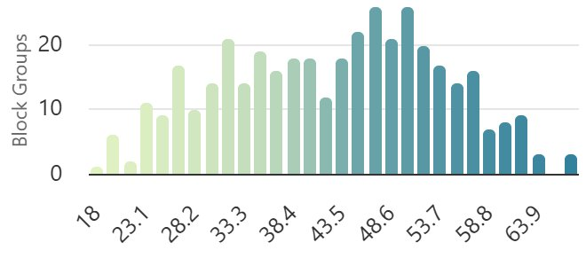
Source: Center for Neighborhood Technology 2025

Technology
Transit agencies across Massachusetts and the United States have employed diverse approaches and levels of initiative towards fleet modernization. Fleet modernization within regional transit agencies has also become highly contingent upon available funding streams at both the federal and state levels. At the federal level, the FTA Section 5339(c) Low or No Emission “Low-No” grant program is trending toward funding a wider array of vehicle procurements outside of “no-emissions” procurements (Ekbatani 2025).
Despite federal policy changes, Massachusetts has maintained fleet modernization goals. However, inadequate energy infrastructure has consistently presented a significant challenge to adoption of zero-emission vehicles. As seen in Figure 54, in a 2025 survey, 80 percent of transit agencies reported infrastructure delays as the largest challenge to adopting zero-emission vehicles (Optibus 2025). Insufficient electrical capacity, complex negotiations, and long lead times with utility providers can delay charging infrastructure. As SRTA continues to work on fleet modernization, there is a focus on hybrid vehicles due to space and power constraints at SRTA facilities. The Fall River maintenance facility, for instance, does not have the required power to install charging infrastructure. Collaboration with utility providers will be key as SRTA explores upgrades at its maintenance facilities to accommodate charging capabilities.
Figure 54. Inadequate Charging Infrastructure is the Leading Obstacle to Fleet Modernization

Source: Optibus 2025 State of Public Transportation Industry Survey
Over the past five years, remote work and virtual connectivity have significantly altered the commuting patterns of SRTA’s general population. Now, five years since the beginning of the COVID-19 pandemic, remote work has been more permanently cemented as a long-term fixture of the job landscape in Massachusetts and the United States in general. Additionally, the transition of other routine daily functions towards remote services, such as telemedicine and online delivery platforms, has further lessened individual travel needs. As remote work and virtual services continue to evolve, SRTA could experience substantially different impacts on ridership and transit demand. For example, a widespread return to in-person work could increase transit demand. Continued expansion of telemedicine services may lessen the need for demand response services. Increased adoption of remote work and long-term normalization of the remote lifestyle could disrupt the public’s perceived function of public transit.

Funding for Transit
The stability and size of funding streams are paramount to determining SRTA’s level of service and operational success. At the federal level, the Infrastructure Investment and Jobs Act (IIJA) has provided over $550 billion in funding towards transportation programs across the United States and is expected to provide $660 billion across its total five-year lifespan. Funding in the amount of $116 billion in IIJA funds is allocated towards transit programs, which represents a 40 percent expansion in federal transit funding compared to past levels (Bureau of Transportation Statistics 2025). However, the IIJA is scheduled to expire at the end of FY 2026. Despite the unprecedented levels of transit funding and investment the act has facilitated, an immediate funding replacement is not guaranteed. Intermediate funding extensions have occurred between each of the last five federal transportation funding laws, comprising 7.5 years of the last three decades, as shown in Figure 55 (Davis 2025). Given this historical record, the level of federal transit funding is uncertain over the next five years.
Figure 55. Record of Extensions for the Last Six Federal Transportation Funding Laws
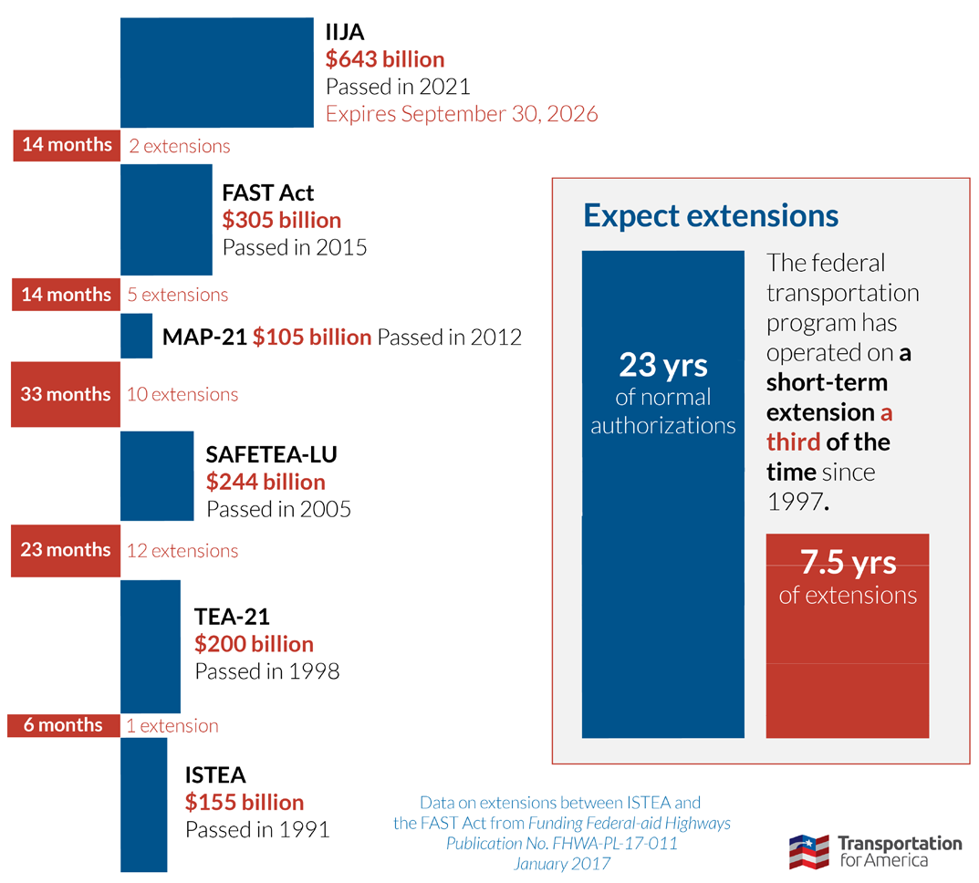
Source: Davis 2025
State funding for Massachusetts’ RTAs has consistently grown in recent years. Since 2020, total funding provided to all RTAs through state contract assistance has nearly doubled from $87 million to $160 million, as shown in Figure 56 (MassDOT 2025). In addition to general operating funds, the Commonwealth of Massachusetts has implemented additional funding through initiative-based channels, such as discretionary grant programs and fare-free pilots.
Fare-free transit at SRTA is on a trajectory to become long term as a product of state funding. $35 million was appropriated in FY 2026 for the implementation or continuation of fare-free transit at all RTAs. Additionally, a statutory amendment to Chapter 161B of Massachusetts General Laws prohibited all RTAs from charging a fare for transit services but still maintains that fare-free transit be subject to annual funding appropriation. (For more information on fare-free transit and SRTA’s fare policy, see Appendix A). Fare-free transit has demonstrated the potential to positively impact ridership at SRTA. However, the dependency on the Commonwealth’s appropriation of future fare-free transit funding introduces uncertainty and could influence SRTA’s operations.
Figure 56. State Funding for Massachusetts’ RTAs from FY 2007 to FY 2025

Source: MassDOT 2025

2020 Alternative Scenarios
SRTA last updated its CRTP in 2020, at the peak of the pandemic, when SRTA was facing many uncertainties across the transportation landscape, which were largely outside of its control. The entire transportation industry was grappling with unknowns about the long-term impact of the pandemic on overall ridership and whether remote work would drive increases in sprawl. Like all transit agencies, SRTA was unsure which routes and services would recover ridership first and which would see a slower recovery. Forces beyond the pandemic such as national economic policy, unemployment rates, education policy, availability of funding for capital investments, and municipal land use plans were all outside of its control. However, SRTA could plan for the resulting impacts to demand for its services.
In order to address this uncertainty, SRTA defined three qualitative ridership scenarios to map out the future of transit demand through 2025. The three scenarios were:
- Low Ridership: Ridership that remains below 60 percent of 2019 levels.
- Medium Ridership: Stable ridership between 60 and 85 percent of 2019 levels.
- High Ridership: Ridership that returns to 86 percent or more of 2019 levels.
Today, looking at ridership levels from FY 2019 to FY 2024, SRTA’s ridership returned to more than 86 percent of 2019 levels.
SRTA’s foresight in planning for three potential scenarios ensured it was well-prepared for high ridership, as shown in Figure 57. This enabled the agency to focus on the 2020 CRTP recommendations that aligned with high ridership to inform decision making and prioritize SRTA action items.
Figure 57. SRTA Annual System Ridership (FY 2019–FY 2024)

Source: MassDOT 2025

Looking Ahead: 2025 to 2030 Scenario Planning
In light of the varied and numerous uncertainties affecting the United States, Massachusetts, and SRTA’s region, key questions emerge: “What comes next?” and “What can be done?” While many of these trends lie beyond SRTA’s control, how they unfold will likely have an impact on ridership. SRTA can proactively respond by planning for different ridership levels over the next five years. As part of this process, SRTA conducted a workshop that explored three different ridership scenarios: low ridership, medium ridership, and high ridership. Topics that were discussed included staffing levels, modes of transit, and funding, among many other issues. Each scenario is detailed in the following sections.

Lower Ridership
Lower ridership for SRTA is characterized by a decrease in ridership numbers across services. While demand response ridership has recovered to pre-pandemic levels and continues to grow steadily, there is the possibility that fixed route ridership may drop. Several factors could potentially contribute to this scenario: a severe economic downturn and widespread unemployment could result in people doing less shopping and fewer errands; the continued prevalence of remote work could further suppress demand for commuting services; and demographic shifts, such as an aging population, might lead to a decline in school-based ridership. These potential market trends, as discussed previously, could collectively shape SRTA's ridership patterns in a low-ridership scenario.

Medium Ridership
Medium ridership for SRTA is characterized by a slight increase from today’s ridership numbers across services over the next five years. This scenario could result from a combination of potential factors: stagnant household incomes or high inflation might make personal vehicle ownership less feasible, leading more people to rely on public transit; the continued popularity of fare free service; a shift toward more consistent in-office work could increase the volume of work-related commutes; or a successful service expansion could drive increased demand. Additionally, localized developments, such as new transit-oriented housing developments, could further contribute to ridership growth in this scenario.

High Ridership
High ridership for SRTA is characterized by a substantial increase from today’s ridership numbers across services. This scenario could be driven by several potential factors: a sharp rise in gas prices may encourage more people to choose public transit over personal vehicles, especially provided the continued fare-free service; an aging population could lead to a significant increase in demand response ride requests; and the expansion of the South Coast Rail line and transit-oriented development may increase SRTA’s ridership base. Together, these dynamics could position SRTA to experience considerable growth in transit utilization.

Future Opportunities
Table 30 summarizes the opportunities and corresponding scenarios that arose during the scenario discussions. Various initiatives, coordination efforts, and solutions arose as potential opportunities for SRTA to embrace. Depending on ridership levels over the next five years, SRTA can determine which strategic opportunities may be applicable to pursue. For items that are applicable regardless of ridership level, “All” is indicated.
Table 30. Opportunities by Ridership Scenario
Ridership Scenario | Description of Opportunity
All | Monitor/ seek opportunities for increased/additional funding. Potential tools:  Ridership reports for data-driven decision making  Expansion of partnerships with member municipalities to support service expansions  Community education and awareness to bring attention to the community benefits of SRTA services
Low | Assess where service could be reduced in areas that are served by multiple routes  Potential for the more expensive express service between Fall River and New Bedford to be reduced if required  Planning for reduced evening services if required
Low | Utilize ridership reports to make data-driven decisions on where to decrease service if funding restraints require
Low | Focus on core ridership base and service use for shopping and errands; explore opportunities for better regional connections for core rider needs and usage
Medium | Assess how microtransit connections to South Coast Rail stations affect ridership; increase connections to South Coast Rail stations especially with growth of transit-oriented development in the SRTA service area
Medium | Explore potential for a transit hub in dense neighborhood areas
Medium | Explore strategies for mitigating difficulties associated with short trips in terms of maintaining headways
Medium and High | Use ridership reports as an educational tool for illustrating why SRTA service deserves increased funding and is important; frame community ideas: SRTA works to help the larger community
Medium and High | Look for opportunities to form and maintain partnerships with other RTAs and technical schools to increase operator and maintenance labor pool. Identify a school champion to maintain partnerships.  Opportunity to possibly be involved with GATRA’s partnership with BCC for CDL driver training
High | Focus on increasing microtransit service use through targeted advertising and marketing in the community
High | Strategize how to handle increased ridership demand for demand response rides; revise eligibility and application process if needed
Source: SRTA Alternative Workshop on October 9, 2025

Recommendations
The recommendations in this five-year plan emerged from a data-informed process that incorporated historical operational data, stakeholder feedback, industry standards, local policy, statewide objectives, and SRTA priorities. These recommendations establish a framework for advancing strategic service adjustments, capital improvements, and policy initiatives based on data-driven analysis and make meaningful progress toward better mobility for residents across the region.

Changes Since the 2020 Comprehensive Regional Transit Plan
The 2020 CRTP included numerous recommendations across a variety of categories, such as service and capital investments. Since that plan was produced, there has been a significant infusion of state and federal funding supporting expanded transit service. Key investments that SRTA has made over the past five years that helped drive ridership recovery include:
- Assess opportunities for implementing targeted Sunday service as ridership rebounds
- Sunday service was implemented in January 2024 as a pilot funded through the Commonwealth’s Fair Share Amendment and adopted by the Advisory Board as permanent service beginning in FY 2025. The Saturday schedule was applied to Sunday to create "weekend" service.
- Better assess market demand with the introduction of South Coast Rail Service
- A study conducted in 2022-2023 evaluated options to best serve South Coast Rail stations in Fall River and New Bedford (SRTA 2023b). The options included a fixed route span expansion to match South Coast Rail schedule times; a new, dedicated fixed route to operate outside the weekday span of service to serve the stations; and a microtransit service to serve the stations. The microtransit service "MicroConnector" began service in March 2025.
- Work toward replacing aging fleet by prioritizing the procurement of 25 buses over the next five years.
- Forty new hybrid drive fixed route buses have been ordered, delivered, and placed into service since 2023 following federal discretionary awards totaling nearly $24 million (FY 2022/2023 Low- and No-Emission Program).
- Pursue funding to run pilot service from Fall River to Taunton
- The Gateway Link pilot, funded through the Commonwealth’s Fair Share Amendment, was implemented by GATRA in collaboration with BAT and SRTA in the summer of 2025 that connects Fall River, Taunton, and Brockton with a direct bus connection.

Planning for an Uncertain Future
As described in Chapter 7, the Commonwealth may face key uncertainties in the next five years, including consistency in ridership levels. The CRTP’s five-year vision accounts for these variables, particularly the level of ridership in the SRTA service area. Refer to Chapter 7 for ridership scenarios and their impact on the plan.
Depending on how the future unfolds, different uncertainties may impact the listed recommendations differently. For the purposes of the CRTP, level of ridership demand was identified as one of the key uncertainties driving SRTA actions, including:
- Lower Ridership: If the level of ridership demand over the next five years is on the lower end of expectations, some recommendations are more relevant. Some of those might include utilizing ridership reports to make data driven decisions on where to decrease service if funding is restrained and focusing on sustaining the core ridership base.
- Medium Ridership: If the level of ridership demand over the next five years is in the mid-level of expectations, more robust service and capital expansions may be warranted. Some of those might include assessing microtransit connections to other services or additional transit hubs.
- Higher Ridership: If the level of ridership demand over the next five years is on the higher end of expectations, then the most enhanced service and capital investments may be warranted. Some of those might include strategizing how to handle increased demand response ridership and forming partnerships aimed at improving the labor pool for operators and maintenance staff.
- Core: Some recommendations are included regardless of ridership level and are considered core needs. For example, advocating for continued, sustainable funding sources and improving communication with the larger community are core needs.
The next section presents the recommendations for SRTA to use as a roadmap for the next five years across a variety of topic areas.

Identified Needs
The recommendations in this plan directly respond to needs identified through SRTA data analysis, market assessment, public and stakeholder input, and needs articulated in other regional and statewide plans. Needs identified through this planning process, as well as the element of the process that identified those needs, are shown in Table 31.
Table 31. Identified Needs
Need | Identified Through…
Expanding access to transit and improved first/last mile connections | Needs and Goals, Market Evaluation
Supporting span of service and frequency improvements for current services | Needs and Goals, Existing Conditions, Market Evaluation
Continuing to deliver fare-free service | Needs and Goals, Market Evaluation, Trends and Uncertainties, Fare Policy
Making data-driven decisions to improve current service and when implementing new service | Needs and Goals, Trends and Uncertainties
Growing capacity at existing hubs or adding hub locations in dense neighborhoods | Needs and Goals, Market Evaluation, Trends and Uncertainties
Positioning SRTA for future funding opportunities to meet evolving capital and operating needs | Needs and Goals, Existing Conditions, Trends and Uncertainties, Fare Policy, Environmental Policy
Updating bus stop infrastructure | Needs and Goals, Market Evaluation
Increasing operator and staff capacity, labor pool | Needs and Goals, Trends and Uncertainties, Environmental Policy
Maintaining a state of good repair for fleet and facility assets | Needs and Goals, Existing Conditions, Performance Monitoring, Trends and Uncertainties
Improving marketing and engagement with the public | Needs and Goals, Market Evaluation, Trends and Uncertainties
Maintaining and improving safety and security for operators and customers | Needs and Goals, Market Evaluation, Performance Monitoring
Coordinating with RTAs for enhanced interconnectivity | Needs and Goals, Market Evaluation, Trends and Uncertainties
Improving service to and coordination with UMass Dartmouth | Needs and Goals, Market Evaluation, Trends and Uncertainties
Enhancing microtransit service expansion and connections to South Coast Rail | Needs and Goals, Existing Conditions, Market Evaluation, Trends and Uncertainties
Working with the utility company to meet the energy needs of the current and future fleet | Needs and Goals, Environmental Policy
Improving maintenance facilities through additional capacity, exploring expanded or consolidated facilities | Needs and Goals, Existing Conditions, Performance Monitoring, Trends and Uncertainties
Source: SRTA
These identified needs drove the development of the recommendations found in this chapter. SRTA discussed these needs during multiple workshops to identify the suite of recommendations presented below, taking into consideration the potential positive impact, risks, the level of effort to implement, feasibility, uncertainties, and other relevant factors.

Recommendations
The needs identified in Chapter 4 and Chapter 5 served as the foundation for the recommendations detailed in the subsequent sections. The quantitative data analysis in the existing conditions section and market assessment, in combination with the qualitative feedback from the public and stakeholder outreach, provided the basis for these recommendations. They were further augmented by staff review to confirm applicability to operational realities and ensure alignment with other planning documents (e.g., regional long-range transportation plan).
The recommendations are organized into categories, including service, capital, policy, performance, coordination, additional studies, and other (Table 32). For recommendations that fall under multiple categories, a note in the final column highlights their cross-listing.
Table 32. Recommendations Categories
Category | Description
Service | Service recommendations deal with specific routing or other operational considerations of day-to-day provision of service.
Capital | Capital recommendations deal with the purchase or management of equipment, rolling stock, facilities, technology, or other assets.
Policy | Policy recommendations deal with practices and standards adopted by the transit agency to guide how the organization functions.
Performance | Performance recommendations deal with the systems and protocols for monitoring agency operations.
Coordination | Coordination recommendations deal with communications between the transit agency and other regional and statewide partners.
Additional Studies | Studies recommendations deal with needs that require further examination in order to make an informed decision.
Other | Other recommendations deal with issues not addressed by the other categories.

Service Recommendations
Service recommendations for SRTA focus on changes to service, either by changing span of service, expanding to new destinations, or maintaining quality of service (Table 33). The growth of microtransit demand has prompted SRTA to focus on how this affects capital needs, staff requirements, and other resources. SRTA is also interested in improving coordination with other services, like MBTA’s South Coast Rail, and to meet the needs of community resources such as UMass Dartmouth.
Table 33. Service Recommendations
ID | Recommendation | Ridership Scenario | Also in Category...
1 | Build from prior planning studies; define actionable next steps for service changes | Core | Policy
2 | Assess costs and operational impacts of running later fixed route service and determine future plans for implementation | Medium, High | Additional Studies
3 | Assess costs, operational impacts, and implementation strategies for increasing fixed route service frequency, with a goal of half hour headways systemwide | Medium, High | Additional Studies
4 | Continue to offer fare-free fixed route services subject to sustained state funding | Core | Policy
5 | Evaluate local assessment impacts on expanding fixed route service | Medium, High | Policy
6 | Maintain Sunday service | Medium, High | N/A
7 | Enhance communication with the public about services and policies | Core | Coordination
8 | Strategize how to accommodate increased ridership demand for demand response services, including capital needs, staff resources, and service eligibility and application process | High | Capital, Policy, Performance
9 | Focus on increasing microtransit service use through targeted advertising and marketing in the community | High | N/A
10 | Assess how microtransit connections to South Coast Rail stations affect ridership; explore expanded service zones and increased connections to South Coast Rail stations especially with growth of transit oriented development in the SRTA service area | Medium | Coordination
11 | Explore the potential to expand service to new locations within the region | Medium, High | N/A
12 | Assess ways to match service with transit ridership potential in coordination with UMass Dartmouth | Core | Coordination
13 | Explore strategies for mitigating difficulties associated with short trips in terms of maintaining headways | Medium, High | Additional Studies
14 | Refresh list of bus stops identified for updates based on previously developed guidelines and secured funding | Core | N/A
15 | Evaluate potential for added capacity at existing transit hubs and opportunities for additional locations | Medium, High | Capital, Additional Studies
N/A = Not available. Recommendation not included in other categories.

Capital Recommendations
Much of SRTA’s capital recommendations are related to maintaining a state of good repair of the existing fleet, understanding capital needs for service expansion, and improving maintenance facilities (Table 34). SRTA is focusing on improvements to the Authority’s facilities, such as exploring expanded capacity at transit hubs and modernizing maintenance facilities and operations. Reflecting the service area, SRTA currently has two maintenance facilities – one in New Bedford and one in Fall River – that are aging and at or nearing capacity. Assessing different maintenance facility alternative location(s) or configuration(s) to meet capacity demands will be a key activity for SRTA in the next five years.
Table 34. Capital Recommendations
ID | Recommendation | Ridership Scenario | Also in Category...
8 | Strategize how to accommodate increased ridership demand for demand response services, including capital needs, staff resources, and service eligibility and application process | High | Service, Policy, Performance
15 | Evaluate potential for added capacity at existing transit hubs and opportunities for additional locations | Medium, High | Service, Additional Studies
16 | Continue capital bus replacement plan to maintain a state of good repair | Core | N/A
17 | Assess the benefits and drawbacks of alternatives to current maintenance facilities configuration, including transit operations and Title VI analyses, environmental review and permitting, and conceptual through final design | Core | Additional Studies
18 | Continue collaborating with utility company to meet the needs of the current and future fleet | Core | Coordination
N/A = Not available. Recommendation not included in other categories.

Performance Recommendations
SRTA is planning for operational and capital needs stemming from increased ridership, particularly with demand response service. In addition, SRTA is looking to improve customer experience through improved communication and education as well as prioritizing safety and comfort.
Table 35. Performance Recommendations
ID | Recommendation | Ridership Scenario | Also in  Category...
8 | Strategize how to accommodate increased ridership demand for demand response services, including capital needs, staff resources, and service eligibility and application process | High | Service, Capital, Policy
19 | Use ridership reports as educational tools to highlight key accomplishments and benefits of increased investment in service | Core | Policy
20 | Continue providing security and increasing public safety at terminals | Core | Policy

Policy Recommendations
Recommendations in this section focus on maintaining and exploring additional funding to bolster services, as well as improving communication with the public and planning for sufficient workforce capabilities (Table 36).
Table 36. Policy Recommendations
ID | Recommendation | Ridership Scenario | Also in  Category...
1 | Build from prior planning studies; define actionable next steps for service changes | Core | Service
4 | Continue to offer fare-free fixed route services subject to sustained state funding | Core | Service
5 | Evaluate local assessment impacts on expanding fixed route service | Medium, High | Service
8 | Strategize how to accommodate increased ridership demand for demand response services, including capital needs, staff resources, and service eligibility and application process | High | Service, Capital, Performance
19 | Use ridership reports as educational tools to highlight key accomplishments and benefits of increased investment in service | Core | Performance
20 | Continue providing security and increasing public safety at terminals | Core | Performance
21 | Continue to advocate for sustainable funding and seek opportunities for additional sources | Core | N/A
22 | Look for opportunities to form and maintain partnerships with other RTAs and technical schools to grow the labor pool for operators and maintenance staff | Medium, High | Coordination
N/A = Not available. Recommendation not included in other categories.

Coordination Recommendations
Several of the recommendations in this plan deal with coordination with other RTAs, as well as ongoing coordination with member communities and institutions within the SRTA service area (Table 37). This coordination can lead to improved labor pools, partnerships for expanded service, and more seamless customer experiences. While the complexity is relatively low, the potential impact of this coordination is substantial.
Table 37. Coordination Recommendations
ID | Recommendation | Ridership Scenario | Also in  Category...
7 | Enhance communication with the public about services and policies | Core | Service
10 | Assess how microtransit connections to South Coast Rail stations affect ridership; explore expanded service zones and increased connections to South Coast Rail stations especially with growth of transit oriented development in the SRTA service area | Medium | Service
12 | Assess ways to match service with transit ridership potential in coordination with UMass Dartmouth | Core | Service
18 | Continue collaborating with utility company to meet the needs of the current and future fleet | Core | Capital
22 | Look for opportunities to form and maintain partnerships with other RTAs and technical schools to grow the labor pool for operators and maintenance staff | Medium, High | Policy

Recommendations for Additional Studies
Several opportunities for additional studies were identified as part of this planning process (Table 38). These have the potential to improve the efficiency of SRTA’s operations, either through fixed route service optimization, assessing transit hub capacity and potential, or planning for the modernization of maintenance facilities.
Table 38. Recommendations for Additional Studies
ID | Recommendation | Ridership Scenario | Also in  Category...
2 | Assess costs and operational impacts of running later fixed route service and determine future plans for implementation | Medium, High | Service
3 | Assess costs, operational impacts, and implementation strategies for increasing fixed route service frequency, with a goal of half hour headways systemwide | Medium, High | Service
13 | Explore strategies for mitigating difficulties associated with short trips in terms of maintaining headways | Medium, High | Service
15 | Evaluate potential for added capacity at existing transit hubs and opportunities for additional locations | Medium, High | Service, Capital
17 | Assess the benefits and drawbacks of alternatives to current maintenance facilities configuration, including transit operations and Title VI analyses, environmental review and permitting, and conceptual through final design | Core | Capital

References
Baker, Charlie. 2018. Executive Order 579, Establishing the Commission on the Future of Transportation in the Commonwealth. January 23, 2018. https://www.mass.gov/executive-orders/no-579-establishing-the-commission-on-the-future-of-transportation-in-the-commonwealth.
Baxandall, Phineas. 2025. Fare-Free Public Buses are Yielding Results in Southeastern MA. Massachusetts Budget and Policy Center. January 13, 2025. https://massbudget.org/2025/01/13/fare-free-srta/.
Bill H.5060. 2022. An Act Driving Clean Energy and Offshore Wind. https://malegislature.gov/Bills/192/H5060.
Bureau of Transportation Statistics. 2025. Statistics on Transportation Funding by Mode in the Infrastructure Investment and Jobs Act. https://data.bts.gov/stories/s/Infrastructure-Investment-and-Jobs-Act-IIJA-Transp/7fjw-dp4g/.
Center for Neighborhood Technology. 2025. Housing and Transportation Affordability Index. https://htaindex.cnt.org/map/.
City of New Bedford. 2020. NB Resilient: New Bedford’s Plan for Community Climate Action + Resilience. City of New Bedford Department of Environmental Stewardship. https://kladashboard-clientsourcefiles.s3.amazonaws.com/New+Bedford/NB+Resilient+Plan+-+Final+3-20.pdf.
Commonwealth of Massachusetts. 2008a. Chapter 169, An Act Relative to Green Communities. https://malegislature.gov/Laws/SessionLaws/Acts/2008/Chapter169.
Commonwealth of Massachusetts. 2008b. Global Warming Solutions Act Background. Executive Office of Energy and Environmental Affairs. https://www.mass.gov/info-details/global-warming-solutions-act-background.
Commonwealth of Massachusetts. 2020. MA Decarbonization Roadmap. Executive Office of Energy and Environmental Affairs. https://www.mass.gov/info-details/ma-decarbonization-roadmap.
Commonwealth of Massachusetts. 2022. 2050 Clean Energy and Climate Plan. Executive Office of Energy and Environmental Affairs. https://www.mass.gov/doc/2050-clean-energy-and-climate-plan.
Commonwealth of Massachusetts. 2024a. Beyond Mobility: Massachusetts 2050 Transportation Plan. July 2024. https://www.mass.gov/doc/massdot-beyond-mobility-full-plan/download.
Commonwealth of Massachusetts. 2024b. Regional Transit Innovation Grant. Rail and Transit Division. https://www.mass.gov/how-to/regional-transit-innovation-grant.
Commonwealth of Massachusetts. 2025a. A Home for Everyone: A Comprehensive Housing Plan for Massachusetts 2025-2029. Executive Office of Housing and Livable Communities. February 2025. https://www.mass.gov/doc/a-home-for-everyone/download.
Commonwealth of Massachusetts. 2025b. Chapter 40R. Executive Office of Housing and Livable Communities. https://www.mass.gov/info-details/chapter-40r.
Commonwealth of Massachusetts. 2025c. Community Transportation Coordination. Rail and Transit Division. https://www.mass.gov/info-details/community-transportation-coordination.
Commonwealth of Massachusetts. 2025d. MassMobility. Rail and Transit Division. https://www.mass.gov/orgs/massmobility.
Commonwealth of Massachusetts. 2025e. Multi-Family Zoning Requirements for MBTA Communities. Executive Office of Housing and Livable Communities. https://www.mass.gov/info-details/multi-family-zoning-requirement-for-mbta-communities.
Davis, Steve. 2025. Five reasons why IIJA will expire without a replacement in September 2026. Transportation for America. July 23, 2025. https://t4america.org/2025/07/23/five-reasons-why-iija-will-expire-without-a-replacement-in-september-2026/.
Ekbatani, Taylor. 2025. Report Highlights Shift in Federal Policy from EVs to Conventional Fuels. April 28, 2025. https://stnonline.com/news/report-highlights-shift-in-federal-policy-from-evs-to-conventional-fuels/.
FTA. 2012. FTA Circular 4702.1B, Title VI Requirements and Guidelines for Federal Transit Administration Recipients. October 1, 2012. https://www.transit.dot.gov/sites/fta.dot.gov/files/docs/FTA_Title_VI_FINAL.pdf.
FTA. 2020. Safety Performance Targets Fact Sheet. August 2020. Federal Transit Administration. https://www.transit.dot.gov/sites/fta.dot.gov/files/2020-08/SafetyPerformanceTargetFactSheet_20200814.pdf.
FTA. 2024. FY 23 FTA Bus and Low- and No-Emission Grant Awards. Federal Transit Administration. https://www.transit.dot.gov/funding/grants/FY 23-fta-bus-and-low-and-no-emission-grant-awards.
GoTriangle. 2025. Collaborative effort draws fresh ideas to help people without homes. https://gotriangle.org/news/collaborative-effort-draws-fresh-ideas-help-people-without-homes.
Massachusetts Executive Office of Elder Affairs. 2021. Massachusetts State Plan on Aging October 1, 2021 – September 30, 2025. October 2021. https://www.mass.gov/doc/massachusetts-state-plan-on-aging-2021-2025/download.
MassDOT. 2019. A Vision for the Future of Massachusetts’ Regional Transit Authorities. Report of the Task Force on Regional Transit Authority Performance and Funding. April 5, 2019. https://www.mass.gov/doc/a-vision-for-the-future-of-massachusetts-regional-transit-authorities/download.
MassDOT. 2023. Would a System of Regional Mobility Managers Benefit Massachusetts? Final Recommended Action Plan. August 2023. https://www.mass.gov/doc/would-a-system-of-regional-mobility-managers-benefit-massachusetts/download.
MassDOT. 2024a. Annual Report on the Regional Transit Authority Performance Management Program. Massachusetts Department of Transportation. February 9, 2024.
MassDOT. 2024b. Healey-Driscoll Administration Announces Fare Free Regional Transit Service Across State. Massachusetts Department of Transportation. October 24, 2024. https://www.mass.gov/news/healey-driscoll-administration-announces-fare-free-regional-transit-across-state.
MassDOT. 2024c. MassDOT Regional Bus Network Assessment. Office of Transportation Planning & Rail and Transit Division. September 2024. https://www.mass.gov/doc/massdot-regional-bus-network-assessment/download.
MBTA. 2025. Fall River/New Bedford Line Schedules & Maps. Massachusetts Bay Transportation Authority. https://www.mbta.com/schedules/CR-NewBedford/line?schedule_direction%5Bdirection_id%5D=0&schedule_direction%5Bvariant%5D=CR-NewBedford-e455f611-0.
NTD. 2024a. 2024 Annual Agency Profile - City of Santa Clarita (NTD ID 90171). https://www.transit.dot.gov/sites/fta.dot.gov/files/transit_agency_profile_doc/2024/90171.pdf.
NTD. 2024b. 2024 Annual Agency Profile - Denton County Transportation Authority (NTD ID 60101). https://www.transit.dot.gov/sites/fta.dot.gov/files/transit_agency_profile_doc/2024/60101.pdf.
NTD. 2024c. 2024 Annual Agency Profile - Kanawha Valley Regional Transportation Authority (NTD ID 30001). https://www.transit.dot.gov/sites/fta.dot.gov/files/transit_agency_profile_doc/2024/30001.pdf.
NTD. 2024d. 2024 Annual Agency Profile - Southeastern Regional Transit Authority (NTD ID 10006). https://www.transit.dot.gov/sites/fta.dot.gov/files/transit_agency_profile_doc/2024/10006.pdf.
NTD. 2024e. 2024 Annual Agency Profile - The Eastern Contra Costa Transit Authority (NTD ID 90162). https://www.transit.dot.gov/sites/fta.dot.gov/files/transit_agency_profile_doc/2024/90162.pdf.
Optibus. 2025. The State of Public Transportation Report. https://optibus.com/wp-content/uploads/2025/02/eBook-2025-State-of-Public-Transportation-Report.pdf.
Point32Health Foundation. 2025. A Healthy Aging Data Report, Massachusetts. https://mahealthyagingcollaborative.org/wp-content/uploads/2025/05/MA_Highlights_2025.pdf.
Renski, Henry. 2015. Long-term Population Projections for Massachusetts Regions and Municipalities. University of Massachusetts, Amherst. March 2015. https://pep.donahue-institute.org/downloads/2015/new/UMDI_LongTermPopulationProjectionsReport_2015%2004%20_29.pdf.
Replica. 2024. Trips by Origin (Northeast, Spring 2024, Thursday).
SRPEDD. 2025. DRAFT Regional Resilience Plan. Southeastern Regional Planning and Economic Development District. https://srpedd.org/regional-resilience-plan//.
SRTA. 2021. Comprehensive Regional Transit Plan Update. Southeastern Regional Transit Authority. January 2021. https://www.srtabus.com/wp-content/uploads/SRTA_CRTPU_MASTER_2021.0505_508.pdf.
SRTA. 2023a. Transit Asset Management Plan. Southeastern Regional Transit Authority. April 2023.
SRTA. 2023b. “South Coast Rail Service Plan.” Southeastern Regional Transit Authority. www.srtabus.com/south-coast-rail-service-plan/.
SRTA. 2025a. Performance Measures. Southeastern Regional Transit Authority. https://www.srtabus.com/performance-measures/.
SRTA. 2025b. Rules for Riding. Southeastern Regional Transit Authority. https://www.srtabus.com/rules-for-riding/.
SRTA. 2025c. Public Transportation Agency Safety Plan. Southeastern Regional Transit Authority.
Transit Workforce Center. 2022. Bus Driver Recruitment and Retention in Challenging Times. April 2022. https://www.transitworkforce.org/resource_library/briefing-reportbus-driver-recruitment-and-retention-in-challenging-times/.
Transportation for Massachusetts. 2024. Poll: Massachusetts Residents Feeling the Squeeze from Housing and Transportation Costs. July 23, 2024. https://t4ma.org/poll-massachusetts-residents-feeling-the-squeeze-from-housing-and-transportation-costs/.
U-Haul. 2025. U-Haul Growth Index. https://www.uhaul.com/About/Migration/.
UMass Donahue Institute. 2025. Massachusetts Population Estimates Program. https://donahue.umass.edu/business-groups/economic-public-policy-research/massachusetts-population-estimates-program/population-estimates-by-massachusetts-geography/by-state.
US Census Bureau. 2023. 2018-2022 American Community Survey 5-year estimates. December 2023. https://www.census.gov/programs-surveys/acs.html.
US Census Bureau. 2024. 2019-2023 American Community Survey 5-year estimates. December 2024. https://www.census.gov/programs-surveys/acs.html.
US Census Bureau. 2025a. Older Adults Outnumber Children in 11 States and Nearly Half of U.S. Counties. June 26, 2025. https://www.census.gov/newsroom/press-releases/2025/older-adults-outnumber-children.html.
US Census Bureau. 2025b. "OnTheMap." https://onthemap.ces.census.gov.
Van Eyken, C. 2022. Bus Operators in Crisis: The Steady Deterioration of One of Transit’s Most Essential Jobs, and How Agencies Can Turn Things Around. TransitCenter. July 2022. https://transitcenter.org/publication/bus-operators-in-crisis/.
Vespa, Jonathan. 2018. The U.S. Joins Other Countries with Large Aging Populations. United States Census Bureau. March 13, 2018. https://www.census.gov/library/stories/2018/03/graying-america.html#:~:text=Although%20declining%20fertility%20plays%20a,as%20older%20adults%20outnumber%20kids.
Volinski, J. 2012. Implementation and Outcomes of Fare-Free Transit Systems. Transit Cooperative Research Program, Transportation Research Board, & National Academies of Sciences, Engineering, and Medicine. https://doi.org/10.17226/22753.
Worcester Regional Research Bureau. 2019. The Implications of a Fare-Free WRTA. Worcester Regional Research Bureau. May 22, 2019. https://www.wrrb.org/reports/2019/05/the-implications-of-a-fare-free-wrta/.

- Fares
Fare policy is part of a broader set of RTA and Commonwealth policies that affect public access to transit, RTA revenue, transit system operations, and many other facets of transit service in Massachusetts.
This appendix explores fare policy for SRTA, and fare replacement programs funded by the Commonwealth of Massachusetts. It also examines the industry’s best practices for fare-free transit operations and provides an outlook for the future of fare collection.

Fare Collection and Revenue Replacement Program
The following subsections explain the evolution of fare collection/revenue replacement—from fare suspension during the COVID-19 pandemic, to the Commonwealth’s Try Transit Program and the funding for operations provided by the Fair Share Amendment.

Fare-free Regional Transit – Statewide Background

COVID-19 Fare Suspension
In March 2020, the Commonwealth, along with the rest of the United States, was grappling with a global pandemic. To slow the spread of COVID-19, measures were put in place to encourage social distancing and minimize contact between front line service workers and the public. Several RTAs responded by suspending fare collection as part of their COVID mitigation measures. Fare suspension durations varied across the Commonwealth, and many RTAs reinstated fare collection once protective measures were in place to protect bus operators from exposure to COVID-19.

Try Transit Program
Beginning on November 25, 2022, and lasting through the end of 2022, RTAs received funding to suspend fare collection. The fare suspension was funded by a $2.5 million appropriation available to RTAs in the FY 2023 Massachusetts State Budget and restricted to fare-free operations. SRTA received $241,102 in 2022 for the Try Transit Program. This was the first program funded with an appropriation in the state budget. The limited duration of the program made it challenging to measure changes in ridership trends. However, anecdotally, it was popular among riders.
Fare-free funding was extended to RTAs again in the FY 2024 Massachusetts State Budget with a $15 million appropriation restricted to fare suspension programs. The funding allowed for longer duration fare suspension but remained a pilot program since it provided funds for a partial fiscal year. SRTA received $1,382,388 and suspended fares for 6 months in 2024.
On balance, RTA customers, staff, and stakeholders across the Commonwealth considered the FY 2024 program successful and funding was again appropriated in the FY 2025 State Budget with $30 million. The FY 2025 appropriation provided for a full year of fare-free operations and went beyond revenue replacement and extended funding to address the increased costs associated with additional ridership. SRTA received a grant of $3,230,893 to support fare-free operation.

Fair Share Act
In November 2022, voters approved an amendment to the Massachusetts Constitution that assesses a 4 percent surtax on incomes over $1 million, where the funds generated would be restricted to education and transportation. The Commonwealth began tax collection on January 1, 2023, and used the revenue collected during the remainder of the FY 2023 budget year to create a trust fund from which funds would be distributed in future years.
The FY 2024 budget was the first year funds were appropriated, and $1 billion was included in the budget; $510 million was appropriated to education and $490 million was appropriated to transportation. The RTAs were appropriated $25 million, and $15 million was used to support the FY 2024 Try Transit program. For FY 2025, the Fair Share Amendment was expected to generate $1.3 billion, $605 million of which was appropriated to transportation. The RTA share increased to $90 million, of which $30 million was used to support the FY 2025 Try Transit program.

State Fiscal Year 2026 Fare-Free Budget and Legislation
The FY 2026 budget for the Commonwealth of Massachusetts was signed into law on July 4, 2025. In FY 2026, $35 million was appropriated for the implementation of year-round fare-free transit service across the Commonwealth's RTAs. This funding accompanies a statutory amendment to Chapter 161B of Massachusetts General Laws, which now prohibits RTAs from charging passenger fares for all fixed route services and paratransit services, subject to appropriation of funding to replace fare revenue. MassDOT is responsible for reimbursing RTAs for lost fare revenue attributable to the fare-free service mandate. SRTA is required to collect and report ridership data to MassDOT in a format and frequency prescribed by MassDOT.

RTA Fare Policy

Fare Rates
Prior to fare-free service, SRTA charged the rates in Table 39 and Table 40 for fares.
Table 39. Fixed Route Fare Policy
Fare Product | Fare Price
Cash Fare- Full Fare | $1.50
Cash Fare- Reduced fare | $0.75
Cash Fare- Transfers | 1 Freeª
Cash Fare- Children under 6 years old | Free
Cash Fare- Children 6-11 years old | $0.75
Charlie Card Fare- Full Fare | $1.25
Charlie Card Fare- Reduced Fare | $0.60
Charlie Card Fare- Transfers | 1 Free ^{b}
Passes- One Ride | $1.50
Passes- All Day | $3.00
Passes- Week Pass | $10.00
Passes- 10 Rides | $14.00
Passes- 10 Rides Students | $7.50
Passes- 31 Day | $30.00
Passes- 31 Day for Seniors, Disabled, and School riders | $20.00
Source: SRTA Fare Policy, June 2025
ª 90 Minute transfer at time of boarding, from inbound bus to outbound bus
^{b} One 2-hour transfer from any bus to any bus in any direction
Table 40. ADA and Senior Van Service Fare Policy
Fare Product | Fare Price
Demand Response- Cash | $3.00
Demand Response Premium- Cash | +$1.00
Demand Response- 10 ticket book | $25.00
Trips outside 2 miles radius of fixed route | +$1.00
Boston Hospital Shuttle- Round Trip | $25.00
Source: SRTA Fare Policy, June 2025

Fare-free Program
SRTA has received nearly $5 million from the Commonwealth over the last three years to invest in fare-free service.
- FY 2023 – Try Transit holiday promotion: $241,102
- FY 2024 – Fare-free Implementation: $1,382,388
- FY 2025 – Fare-free Implementation: $3,230,893

Fare Collection Infrastructure
Fare collection equipment serves two main purposes: (1) collect, count, and securely store money deposited by riders upon boarding and (2) count passenger boardings. The amendment to Massachusetts General Laws Chapter 161B in the State FY 2026 budget, which mandates fare-free service, changes considerations around the maintenance and use of fare collection equipment today and in the future.
Absent the need to collect fares, the equipment will likely be used primarily to count passenger boardings.

On-board Equipment and Ticket Vending Machines
Prior to its fare-free operations, SRTA had been using Scheidt & Bachmann fareboxes on their fixed route buses since 2013. These fareboxes accepted cash, transfers, and MBTA CharlieCards to enable the use of prepaid value and passes as well as interconnectivity with the MBTA system. Other RTAs have also deployed these same farebox systems primarily for interoperability with MBTA. SRTA also has ticket vending machines (TVMs) at its terminal where customers could purchase new CharlieCards and load value onto already purchased CharlieCards. Customers using SRTA’s ADA demand response service must pay drivers exact fare at the time of boarding. Currently, the TVMs in the terminals are inactive, and demand response as well as fixed route service is running fare-free through June 30, 2026.
Scheidt & Bachmann fareboxes have been out of use due to SRTA’s fare-free service since January 1, 2024. Although there are no capital plans for replacement at the time of this document’s publication, SRTA anticipates the possibility of its unused technology becoming inoperative.
SRTA is exploring the long-term feasibility of updating its fare collection technology should it need to reinstate fares in the absence of continued funding for fare-free operations. The replacement would seek to address challenges with the Scheidt & Bachmann system, ensure the technology is up-to-date and functional, and allow interoperability with other RTAs and MBTA’s ongoing fare collection system update. SRTA continues to explore the feasibility of a long-term fare technology joint procurement should it be determined that a long-term fare technology solution is required.

Retail Sales
Prior to fare-free operations, CharlieCards could be purchased, along with passes, at SRTA terminals, from a TVM, or from a ticket agent. Acceptable forms of payment were cash, debit, or credit. Access Passes or Reduced Fare Cards were available for older adults and persons with a disability. To qualify for an Access Pass, riders must bring one of the following documentations to the New Bedford Terminal, the Fall River Terminal, or the SRTA Administrative Office.
- Veterans ID from the Department of Veterans Affairs with a disability rating of 70 percent or greater.
- Medicare card holder.
- Senior ID (60+)
- Certificate of blindness
- Demand response certification letter
- Transportation Access Pass ID from any RTA in Massachusetts
- Letter from agency: Department of Mental Health (DMH), Disability Determination Services (DDS), Massachusetts Rehabilitation Commission (MRC), or Massachusetts Commission for the Blind (MCB)
- Registry of Motor Vehicles (RMV) Disability Placard

Cash Control and Management
SRTA’s Scheidt & Bachmann system accepts cash, which required SRTA to develop a process for cash control and management. When SRTA was previously collecting cash, it was routed to the vault for proper counting and management by SRTA’s contracted operations team. SRTA dedicated one staff person who would reconcile and post the daily cash deposits. The cash would be picked up by armored car service, twice a week, to be deposited. SRTA estimates that in FY 2025, if charging fares, the associated cash control and management would be $704,705.09.

Fare-free Transit Best Practices

Transit Access and Efficiency

Ridership
Fare-free transit almost always is associated with a significant increase in ridership. Fare-free transit has repeatedly been shown to increase ridership by 20 percent to 60 percent for transit agencies in the United States. Agencies that went fully fare-free before the COVID-19 pandemic experienced 20 percent to 100 percent increases in ridership within the first two years of the policy change. Paratransit services have seen similar growth, with increases up to 60 percent after implementation of fare-free service. Studies suggest that 5 percent to 30 percent of new trips resulting from fare-free policy come from those who previously took other motorized modes of travel (Volinski 2012).

Operational Efficiency
Fare-free transit simplifies both the ride experience for passengers and the workload of operators. With no fare collection, dwell time per passenger during boarding and alighting is reduced without the queues at the farebox; it also enables more efficient all-door boarding. Short dwell time improves on-time performance and service reliability. Fare-free transit has been acknowledged to have significantly improved on-time performance at RTAs in Massachusetts (Baxandall 2025).
The removal of fares may encourage passengers who would otherwise walk to use transit more frequently for short trips. Despite the reduced dwell time per passenger resulting from elimination of farebox queues, more stops and larger boarding and alighting volumes may negatively impact absolute dwell time. This is most acute where stops are located in close proximity to each other. This could be mitigated with increased spacing that balances operational efficiency with passenger access.

Financial Health

Revenue Sources
Identifying and acquiring alternative revenue sources to replace fare revenue is a significant barrier to implementing and maintaining fare-free transit. Securing a funding source for Massachusetts RTAs is important to the maintenance of fare-free transit. Small to mid-sized agencies, like Massachusetts’ RTAs, where fare revenue is a small portion of operating revenue, face less financial difficulty in implementing and maintaining fare-free transit.

Revenue Collection Costs
The loss of revenue by eliminating fare collection is a concern for RTAs. However, fare-free transit also provides an opportunity for cost savings. Fare-free transit eliminates costs associated with the administration, enforcement, and equipment maintenance of fare collection. Fare administration, collection, and enforcement have been documented as consuming over 25 percent of fare revenue at Massachusetts RTAs (Worcester Regional Research Bureau 2019).
Increased ridership resulting from fare-free transit often creates the need for increased capacity. RTAs may need to act to effectively handle the increased demand, such as expanding fleets, hiring more staff, or expanding service. Agencies should anticipate or acknowledge the potential for high costs associated with providing high-capacity service to accommodate increased ridership.
A bigger challenge for SRTA may be the complementary paratransit service provided for older adults and people with disabilities. Paratransit services do not scale the same as fixed route services. The personalized nature of the service means that, as more riders book more trips, both vehicle and staff productivity tend to fall, and capacity to provide trips becomes strained. Funding is needed to not only replace revenue lost from fare suspension but also provide resources to hire and train additional staff needed to meet the growing demand for paratransit service.

Operator and Passenger Experience
Farebox disputes are the most likely incident that results in transit operator assaults. FTA reports operator assaults per unlinked passenger increased fourfold from 2009 to 2020 (Van Eyken 2022). Fare-free transit programs improve operator safety by eliminating conflict over fare collection and have generally received positive feedback from operators. Many prominent transit organizations are in support of fare-free transit for its positive implications towards ensuring operational safety. Fare-free transit also reduces barriers to operator recruitment by reducing the need of operators to hold technical knowledge regarding farebox technologies (Transit Workforce Center 2022).
Fare-free transit can increase the number of non-destination riders (i.e., people who use the transit system for shelter or as a pastime). Fare-free transit is an attractive option for someone without shelter to find respite from inclement weather. Because transit is a public service, it is a challenge to provide equitable access for all members of the community while discouraging non-destination riding that may be disruptive to other passengers.
Riding policies, like having all passengers exit the bus at the end of the line, can dissuade non-destination riding. Agencies can collaborate with social service providers to extend outreach and intervention opportunities (GoTriangle 2025). Loitering rules can be better enforced at terminals and bus stops, and rules of conduct can be imposed and enforced when customers act unruly or disturb other passengers on board.

Future of Fare-free Regional Transit

Risks

State Funding
Starting in the State FY 2024 budget, fare-free service was funded with a discretionary grant program appropriated annually and funded with Fair Share Act revenue. The state FY 2026 budget amended Massachusetts General Laws Chapter 161B with a mandate for fare-free transit service. The transition from a discretionary program to a statutory funding requirement provides a greater degree of certainty to SRTA that the funds will be available each year; however, the term “subject to appropriation” in the amendment suggests that the funding could be at risk from prolonged budgetary constraints.

Federal Compliance
FTA Circular 4702.1B establishes requirements and guidelines for Title VI of the 1964 Civil Rights Act. Transit providers that operate 50 or more fixed route vehicles in peak service and are located in an urbanized area of 200,000 or more in population are required to evaluate fare changes. This is to ensure there is no disparate impact on racial minorities or disproportionate burden on the low-income population. The requirement applies to any fare change, whether it is an increase or decrease in fare rate, and applies when a fare rate is expected to remain in place for more than six months.
Suspending or eliminating fares is a simple and straightforward analysis since all population groups benefit equally regardless of race or socioeconomic status. However, increasing or restoring fares can be more complicated. Protected groups such as the low-income and racial minority populations may experience a disproportionate impact, depending on the specifics of the agency’s Title VI policy and analysis framework. Conducting this analysis is time consuming, as it can involve examining alternatives, and typically requires public hearings. SRTA would have to consider how to maintain compliance with Title VI Fare Equity requirements should funding for fare-free service no longer be available and fares reinstated.

Fare Equipment State of Good Repair
SRTA continues to maintain fare collection equipment that is not being used. This maintenance adds costs to operating budgets with no direct benefit to the public or improved operating efficiency. The Scheidt & Bachmann farebox system is now 12 years old. Fare collection equipment has a usable life benchmark of 12 years as set by SRTA. Maintaining equipment that is no longer needed for fare collection and is only used to count passengers is costly and does not produce the same precision passenger counts as an APC system.
The amendment to Massachusetts General Law provides certainty that lost fare revenue will be reimbursed. The risk, however, is that if the state budget is constrained and funds are not appropriated to reimburse lost fare revenue, SRTA will not have the capacity to collect fares once fare collection equipment has been phased out. The timeline for a fare collection system design and implementation can take years. The long lead time means it is unlikely a new system can be deployed between the time fare-free funding is suspended and revenue is needed to maintain a balanced operating budget.

Opportunities
Fare-free transit benefits social service agencies, school districts, community colleges, four-year colleges and universities, and other community-based organizations that have historically made bulk pass purchases. SRTA had agreements with UMass that allowed students to ride for free with their University ID card, and SRTA would bill the University for those rides at a discounted rate monthly. Fare-free transit is cost-saving for these institutions; however, it represents a revenue loss for SRTA, which is offset with Massachusetts General Laws Chapter 161B funds.
Opportunities for revenue enhancements to replace farebox collections are limited. High ridership may make advertising space inside the bus, at terminals, and stops more attractive as it is visible to more people. Additional vehicles in service to meet the demands of high ridership may present more opportunities for vehicle exterior advertising space.

Future of Fare-Free Policy
With the passage of the FY 2026 state budget and the changes to Massachusetts General Laws Chapter 161B, there is increased certainty in the state policy environment with regard to fare-free regional transit. RTAs around the Commonwealth may choose to make policy and operational decisions that assume future funding replacement for fare revenue.
In the event that SRTA reinstates fares, SRTA anticipates possibly assessing the previously suspended fare policy. The fare policy update would be consistent with SRTA procedures for fare policy amendment including Board review, peer assessment, market analysis, and public engagement activities. Additionally, SRTA continues to engage with its RTA peers to understand best practices in fare technology and will consider long-term need for fare technology procurement.

- Environmental Policy
The Commonwealth of Massachusetts has set ambitious statewide goals regarding environmental quality, as have many of its regions and municipalities. With transportation emissions contributing significantly to statewide greenhouse gas emissions and poor air quality, this appendix describes efforts to reduce those emissions through technological advancements and initiatives to boost transit ridership.
The following sections identify RTA activities and the associated supportive policies:
- Commonwealth policies are statewide policies or goals that support specific RTA activities.
- Regional policies are any climate action plans established by Regional Planning Agencies if those plans include transportation goals, targets, or actions.
RTA-specific goals and studies are another important source of information supporting specific RTA actions regarding environmental quality. Together, the statewide and regional policy context should help to inform decision making and goals contained within this five-year CRTP.

Foundational Environmental Policies
There are several foundational Commonwealth policies that set the stage for greenhouse gas emissions reduction from the transportation sector. These policies may support numerous RTA activities as they relate to greenhouse gas emissions reduction, given the alignment between emissions reductions and maximizing transit ridership, serving transit-oriented places, and installing green energy infrastructure.
- Global Warming Solutions Act: Signed into law in August 2008, this act required the Massachusetts Executive Office of Energy and Environmental Affairs to set economy-wide greenhouse gas emissions reduction goals, including for transportation, to achieve between a 10 percent and 25 percent reduction below statewide 1990 levels by 2020 and at least 80 percent reduction below statewide 1990 levels by 2050 (Commonwealth of Massachusetts 2008b).
- Commission on the Future of Transportation in the Commonwealth: Established by Executive Order 579, this commission developed multiple recommendations related to reducing greenhouse gas emissions and promoting energy efficiency (Baker 2018).
- 2050 Decarbonization Roadmap: Published in December 2020, the Roadmap is a result of a Massachusetts Executive Office of Energy and Environmental Affairs planning process to identify cost-effective and equitable strategies for Massachusetts to reach its goal of 85 percent greenhouse gas emissions reduction by 2050 and achieving net zero emissions (Commonwealth of Massachusetts 2020).
- Clean Energy and Climate Plan for 2050: Released in 2022, this plan represents Commonwealth policies and strategies to reach net zero in 2050 (Commonwealth of Massachusetts. 2022).
- Green Communities Act: Signed in 2008, this act expanded energy efficiency, supported the development of renewable energy resources, created a greener state building code, and created the Green Communities Program (Commonwealth of Massachusetts 2008a).
- Beyond Mobility: The statewide long-range transportation plan, published in 2024, lays out a number of actions to be undertaken by MassDOT, several of which focus on reducing greenhouse gas emissions from the transportation sector (Commonwealth of Massachusetts 2024a).
- 2025 SRPEDD Regional Resilience Plan: The region’s MPO, Southeastern Regional Planning and Econmic Development District (SRPEDD), is currently updating its Regional Resistence Plan. The latest draft focuses on building environmental, economic, and social resilience across Southeastern Massachusetts (SRPEDD 2025).
- NB Resilient: The city of New Bedford’s Plan for community climate action and resilience, NB Resilience, is a comprehensive strategy designed to enhance the resilience of New Bedford against climate change impacts (City of New Bedford 2020).

Maximizing Transit Ridership

Commonwealth Efforts
A key method of reducing environmental impacts from the transportation sector is to increase transit ridership, particularly if it shifts people from single-occupancy vehicles into a comparatively efficient transit bus. There have been multiple efforts undertaken at the statewide level to achieve greater RTA ridership:
- Funding for Fare-Free Service: After a $15 million pilot for fare-free RTA transit in FY 2024, Massachusetts approved funding in its FY 2025 budget granting $30 million to 13 RTAs to provide year-round, fare-free service (MassDOT 2024b).
- Coordination of Service Providers: MassDOT provides a toolkit on coordinating service providers to maximize mobility, increase ridership, and serve riders more efficiently. The toolkit includes case studies, ways to get involved, and Coordinated Human Service Transportation Plans developed by Regional Planning Agencies (Commonwealth of Massachusetts 2025c).
- Mobility Management: MassMobility is a MassDOT initiative that aims to increase mobility for those who lack transportation access, including older adults, people with disabilities, veterans, and low-income commuters (Commonwealth of Massachusetts 2025d).
- Regional Transit Innovation Grant: MassDOT has provided grants that provide funding to transit providers for innovative projects. Eligible projects enhance or expand existing service, provide innovative transit service, improve connectivity of rural areas and between regional transit service areas, or support electrification (Commonwealth of Massachusetts 2024b).
- 310 Code of Massachusetts Regulations 60.05, Global Warming Solutions Act Requirements for Transportation: Includes requirements that support maximizing transit ridership and may be an effective tool for RTAs who are working to increase ridership in communities that they serve.

Regional Efforts
The 2025 Draft SRPEDD Regional Resilience Plan prioritizes maximizing public transit use and reducing reliance on single-occupancy vehicles (SRPEDD 2025). For New Bedford specifically, NB Resilient aims to allocate resources to a multimodal master plan that will enhance safety and access to non-motorized transportation and connections to public transit with the intent to increase the ease of public transportation connections (City of New Bedford 2020).

Serving Transit-Oriented and Transit-Dependent Places

Commonwealth Efforts
There are several statewide initiatives to support the development of transit-oriented places and focus transit service on those places that are most dependent on public transportation.
- Massachusetts Chapter 40R, or The Smart Growth Zoning Overlay District Act, Chapter 249 of the Acts of 2004: Encourages dense residential and mixed-use development through “smart growth” zoning districts. The goal is to increase housing supply by increasing the amount of land zoned for dense housing, including a high percentage of the affordable housing units that would be located near transit stations. Communities are eligible for Chapter 40R payments and other financial incentives upon state review and approval of a local overlay district (Commonwealth of Massachusetts. 2025b).
- Section 3A of Massachusetts General Laws c.40A, also known as the MBTA Communities Law: The goal of this law is to create zoning that encourages the development of housing in areas served by MBTA rapid transit (Commonwealth of Massachusetts 2025e). Given the overlap between RTA and MBTA rapid transit-served areas, as housing developments come to those areas targeted by the law, RTAs may consider enhancing complementary fixed route service depending on the context and need.

Regional Efforts
SRPEDD’s Draft 2025 Regional Resilience Plan calls to enhance and expand local pedestrian and bicycle networks through collaboration with communities (SRPEDD 2025).
NB Resilience also includes actions to promote sustainable land development and redevelopment. This is part of a broader strategy to reduce greenhouse gas emissions by encouraging transit-oriented development, more accessible bike routes, increased walkability, and dense neighborhoods (City of New Bedford 2020).

Vehicle Emission Reductions

Commonwealth Efforts
The Commonwealth has provided policy and funding support for the transition of public transportation vehicles to zero-emission forms of propulsion. This complements SRTA’s efforts to incorporate low- and zero-emission vehicles into its fleet.
- H.5060 An Act Driving Clean Energy and Offshore Wind, the Clean Energy and Climate Plan for 2050: This act contains numerous transportation-related actions. This policy calls for the MBTA bus fleet to be all electric by 2040; RTAs could potentially leverage that electrification effort to support procurement of their own electric vehicles. Additionally, it requires MassDOT to provide technical and funding assistance to RTAs to help electrify their fleets and to provide RTAs with assistance to create an electric bus rollout plan. MassDOT is also directed to consult with RTAs on developing and issuing recommendations for a program of incentives for authorities to develop and maintain buses and other zero emissions vehicles (Bill H. 5060, 2022). The directives to MassDOT could be a significant source of support for RTAs in this work.
- Beyond Mobility: This statewide plan contains a specific action to support electrification of public transportation vehicles, including RTA vehicles (Commonwealth of Massachusetts 2024a).

Regional Efforts
SRPEDD’s 2025 Draft Regional Resilience Plan encourages the transition to electric and other zero-emission vehicles across municipal and private fleets (SRPEDD 2025).
New Bedford is seeking to reduce greenhouse gas emissions from vehicles through the adoption of low or no-emission vehicles, specifically by transitioning the municipal fleet to clean fuel or electric vehicles and upgrading grid infrastructure to support the expansion of municipal electric vehicles (City of New Bedford 2020).

Challenges and Opportunities
As SRTA navigates the evolving landscape of public transportation and aims to align with the Commonwealth’s environmental policies, it is essential to recognize both the challenges and opportunities that lie ahead in SRTA’s pursuit of sustainable and efficient transit solutions.
SRTA received $11,560,000 in Low-No Funds in 2023 to procure hybrid-electric buses and replace end-of-life diesel vehicles (FTA 2024). This award was a major step forward in SRTA’s journey to modernizing its fleet and continuing to provide excellent service. However, securing consistent federal funding remains a significant challenge, as it directly impacts the ability to plan and execute long-term transportation projects. Leveraging innovative funding mechanisms and partnerships could potentially provide new avenues for financial support.
Meanwhile, the current electric grid infrastructure poses limitations for the widespread adoption of electric vehicles. Most, if not all, installations of electric vehicle charging stations require substantial electrical grid upgrades to support the increased demand. Advances in the capabilities of the electric grid and supportive policies will be essential to continue to transition to a more sustainable and efficient fleet.
Space constraints, especially at its New Bedford Maintenance Facility, also limit SRTA’s ability to expand its fleet, regardless of the propulsion system.
Additionally, consistent driver shortages hinder service expansion, making it difficult to enhance transit offerings to meet growing community needs and align with the recommendations to maximize transit ridership. SRTA is continuing to attract and retain a talented workforce, ensuring reliable service and fostering community trust in public transit.

- Survey Comments
Survey respondents provided supplemental feedback in an open-ended format for certain questions in the surveys, which are provided below.

Employee Survey Results
Question 1: What feedback have SRTA riders and the public given about places they want to travel to but can't with current SRTA services?
- Seekonk,Taunton
- Seekonk or shuttle bus westport beaches
- Taunton, Lakeville, and Cape area
- Seekonk, Taunton
- I have not heard any riders discuss this topic
- Express to Boston
- They would like the bus that went to Horseneck Beach to come back during the summer. SRTA put that bus on when the public pool was closed due to a drowning. A lot of the elderly and couples with children loved taking that bus to the beach and would love to see it come back.
- Taunton
- Seekonk and the Cape
- A lot of passengers would like to see services that goes to Seekonk.
- Seekonk
- Late night service on existing routes.
- Most people I been talking to want the free fares to stop.
- Night service Fairhaven; night service Mount Pleasant; night service Shawmut Avenue.
- Everyone seems to be satisfied.
- Taunton, Somerset. More of Westport as well and Dartmouth. A lot of people try to get further then the bus can take them. Especially MOUNT PLEASANT STREET.
- Hawthorn Street in New Bedford, Battleship Cove, Horseneck Beach, County Street in Somerset
- Seekonk shopping and Horseneck Beach
- They want the Horseneck Beach run brought back. Customers want to go to Providence. They also want a bus to go to Wareham for the beaches.
- They want to be able to go to Horseneck Beach.
- 480 Hawthorn St. is the Southcoast Health Brain & Spine Center. The closest stop is a 20-plus minute walk. Rockdale Avenue, which was formerly serviced by Route 6; Orchard Street area formerly serviced by Route 5.
- Horseneck Beach/early Swansea Mall bus
- I've heard connections to Providence from Fall River would be beneficial for VA health care, school, employment. I've heard in past SERCCOT meetings people wanting connections from New Bedford to TF Green shuttle since the airport is closer and less expensive. I've also heard from Youth Opportunities Unlimited that there is an opportunity gap for high school students in the North End of New Bedford to access youth development programming on the South Side of the City. At a COA education training in Fairhaven for South Coast Rail/Microconnector, at least five people expressed wanting connections from either the Fairhaven COA or Library/Town Hall to get direct to the New Bedford Station.
- Certain areas of the city with high traffic, such as Buttonwood Park don't have direct service.
- Make the Route 3 in Fall River later.
- 480 Hawthorn Street, Buttonwood Park, 651 Orchard Street, Howland Place, the church in the old Shaws building on Cove Road, Police Station on Rockdale, places along Hathaway Road, the New Bedford Airport, Church Street train station, SEABRA
Question 2: What would you say is the biggest improvement riders want to see SRTA make over the next five years?
- Keep free fares.
- Keep free.
- Stop free rides.
- More demand response availability
- Eliminate school kids from the buses because they are a public nuisance and disrespectful to other riders personal spaces.
- Return of fares
- Once the fares go back a lot of people would like it to be strictly CHARLIE CARD because it eliminates the hangup at the fare box due to people looking for their fare.
- Charlie cards
- Later runs on each line.
- Bathrooms need improvement.
- They would like to see some of the bus service extended. For example: Bus 109.
- Run service later to align with last MBTA train coming in from Boston.
- A new bus terminal in New Bedford. Also removing the problematic persons who cause trouble and loiter from the terminals so everyone feels safe.
- Expand area.
- Service that corresponds to business closing times so workers can return home from work after closing shifts. 9 PM,10 PM,11 PM, etc.
- Elders want more security - police presence.
- Better pick up and drop off and even New Bedford terminal. Passengers can’t see buses picking up and dropping off at the end of the line, and the buses don’t stop for others.
- Passenger safety and a bus app that is accurate and simple to use.
- It should be only a Charlie card no money.
- They want sandwiches and sodas and music at the terminal. They want to bring back the Charlie card they want the buses to run past 11:30 PM.
- Bring back fares and accurate ETA and live tracking of where the buses are.
- Not being left at bus stops or the terminal by drivers who are leaving early or with the incorrect sign. More weekend service hours, earlier and later. Accurate real time bus tracker app with notifications of detours/cancellations. Coordinate the schedules so there's better connections at the terminal and multiple inbound buses. Don't leave major locations, like malls, at the same time leaving a gap in service. Phone charging station at the terminal.
- No cash fair, only Charle Cards. Trippers only for students and not general public.
- I think from what I've heard and seen, a renovation to the New Bedford Terminal, improved shelters, and early morning service for dockworkers have been the things I have heard from people who utilize SRTA.
- More buses during peak hours.
- Bring back fares and better security at terminal and buses.
- More access to places. Regular customers want free fares to stop. Safer and cleaner terminal. No skipped trips.

Public Survey Results Summary
For service locations, other locations respondents said they would like the bus to go included:
- Acushnet
- Bellevue Avenue in New Bedford
- More stops at industrial park
- New Bedford beaches, Fort Phoenix in Fairhaven
- Fort Rodman, Ashley Boulevard, Mount Pleasant
- Providence
- New Bedford beaches, Fort Phoenix
- No preference
- Price Rite on Hathaway Road
- Boston, Providence
- More of Wareham, including Gleason YMCA, Fort Phoenix, and at least Main Street in Acushnet/Fairhaven
- Downtown Fairhaven by churches
- Boston
- New Bedford Airport/New Bedford RMV routes
- Palmer Street in Fall River 02724
- Broadway served by route 101
- Maine
- Mars
- New York
- New York
- Providence
- Route 138 Somerset
- Providence
- Senior center at Buttonwood Park
- Slocum Road in Dartmouth
- More service to shopping centers
- Stop and Shop, grocery stores
- Acushnet
- Up Hawthorn Street
Respondents were asked where they would like to see bus stop improvements, including benches, bus shelters, and other items, with an ask to specify what and which station. Responses included:
- I'd like to see a bus stop on Bellevue Avenue in New Bedford. I live all the way at the bottom of Coffin Avenue, and in order to catch my bus to be at work at 7 AM I have to leave work at 6 AM, walk up five streets up a slight hill, then get dropped off for work 30 minutes early. Luckily I have a key to get into the building.
- I have no answer; all I would like to see is that an area that I could sit or stand while I wait for my ride.
- All of it
- Bus stop at Quequechan and Pleasant streets
- Bus goes into Shaw's parking lot in Dartmouth, because it's dangerous crossing Route 6 over there. Bus stops at Buttonwood Park all day. Bus stops by New Bedford beaches all year.
- Benches
- Add stops where routes have changed.
- Bus stop in Shaw's Dartmouth parking lot. It's difficult crossing the street over there. And bus stops right at the beaches.
- The 103 run longer and everywhere
- Benches at bus stops
- Bus shelters are big
- Rock Street, Rodman Street, Johnson Street, all in Fall River
- More beaches
- Benches
- North part of Fall River and more residential areas.
- Better signage, replacing missing signs, adding stops
- It would be awesome to have a good bus tracker. Benches and bus shelters are fine, no big deal, but bus tracker does help a lot.
- Bus stops
- Many routes are in need of new stops, replacement signs, shelters—too many to list. 109 County for example has zero stop signs from Pleasant Street to County Street; 107 Bay has missing stops in various places, also too many. Sunset Hill has two stops in about 100 feet of each other. Far too close together, significantly slows down service.
- A bench at the Swansea Walmart and the stop at the Somerset Stop and Shop area would be appreciated by many people.
- Acushnet Avenue and Nash Road
- Benches
- I would like them to have a shelter that has shade and a charging system.
- 201 route, 204 route, 203 route
- Bringing back the 9x route, the Sunday service, and expanding to later night service has been an absolute blessing these last two years! The free ride grants have also been very cost-saving for many of us as well. I now live in Connecticut but still use the SRTA daily, especially routes 204 and 9 bus often to see family and or occasionally temp contract jobs when in town. At one point I lived here full time. I would take the bus from Truccis—the last 7 PM 204 bus—and ride it all the way to Fall River to just miss the last connecting 9 PM 201bus, lol. The shift in Fall River started at 12 AM. Or I would spend a lot of hours in between due to the bus not being able to run later. When I moved back to CT you guys expanded to later night service that would've helped me a ton and saved me a whole state move at the time, lol, but any service expansion you guys bring will always be a blessing especially for every local rider and out-of-state bus users. Aside from the positive it would be nice for buses to run till at least 12 AM depatutre for later option rides accessibilty and mobility around Bristol County. Certain areas could use bus shelters and sidewalk improvement—examples Church Street and Achushnet Avenue. It would also be nice to have a service to Providence. The Peter Pan and Uber and MBTA connections are time-consuming and expensive when you have to make daily commutes. Bus connections like the 24L route in Rhode Island are rare and need more attention for better service—it would benefit literally hundreds in the New Bedford and Fall River and Tiverton areas. Expansions to Seeonk and Taunton also increase job opportunity, economic boost, and tourism being able to get to Providence for under 20 dollars via city bus would be a game changing to complement the Fall River/New Beford train line. Even that took years to come to fruition. Aside from a few setbacks, it’s been a blessing to watch the SRTA catch up and improve and expand its service to better cater to its community throughout the years. Please continue to go forward and please consider connection to more cities for better easier commutes. Out-of-state riders like myself do exist more often than you think. My state service is CTTRANSIT. Please catch up and find funding.
- Bus shelters for New England weather.
- All bus stops in New Bedford
- More shelters for weather shelter (shelter from snow/rain); many people that take the bus have children or are elderly/disabled.
- More bus shelters
- Inbound 201 at corner of Rivet and County
- A direct connection to Providence would be nice—Uber is expensive.
- Minimalize the homeless and ghetto people hanging around the stations. I’m talking about the dangerous and sketchy ones who come to the stations and cause trouble like start fights, aggressively panhandle, argue with random people. We can minimalize this by having security guards more present and active!
- Ruth Street needs more stops.
- More bus shelters but ones that have their own lighting at night. Preferably ones that use renewable energy like wind, solar, or if possible a combination of the two.
- Benches, shelters, and the timings written or the tracker app. And new routes. The frequency of buses. Late night buses. And weekend buses.
- I would like to see more bus stop benches for elderly people. I would like to see more travel time because the MBTA runs later. And need more updates on the app.
- Can’t name any stops specifically, but more benches and bus shelters along the Number 9/10/11 (possibly even the Walmart in Fairhaven stop) routes in general.
- N/A
- St. Luke's
- Grocery store bus stops—specifically Stop & Shop on Dartmouth Street.
- Number 9 Route, Number 210 Route, Number 202 Route
- I'd like to see more benches. I know a lot of elderly take the bus some have a hard time to stand. Longer buses on the weekends would really help a lot of people as well. I've noticed more people recognize our city for offering the fare-free buses. I saw someone on TikTok say it's the only city that helps their people like that.
- Shelter or benches at Walmarts
- Bus stop at 188 Palmer Street, Fall River, Masschusetts 02724
- Shelters for some protection from rain and snow and a bench
- New bus stops being implemented across from existing stops. Route 6 stops are inconsistent and have long gaps between them in some spots followed by multiple stops that are within blocks from each other. Stops that have a higher passenger loading should have a bench or shelter. The only two sheltered stops along Route 9 are by Stop and Shop, the mall, and UMass, and that is not enough.
- Bus shelters
- Benches, bus shelters when it rains
- No preference
- Maxfield Street/Pleasant Street bus stop is not accessible. Would like bus to take them to Wareham Walmart.
- Benches
- Cisco Brewery/Beach Walk bus stop. Bus stop on Maxfield Street near Dillon's restaurant. Benches North Street near the Old Dogg Mill.
- More shelters
- Benches
- Bus shelters and benches
- Back at Kings Highway old stop, too dangerous for handicap people to cross highway.
- Sawyer Street and A. Avenue
- 208 more often.
- Benches, bus shelters.
- Benches.
- Improve all.
- More bus seaters around the city, at stops; staying open for 24-hour service.
- Be more consistent with the time. Stop being early so we have to wait another 30 minutes to 1 hour to go where we need to and often are late getting there.
- South end of New Bedford.
- Water fountains, benches.
- All shelters should have benches.
- New Bedford East/West on Beachfront. Sheltered bench at bus stop.
- Shaw's or any missing.
- Anywhere
- Walmart in Fall River
- Benches
- Charton in front.
- Benches
- Benches, bus shelters
- Benches
- Benches. Bus shelters at Walmart.
- Yes, I will like.
- Transportation to local beaches.
- Need bus stop near Holyoke Street.
- Bus shelter.
- Benches, shelters
- More seats.
- More bus stops; less stuff that goes on at he terminal.
- Everywhere
- More seating, more amenities, no vaping.
- Benches; earlier/later bus runs; bus shelters; clean bathrooms more/better.
- Benches
- Fix the shelter at Walmart in Fall River—stop the plastic, if it is gone, no shelter.
- More benches, bus shelters; say something about vaping on bus; more cleanliness.
- Rhode Island
- Wi-Fi, wall outlets.
- Benches, bus shelter; Bedford Street to run later and more often on weekends.
- Me gustaría que las paradas tengan asientos
- I would like the stops to have seats.
- Me gustaria q cuando el chofer ve que viene un ansiano o alguien con dificultades fisicas,bake la Tampa de entrada, pero mayormente a Ellis les molesta hacerlo
- I would like the driver to lower the entry ramp when they see an elderly person or someone with physical difficulties approaching, but most of the time they are bothered by doing it.

