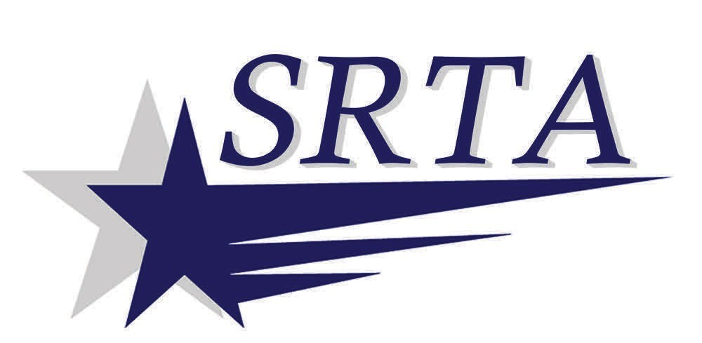

On-Request
Buttonwood Community Center

Any passengers requesting to go to Buttonwood Community Center will need to notify the Bus Operator when boarding the bus. Any passengers requesting to board bus at the Buttonwood Community Center can be made through Community Center Staff

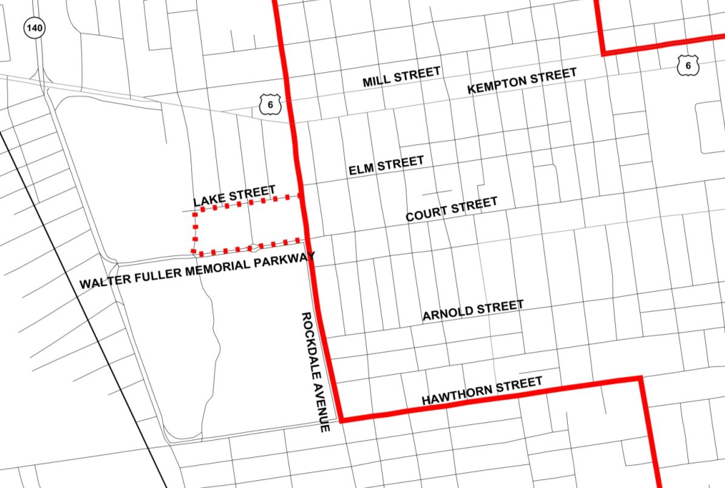

If you need further information email :

info@srtabus.com

Or call SRTA at 508-999-5211

New Bedford Route 6—Shawmut/Rockdale
Buttonwood Community Center Deviation

Si usted desea traducer esto en Español, por favor llame 508-999-5211 o maquino@srtabus.com
Se voce preferir esto traduzido em Português, por favor ligue 508-999-5211 ou maquino@srtabus.com

www.srtabus.com

