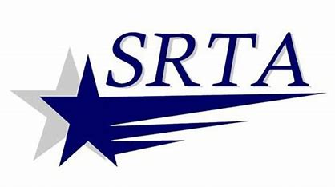
Rules for Conduct
*Drivers have the authority to ensure the safety and comfort of all passengers.

*Rude, loud, or abusive language will not be allowed

*Proper behavior is expected at all times

Objectionable persons:
SRTA has the right to refuse transportation to any persons under the influence of intoxicating beverages or drugs or to a person whose conduct or personal hygiene is such or likely to be such as to make them objectionable to other passengers.

Any questions or concerns, please contact the Customer Service Representative at
(508) 997-6767 x 3310

Revised: 10/14/2025

