Rules for Riding
- Respect fellow passengers
- Please reserve front seats for people with disabilities
- Smoking, vaping or illegal activity is prohibited on SRTA buses
- No cursing or disruptive behavior. Keep conversations quiet
- Music must be listened to with headphones
- Eating and Drinking are prohibited while riding the bus
- Shirts and shoes must be worn
- Use handrails at all times, bus makes sudden movements
- All passengers must remain behind the yellow line
- Do not cross in front of the bus after exiting
- Service and Support animals must always be under their owners’ control.
- All strollers, scooters, and shopping carts must be folded
- Bags are limited to what can be carried on in one trip
- All personal items must be stowed to NOT BLOCK isles and doorways

Any questions or concerns, please contact the Customer Service Representative at
(508) 997-6767 x 3310

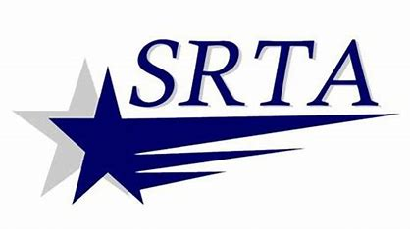
Revised: 5/6/2025

