Table of Contents
1. Executive Summary 1
1.1 Overview of SRTA Services 2
1.2 Planning Process 2
1.2.1 Review of Transit Services and Market Conditions 2
1.2.2 Scenario Planning 3
1.2.3 Public Outreach 3
1.3 Core Needs and Recommendations 3
2. Background and 2020 Context 5
2.1 Background 5
2.1.1 Governor’s Commission on the Future of Transportation 6
2.1.2 A Vision for the Future of Massachusetts’ Regional Transit Authorities 7
2.1.3 Transportation & Climate Initiative 8
2.1.4 MBTA Fare Transformation 8
2.2 2020 Context 9
2.2.1 COVID-19 Pandemic 9
2.2.2 Federal Coronavirus Aid, Relief, and Economic Security (CARES) Act 11
2.3 Plan Considerations 11
2.3.1 Transit Demand and Economic Uncertainties 11
3. Agency Overview 13
3.1 Transit Agency Background 13
3.2 Mission 15
3.3 Goals and Objectives 18
4. Transit Service Overview (FY 2015–FY 2019) 19
4.1 Description of Existing Services 19
4.1.1 SRTA Route Descriptions 22
4.1.2 Service Hours 26
4.1.3 Service Frequency 28
4.1.4 Operating Funding 29
4.2 Ridership and Service Operations 30
4.2.1 Fixed Route Service 31
4.2.2 Demand Response Service 34
4.3 Policies and Procedures 35
4.4 Regional Connections and Other Transit Providers 36
4.5 Sustainable Practices 36
4.5.1 Current Practices 37
4.5.2 Documented Needs 39
5. Market Evaluation 40
5.1 Key Demographic and Geographic Factors 40
5.2 Transit Score 49
6. Performance 51
6.1 Current Performance Measurement Practices 51
6.1.1 Monthly and Annual Performance Monitoring 52
6.1.2 Performance Metrics and Targets from MassDOT Memorandum of Understanding 55
6.1.3 How SRTA’s Market Has Been Affected by COVID-19 58
6.2 Considerations for the Next 5 Years 59
6.2.1 Principles for Data Collection and Evaluation 59
6.2.2 Additional Measures to Consider Including in Performance Reports (Technology Permitting) 59
7. Stakeholder Engagement 61
7.1 Stakeholder Survey 61
7.1.1 Survey Approach and Limitations 61
7.1.2 Limited English Proficiency 64
7.1.3 Survey Results 65
7.2 Key Takeaways 72
8. Transportation Service Needs 73
8.1 FY 2020 Service 73
8.2 Needs Identification Process 74
8.2.1 Review of Transit Services and Market Conditions 74
8.2.2 Review of Previous Studies 74
8.3 List of Identified Needs 75
8.3.1 Service Needs 76
8.3.2 Capital Needs 76
8.3.3 Performance Needs 78
8.3.4 Policy Needs 78
8.3.5 Coordination Needs 79
8.3.6 Study Needs 79
8.3.7 Other Needs 81
9. Recommendations 82
9.1 Guiding Principles 82
9.2 Performance Monitoring 83
9.3 Ridership Scenarios 83
9.3.1 High-Ridership Scenario 84
9.3.2 Medium-Ridership Scenario 84
9.3.3 Low-Ridership Scenario 85
9.4 Key Recommendations 86
9.4.1 Service Recommendations 88
9.4.2 Capital Recommendations 90
9.4.3 Performance Recommendations 92
9.4.4 Policy Recommendations 93
9.4.5 Coordination Recommendations 94
9.4.6 Studies Recommendations 96
9.4.7 Other Recommendations 98
Appendix A Fare Rates and Structure 99
Collection Methods and Media 99
Fare Policy 100
Fare Technology and Media 101
Fare Structure 101
Fixed Route Fares 102
Demand Response Fares 102
Considerations for the Next 5 Years 103
Appendix B Illustrative FY 2015–FY 2019 Performance Results and Peer Review 107
Fixed Route Service Performance 107
On-Time Performance 107
Service Effectiveness 107
ADA Demand Response Service Performance 111
Demand Response On-Time Performance 111
Demand Response Service Effectiveness 111
Financial Performance 112
Capacity 115
Customer Service 116
Safety and Security 117
Asset Management 117
Peer Evaluation 120
Appendix C Commonwealth Environmental Policies 125
Appendix D Community and Stakeholder Outreach Results 127
Survey Instrument 127
Survey Comments 135

Figures
Figure 1. Change in Transit Demand (April 15, 2020–October 12, 2020) 10
Figure 2. National Change in Annual Ridership by Year for Bus, Rail, and All Modes (1985–2020) 12
Figure 3. System Map 14
Figure 4. Operating Funding Sources (FY 2019) 15
Figure 5. SRTA Organizational Chart 16
Figure 6. South Coast Transit Management, Inc. Organizational Chart 17
Figure 7. System Map (Fall River) 20
Figure 8. System Map (New Bedford) 21
Figure 9. Annual System Ridership Trends (FY 2015–FY 2019) 30
Figure 10. Ridership Breakdown by Service Type (FY 2019) 31
Figure 11. Fixed Route Annual Ridership (FY 2015–FY 2019) 31
Figure 12. Average Daily Fixed Route Ridership by Mode and Day Type (FY 2019) 32
Figure 13. Annual Ridership by Route (FY 2019) 32
Figure 14. Annual Ridership Change by Route (FY 2014–FY 2019) 33
Figure 15. Demand Response Annual Ridership (FY 2015–FY 2019) 34
Figure 16. Average Daily Demand Response Ridership by Mode and Day Type (FY 2019) 35
Figure 17. Sample Survey Result from SRTA’s 2019 Forum 38
Figure 18. Population Density 41
Figure 19. Senior Population 42
Figure 20. Median Household Income 43
Figure 21. Population Below Poverty Level 44
Figure 22. Zero-Vehicle Households 45
Figure 23. Minority Population 46
Figure 24. Job Density 47
Figure 25. Major Trip Generators 48
Figure 26. Transit Score 50
Figure 27. SRTA Website Interactive Dashboard 54
Figure 28. SRTA Online Survey 61
Figure 29. Race/Ethnicity (2020 CRTP versus 2019 Title VI Report) 62
Figure 30. Primary Language Spoken at Home (2020 CRTP versus 2019 Title VI Report) 63
Figure 31. Survey Social Media Post 64
Figure 32. Survey Respondents’ Rider Status 66
Figure 33. Current Riders’ Reasons for Using SRTA Service 67
Figure 34. Frequency of Fixed Route Use 67
Figure 35. Respondents' Primary Trip Purpose(s) 68
Figure 36. Other Transportation Services Used in Past Year 68
Figure 37. Riders’ Preference for Longer Service Hours or More Frequent Service 70
Figure 38. Improvements that SRTA Could Make in the Next 5 years 70
Figure 39. SRTA Monthly Ridership (2017–2020) 73
Figure 40. Fare Media Usage (FY 2019) 101
Figure 41. Fixed Route Passengers per Revenue Mile by Route (FY 2019) 110
Figure 42. Fixed Route Passengers per Revenue Hour by Route (FY 2019) 110
Figure 43. On-Time Performance – Demand Response (FY 2016–FY 2019) 111
Figure 44. Farebox Recovery Ratio by Mode (2019) 114
Figure 45. Fare Media Usage by Route (FY 2019) 114
Figure 46. Percent Scheduled Trips Operated Systemwide (FY 2015–FY 2019) 115
Figure 47. Valid Complaints per 100,000 Passenger Trips – Fixed Route (FY 2015–FY 2019) 116
Figure 48. Valid Complaints per 100,000 Passenger Trips – Demand Response (FY 2015–FY 2019) 116
Figure 49. Maintenance Cost per Revenue Mile (FY 2015–FY 2019) 119
Figure 50. Miles Between Road Calls (FY 2015–FY 2019) 119
Figure 51. Preventable Accidents per 100,00 Miles (FY 2015–FY 2019) 120
Figure 52. SRTA Peer Comparison – Trips per Mile (FY 2017) 122
Figure 53. SRTA Peer Comparison – Trips per Hour (FY 2017) 122
Figure 54. SRTA Peer Comparison – Cost per Hour (FY 2017) 123
Figure 55. SRTA Peer Comparison – Cost per Passenger (FY 2017) 123
Figure 56. SRTA Peer Comparison – Subsidy per Passenger (FY 2017) 124
Figure 57. SRTA Peer Comparison – Farebox Recovery Ratio 124
Figure 58. SRTA Survey Heading 127

Tables
Table 1. Core Recommendations 4
Table 2. Statistics by Service (FY 2019) 13
Table 3. Span of Service Hours 27
Table 4. Frequency of Service (Minutes) 28
Table 5. Operating Funding Sources 29
Table 6. Annual Fixed Route Operating Statistics (FY 2015–FY 2019) 34
Table 7. Demand Response Operating Statistics (FY 2015–FY 2019) 35
Table 8. Current Demographic and Socioeconomic Profile (2017) 40
Table 9. MOU Service Effectiveness Measures 57
Table 10. MOU Financial Efficiency Measures 57
Table 11. Condition of SRTA’s Vehicles and Facilities 58
Table 12. Partner Organizations Contacted for Survey Distribution 64
Table 13. Service That Riders Would Like That SRTA Doesn't Currently Offer 71
Table 14. Review of Previous Studies 74
Table 15. Service Needs 76
Table 16. Capital Needs 77
Table 17. Performance Needs 78
Table 18. Policy Needs 78
Table 19. Coordination Needs 79
Table 20. Study Needs 80
Table 21. Other Needs 81
Table 22. Recommendations Categories 86
Table 23. Service Recommendations 88
Table 24. Capital Recommendations 90
Table 25. Performance Recommendations 92
Table 26. Policy Recommendations 93
Table 27. Coordination Recommendations 94
Table 28. Studies Recommendations 96
Table 29. Other Recommendations 98
Table 30. Fare Structure 102
Table 31. Phase 1 Reduced Fare Structure 104
Table 32. Fixed Route Productivity (FY 2018–FY 2019) 108
Table 33. Operating Statistics by Route (FY 2019) 108
Table 34. Demand Response Productivity (FY 2018–FY 2019) 111
Table 35. Fixed Route Financial Efficiency (FY 2018–FY 2019) 113
Table 36. Demand Response Financial Efficiency (FY 2018–FY 2019) 113
Table 37. Demand Response Capacity (FY 2017–FY 2019) 115
Table 38. PTASP Safety and Security Targets (Adopted December 2020) 117
Table 39. Safety and Security (FY 2019) 117
Table 40. Facility Inventory Summary 118
Table 41. Equipment Inventory Summary 118
Table 42. Peer Systems Census Data (FY 2017) 120
Table 43. Peer Systems Operating Data (FY 2017) 121
Table 44. Open Ended Survey Comments 135

Acronyms
ADA American With Disabilities Act of 1990
APC Automatic Passenger Counter
AVL Automatic Vehicle Locator
CARES Coronavirus Aid, Relief, and Economic Security Act
CCRTA Cape Cod Regional Transit Authority
CFR Code of Federal Regulations
COA Council on Aging
COVID-19 Novel Coronavirus Disease of 2019
CRTP Comprehensive Regional Transit Plan
CSA Comprehensive Service Assessment
EJ Environmental Justice
FTA Federal Transit Administration
FY Fiscal Year
GATRA Greater Attleboro Taunton Regional Transit Authority
GHG Greenhouse Gas
GWSA Global Warming Solutions Act
LBE Leading by Example
LEED Leadership in Energy and Environmental Design
LEP Limited English Proficiency
MART Montachusett Regional Transit Authority
MassDOT Massachusetts Department of Transportation
MBTA Massachusetts Bay Transportation Authority
MOU Memorandum of Understanding
MPO Metropolitan Planning Organization
NSP National Public Transportation Safety Plan
NTD National Transit Database
PPE Personal Protective Equipment
PTASP Public Transportation Agency Safety Plan
RIPTA Rhode Island Public Transit Authority
RTA Regional Transit Authority
SMMPO Southeastern Massachusetts Metropolitan Planning Organization
SRPEDD Southeastern Regional Planning and Economic Development District
SRTA Southeastern Regional Transit Authority
TAM Transit Asset Management
TCI Transportation and Climate Initiative
TCRP Transportation Cooperative Research Program
TERM Transit Economic Requirements Model
ULB Useful Life Benchmark
UMass University of Massachusetts
VOMS Vehicles Operated in Annual Maximum Service

Glossary
Access: The opportunity to reach a given destination within a certain timeframe or without significant physical, social, or economic barriers.
Accessible Vehicle: A public transportation vehicle that does not restrict access, is usable, and provides allocated space and/or priority seating for individuals who use mobility devices.
Americans with Disabilities Act (ADA): The Americans with Disabilities Act, passed in July 1991, gave direction to local transit agencies to ensure full access to transportation for persons with disabilities.
Boardings: The total number of passengers getting on a transit vehicle during a specified period of time. See also Ridership and Passenger Trip.
Capital Cost: The cost of equipment and facilities required to support transportation systems, including vehicles, radios, shelters, software, etc.
Central Transfer Point: A central meeting place where routes or zonal demand response buses intersect so that passengers may transfer. Routes are often timed to facilitate transferring and depart once passengers have had time to transfer. When all routes arrive and depart at the same time, the system is called a pulse system. The central transfer point simplifies transfers when there are many routes (particularly radial routes), several different modes, and/or paratransit zones. A downtown retail area is often an appropriate site for a central transfer point, as it is likely to be a popular destination, a place of traffic congestion and limited parking, and a place where riders are likely to feel safe waiting for the next bus. Strategic placement of the transfer point can attract riders to the system and may provide an opportunity for joint marketing promotions with local merchants.
Circulator: A bus that makes frequent trips around a small geographic area with numerous stops around the route. It is typically operated in a downtown area or area attracting tourists, where parking is limited, roads are congested, and trip generators are spread around the area. It may be operated all-day or only at times of peak demand, such as rush hour or lunchtime.
Commuter Bus Service: Transportation designed for daily, round-trip service, which accommodates a typical 8-hour, daytime work shift (e.g., an outbound trip arriving at an employment center by 8 AM, with the return trip departing after 5 PM).
Coordination: Coordination means pooling the transportation resources and activities of several agencies. The owners of transportation assets talk to each other to find ways to mutually benefit their agencies and their customers. Coordination models can range in scope from sharing information, to sharing equipment and facilities, to integrated scheduling and dispatching of services, to the provision of services by only one transportation provider (with other former providers now purchasing services). Coordination may involve human service agencies working with each other or with public transit operations.
Cost per Boarding: The total operating expenditures of a route or service divided by the number of total boardings.
Cost per Revenue Mile or Hour: The total operating expenditures of a route or service divided by the number of revenue miles or revenue hours.
Demand Response Service: Service to individuals that is activated based on passenger requests. Usually passengers call the scheduler or dispatcher and request rides for dates and times. A trip is scheduled for that passenger, which may be canceled by the passenger. Usually involves curb-to-curb or door-to-door service. Trips may be scheduled on an advanced reservation basis or in “real-time.” Usually smaller vehicles are used to provide demand response service. This type of service usually provides the highest level of service to the passenger but is the most expensive for the transit system to operate in terms of cost per trip. In rural areas with relatively high populations of elderly persons and persons with disabilities, demand response service is sometimes the most appropriate type of service. Sub-options within this service type are discussed in order of least structured to most structured, in terms of routing and scheduling.
- Pure Demand Response Service: Drivers pick up and drop off passengers at any point in the service area, based on instructions from the dispatcher. In pure demand response systems, the dispatcher combines immediate requests, reservations, and subscription service for the most efficient use of each driver’s time.
- Zonal Demand Response Service: The service area is divided into zones. Buses pick up and drop off passengers only within the assigned zone. When the drop off is in another zone, the dispatcher chooses a meeting point at the zone boundary for passenger transfer or a central transfer is used. This system ensures that a vehicle will always be within each zone when rides are requested.
- Flexibly Routed and Scheduled Services: Flexibly routed and scheduled services have some characteristics of both fixed route and demand response services. In areas where demand for travel follows certain patterns routinely, but the demand for these patterns is not high enough to warrant a fixed route, service options such as checkpoint service, point deviation, route deviation, service routes, or subscription service might be the answer. These are all examples of flexible routing and schedules, and each may help the transit system make its demand response services more efficient while still maintaining much of the flexibility of demand responsiveness.
- Microtransit: A form of demand response service, open to the general public, that requires some type of "reservation," typically made via an app-based system. Typically, microtransit uses software algorithms to completely automate the scheduling of the trip, the fare collection (if any), and the route the driver will utilize (communicating with the driver via some type of mobile data terminals).
Deviated Fixed Route Service: Transit buses travel along a predetermined alignment or path with scheduled time points at each terminal point and in some instances at key intermediate locations. Route deviation service is different than conventional fixed route bus service in that the vehicle may leave the route upon requests of passengers to be picked up or returned to destinations near the route. Following an off-route deviation, the vehicle typically returns to the point at which it left the route. Passengers may call in advance for route deviation or may access the system at predetermined route stops. The limited geographic area within which the vehicle may travel off the route is known as the route deviation corridor.
Dial-A-Ride Service: A name that is commonly used for demand response service. It is helpful in marketing the service to the community, as the meaning of “dial-a-ride” may be more self-explanatory than “demand response” to someone unfamiliar with transportation terms.
Environmental Justice: Executive Order 12898, issued in 1994, requires agencies receiving federal funds to determine whether their programs, policies, and activities will have disproportionately high and adverse human health or environmental effects on minority or low-income populations.
Express Bus Service: Express bus service characteristics include direct service from a limited number of origins to a limited number of destinations with no intermediate stops. Typically, express bus service is fixed route/fixed schedule and is used for longer distance commuter trips. The term may also refer to a bus that makes a limited number of stops, while a local bus makes many stops along the same route but as a result takes much longer.
Farebox Recovery Ratio: The percentage of operating costs covered by revenue from fares and contract revenue (total fare revenue and total contract revenue divided by the total operating cost).
Fares: Revenue from cash, tickets, and pass receipts given by passengers as payment for public transit rides.
Federal Transit Administration (FTA): An operating administration within the United States Department of Transportation that administers federal programs and provides financial assistance to public transit.
Feeder Service: Local transportation service that provides passengers with connections to a longer-distance transportation service. Like connector service, feeder service is service in which a transfer to or from another transit system, such as an intercity bus route, is the focal point or primary destination.
Fixed Route: Transportation service operated over a set route or network of routes on a regular time schedule.
Headway: The length of time between vehicles moving in the same direction on a route. Headways are called short if the time between vehicles is short and long if the time between them is long. When headways are short, the service is said to be operating at a high frequency; if headways are long, service is operating at a low frequency.
Intercity Bus Service: Regularly scheduled bus service for the public that operates with limited stops over fixed routes connecting two or more urban areas not near, that has the capacity for transporting baggage carried by passengers, and that makes meaningful connections with scheduled intercity bus service to more distant points, if such service is available. Intercity bus service may include local and regional feeder services, if those services are designed expressly to connect to the broader intercity bus network.
Interlined Routes: When fixed routes are routed through a transfer center or some other terminal location and become another route, with passengers typically allowed to ride through from one route to another without an additional fare and/or transfer fee. The “interline” is typically identified on public materials.
Operating Expenditures: The recurring costs of providing transit service (wages, salaries, fuel, oil, taxes, maintenance, insurance, marketing, etc.).
Operating Revenue: The total revenue earned by a transit agency through its transit operations. It includes passenger fares, advertising, and other revenues.
Paratransit Service: "Paratransit" means the transportation of passengers by motor vehicle or other means of conveyance by persons operating on a regular and continuing basis and the transportation or delivery of packages in conjunction with an operation having the transportation of passengers as its primary and predominant purpose and activity but excluding regular route transit. "Paratransit" includes transportation by carpool and commuter van, point deviation and route deviation services, shared-ride taxi service, dial-a-ride service, and other similar services.
Boardings per Mile or Hour: Productivity measure that takes the total boardings and divides by the miles and/or hours operated. The hours and/or miles may be presented as either total vehicle miles or hours or as revenue miles or hours.
Passenger Trip (Unlinked): Typically, one passenger trip is recorded any time a passenger boards a transportation vehicle or other conveyance used to provide transportation. “Unlinked” means that one trip is recorded each time a passenger boards a vehicle, no matter how many vehicles that passenger uses to travel from their origin to their destination.
Performance Indicator: An indicator is a metric that provides meaningful information about the condition or performance of the transportation system but is neither managed nor used to evaluate the effectiveness of policies, strategies, or investments.
Performance Measure: A performance measure is a metric that measures progress toward a goal, outcome, or objective. This definition covers metrics used to make decisions or evaluate the effectiveness or adequacy of a policy, strategy, or investment.
Performance Target: A target is a specific performance level representing the achievement of a goal, outcome, or objective.
Point Deviation Service: A type of flexible route transit service in which fixed scheduled stops (points) are established but the vehicle may follow any route needed to pick up individuals along the way if the vehicle can make it to the fixed points on schedule. This type of service usually provides access to a broader geographic area than does fixed route service but is not as flexible in scheduling options as demand response service. It is appropriate when riders change from day to day, but the same few destinations are consistently in demand. Also sometimes called checkpoint service.
Public Transportation: Transportation service that is available to any person upon payment of the fare either directly, subsidized by public policy, or through some contractual arrangement, and that cannot be reserved for the private or exclusive use of one individual or group. “Public” in this sense refers to the access to the service, not to the ownership of the system that provides the service.
Revenue Hours: The number of transit vehicle hours when passengers are being transported. Calculated by taking the total time when a vehicle is available to the public with the expectation of carrying passengers. Excludes deadhead hours, when buses are positioning but not carrying passengers, but includes recovery/layover time.
Revenue Miles: The number of transit vehicle miles when passengers are being transported. Calculated by taking the total mileage operated when a vehicle is available to the public with the expectation of carrying passengers. Excludes deadhead mileage, when buses are moving but not carrying passengers.
Ridership: The total of all unlinked passenger trips, including transfers. One trip that includes a transfer would be counted as two unlinked passenger trips.
Ridesharing: A form of transportation, other than public transit, in which more than one person shares the use of a vehicle, such as a van or car, to make a trip. Variations include carpooling or vanpooling.
Section 5304 (State Transportation and Planning Program): The section of the Federal Transit Act of 1991, as amended, that provides financial assistance to the states for purposes of planning, technical studies and assistance, demonstrations, management training, and cooperative research activities.
Section 5307 (Urbanized Area Formula Program): The section of the Federal Transit Act of 1991, as amended, that authorizes grants to public transit systems in urban areas with populations of more than 50,000 for both capital and operating projects. Based on population and density figures, these funds are distributed directly to the transit agency from the FTA.
Section 5310 (Enhanced Mobility for Seniors and Persons with Disability): The section of the Federal Transit Act of 1991, as amended, that provides grant funds for the purchase of accessible vehicles and related support equipment for private non-profit organizations to serve elderly and/or people with disabilities, public bodies that coordinate services for elderly and people with disabilities, or any public body that certifies to the state that non-profits in the area are not readily available to carry out the services.
Section 5311 (Non-urbanized Area Formula Program): The section of the Federal Transit Act of 1991, as amended, that authorizes grants to public transit systems in non-urbanized areas (fewer than 50,000 population). The funds initially go to the governor of each state.
Section 5339 (Bus and Bus Facilities): The section of the Federal Transit Act of 1991, as amended, that makes federal resources available to states and designated recipients to replace, rehabilitate, and purchase buses and related equipment and to construct bus-related facilities, including technological changes or innovations to modify low or no emission vehicles or facilities. Funding is provided through formula allocations and competitive grants. A sub-program provides competitive grants for bus and bus facility projects that support low and zero-emission vehicles.
Service Area: The geographic area that coincides with a transit system’s legal operating limits (city limits, county boundary, etc.).
Service Gaps: When certain geographic segments cannot be covered by transportation services. This term can also refer to instances where service delivery is not available to a certain group of riders, or at a specific time.
Service Span: The duration of time that service is made available or operated during the service day (e.g., 6 AM to 10 PM on weekdays).
Spare Ratio: The percentage/number of vehicles that an operator purchases in excess of the number of vehicles required to provide the maximum level of service. The spares are required so that some vehicles may cycle through a preventive maintenance regimen while the full level of planned service can still be provided.
Standard: A recommendation that leads or directs a course of action to achieve a certain goal. A standard is the expected outcome for the measure that will allow a service to be evaluated. There are two sets of transit standards.
- Service design and operating standards: Guidelines for the design of new and improved services and the operation of the transit system.
- Service performance standards: The evaluation of the performance of the existing transit system and of alternative service improvements using performance measures.
State Contract Assistance: The program through which the RTAs receive state operating funding for transit at the discretion of the Massachusetts Legislature via the state budget process annually. The total amount of state contract assistance funding provided in the state budget is allocated to the RTAs via a formula developed with RTA input.
Through Routes: When fixed routes are routed through a transfer center or some other terminal location and become another route, but – unlike interlining – passengers are not typically allowed to ride through from one route to another, as a “through-route” is typically only visible/presented on the operating schedule for bus operators and is not identified on public materials.
Title VI: Title VI of the Civil Rights Act of 1964 requires that “No person in the United States shall, on the grounds of race, color, or national origin, be excluded from participation in, be denied the benefits of, or be subjected to discrimination under any program or activity receiving federal financial assistance.”
Transportation Network Companies: Private sector companies that provide software routing, scheduling, and payment services to independent contractor drivers for a fee; these drivers then utilize their own vehicles to provide a (typically) curb-to-curb transportation service, sometimes to sole riders and sometimes to pooled groups.
Total Operating Cost: The total of all operating costs incurred during the transit system calendar year, excluding expenses associated with capital grants.
Transfer: Passengers arrive on one bus and leave on another (totally separate) bus to continue their trip. The boarding of the second vehicle is counted as an unlinked passenger trip.
Transit Dependent: A description for a population or person who does not have immediate access to a private vehicle, or because of age or health reasons cannot drive and must rely on others for transportation.
Transit Subsidy: The operating costs not covered by revenue from fares or contracts.
Trip Denial: Occurs when a trip is requested by a passenger, but the transportation provider cannot provide the service. Trip denial may happen because capacity is not available at the requested time. For ADA paratransit, a capacity denial is specifically defined as occurring if a trip cannot be accommodated within the negotiated pick-up window. Even if a trip is provided, if it is scheduled outside the +60/-60-minute window, it is considered a denial. If the passenger refused to accept a trip offered within the +60/-60-minute pick-up window, it is considered a refusal, not a capacity denial.
Volunteers: Persons who offer services to others but do not accept monetary or material compensation for the services that they provide. In some volunteer programs, the volunteers are reimbursed for their out-of-pocket expenses; for example, volunteers who drive their own cars may receive reimbursement based on miles driven for the expenses that they are assumed to have incurred, such as gasoline, repair, and insurance expenses.

Executive Summary
This 5-year Comprehensive Regional Transit Plan (CRTP) Update builds on the work of the Southeastern Regional Transit Authority (SRTA) 2014 Comprehensive Service Assessment (CSA). This update was recommended by the Task Force on Regional Transit Authority Performance and Funding in its final report issued in April 2019. The Task Force Report included 24 recommendations in 5 categories:
- Investment and Performance
- Accountability
- Service Decisions
- Quality of Service
- Environmental Sustainability
The CRTP update recommendation (No. 7) was included in the service decisions grouping. Specifically, recommendation 7 advised that, “RTAs will continue to succeed by understanding their markets and by aiming to have their service networks meet the current and future mobility needs of their region as well as support connectivity to other regions where possible. This effort will be guided by (1) the completion or updating of Comprehensive Regional Transit Plans (CRTPs) every five years…”
Following publication of the Task Force Report, a commitment to complete the CRTP update was included in SRTA’s 2-year Memorandum of Understanding (MOU) with the Massachusetts Department of Transportation (MassDOT) executed on August 14, 2019.
The primary goals of this CRTP are to (1) provide an agency and service overview, including fare structure; (2) identify essential markets, gaps in service, and ridership growth opportunities given demographic, socioeconomic, and employment data and the impacts of the novel coronavirus (COVID-19) pandemic; (3) evaluate the results of performance indicators and assess performance monitoring systems; and (4) provide recommendations for a strategic 5-year vision that will prioritize the development and implementation of a decision-making framework driven by data analysis and focused on performance.

“SRTA has switched to a Saturday Schedule as part of the response to COVID-19 as of Wednesday, March 25, 2020. Saturday service schedule will remain in place until further notice. Beginning in late February, ridership began declining daily. Since then, we have seen the steepest decline in ridership in SRTA history, a trend that is common among transit authorities across Massachusetts and the USA.”– SRTA website, March 25, 2020
The SRTA CRTP update started in December 2019 but took a profound and unexpected turn mid-way through the project. Following the kick-off meeting in January 2020, the process proceeded with data collection, goal development, and planning for community and rider engagement. However, by the middle of March 2020, when the engagement activities were scheduled to commence, the world experienced a historic pause due to the COVID-19 pandemic.
In response to the pandemic, on March 10, 2020, Governor Baker declared a state of emergency and subsequently issued a stay-at-home order on March 23, 2020, closing all non-essential businesses. These safety measures, issued in the face of an unprecedented threat to public health, had serious, sweeping impacts, including on the development of this plan and transit operations writ large. SRTA, along with the other Regional Transit Authorities (RTAs), reduced service levels, encouraging non-essential riders to temporarily discontinue travel.
While SRTA continues its return to normal service in accordance with public health guidelines, ridership is still depressed due to pandemic impacts such as distance learning, business closures and capacity limitations, remote work, furloughs, layoffs, and reluctance to use public transportation due to health safety concerns. In response to continued ridership volatility, this CRTP acknowledges that there will be many uncertainties and challenges over the coming months and years and equips SRTA with data-driven and performance-focused recommendations so that the Authority will be able to adapt quickly to a volatile transit market and ensure success.

Overview of SRTA Services
SRTA is headquartered in New Bedford, Massachusetts and is 1 of the 15 RTAs that, along with the Massachusetts Bay Transportation Authority (MBTA), operates public transportation in the Commonwealth. SRTA provides fixed route and demand response service to 10 communities on Massachusetts’ South Coast. SRTA’s service area features two gateway cities (Fall River and New Bedford) that act as individual hub-and-spoke systems connected by a single route. SRTA offers a robust level of service with 25 routes largely split between the two cities. Beyond the two hubs, there is limited fixed route service in the surrounding communities.
SRTA also provides American With Disabilities Act (ADA) demand response service to all 10 communities in the service area and to communities located along a route operated jointly with the Greater Attleboro-Taunton Regional Transit Authority (GATRA). Fall River and New Bedford will soon be connected to Boston via commuter rail, with the launch of South Coast Rail, which is slated for 2023.
The fixed route and demand response service runs Monday through Saturday. On Saturdays SRTA operates a slightly reduced schedule, with all routes operating with the exception of the Boston Hospital Shuttle. There is no Sunday service, although demand response service operates from 9:00 AM to 6:00 PM.
SRTA has implemented a variety of service improvements over the last 5 years that support efforts to improve the customer experience and inform service improvements by better tracking system performance. Improvements include:
- Recent implementation of an automatic vehicle locator (AVL) system for SRTA’s fleet
- Addition of an interactive performance dashboard to SRTA’s website
- Launch of the Wareham-New Bedford Connection as part of a partnership with GATRA

Planning Process
The impacts and limitations imposed by the COVID-19 pandemic required flexibility in the approach for developing this 5-year plan. While some elements of the original process developed pre-pandemic remained viable, many had to be adapted to respond to the new realities of COVID-19. From public outreach to the structure of the recommendations, this planning process incorporates considerations relating to uncertainty around how the future might unfold.

Review of Transit Services and Market Conditions
A review of service from the last 5 years and market demand analysis were conducted to identify performance trends as well as gaps and needs in SRTA’s service area. The analysis overall indicated that SRTA’s service is efficient, performing better than national peers with regard to both cost of service and passengers transported, and that service is provided to areas where demographic data indicate demand is highest.
However, safety measures like remote learning and teleworking, along with furloughs and lay-offs, greatly disrupted SRTA’s existing ridership patterns, making it difficult to infer future transit demand from past performance. This planning process brought to light the importance of harnessing new technology to conduct ongoing analysis of real-time data rather than focusing primarily on historical trends.

Scenario Planning
The project team used scenario planning exercises to imagine what the next 5 years might hold in terms of ridership and market demand. Two months after the state of emergency was issued, SRTA leadership participated in an hour-long workshop with the consultant team centered around key uncertainties in the face of the COVID-19 pandemic. After that workshop, a high-ridership scenario (a return to 86 percent of pre-pandemic ridership), medium-ridership scenario (60 to 85 percent of pre-pandemic ridership), and low-ridership scenario (below 60 percent of pre-pandemic ridership) were developed to inform the development of needs and recommendations. These scenarios formed the framework of the recommendations in this plan.

Public Outreach
Due to social distancing guidelines and other safety protocols resulting from the COVID-19 pandemic, no in-person outreach could be conducted. The bulk of the outreach for this CRTP was undertaken through an online stakeholder outreach survey conducted in early summer 2020.

“I feel safe riding the buses there are nice drivers for SRTA” – 2020 Rider Survey Comment
Three hundred and seventeen survey responses were collect using the online survey. The findings are not a statistically valid sample of SRTA riders or the region’s residents and should be used as a guide in the context of other public outreach and data analysis. Nonetheless, key takeaways that comport with other planning efforts include:
- The majority of riders used the service due to a lack of car and the low cost of the fares, suggesting a strong customer base among those who ride for economic reasons and do not have alternative means of traveling.
- The majority of SRTA riders used ride hailing services. In the year before the survey, 50 percent of respondents answered they had used Uber or Lyft and 55 percent answered they had used taxi service.
- The majority of SRTA riders thought that additional service should be the top priority, such as expanded hours (42 percent) and Sunday service (23 percent).

Core Needs and Recommendations
SRTA identified 17 core recommendations that directly respond to the needs and requests articulated by the public, key stakeholders, as well as those identified through data analysis and review of prior planning efforts. Table 1 lists core recommendations that SRTA will pursue in the next 5 years, regardless of ridership levels. The full list can be found in Chapter 9.
Table 1. Core Recommendations
Recommendation
Plan for expanded service on Church Street with the implementation of South Coast Rail.
Pursue mobile fare payment options.
Pursue funding for bus stop capital improvements such as new shelters, benches, and ADA improvements as opportunities arise.
Pursue grant funding for engineering and design for an upgraded or new terminal in New Bedford (pending finalization of feasibility study).
Address aging fleet through the procurement of 25 buses as funding becomes available.
Work with the Metropolitan Planning Organization (MPO) to undertake future transit signal prioritization planning on congested corridors.
Explore options for offering online trip booking, mobile fare payment, and mobile/online "where's my ride" tracking.
Undertake a comprehensive evaluation on understanding revenue sources and affordability issues with the ridership market on the South Coast and the best fare methods for that market.
Continue coordination with MBTA and MassDOT regarding South Coast Rail developments.
Coordinate with MassHealth regarding efficient and effective transportation for non-emergency medical transportation (NEMT) purposes.
Undertake a study looking at potential sites for a new Fall River Maintenance Facility.
Pursue opportunities for partnership with the Department of Transitional Assistance to maximize transportation efficiency.
Evaluate the mobility needs of the customers and invest in modes that best serve their needs.
Pursue new communications platforms such as social media, multimedia information, and more frequent interactions with local news outlets. Consider additional staff capacity to focus on communications.
Pursue opportunities for shifting trips from single occupancy vehicles to transit.
Explore the possibility of adding solar panels above bus parking areas.
Expand travel training capacity for residents of the SRTA service area.

Background and 2020 Context
The 15 RTAs provide vital mobility options and lifeline services to the millions of people across the Commonwealth outside of the Greater Boston region. The 2020 CRTP update process for the RTAs, funded by MassDOT, came out of Commonwealth-wide initiatives in 2018 and 2019, which prompted this plan update, most of which were last developed in 2015. The CRTP updates are both a result of and a contributor to the ongoing discussions on regional transportation. Recent and ongoing initiatives include the following:
- Governor’s Commission on the Future of Transportation
- A Vision for the Future of Massachusetts’ Regional Transit Authorities (RTA Task Force)
- Transportation & Climate Initiative
- MBTA Fare Transformation
The RTA Task Force Final Report Recommendation No. 7 was a primary driver for the development of this CRTP. The CRTP is carried out as a commitment to SRTA’s 2-year MOU with MassDOT signed in August 2019. In addition to the CRTP update, the MOU also contained commitments on performance metrics and targets, maintaining an up-to-date asset inventory, submitting a fare policy by December 2020, submitting a balanced budget annually, and reporting timelines. The SRTA MOU is discussed in more detail in Chapter 6.
The SRTA CRTP update process started in December 2019 but took a profound and unexpected turn mid-way through the project. Following the kick-off meeting in January 2020, the process proceeded with data collection, goal development, and planning for community and rider engagement. However, by the middle of March 2020, when the engagement activities were scheduled to commence, the world experienced a historic pause due to the COVID-19 pandemic.
In response to the pandemic, on March 10, 2020, Governor Baker declared a state of emergency and subsequently issued a stay-at-home order on March 23. The stay-at-home order, originally intended for two weeks, ended up lasting until May 18, 2020. As of the finalization of this plan in early 2021, the pandemic continues to disrupt services and negatively impact transit ridership. Given the unprecedented nature of this disruption and unknown long-term economic, social, and public health implications, the next few years will likely see continued widespread societal change. Therefore, transit agencies especially will need to continue to build a data-driven and performance-focused decision-making framework to respond to these uncertain demographic and industry trends.
This chapter provides background and current context around the CRTP update process for all RTAs. SRTA-specific contextual information is included in Sections 2.2 and 2.3.

Background
Commonwealth-wide initiatives, organized generally around the themes of climate change, new technology, and providing affordable and convenient transportation options for all people, set the stage for the CRTP update process. The RTAs play an important role in getting people across the diverse regions of the Commonwealth to work, to school, and to essential services. Because of this role, the RTAs are pivotal in improving the public’s mobility options as explored through the Commonwealth-wide initiatives described in this section.

Governor’s Commission on the Future of Transportation
Established by Executive Order in January 2018, the Governor’s Commission on the Future of Transportation (the Commission) was convened to explore the following topics across the Commonwealth and their impact on transportation between 2020 and 2040:
- Climate and Resiliency
- Transportation Electrification
- Autonomous and Connected Vehicles
- Transit and Mobility Services
- Land Use and Demographics
The Commission completed its work and released findings in December 2018 in a report entitled Choices for Stewardship: Recommendations to Meet the Transportation Future. Findings from the report included:
- The Commonwealth is expected to grow by 600,000 residents by 2040 and job growth is also expected to continue.
- Commonwealth residents are on average older than in many other US states, and older adults are expected to comprise a larger portion of the population in the future.
- As with the national trend, transit ridership has been declining in recent years.
- Use of transportation network companies has increased dramatically in recent years.
- Connected and autonomous vehicles are expected to radically change transportation and mobility in the future.
- The impacts of climate change are happening sooner and more intensely than originally projected with significant implications by 2040.
- Transportation in the Commonwealth accounts for 40 percent of all greenhouse gas (GHG) emissions.
- Electric vehicles could be part of the solution to reducing transportation emissions but would require significant infrastructure to implement.
The Commission used a scenario planning approach to itemize recommendations to prepare the Commonwealth’s transportation system for the future. While many trends were evaluated for use in the scenario planning exercise, technology adoption as well as jobs and housing distribution were chosen as the two major trends that will most likely shape people’s mobility options and needs. Based on the scenario planning trend analysis, the Commission then identified key challenges facing the Commonwealth’s transportation system and developed recommendations across five categories to prioritize improvements over the next 20 years:
- Modernize existing state and municipal transit and transportation assets to more effectively and sustainably move more people throughout a growing Commonwealth.
- Create a 21st century “mobility infrastructure” that will prepare the Commonwealth and its municipalities to capitalize on emerging changes in transportation technology and behavior.
- Substantially reduce GHG emissions from the transportation sector in order to meet the Commonwealth’s Global Warming Solutions Act (GWSA) commitments, while also accelerating efforts to make transportation infrastructure resilient to a changing climate.
- Coordinate and modernize land use, economic development, housing, and transportation policies and investment in order to support resilient and dynamic regions and communities throughout the Commonwealth.
- Make changes to current transportation governance and financial structures in order to better position Massachusetts for the transportation system that it needs in the coming years and decades.
Within these five categories are a total of 18 recommendations on how to best prepare the Commonwealth’s transportation network for challenges and opportunities through 2040. The recommendations will guide Commonwealth-wide systems, specific solutions, and transportation investments, and will have a profound impact on the RTAs over the next 20 years.

A Vision for the Future of Massachusetts’ Regional Transit Authorities
Resulting from the Governor’s Commission on the Future of Transportation initiative and directed by Outside Section 72 of the FY 2019 Massachusetts State Budget, a Task Force on Regional Transit Authority Performance and Funding was established in the fall of 2018. The Task Force issued a final report entitled A Vision for the Future of Massachusetts’ Regional Transit Authorities: Report of the Task Force on Regional Transit Authority Performance and Funding in April 2019.
The report built on the first recommendation from the Commission, “Prioritize investment in public transit as the foundation of a robust, reliable, clean, and efficient transportation system.” It set forth a path to stabilize, modernize, and improve the RTAs through five categories of action: Investment and Performance, Accountability, Service Decisions, Quality of Service, and Environmental Sustainability.
From those five categories, several goals related to the CRTP emerged:
- Sign a mutually negotiated MOU with MassDOT on a plan for performance monitoring and development of performance targets.
- Complete the CRTP and update every 5 years.
- Identify and evaluate demonstrated community need for evening and 7-day service.
- Identify and evaluate appropriate transit services and potential partnerships based on level of demand and efficiency.
- Develop pilot programs for innovative delivery models.
- Increase regional collaboration, including cross-RTA services.
- Collaborate with municipalities to provide safe walking and bicycle access to transit and comfortable, safe bus stops.
- Conduct a fare equity analysis every 3 years.
- Collaborate with the MBTA Fare Transformation process and adopt the proposed system.
- Participate in the Massachusetts Environmental Policy Act process.
- Maximize multimodal connectivity.
- Maintain an easily accessible website and robust social media presence.
- Collaborate with MassDOT and MBTA to integrate information services.
- Employ intentional outreach strategies.
- Purchase all zero-emission public buses by 2035.
Many of these goals are addressed and/or discussed as part of this CRTP.

Transportation & Climate Initiative
Massachusetts is a participating state in the Transportation & Climate Initiative of the Northeast and Mid-Atlantic States:
The Transportation and Climate Initiative (TCI) is a regional collaboration of Northeast and Mid-Atlantic states and the District of Columbia that seeks to improve transportation, develop the clean energy economy, and reduce carbon emissions from the transportation sector. The participating states are Connecticut, Delaware, Maine, Maryland, Massachusetts, New Jersey, New York, Pennsylvania, Rhode Island, Vermont, and Virginia, as well as the District of Columbia.
The initiative builds on the region's strong leadership and commitment to energy efficiency and clean energy issues, and its programs to reduce carbon emissions in the power sector, which have resulted in the region becoming one of the most energy efficient areas in the nation. At the same time, the effort underscores the sense of urgency shared by all 12 jurisdictions, and their collective aspirations to become the leading region for sustainability and clean energy deployment in the country.
While the COVID-19 pandemic temporarily reduced congestion and associated pollution in the short-term, it has likely altered commuting patterns and housing choice in the long-term, which has environmental and sustainability implications. As such, the need to reduce carbon emissions from the transportation sector is just as important as it was before the COVID-19 pandemic. Additionally, the COVID-19 pandemic highlighted racial disparities in exposure to air pollution and disproportionate impacts of threats to public health. To that end, the TCI jurisdictions are collaborating to develop a low-carbon transportation program that advances equity.
The TCI jurisdictions are collaborating to develop a regional agreement to cap pollution from transportation fuels and invest in solutions that result in reduced emissions, cleaner transportation, healthier communities, and more resilient infrastructure. Massachusetts TCI participation will likely impact the RTAs in several ways, including vehicles, infrastructure, technology, and funding.
In December 2020, Massachusetts joined with Connecticut, Rhode Island, and the District of Columbia to be the first jurisdictions to launch a multi-state program to reduce pollution and invest $300 million per year in cleaner transportation choices and healthier communities.

MBTA Fare Transformation
Because several RTAs are located adjacent to and/or connect with MBTA services, many use MBTA’s Scheidt & Bachmann CharlieCard/CharlieTicket fare media. SRTA is one of those participating authorities and could be impacted by MBTA’s efforts to modernize their fare payment system (“Fare Transformation”) using mobile fare payment platforms and other new technologies. One of the key goals of Fare Transformation is reducing the use of cash on board transit vehicles (which is also an interest of SRTA, as discussed in Appendix A).

2020 Context
The year 2020 unfolded in a radically different manner than was anticipated. Because of the COVID-19 pandemic and the as-yet-unknown ways that the pandemic and its aftermath will permanently alter how, when, and where people travel, the CRTP update process had to be flexible and SRTA will need to continue being nimble, data-driven, and performance-focused in responding to an uncertain future. To that end, it will be critical for SRTA to continue utilizing and expanding its data-driven and performance-focused decision-making and management framework to lean into and respond to the rapid changes that are expected to continue to impact the future of the transit industry. This data-driven and performance-focused approach will position SRTA for continued success.

COVID-19 Pandemic
Impacts to the transit industry from the COVID-19 pandemic included the following:
- Reduction of service due to diminished driver availability, social distancing requirements and associated capacity constraints on transit vehicles, and reduced demand
- Loss of ridership due to business closures/disruptions, remote working and learning, increased popularity of online shopping and telemedicine due to safety concerns, and stay-at-home orders and advisories that have depressed demand for discretionary student and work trips
- Temporary suspension of fare collection or fare collection enforcement along with rear-door boarding
- Implementation of employee protection measures, such as plexiglass shields and distribution of personal protective equipment (PPE)
- New rigorous public space cleaning protocols and the removal of seats and tables from transit facilities to discourage congregation
As a result of these impacts, ridership on systems across the country initially declined by up to 80 percent and has been rebounding slowly (Figure 1).
Figure 1. Change in Transit Demand (April 15, 2020–October 12, 2020)
Source: Transit App
In the early months of the pandemic, SRTA, like transit agencies nationwide, experienced a dramatic drop in ridership – SRTA’s April 2020 ridership saw a decline of 72 percent from the previous year. SRTA reduced their service in response, making the following modifications:
- Fixed routes and demand response service operated on a Saturday schedule.
- Boston Hospital service was suspended.
On top of working quickly to adjust their service levels, SRTA also implemented the following safety measures as a result of the COVID-19 pandemic:
- Drivers were supplied with PPE.
- SRTA required all customers to wear masks and provided masks to those who didn’t have one.
- SRTA discouraged all but essential trips.
- SRTA implemented rear door boarding and suspended fare collection enforcement.
- All vehicles and terminals were cleaned daily.
By the fall of 2020, SRTA’s ridership had rebounded, closing the gap from a 72 percent decline in April 2020 to a 43 percent decline in August 2020 ridership compared to August 2019. SRTA had returned service to nearly pre-pandemic levels and focused on maximizing service to high-demand locations like the New Bedford Market Basket, Dartmouth Mall, St. Luke’s Hospital, and Fall River Industrial Park. The following service changes are in place as of October 2020:
- Weekday service was restored to all Fall River and New Bedford routes. Fall River Routes 6 and 9 and New Bedford Routes 3, 5, and 6 have been realigned to better allocate service.
- New Bedford Route 8 no longer has evening service.
- Service on the New Bedford-Wareham Connection has resumed.
- Boston Hospital service remains suspended.
Additionally, SRTA has enacted the following policies to meet state guidelines and maintain a safe environment for customers and drivers:
- Masks are required on SRTA vehicles. SRTA distributes masks to customers who do not have one.
- Fare collection enforcement remains suspended as SRTA works toward identifying a cash-free and/or touchless fare payment system.
- Signage has been added to vehicles to remind passengers of social distancing protocols.
- All vehicles and terminals are cleaned daily.

Federal Coronavirus Aid, Relief, and Economic Security (CARES) Act
SRTA has been able to continue to mitigate the financial impacts of the pandemic through funding from the federal Coronavirus Aid, Relief, and Economic Security (CARES) Act. The CARES Act has provided operating and capital funds for public transportation to mitigate lost revenue due to severe ridership decline, the suspension of fare collection enforcement, the implementation of cleaning and protection protocols, etc. The funding has been provided through the Federal Transit Administration (FTA) Section 5307 (urbanized area) and Section 5311 (rural areas) programs. For the RTAs, a total of $213.4 million was apportioned through the CARES Act with $22,499,317 provided to SRTA.

Plan Considerations
Given all the previous work that led to the development of the CRTP and the unprecedented, transformational conditions during which the CRTP was developed, the CRTP update process necessarily evolved through 2020. Considerations included the following:
- The 5-year period prior to the 2020 pandemic year, fiscal year (FY) 2015 to FY 2019, was considered for recent historical trend analysis to understand how the systems were operating prior to the pandemic and to provide a baseline for understanding the market for transit service in each community.
- Rider, community, public, and stakeholder outreach was primarily conducted online. As with all transit planning processes, outreach is one component of many that go into the identification of needs, solutions, and recommendations.

Transit Demand and Economic Uncertainties
Notwithstanding COVID-19 pandemic-related disruptions, for many years, transit ridership has been stagnant or declining nationally (Figure 2). This trend has accelerated in the past few years, with most systems – and bus transit in particular – experiencing steady declines in ridership, despite a historically good economy. The American Public Transportation Association attributes the decline to four broad categories: erosion of time competitiveness, reduced affinity, erosion of cost competitiveness, and external factors. The erosion of time competitiveness is related to increasing traffic congestion and competing uses of street and curb space. Reduction in affinity refers to more competition for customer loyalty and the erosion of cost competitiveness has to do with increasing costs without corresponding increase in demand for the service. And, finally, external factors are both the most challenging to define and to mitigate and include such things as policy changes that could improve transit usage but are too far-reaching for a transit agency alone to tackle.
Figure 2. National Change in Annual Ridership by Year for Bus, Rail, and All Modes (1985–2020)
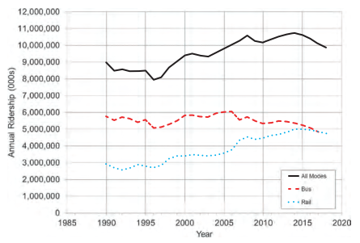
Source: TCRP Research Report 209, Analysis of Recent Public Transit Ridership Trends
It is uncertain whether the pre-pandemic downward trends in transit ridership in recent years combined with the pandemic’s negative impact on transit ridership to become a longer-term pattern that will continue to depress transit usage. Pandemic trends potentially most impactful to SRTA include the increase in remote work and distance learning. Those trends could significantly impact the workforce and student ridership markets for commuter and express services as well as local routes that serve colleges and universities.
For all transit systems, including SRTA, public concern about the health impacts of shared ride services will remain a challenge. While public transit has instituted facial covering requirements, cleaning protocols, social distancing, and other mitigation measures, systems will also have to continue to reassure riders about the public health and safety of their services.
To monitor and lean into these trends and position the Authority for success, it will be critical for SRTA to use data tools to routinely analyze key system performance metrics and make service and financial decisions within the context of a performance-focused framework.

Agency Overview
Each of the Commonwealth’s 15 RTAs operates in a unique context serving different geographic regions and mixes of urban, suburban, and rural communities and providing service tailored to the needs of their riders. This chapter provides an overview of SRTA that establishes context for the findings contained in this CRTP.

Transit Agency Background
Established in 1974 to provide public transportation services to southeastern Massachusetts, SRTA provides fixed route and demand response services to 10 communities on Massachusetts’ South Coast. These communities include Acushnet, Dartmouth, Fairhaven, Fall River, Freetown, Mattapoisett, New Bedford, Somerset, Swansea, and Westport. In 2019, SRTA carried over 2.7 million passengers, traveling approximately 110,000 miles and nearly 2.6 million hours with an operating budget of nearly $18.8 million (Table 2).
SRTA’s service area features two gateway cities (Fall River and New Bedford) that act as individual hub-and-spoke systems connected by a single route (Figure 3). SRTA offers a robust level of service with 25 routes largely split between the two cities. These routes are a combination of historical transit corridors and newer corridors serving specific large employer hot spots like University of Massachusetts at Dartmouth (UMass Dartmouth). Beyond the two hubs, there is limited fixed route service in the surrounding communities. SRTA also provides demand response service to qualified people with disabilities to these 10 communities and to communities located along a route operated jointly with GATRA, the New Bedford Wareham Shuttle. Since the latter is funded by GATRA, the Shuttle is not included in this report.
The fixed route and demand response service runs Monday through Saturday. On Saturdays SRTA operates a reduced schedule. There is no Sunday fixed route service, although demand response service operates from 9:00 AM to 6:00 PM. Nearly all routes have weekday and Saturday service with the exception of trips that provide publicly available service to public schools (or “school trippers”) and the Boston Hospital Shuttle.
Table 2. Statistics by Service (FY 2019)
FY 2019 Data | Fixed Route | % of Total | Demand Response | % of Total | Total
Ridership | 2,666,225 | 96.9% | 82,500 | 3.0% | 2,748,725
Revenue Miles | 1,570,714 | 73.3% | 571,266 | 26.7% | 2,141,980
Revenue Hours | 110,316 | 46.8% | 125,189 | 53.2% | 235,505
Source: SRTA

Figure 3. System Map
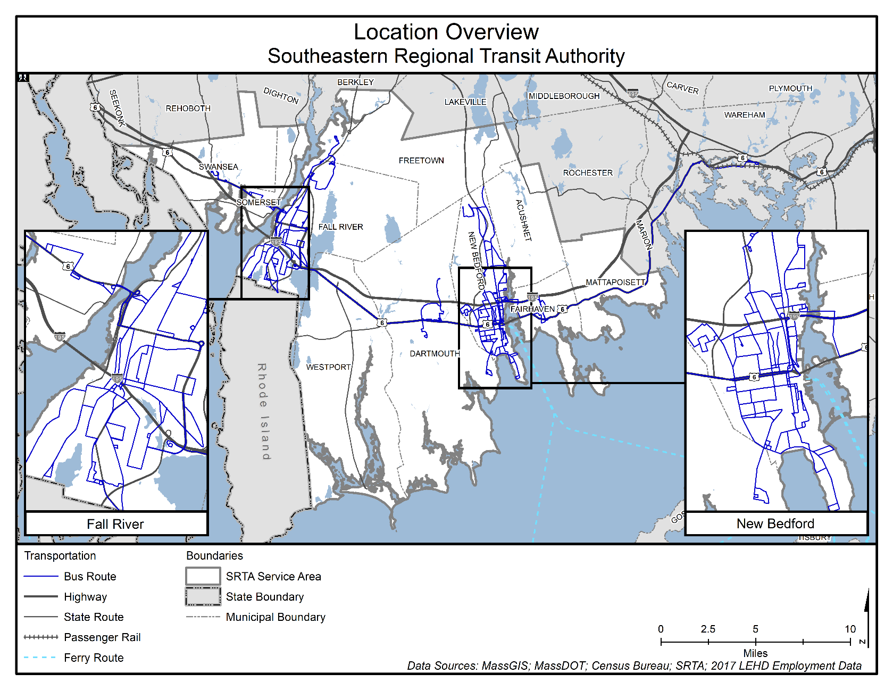
Source: SRTA

Federal (37.4 percent) and state (30.7 percent) funding provide the majority of SRTA’s operating budget, each comprising roughly one-third of total operating revenues (Figure 4). Local assessments comprise around 17 percent of operating funding and farebox revenues (13 percent); the remainder is derived from other sources of funding such as advertising revenue.
Figure 4. Operating Funding Sources (FY 2019)

Source: SRTA
SRTA’s organizational structure (Figure 5) includes an Advisory Board made up 12 voting members, composed of one member from each community in the service area, one community member with a disability, and one member of the riding population. The Advisory Board is responsible for hiring the Administrator, passing the annual budget, and performing other duties as outlined in state law and Advisory Board bylaws. The Administrator is responsible for day-to-day administration of the agency, which has five full-time and two part-time staff members. According to the Commonwealth of Massachusetts statute, RTAs are prohibited from operating service directly, and instead must contract with private operators for the provision of service. SRTA contracts its fixed route and demand response services with South Coast Transit Management, Inc. (Figure 6).

Mission
Recognizing its commitment to the 10 cities and towns in its service area, SRTA has the following mission statement:
“The SRTA’s mission is to provide safe, convenient, and economical transportation opportunities for people that supports economic development and improved quality of life for South Coast residents.”

Figure 5. SRTA Organizational Chart
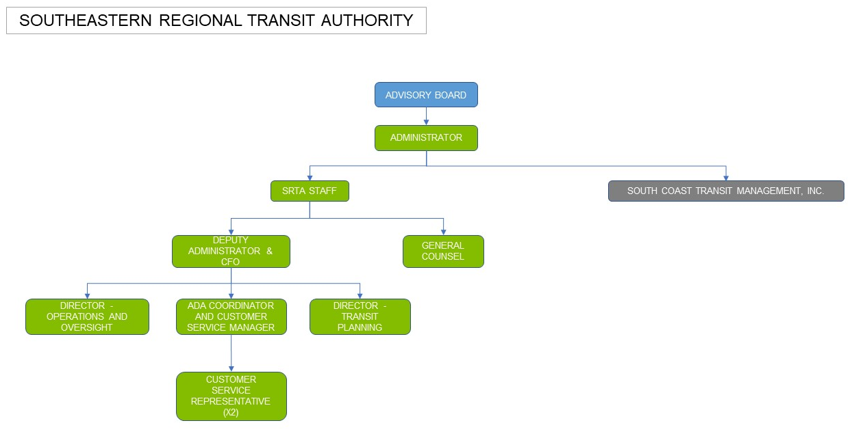

Figure 6. South Coast Transit Management, Inc. Organizational Chart
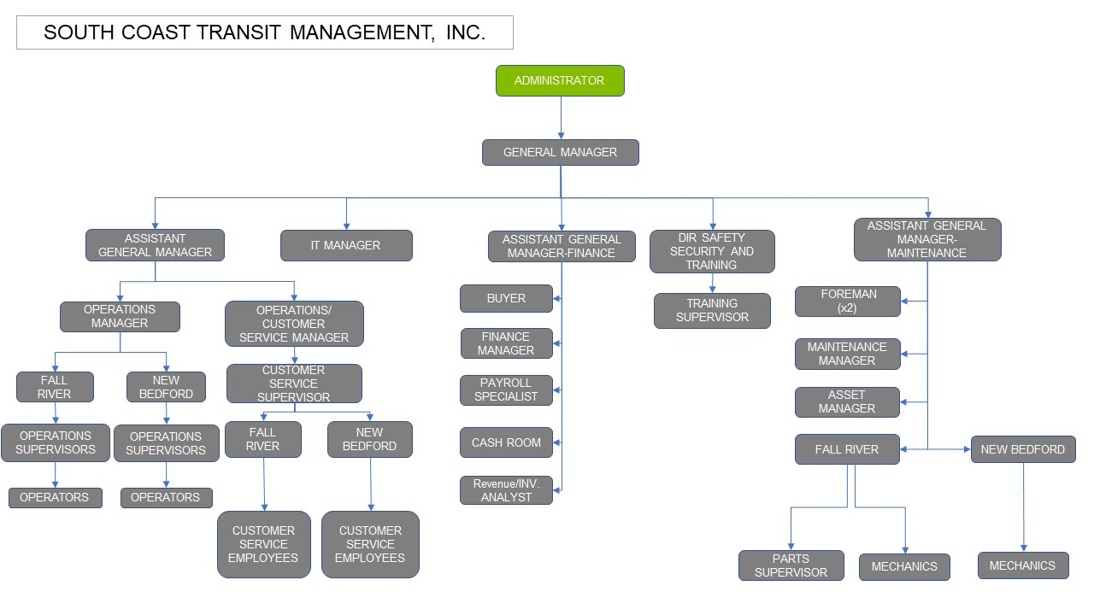

Goals and Objectives
The 5-year CRTP update is an opportunity for SRTA and its stakeholders to direct its future course. Goal setting is an iterative process where SRTA takes stock of the completed and outstanding goals from previous plans and creates new goals. In consultation with members of the community, local and state leaders, past plans, and other stakeholders, the following are the goals and objectives for the coming 5 years:
- Increase service hours and/or coverage to major destinations (New Bedford Business Park, seafood processing plants, Dartmouth employment, Bristol Community College in the evening for night classes).
- Form partnerships with private partners.
- Move away from cash fares.
- Increase technology assets.
- Prepare for the expansion of South Coast Rail and associated new New Bedford Terminal.
- Enhance communications.
- Increase overall performance and efficiency.

Transit Service Overview (FY 2015–FY 2019)
The 2014 CSA served as a blueprint for SRTA service improvements between 2014 and 2020. Many of the recommended service improvements have since been implemented along with several additional improvements that helped grow fixed route system ridership from 2.36 million trips in FY 2014 to 2.67 million in FY 2019. The improvements include:
- Decreasing weekday headways on the New Bedford Route 9 – New Bedford/Fall River Intercity from 60 minutes to 30 minutes.
- Adding night service to the Fall River Route 5 – Stafford Road, New Bedford Route 8 – Mt. Pleasant Street, and New Bedford Route 11 – Fairhaven.
- Partnering with Atlantis Charter School to extend service on Fall River Route 5 – Stafford Road and Fall River Route 10 – Rodman Street.
- Establishing a fare reimbursement partnership with the UMass Dartmouth that provides students with fare-free boardings paid for by the university.
- Partnering with GATRA to operate service between New Bedford and Wareham.
- Establishing a terminal use agreement with the Rhode Island Public Transit Authority (RIPTA) to include the Fall River terminal as a stop on the commuter express service between Newport, Rhode Island and Providence, Rhode Island.
Individually, these service enhancements have made transit a much more viable form of transportation for South Coast residents. Collectively, they demonstrate the pent-up demand for transit among SRTA communities and that a mode shift can be achieved with thoughtful planning and a customer-focused approach to service delivery.

Description of Existing Services
SRTA’s system has been characterized as a “bicycle,” with two separate hub-and-spoke systems in Fall River and New Bedford connected via service along US Route 6. Fixed route service is concentrated in these two main urban centers, with limited fixed route service to surrounding communities. SRTA provides demand response service to all 10 communities, as well as the ¾ mile buffer around a route operated jointly with GATRA.
SRTA operates 25 routes largely split between the two hubs in Fall River and New Bedford (Figure 7 and Figure 8). The routes include 22 fixed routes (with four school trippers) and two shuttles.
Figure 7. System Map (Fall River)
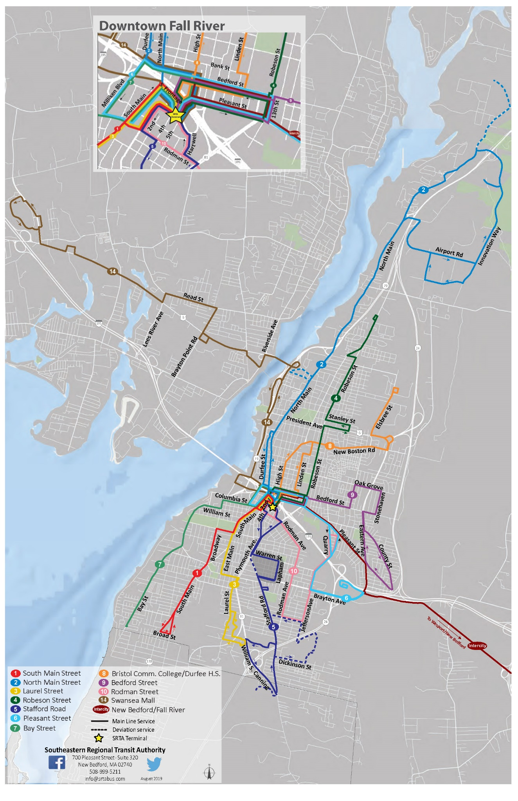
Source: SRTA, Southeastern Regional Planning and Economic Development District (SRPEDD)
Figure 8. System Map (New Bedford)
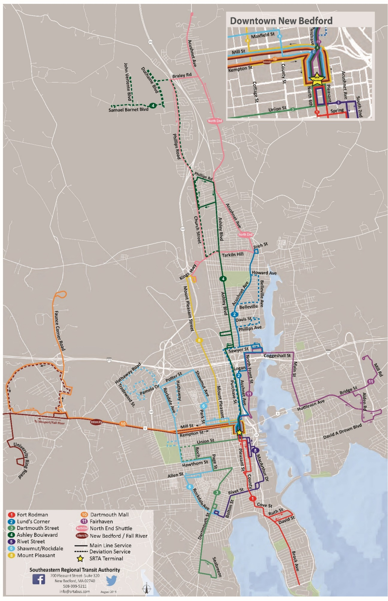
Source: SRTA, SRPEDD (dotted lines are deviated fixed route)

SRTA Route Descriptions
In general, SRTA routes connect the outlying communities with the two main cities in the service area (New Bedford and Fall River) and provide a connection between the two cities via the New Bedford to Fall River Intercity Route. Many of these routes operate along corridors that have been served for decades by public transportation (first streetcars and now buses), while others were developed to serve newer destinations and outlying large employers like UMass Dartmouth. As of the drafting of this report, SRTA had made a number of long-term (possibly permanent) service changes in response to the COVID-19 pandemic.

Fall River

Fall River Route 1 – South Main Street
This route serves as the primary transit artery for the south side of the SRTA Fall River division. The major generators served are multiple health care providers including St. Anne’s Hospital (the largest employer along the route) and a Save A Lot grocery store. This route is regularly used to access the south side of Fall River as well as the hospital. Most of the route serves environmental justice areas with housing complexes for low-income and older adults along the route.

Fall River Route 2 – North Main Street
Traveling the length of North Main Street, Route 2 serves as the primary transit artery for the north side of the SRTA Fall River division. This route serves multiple apartment and condominium complexes in the north end of the city and various employment hubs, including Amazon and Stop & Shop distribution centers (one trip daily); it is the only route that serves the Fall River Industrial Park. Route 2 also serves several social service providers, including the Department of Transitional Assistance as well as multiple elementary schools and childcare facilities. It is also the primary route to serve the waterfront Priority Redevelopment Area. The majority of Route 2 serves areas of low population density where most residents have access to a vehicle.
Route updates since 2014 CSA: Route was extended to serve the Amazon Fulfillment Center and Stop & Shop Facility in Freetown.

Fall River Route 3 – Laurel Street
Route 3 serves as another major connection to the southern side of Fall River. It serves various health care providers, shopping plazas, and apartment complexes. The major generators served are St. Anne’s Hospital, Stop & Shop, and Fall River Shopping Center. The end of the line for Route 3 is a shopping plaza with Ocean State Job Lot and Aldi supermarket and is adjacent to the South Coast Marketplace. Route 3 serves a mixed area of high and low population density; higher density housing developments are located along the route. The entirety of Route 3 serves limited English proficiency (LEP) tracts, and the majority of the route serves minority and low-income areas.

Fall River Route 4 – Robeson Street
Route 4 is the only other route (besides Routes 2 and 8) to serve northern Fall River. The route serves an area with a high concentration of social services. Route 4 is the only route to serve the Highlands area, Truesdale Clinic, and SStar Treatment Center. It travels near Charlton Memorial Hospital and Durfee High School. It also serves multiple housing complexes (including senior housing) and medical facilities and terminates at the Catholic Memorial Home.

Fall River Route 5 – Stafford Road
Route 5 serves the South Coast Marketplace as well as the Seabra Shopping Plaza, a health care facility, and other retail establishments. The route serves the plaza across from South Coast Marketplace, which has an Ocean State Job Lot and Aldi supermarket where it also intersects with Route 3. Route 5 serves densely populated neighborhoods of minority and low-income persons and serves a low-income housing complex. The entire route serves a minority, low-income, and LEP area.
Route updates since 2014 CSA: Night service added and service to the Tiverton Casino and Atlantis Charter School were added.

Fall River Route 6 – Pleasant Street
Route 6 provides a connection to the west-central part of Fall River. It travels a corridor that includes many small shops and public housing areas in the Flint neighborhood. Major trip generators are Price Rite Supermarket, WIC, Walmart, Prima Care Medical as well as various housing complexes. This route shares a majority of its route with the New Bedford to Fall River Intercity route. Route 6 inbound also serves the waterfront area to Battleship Cove as does the Route 7 Bay Street outbound. The entirety of Route 6 serves densely populated EJ areas.
Route updates since 2014 CSA: Route was extended to serve Father DeValles Boulevard and service to Walmart was added.

Fall River Route 7 – Bay Street
Route 7 serves the southwest side of Fall River. This route serves housing complexes as well as industrial/commercial areas along the route. The two major generators for Route 7 are the Gold Medal Commercial Bakery and Bay Village Apartments. Route 7 outbound also serves the waterfront area to Battleship Cove, as does the Route 6 inbound. The entire route serves an LEP area. The southern segments of Route 7 serve two low-income housing complexes, which have high numbers of residents without a vehicle.

Fall River Route 8 – Bristol Community College/Durfee High School
Route 8 serves the northeast-central part of Fall River. Major trip generators on this route are Bristol Community College, Charlton Memorial Hospital, and Durfee High School. Route 8 serves Bishop Connolly High School as well. Route 8 is one of the few SRTA routes that does not serve a minority area.

Fall River Route 9 – Bedford Street
Route 9 serves a corridor of many small businesses along Bedford Street. With only one major trip generator, Diman Regional Vocational High School, Route 9 is more of a collector route for residents to travel into downtown. Route 9 turns around at County and Knight Streets where it intersects with Route 6. Route 9 serves densely populated areas of low-income and minority populations.
Route update since 2014 CSA: Route was extended to Pleasant Street/Eastern Avenue/Bedford Street.

Fall River Route 10 – Rodman Street
Route 10 serves the southeastern section of Fall River. Major trip generators are Stop & Shop, Comcast, and Walmart. Most of the route serves an EJ area; the route primarily serves minority, low-income, and LEP areas.
Route update since 2014 CSA: Route now terminates at Walmart, no longer traveling north to the Curtain Lofts. Service was added to Atlantis Charter School.

Fall River Route 14 – Swansea Mall
Route 14 serves the Swansea Mall as well as a major retail corridor along the Grand Army Highway (Route 6). In addition to the Swansea Mall, other retail generators include Stop & Shop, Ocean State Job Lot, and Target. In Somerset, Route 14 serves two housing complexes that cater to older adults and persons with disabilities, Eugene Murphy Village, and John F. Kennedy Terrace. Route 14 provides limited service to EJ areas, which are found on the eastern portions of the route in Fall River.
Route update since 2014 CSA: Route was realigned from I-195 to Davol Street and Veterans Memorial Bridge.

New Bedford

New Bedford Route 1 – Fort Rodman
Route 1 is considered the southern portion of the “main line,” which is the north-south interlined bus routes of Route 1 - Fort Rodman and Route 2 - Lund’s Corner. Route 1 provides connections to Fort Rodman, UMass School of Marine Science and Technology, Tripp Towers Apartments, and Roosevelt Middle School. Route 1 travels through areas with a high population density in which housing complexes and multi-family housing units are located. Route 1 serves low-income, minority, and LEP populations within New Bedford. The southern segments of the route primarily serve LEP populations.
Route updates since 2014 CSA: Route was realigned to Second Street and Acushnet Avenue and weekend service to New Bedford beaches and parks was added.

New Bedford Route 2 – Lund’s Corner
Route 2 is considered the northern portion of the “main line” and serves as the connection to Acushnet Avenue north of downtown. Major trip generators along Route 2 include the New Bedford Career Center and Market Basket. Along with the local business corridor north of I-195, Route 2 also serves Whaler’s Cove Assisted Living during specific trips only. Route 2 primarily serves EJ areas, including minority, low-income, and LEP, with the exception of the northern terminus, which is outside of an EJ area.

New Bedford Route 3 – Dartmouth Street
Route 3 serves as a connection from downtown to the southwestern portion of New Bedford and travels into South Dartmouth ending at the Big Value Shopping Plaza. Route 3 provides connections to various medical, retail, and housing facilities. Major generators along Route 3 include St. Luke’s Hospital, Stop & Shop Supermarket, Dartmouth Council on Aging, Solemar Apartments, and Big Value Shopping Plaza. Route 3 intersects with Route 5 – Rivet Street and Route 6 – Shawmut/Rockdale at the Stop & Shop Plaza. Route 3 serves minority, low-income, and LEP areas within New Bedford, and an LEP area in Dartmouth.

New Bedford Route 4 – Ashley Boulevard
Route 4 serves Ashley Boulevard, one of two main corridors, from downtown to the north end of New Bedford (Route 2 serves the Acushnet Avenue corridor). Route 4 provides connections to multiple grocery stores, including Trucchi’s, as well as the Greater New Bedford Regional Vocational High School and Dottin Place Apartments. Normally, this route terminates at Trucchi’s, but it extends to the New Bedford Business Park twice in the morning and once in the afternoon. Route 4 riders can connect with the North End Shuttle at Trucchi’s. Route 4 serves large employment centers in the New Bedford Business Park; the route also serves low-income housing for older adults and persons with disabilities.

New Bedford Route 5 – Rivet Street
Route 5 serves as a connection between downtown and the southeastern area of New Bedford. It parallels Route 1, mainly traveling on MacArthur Drive, serving apartment complexes, including Harborview Towers, Boa Vista, and Verdean Gardens and a high concentration of fish houses. This route also serves the Ashley Park Senior Center, Catholic Social Services, Immigrants Assistance Center, Howland Place, Seabra Supermarket, Price Rite, and Stop & Shop Supermarket. At the Stop & Shop, Route 5 provides a connection to Route 3 – Dartmouth Street. This entire route serves minority, low-income, and LEP areas with a high population density including several housing complexes.
Route updates since 2014 CSA: Route was realigned to MacArthur Drive and night service was added to the route in April 2019.

New Bedford Route 6 – Shawmut/Rockdale
Route 6 travels from downtown to the north-central area and to the southwestern area of New Bedford. It provides a connection to St. Luke’s Hospital and deviates to New Bedford High School and Keith Middle School. This route travels to many housing complexes, including Shawmut Village, Parkdale, and Blue Meadows. Route 6 deviates to Bayberry Estates and Hidden Brook Apartments and this is known as the Rockdale West Extension. Route 6 intersects the Intercity Route and Route 10 – Dartmouth Mall at points along US Route 6. It also crosses paths with Route 8 – Mt. Pleasant Street and intersects with Route 3 – Dartmouth Street at the Stop & Shop. Although this route serves New Bedford High School and Keith Middle School as well as Stop & Shop, the major employment served on this route is St. Luke’s Hospital.
Route updates since 2014 CSA: Route 6 was extended to Hathaway Road to serve Hathaway Manor Assisted Living Facility (pilot service through FY 2020) and Buttonwood Senior Center deviation was eliminated (but is still available as “flex-service”).

New Bedford Route 8 – Mt. Pleasant Street
Route 8 serves the north-central area of New Bedford. This route serves Save A Lot Supermarket, King’s Highway Plaza and terminates at Fieldstone Market Place. Route 8 serves multiple housing complexes such as Crestview Senior Housing, Presidential Heights, and Nashmont Housing. Route 8 connects with the North End Shuttle at Fieldstone Marketplace. Route 8 primarily serves minority, low-income, and LEP areas. Route 8 serves a high percentage of low-income population along Mt. Pleasant Street, as well as multiple low-income housing complexes.
Route update since 2014 CSA: Night service was added in June 2019 through a pilot program. However due to low ridership the pilot was not carried forward into regular service.

New Bedford Route 9 – New Bedford/Fall River Intercity
The Intercity Route serves as a connection between the downtown terminals of the two cities in the SRTA service area. It passes through the Town of Westport along US Route 6 and stops in Dartmouth at the Dartmouth Mall and the University of Massachusetts Dartmouth Main Campus. It serves multiple Faunce Corner Road destinations including Vanity Fair Outlets and the Bristol County House of Corrections. This route is frequented by UMass Dartmouth and Bristol Community College students traveling between campuses, as well as shoppers and employees. The Intercity Route travels through areas of high population density in both Fall River and New Bedford; however, population density in Dartmouth and Westport is very low. The University of Massachusetts Dartmouth Campus is the exception, which is an area of high population density.
Route update since 2014 CSA: Headways were decreased from 60 minutes to 30 minutes.

New Bedford Route 10 – Dartmouth Mall
Route 10 serves as a connector from New Bedford to the major retail corridors and medical facilities in Dartmouth. The route travels via Faunce Corner Road, which is an extremely congested corridor. There are numerous trip generators along Faunce Corner Road including the Dartmouth Mall, Ann & Hope Plaza, Southcoast Wellness Center, Shields MRI, UMass School of Law, Vanity Fair shopping complex, and Hawthorn Medical. Route 10 also serves Cross Road Apartments, Walmart, and Target. The Mall is a popular destination, but riders use this route to get to other points in New Bedford and Dartmouth. The route serves areas with ample employment opportunities along Faunce Corner Road and at the University of Massachusetts Dartmouth Campus.
Route update since 2014 CSA: Span of service was extended with three additional morning trips.

New Bedford Route 11 – Fairhaven
Route 11 – Fairhaven connects residents of New Bedford and Fairhaven and allows them to travel to destinations in both communities. The route travels from Market Basket to northern Fairhaven via Coggeshall Street in New Bedford (named Howland Road past the Fairhaven line) and via Main Street in Fairhaven where it serves multiple 55 years and older housing complexes. It also serves the retail area of Fairhaven that includes Stop & Shop and Walmart. Along with housing and retail, Route 11 serves the Fairhaven Council on Aging, the Fairhaven Bike Path, and the new Southcoast Cancer Center. There is an opportunity to serve more passengers in north Fairhaven and along the southern end of New Bedford Route 2 – Lund’s Corner. The route serves several housing complexes of low-income and older populations.
Route update since 2014 CSA: Night service was added in June 2019.

New Bedford North End Shuttle
The North End Shuttle is a loop route that serves the far north end of New Bedford. It does not return to the Downtown Terminal but makes connections with Route 4 – Ashley Boulevard at Trucchi’s, Route 8 – Mt. Pleasant Street at Fieldstone Marketplace, and Route 2 – Lund’s Corner. This route was developed to serve north end residents who could not get to local shopping without first traveling to the Terminal and transferring to another route, thus making such a trip inconvenient and expensive. There are also various trip generators along the North End Shuttle. Retail/shopping areas include Fieldstone Marketplace, Stop & Shop Supermarket, Lund’s Corner, and Trucchi’s. Other generators consist of housing and the New Bedford Medical Associates. The majority of the route serves LEP areas; the western segments of the route serve minority areas. The North End Shuttle also serves several areas with a high concentration of older adults.

Boston Hospital Shuttle
The Boston Hospital Shuttle is a twice weekly shuttle to Boston-area hospitals serving New Bedford on Tuesday and Fall River on Thursday. Reservations are required.

Service Hours
Fixed route and demand response service is operated weekdays between 5:20 AM and 10:10 PM, and Saturdays from 6:10 AM to 8:05 PM. There is no Sunday fixed route service, although demand response service operates from 9:00 AM to 6:00 PM. All routes have weekday and Saturday service with the exception of the Trippers and Boston Hospital Shuttle. Only select routes operate into the evening until 10:10 PM; several end service earlier in the evening. Table 3 describes the schedule for each route. Demand response service is available 7 days a week.
Table 3. Span of Service Hours
Route | Weekday | Saturday | Sunday
Fall River Route 1 - South Main Street | 6:00 AM–8:55 PM | 6:10 AM–6:00 PM | No service
Fall River Route 2 - North Main Street | 5:55 AM–9:55 PM | 7:00 AM–6:22 PM | No service
Fall River Route 3 - Laurel Street | 6:20 AM–5:55 PM | 7:30 AM–5:55 PM | No service
Fall River Route 4 - Robeson Street | 6:00 AM–6:00 PM | 6:30 AM–6:30 PM | No service
Fall River Route 5 - Stafford Road | 6:10 AM–8:20 PM | 6:50 AM–6:00 PM | No service
Fall River Route 6 - Pleasant Street | 6:15 AM–5:59 PM | 6:35 AM–6:05 PM | No service
Fall River Route 7 - Bay Street | 6:10 AM–6:02 PM | 6:40 AM–5:18 PM | No service
Fall River Route 8 - Bristol Community College/Durfee High School | 6:30 AM–8:40 PM | 7:20 AM–6:00 PM | No service
Fall River Route 9 - Bedford Street | 6:20 AM–5:40 PM | 6:50 AM–6:10 PM | No service
Fall River Route 10 - Rodman Street | 6:20 AM–5:45 PM | 7:05 AM–6:20 PM | No service
Fall River Route 14 – Swansea Mall | 8:30 AM–9:30 PM | 8:30 AM–6:30 PM | No service
New Bedford Route 1 - Fort Rodman | 5:20 AM–9:09 PM | 7:00 AM–5:59 PM | No service
New Bedford Route 2 - Lund's Corner | 5:20 AM–8:50 PM | 7:00 AM–6:20 PM | No service
New Bedford Route 3 - Dartmouth Street | 6:35 AM–9:30 PM | 7:40 AM 5:33 PM | No service
New Bedford Route 4 - Ashley Boulevard | 5:40 AM–8:55 PM | 7:35 AM–6:01 PM | No service
New Bedford Route 5 - Rivet Street | 6:00 AM–6:50 PM | 8:45 AM–5:30 PM | No service
New Bedford Route 6 - Shawmut/Rockdale | 6:00 AM–6:28 PM | 8:05 AM–5:13 PM | No service
New Bedford Route 8 - Mt. Pleasant Street | 6:45 AM–8:41 PM | 8:05 AM–5:11 PM | No service
New Bedford Route 9 - New Bedford/Fall River Intercity | 6:00 AM–10:10 PM | 8:00 AM–8:05 PM | No service
New Bedford Route 10 - Dartmouth Mall | 5:45 AM–6:45 PM | 9:30 AM–6:36 PM | No service
New Bedford Route 11 - Fairhaven | 6:25 AM–8:55 PM | 7:55 AM–5:25 PM | No service
New Bedford North End Shuttle | 9:05 AM–4:55 PM | 9:05 AM–4:55 PM | No service
Boston Hospital Shuttle (Tuesdays and Thursdays only) | 8:30 AM–2:30 PM (return trip leaves from Boston) | No service | No service
ADA Demand Response | 5:20 AM–10:10 PM | 6:10 AM–8:05 PM | 9:00 AM–6:00 PM
Source: SRTA

Service Frequency
Over half the routes (52 percent) have 30-minute headways or better during the weekdays. New Bedford Route 1 – Fort Rodman and New Bedford Route 2 – Lund’s Corner have the most frequent weekday service with 20-minute headways. Three routes (Fall River Route 1 - South Main Street, Fall River Route 3 - Laurel Street, and New Bedford Route 11 – Fairhaven) have 30-minute headways on weekdays and Saturdays. A fifth of the routes have 60-minute weekday headways as do nearly a quarter of Saturday routes (Table 4). In response to the COVID-19 pandemic, SRTA has made long-term changes to frequencies on several routes; these changes have the potential to become permanent.
Table 4. Frequency of Service (Minutes)
Route | Weekday | Saturday | Sunday
Fall River Route 1 - South Main Street | 30 | 30 | No service
Fall River Route 2 - North Main Street | 30 | 60 | No service
Fall River Route 3 - Laurel Street | 30 | 30 | No service
Fall River Route 4 - Robeson Street | 30 | 60 | No service
Fall River Route 5 - Stafford Road | 30 | 30 | No service
Fall River Route 6 - Pleasant Street | 60 | 60 | No service
Fall River Route 7 - Bay Street | 60 | 60 | No service
Fall River Route 8 - Bristol Community College/Durfee High School | 30 | 60 | No service
Fall River Route 9 - Bedford Street | 30 | 60 | No service
Fall River Route 10 - Rodman Street | 60 | 60 | No service
Fall River Route 14 – Swansea Mall | 60 | 60 | No service
New Bedford Route 1 - Fort Rodman | 20 | 40 | No service
New Bedford Route 2 - Lund's Corner | 20 | 40 | No service
New Bedford Route 3 - Dartmouth Street | 30 | 60 | No service
New Bedford Route 4 - Ashley Boulevard | 30 | 45 | No service
New Bedford Route 5 - Rivet Street | 45 | No regular headways | No service
New Bedford Route 6 - Shawmut/ Rockdale | 45 | 45 | No service
New Bedford Route 8 - Mt. Pleasant Street | 40 | 40 | No service
New Bedford Route 9 - New Bedford/Fall River Intercity | 30 (60-minute early morning and evening) | 60 | No service
New Bedford Route 10 - Dartmouth Mall | 60 | 60 | No service
New Bedford Route 11 - Fairhaven | 30 | 30 | No service
New Bedford North End Shuttle | 40 | 40 | No service
Boston Hospital Shuttle | NA | No service | No service
ADA Demand Response | NA | NA | NA
Source: SRTA

Operating Funding
Most of SRTA’s operating funds are provided by the federal government (37.4 percent) in the form of Section 5307 urbanized area formula grants, and state contract assistance from the Commonwealth (32.4 percent) (Table 5). Overall funding has grown from $17.1 million in FY 2017 to $18.8 million in FY 2019 (or 9.7 percent), largely due to an increase in federal funding. Farebox revenues increased 2.2 percent and funding from “Other” sources increased 12 percent between FY 2017 and FY 2019.
Table 5. Operating Funding Sources
Funding Source | FY 2017 | % | FY 2018 | % | FY 2019 | %
Federal | $5,613,141 | 32.8% | $6,242,447 | 35.3% | $7,036,414 | 37.4%
State | $5,766,018 | 33.7% | $5,653,509 | 31.9% | $5,766,016 | 30.7%
Local | $3,129,871 | 18.3% | $3,208,118 | 18.1% | $3,293,539 | 17.5%
Farebox | $2,413,058 | 14.1% | $2,378,967 | 13.4% | $2,466,765 | 13.1%
Other | $205,000 | 1.2% | $218,550 | 1.2% | $229,450 | 1.2%
TOTAL | $17,127,088 | 100.0% | $17,701,591 | 100.0% | $18,792,184 | 100.0%
Source: SRTA
SRTA maintains several revenue-producing agreements. In FY 2020, SRTA entered an advertising contract with a new vendor that, prior to the COVID-19 pandemic, was on pace to produce substantial increases in revenue compared with the previous contract. SRTA also generates revenue through a partnership with GATRA in which SRTA operates the agencies’ joint service, the New Bedford-Wareham Shuttle. Additionally, SRTA has a partnership with UMass Dartmouth; the university reimburses SRTA at a rate of $0.75 per trip and is invoiced monthly; the goal of the partnership is to be cost and revenue neutral and generate ridership. SRTA was providing service to the area via the New Bedford Route 9 prior to the formation of the partnership. SRTA also has a guaranteed source of passenger revenue through its sale of bulk fares to other agencies.

Ridership and Service Operations
Despite a national trend of declining ridership, SRTA’s overall system ridership (including fixed route and demand response) remained relatively steady from FY 2015 to FY 2019, ranging between 2.7 million and 2.8 million (Figure 9).
Figure 9. Annual System Ridership Trends (FY 2015–FY 2019)

Source: SRTA, MassDOT
SRTA provides a high proportion of its trips on traditional fixed route buses, with only 3 percent of trips taken on the demand response service (Figure 10). From a financial efficiency perspective, this is preferable, as fixed route trips are much less expensive to operate than door-to-door service.
Figure 10. Ridership Breakdown by Service Type (FY 2019)

Source: SRTA

Fixed Route Service
SRTA ridership comes predominately from fixed route bus service as noted in Figure 10. Ridership in the fixed route system increased 2.2 percent between FY 2015 and FY 2019. Fixed route ridership has vacillated between 2.7 million and 2.8 million trips per year over the 5-year period of analysis, with a small increase in FY 2019.

Fixed Route Ridership Profile
Ridership peaked in 2016 at over 2.7 million annual boardings and rose slightly in 2019 after 2 years of equally small declines (Figure 11). Average ridership on Saturdays is about 46 percent of average weekday ridership (Figure 12).
Figure 11. Fixed Route Annual Ridership (FY 2015–FY 2019)

Source: SRTA, NTD, MassDOT
Figure 12. Average Daily Fixed Route Ridership by Mode and Day Type (FY 2019)

Source: SRTA
As shown on Figure 13, New Bedford Routes 9 and 1 are the highest ridership routes in the system, while the North End Shuttle is among the lowest.
Figure 13. Annual Ridership by Route (FY 2019)

Source: SRTA
All but seven routes experienced an increase in ridership between 2014 and 2019, and of those seven, only four had a decrease of more than 10 percent (Figure 14).
SRTA tracks route-level performance and compiles findings in their Annual Ridership Report, including a path forward for routes with relatively low ridership (described in greater detail in Chapter 6). Some details on route-level service performance are as follows:
- Fall River Route 14, the route with the second lowest ridership, showed the most significant loss in ridership since the 2014 CSA. This was partly due to the closure of the Swansea Mall, a trip generator at the end of the route. However, redevelopment with commercial and residential uses is planned at the site. As a result, the route was identified by SRTA as a route to monitor closely, with the Authority realigning the route in FY 2020 in an effort to boost ridership.
- There was a substantial decrease in ridership on New Bedford Route 10 between FY 2014 and FY 2019. This is because SRTA increased frequency on their highest ridership route, New Bedford Route 9 - New Bedford/Fall River Intercity, to 30 minutes on weekdays. New Bedford Route 10 overlaps service with New Bedford Route 9 - New Bedford/Fall River Intercity for much of its route, but has 60 minute headways, resulting in some riders switching from Route 10 to Route 9.
- The New Bedford North End Shuttle has been one of SRTA’s lowest ridership routes. SRTA has studied the route and found that replacing the service on its busiest sections by extending other existing routes was costlier than keeping the service as-is.
- Of the routes that experienced increases in ridership since the 2014 CSA, none has been more successful than Fall River Route 5. SRTA attributes the 64 percent jump in ridership to an increase in commercial activity in Fall River, including a new Market Basket in the South Coast Marketplace.
Figure 14. Annual Ridership Change by Route (FY 2014–FY 2019)

Source: SRTA

Fixed Route Ridership, Hours, Miles, and Operating Cost
SRTA’s fixed route ridership remained fairly flat between FY 2015 and FY 2019 with a 2 percent increase, while revenue hours and revenue miles increased steadily between FY 2016 and FY 2019 after a significant jump between FY 2015 and FY 2016 (Table 6). Operating costs dropped slightly between FY 2018 and FY 2019 after 3 years of increases.
Table 6. Annual Fixed Route Operating Statistics (FY 2015–FY 2019)
Fixed Route Statistics | FY 2015 | FY 2016 | FY 2017 | FY 2018 | FY 2019 | % Change 2015 – 2019
Ridership | 2,609,447 | 2,733,846 | 2,668,001 | 2,632,161 | 2,666,225 | +2.1%
Revenue Hours | 118,423 | 123,576 | 124,565 | 124,007 | 125,189 | +5.4%
Revenue Miles | 1,466,684 | 1,540,177 | 1,557,258 | 1,559,066 | 1,579,583 | +7.1%
Operating Costs | $12,957,983 | $13,149,944 | $14,084,571 | $14,559,283 | $14,469,923 | +10.4%
Source: NTD, SRTA

Demand Response Service
SRTA provides ADA demand response service to its 10 member communities. While the ADA requires service to be provided only within ¾ mile of fixed route service, SRTA provides ADA service community-wide to the 10 member communities. While demand response service is provided above and beyond minimum requirements, it remains a small proportion of overall SRTA ridership.

Demand Response Ridership Profile
Demand response annual ridership increased substantially from FY 2015 to FY 2019 (Figure 15). SRTA began offering Sunday service in October 2016, which accounts for some of the increase. Ridership in FY 2019 was 82,500. Demand response is the only service that SRTA offers on Sundays; this service goes beyond federally required complementary ADA service.
Figure 15. Demand Response Annual Ridership (FY 2015–FY 2019)
Source: SRTA, NTD, MassDOT
Demand response ridership is highest on weekdays, followed by Saturdays, holidays, and Sundays (Figure 16).
Figure 16. Average Daily Demand Response Ridership by Mode and Day Type (FY 2019)

Source: SRTA

Demand Response Ridership, Hours, Miles, and Operating Cost
Demand response service has steadily grown between 2015 and 2019. Revenue hours increased 18.3 percent and revenue miles increased 35.4 percent (Table 7). Ridership and operating costs kept pace with these increases, with ridership rising 34.4 percent and operating costs rising 36.1 percent.
Table 7. Demand Response Operating Statistics (FY 2015–FY 2019)
Demand Response Statistics | FY 2015 | FY 2016 | FY 2017 | FY 2018 | FY 2019 | % Change 2015–2019
Ridership | 50,002 | 59,293 | 66,061 | 74,036 | 82,500 | +34.4%
Revenue Hours | 31,445 | 31,681 | 33,859 | 34,561 | 38,478 | +18.3%
Revenue Miles | 398,493 | 435,834 | 488,109 | 536,282 | 616,819 | +35.4%
Operating Costs | $2,793,491 | $2,841,007 | $3,048,620 | $3,142,032 | $4,372,356 | 36.1%
Source: NTD, SRTA

Policies and Procedures
SRTA’s Rules of Conduct are posted on the Authority’s website and give drivers authority to ensure the safety and comfort of all passengers; prohibit rude, loud, or abusive language; and give SRTA “the right to refuse transportation to any persons under the influence of intoxicating beverages or drugs or to a person whose conduct or personal hygiene is such or likely to be such as to make them objectionable to other passengers.”
Additionally, SRTA bans smoking, food and drinks, and music without headphones. SRTA requires passengers to sit down if possible, requires strollers and shopping carts to be folded and removed from the aisle, and states that service animals are the only animals allowed on the bus. SRTA also asks that front seats be reserved for persons with disabilities.

Regional Connections and Other Transit Providers
SRTA provides connections to other public transportation services and has limited service to Rhode Island. SRTA and GATRA jointly operate the Wareham-New Bedford Connection, which connects SRTA customers to GATRA services at several transit hubs in the GATRA network. SRTA’s Fall River Route 5 brings customers to the Tiverton Casino Hotel in Rhode Island. In addition to Fall River Route 5, SRTA has a terminal use agreement with RIPTA that enables RIPTA’s Route 24X (which travels to Newport and Providence) to serve SRTA’s Fall River Terminal.

Sustainable Practices
SRTA and the Commonwealth of Massachusetts have prioritized sustainability and environmental stewardship in public transportation policy and operations. Recently, the Commonwealth convened a Commission on the Future of Transportation, which released a report in 2018 that examined, among other topics, climate, and resiliency. The report stated the following as one of the chief transportation goals of the Commonwealth:
“Substantially reduce greenhouse gas (GHG) emissions from [the] transportation sector in order to meet the Commonwealth’s Global Warming Solutions Act (GWSA) commitments, while also accelerating efforts to make transportation infrastructure resilient to a changing climate.” (page 8)
The Commission recommended the Commonwealth pursue the following sustainable efforts that directly affect SRTA’s operations:
- Prioritize investment in public transit as the foundation for a robust, reliable, clean, and efficient transportation system.
- Establish a goal that all new cars, light duty trucks, and buses sold in Massachusetts will be electric by 2040.
- Make transportation infrastructure resilient to a changing climate by providing RTAs with resources to assess the vulnerability of their infrastructure and provide design standards to construct resilient infrastructure moving forward, with a mandate that all construction meet statewide LEED Plus green building standards. As of September 2020, 92 public buildings have been LEED Certified since the first certification in 2006.
- Reduce overall energy consumption by 35 percent at state owned and leased buildings by 2020, using FY 2004 as the baseline. As of FY 2018, overall energy usage decreased by 14 percent.
The Commission on the Future of Transportation led to the convening of the RTA Task Force, consisting of representatives from the Commonwealth, RTA Administrators, and other public transportation stakeholders. Among numerous recommendations, the final RTA Task Force report noted that:
“A top concern for the [Commission on the Future of Transportation] was increased public transit ridership as part of a broader effort to reduce greenhouse gas emissions and combat climate change . . . The RTAs will require additional investment, both in operations and capital funds, to achieve these goals.” (page 33)
This section outlines SRTA’s efforts around sustainability and environmental stewardship undertaken to date, describes planned implementations of future sustainability efforts, and lists needs related to climate change and the environment.

Current Practices
SRTA has made numerous adjustments or investments to make their operations more sustainable. These practices support Commonwealth initiatives, take advantage of federal funding opportunities, provide environmental benefits, enhance cost efficiency, and improve resiliency.

Clean Vehicles
In the past two decades, there has been growing interest in transitioning transit fleets from diesel to hybrid-electric and all-electric (“clean”) vehicles. There have been significant advancements in hybrid and electric bus technology in recent years and the vehicles have become cheaper as batteries have become less expensive.
SRTA maintains the following equipment and policies relating to clean vehicles:
- Owns and operates two diesel/electric hybrid 35-foot buses.
- Fixed route buses are equipped with a diesel particulate filter.
- Operates under anti-idling policy, which allows a maximum of 3 minutes of idling when not in revenue service, which is a higher standard than MassDOT’s policy of idling not to exceed 5 minutes.

Education
Public transit usage plays an important role in the reduction of GHG emissions. According to FTA’s 2010 report Public Transportation’s Role in Responding to Climate Change, public transit produces 51 percent less CO₂ emissions per passenger mile than single-occupancy vehicles. The majority of Massachusetts residents (68.5 percent) indicated they used an automobile as their primary mode of travel in the 2010-2011 Massachusetts Travel Survey, while 7.6 percent indicated they used transit.
Transit authorities play an important role in encouraging mode shift, and one of the tools available to them is promoting use of their service through education. Education comes in many forms including providing wayfinding, regional partnerships with large trip generators, and generating instructional materials that make transit services less intimidating to use.
In order to better educate the public, in addition to gaining feedback from their customers, SRTA started holding informal open forums in its New Bedford and Fall River Terminals in 2017. The motivation for the forums is to engage customers in conversation regarding their transportation needs, give customers an opportunity to ask questions about the service, and share how they use it. SRTA uses prompts phrased as a general concept (e.g., “Are there destinations not currently served that you would like to see served) to initiate a conversation.
In addition to engaging customers in discussion, SRTA conducts surveys and activities like dot voting exercises (Figure 17). Additionally, staff are available at the terminals throughout the day to speak with customers. A total of 148 customers were engaged during the 2019 forum. SRTA also provides the following items at the events:
- Schedules
- Information about demand response service
- SRTA paraphernalia
Also, SRTA regularly updates its Facebook and Twitter accounts (which both have feeds posted on the homepage of SRTA’s website) with information regarding service changes and other relevant information for riders.
Figure 17. Sample Survey Result from SRTA’s 2019 Forum

Source: SRTA

Multimodal Integration
Transit authorities can also strengthen multimodal connections in efforts to boost ridership, which is a priority for the Commonwealth. Safe and convenient access to transit facilities via different modes increases the catchment area for transit service. Integrating transit with alternative modes boosts ridership, encourages active transportation, and reduces GHG emissions by offering alternatives to driving.
SRTA has implemented the following measures to support multimodal integration:
- All SRTA buses are equipped with bike racks.
- SRTA’s New Bedford and Fall River Terminals have bike racks.
- SRTA’s services connect with Boston, Hyannis, Newport, and Providence-bound intercity bus service at the Authority’s Fall River and New Bedford terminals and at other SRTA bus stops.
- Some of this service is facilitated by a terminal use agreement between SRTA and RIPTA, which includes SRTA’s Fall River Terminal as a stop on the commuter express service between Newport and Providence.

Efficient Facilities
Building green facilities (e.g., LEED certified) or retrofitting existing facilities with green infrastructure is an opportunity for transit authorities to reduce both environmental impacts and operational costs. The Commonwealth has committed that state-funded infrastructure must follow green construction guidelines from 2020 on, stating in the 2018 report Commission on the Future of Transportation in the Commonwealth, that if infrastructure does not meet MassDOT-developed resiliency design standards it will not receive state funding.
This commitment is echoed in the Commonwealth’s Clean Energy and Climate Plan for 2020, which established the Leading by Example (LBE) Program in 2007 to reduce energy use in public buildings across the state. The LBE program created a “Massachusetts LEED Plus” building standard for new construction and major renovations that requires all state government projects to perform 20 percent better than the Massachusetts energy code and be LEED-certified.
SRTA has made the following improvements, replacing less efficient infrastructure and systems to minimize environmental impacts in their operations:
- SRTA’s Fall River Transportation Center, also known as the Louis D. Pettine Transportation Center, is located on a reclaimed brownfield site and:
- Is constructed of green building materials.
- Has energy-efficient lighting.
- Uses solar power for trash compacting.
- Is equipped with high-tech building controls.
- SRTA’s two garages and two terminals have installed motion sensors for LED lighting.

Recycling
Recycling waste products has been commonplace across the nation for the past several decades. The Commonwealth has been at the forefront of recycling efforts with the plan 2010-2020 Solid Waste Master Plan: A Pathway to Zero Waste, which outlines actions the Commonwealth could take to reduce solid waste production. The plan stated that public institutions should “lead by example and implement innovative materials management strategies that improve purchasing efficiencies, reduce waste, maximize the percent of waste that is recycled or composted and minimize disposal.”
In addition to recycling solid waste, recycling water used for washing vehicles is also increasingly commonplace in the transit industry. Recycling water used in bus washes and capturing rainwater for use reduces water consumption and contamination and saves money. SRTA has modified their operations in the following ways to reduce waste:
- Waste oil from SRTA’s buses is reused for heating the maintenance facilities.
- All facilities use recycled paper products.

Documented Needs
SRTA hopes to continue working to make their operations more sustainable. However, SRTA acknowledges that the ability to make any capital improvements is contingent on securing funding, which may be challenging given the uncertainty surrounding impacts on federal, state, and local funding from the COVID-19 pandemic.
SRTA’s New Bedford Terminal is being considered for an upgrade or relocation, and both options are being explored in an ongoing feasibility study that SRTA expects to finalize soon (pending finalization as of the drafting of this report). A new terminal would incorporate environmentally friendly design elements where feasible.
SRTA is also exploring capital investments in its Fall River Maintenance Facility. SRTA plans to upgrade or replace the facility and has completed a feasibility study including several alternatives. SRTA is exploring the capital costs and ongoing operations implications associated with each option.

Market Evaluation
This chapter describes existing and projected socioeconomic characteristics of the area served by SRTA.

Key Demographic and Geographic Factors
This section looks at the following key demographic and geographic measures impacting transit demand for the region:
- Population Density: Fixed route transit operates most efficiently in areas where people are in close proximity to one another. Population density is particularly important when evaluating a transit market as it gives a good general proxy for where fixed route service can be most effective, with more flexible forms of transportation in less dense areas.
- Senior Population: As people age, they are more likely to need public transportation due to health issues (degraded vision or motor skills) or lower incomes. Areas with high proportions of seniors indicate current or future demand potential for public transportation services.
- Income and Poverty: Economic status is a strong factor in the propensity for using transit; low-income households depend on public transportation to get to essential destinations such as work, school, medical appointments, and grocery shopping.
- Vehicle Ownership: Related to general economic status, households without access to an automobile are much more likely to use public transportation.
- Race/Ethnicity: As per agency goals and federal regulations, ensuring appropriate service to areas that are majority minority is a priority for SRTA.
- Job Density: Census maps show where people live. However, major employment centers are also areas where investing in transit can provide an essential link between communities predisposed to using transit and a key destination.
In general, the SRTA service shows multiple factors that indicate a strong transit market. The median household income, poverty rate, proportion of households without vehicles, proportion of population over age 65, and proportion of population with disabilities all suggest a strong propensity among the residents in the SRTA service area to use the transit system.
Table 8. Current Demographic and Socioeconomic Profile (2017)
Area | Medium Household Income | % Below 150% Poverty Level | % without Vehicles | % Seniors | % Minority | % with Disabilities
SRTA | $53,680 | 24.3% | 14.3% | 17.9% | 20.3% | 16%
Massachusetts | $74,167 | 17.4% | 12.4% | 15.5% | 27.1% | 11.6%
United States | $57,652 | 23.7% | 8.8% | 14.9% | 38.5% | 12.6%
Source: US Census Bureau 2017 American Community Survey

Figure 18 through Figure 25 show the geographic distribution of these key demographic groups, and where concentrations indicate a strong transit market. As the maps show, many of them are concentrated in the two urban centers of Fall River and New Bedford.

Figure 18. Population Density
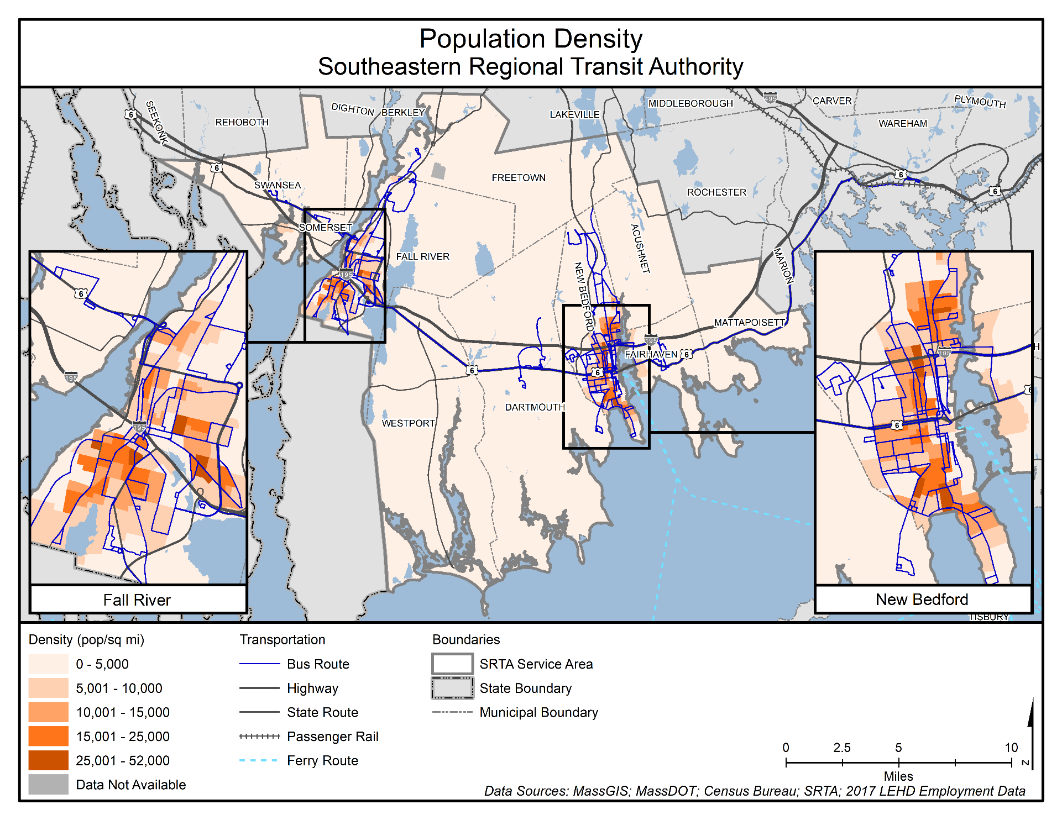

Figure 19. Senior Population
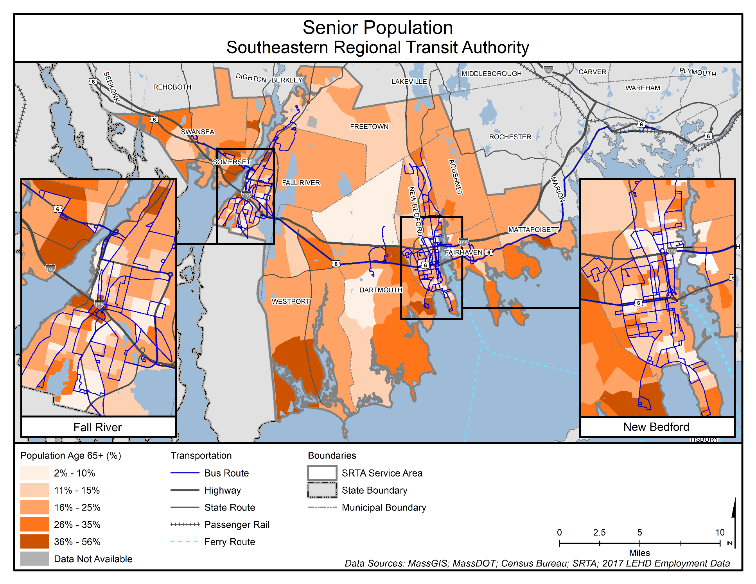

Figure 20. Median Household Income
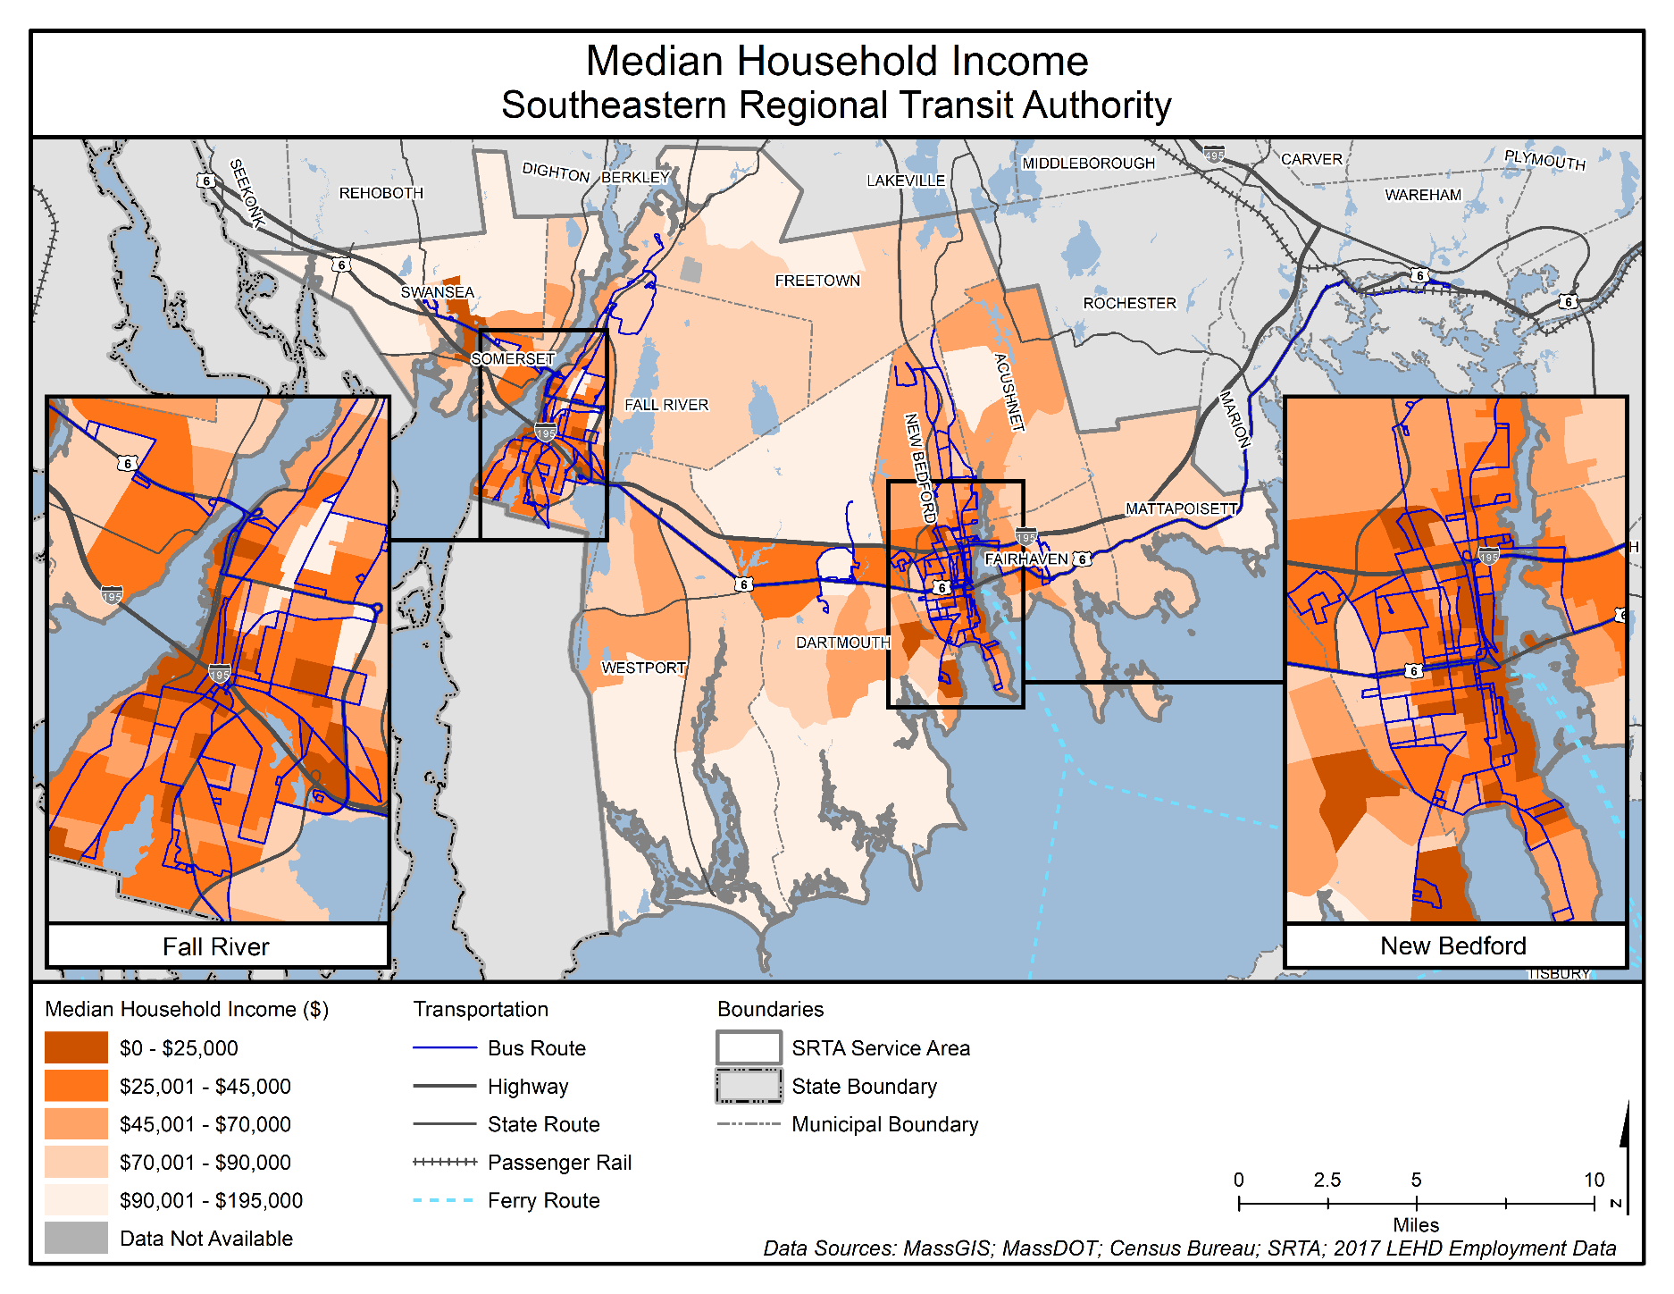

Figure 21. Population Below Poverty Level
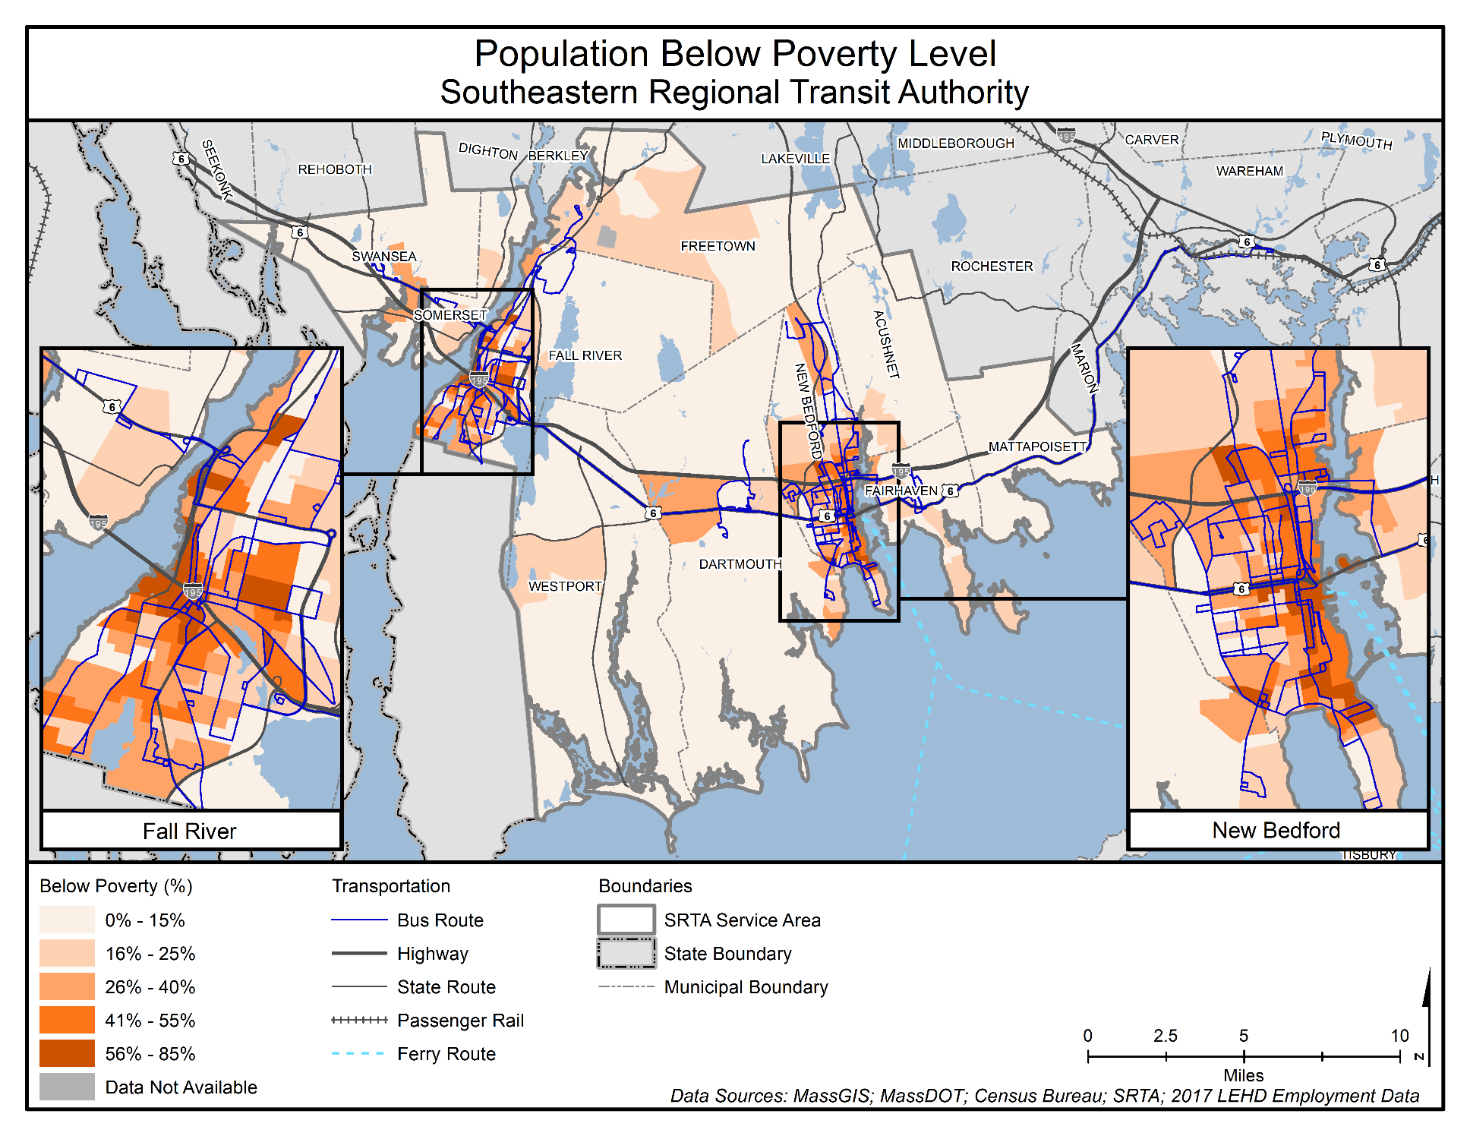
Figure 22. Zero-Vehicle Households
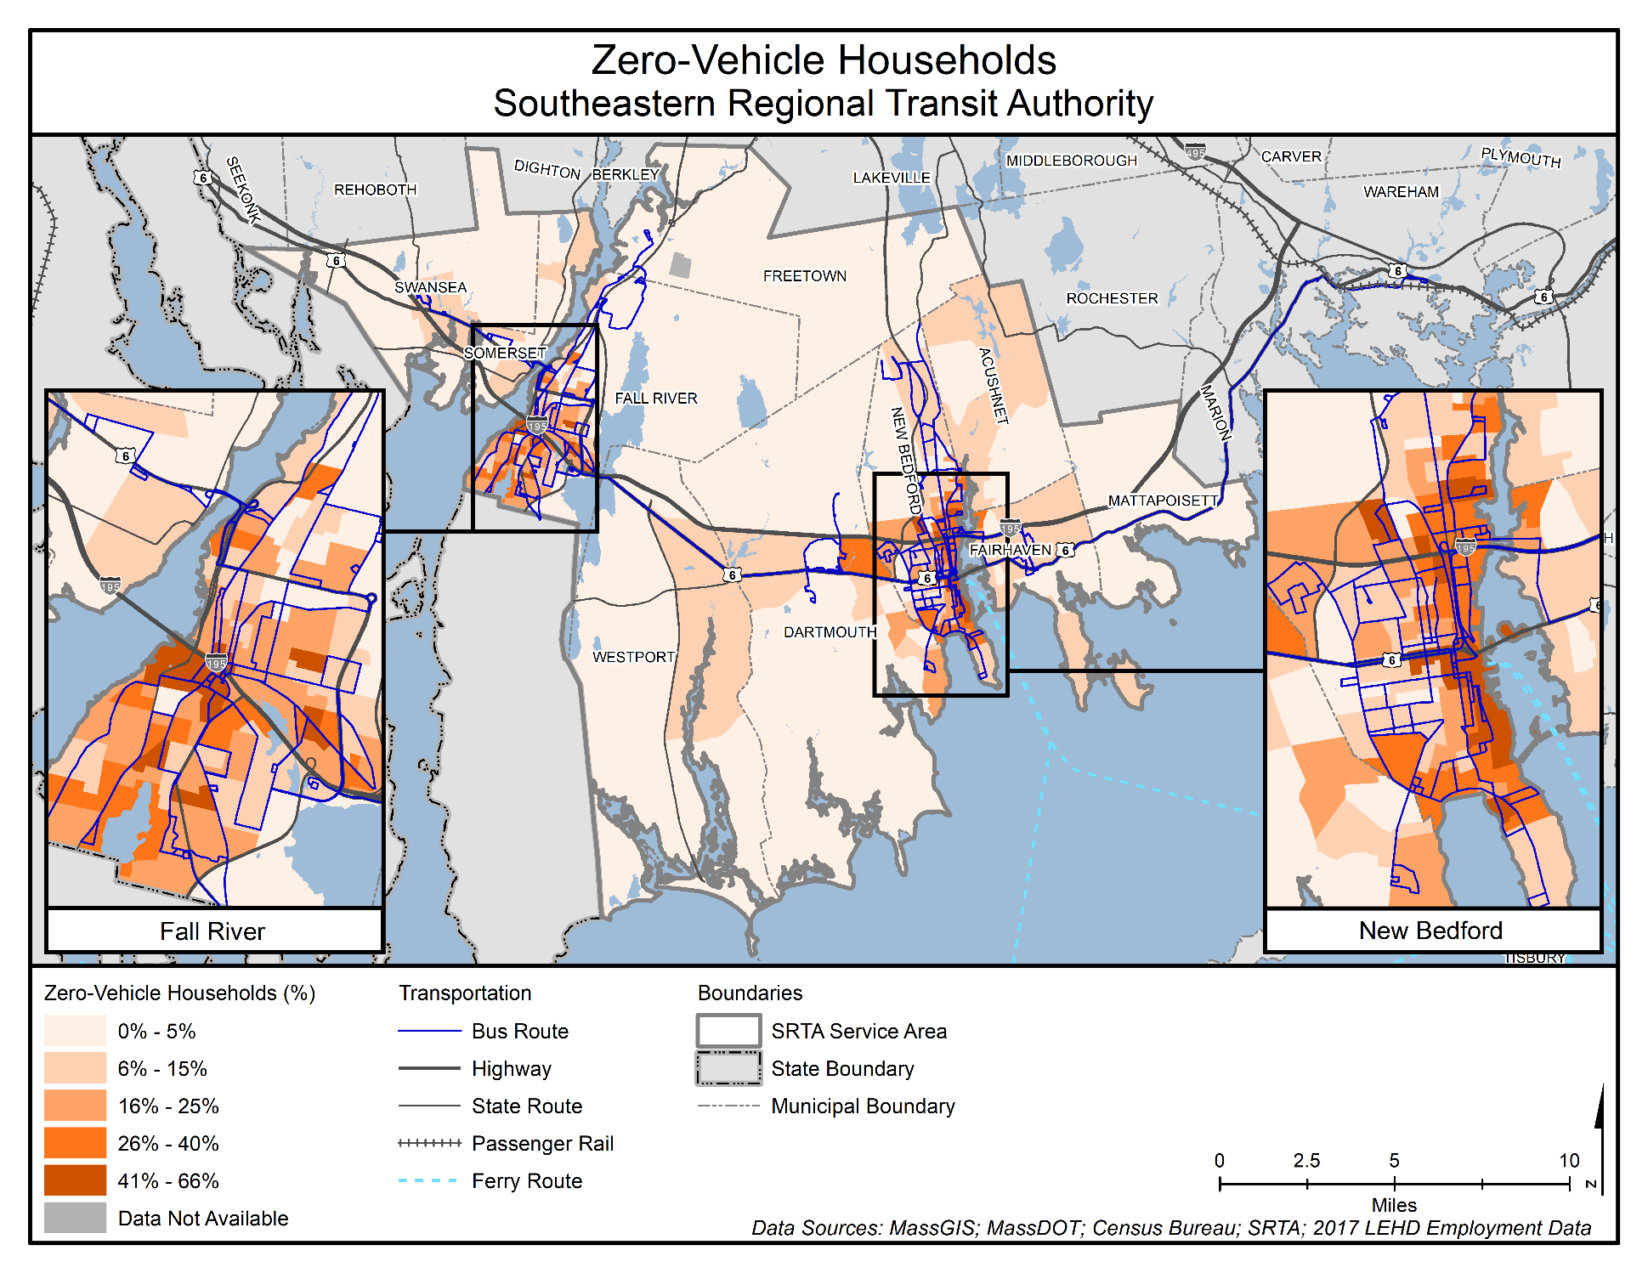
Figure 23. Minority Population
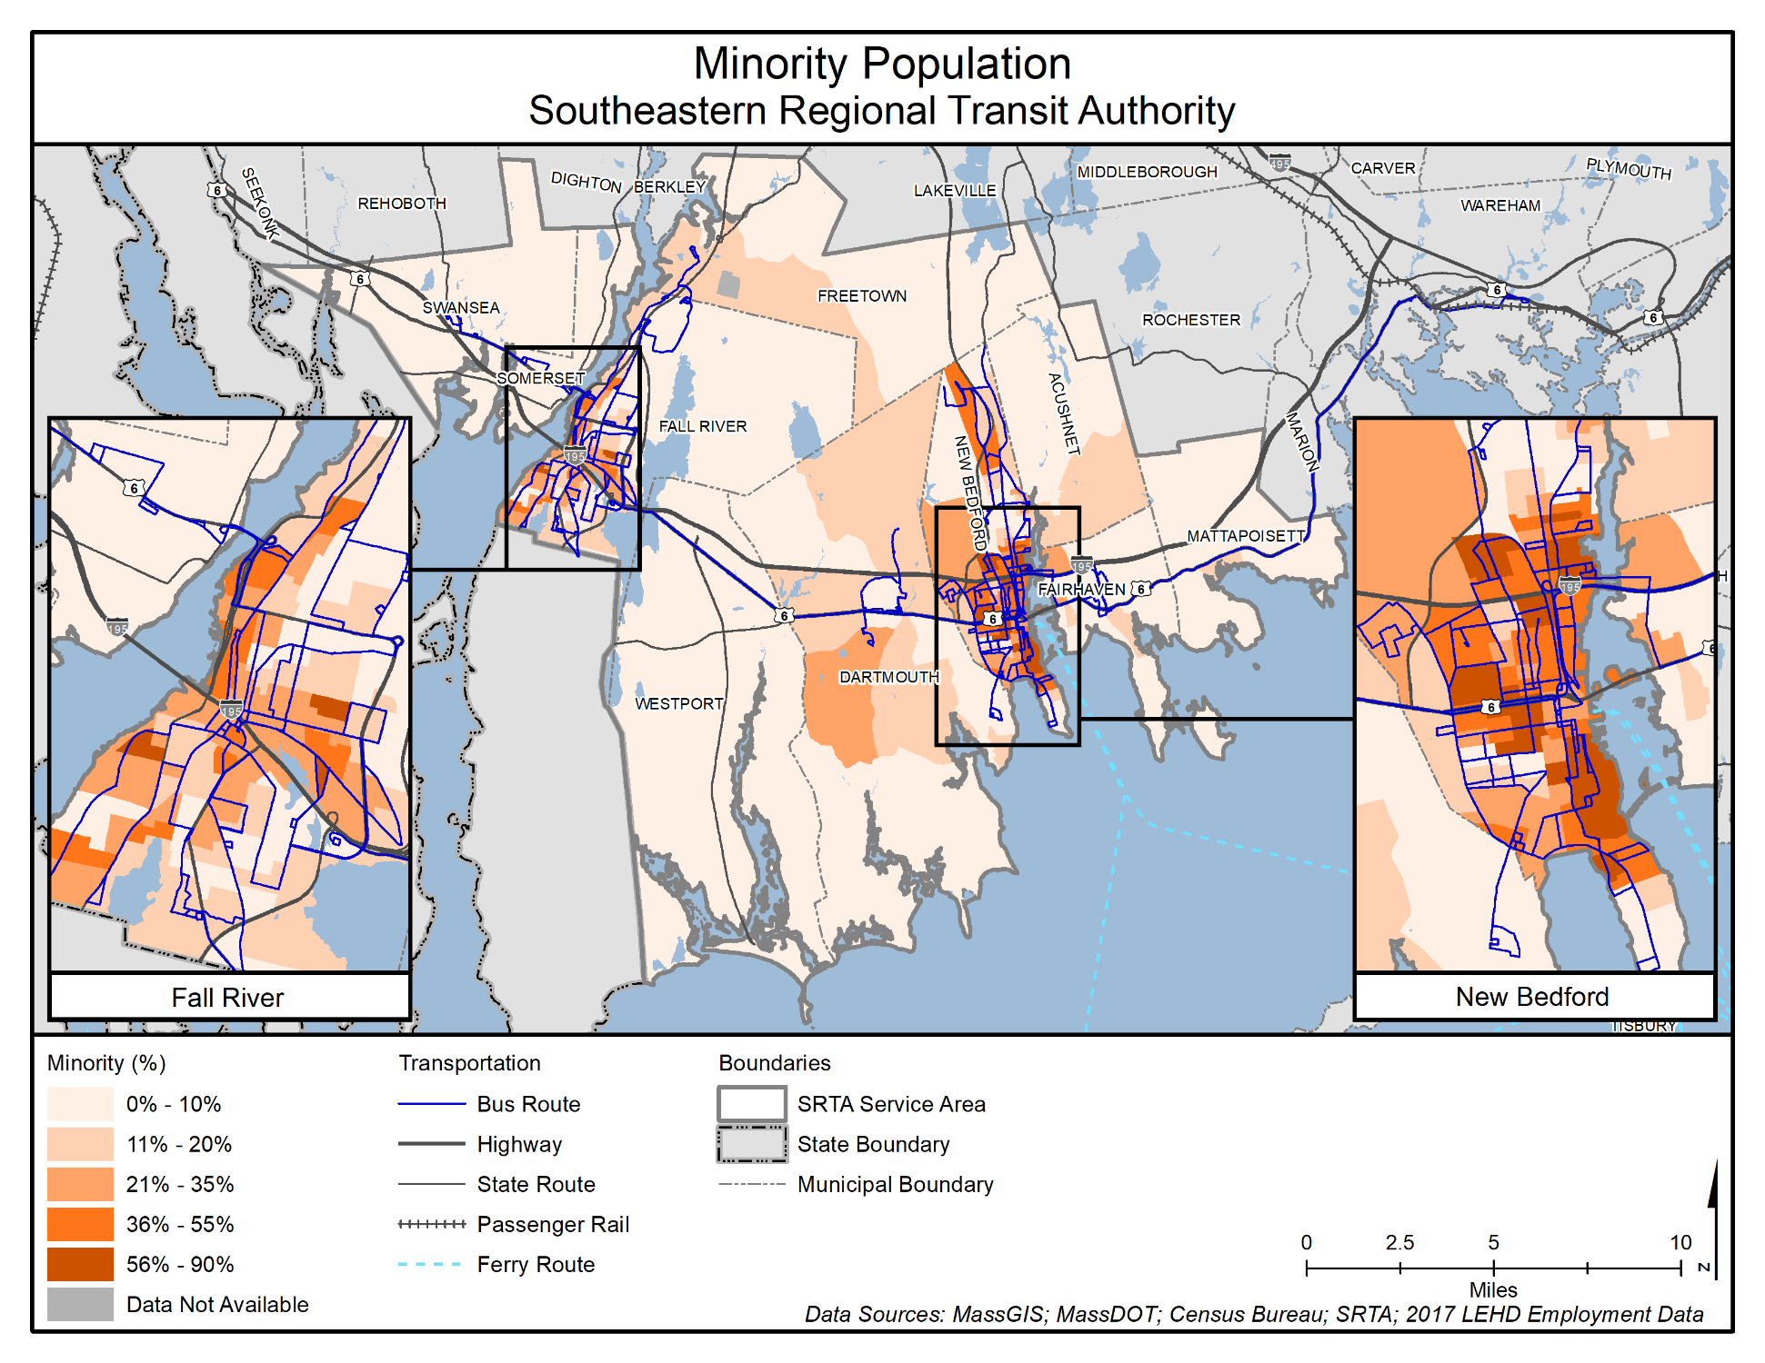

Figure 24. Job Density
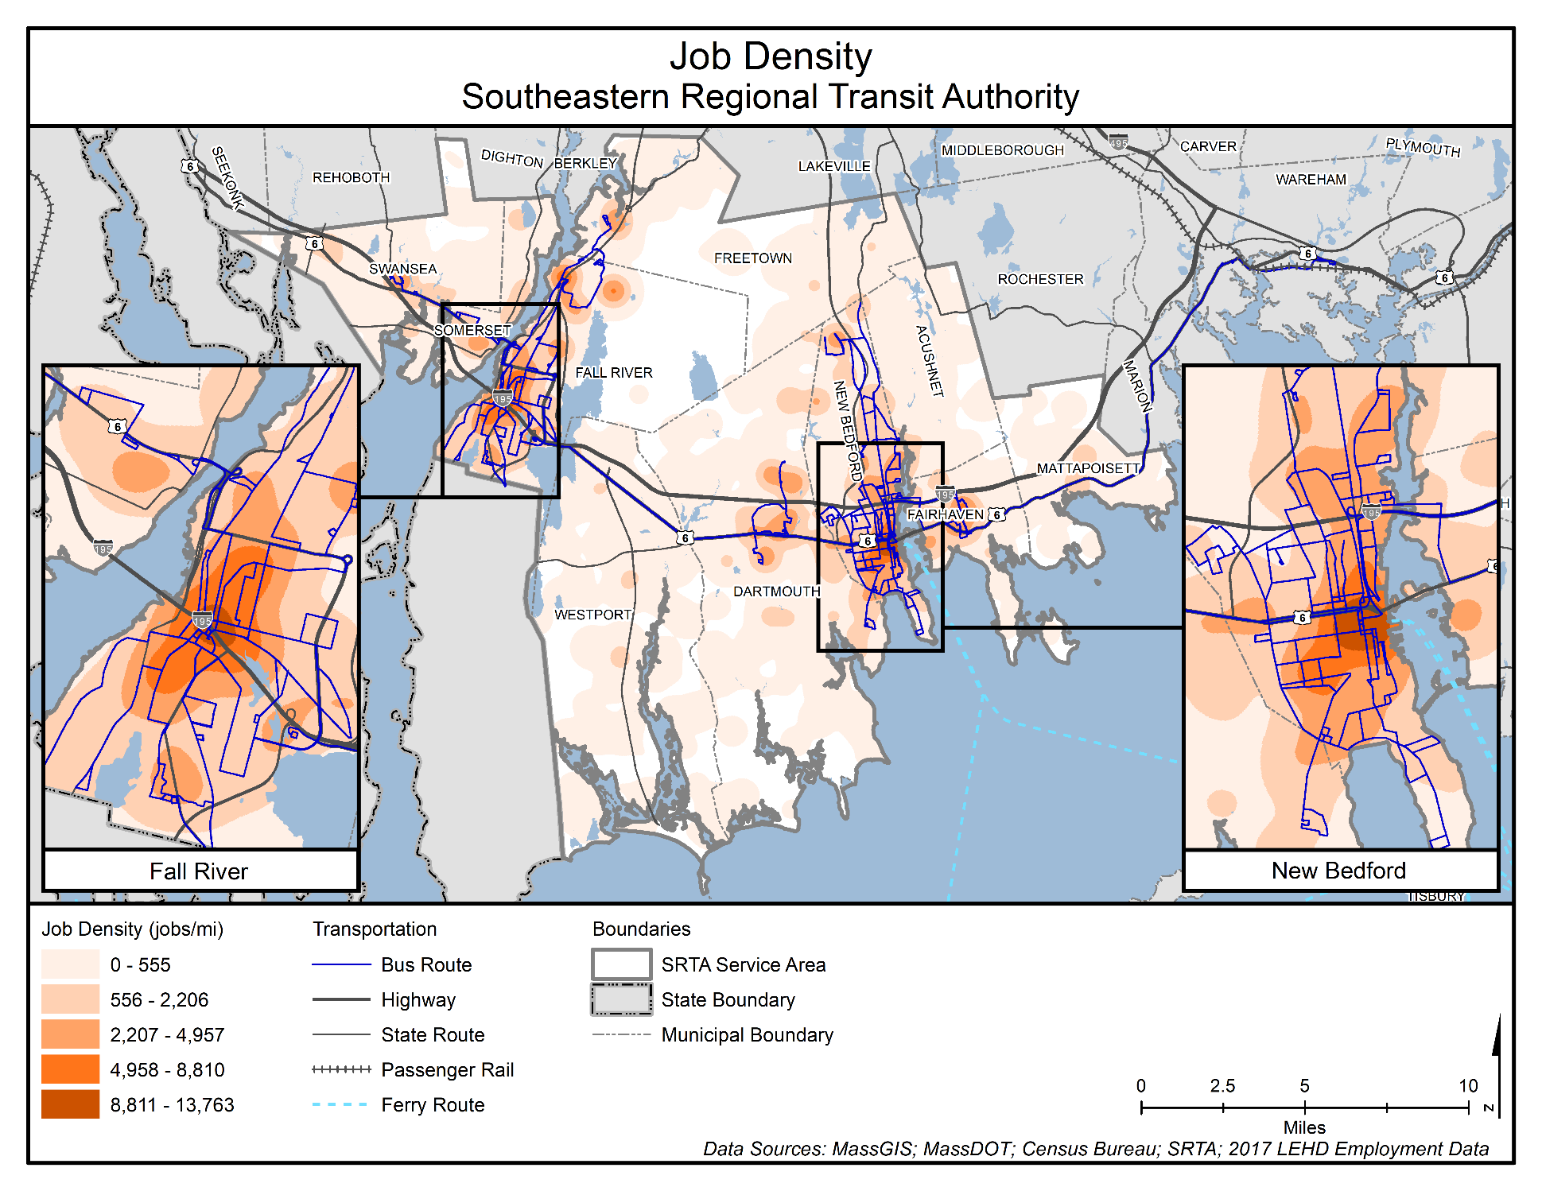

Figure 25. Major Trip Generators
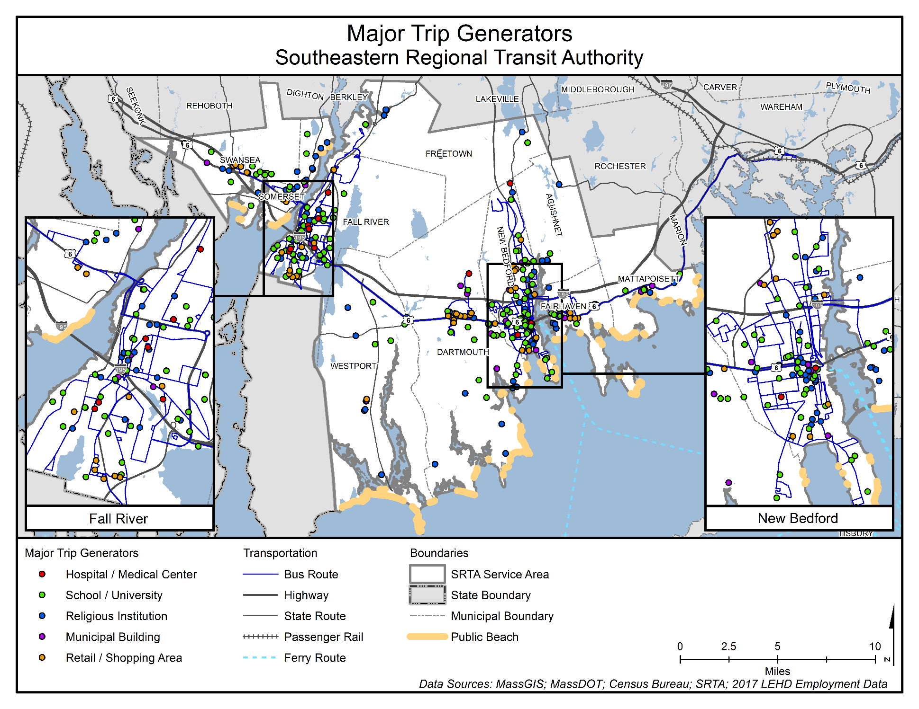

Transit Score
The transit score map (Figure 26) is a composite score based on many of the factors discussed in the prior section. The transit score is a relative measure of how successful a fixed route transit system is expected to be in a particular area. Used in conjunction with a congruency analysis of major transit generators, the transit score can be used to evaluate existing service and to identify areas of potential demand.
To calculate the transit score, demographic and socioeconomic information was collected from the US Census Bureau for a region divided into smaller geographic units such as tracts, block groups, or blocks. Block groups and census tracts were used for this analysis. Transit-oriented variables used for the analysis include:
- Overall Population Density
- Overall Job Density
- Density of the Population under the age of 18
- Density of the Population over the age of 65
- Percentage of the Population Living Below the Poverty Level
- Percentage of Zero-Car Households
Based on the variables above, a composite score was calculated for each geographic area in SRTA’s service area. The composite transit score map is only suggestive of potential transit markets. Fixed route public transportation might not currently exist in areas the analysis identifies as opportunities for good reasons, including topography, roadway geometry, presence of overpasses, or other local context. However, this map does provide some insight on areas to consider for future transit expansion should the opportunity arise.
Overall, SRTA service does an excellent job of covering the key transit markets in the region (Figure 26). Most transit demand is located in Fall River and New Bedford, which are also the two hubs for the region’s fixed route service.

Figure 26. Transit Score
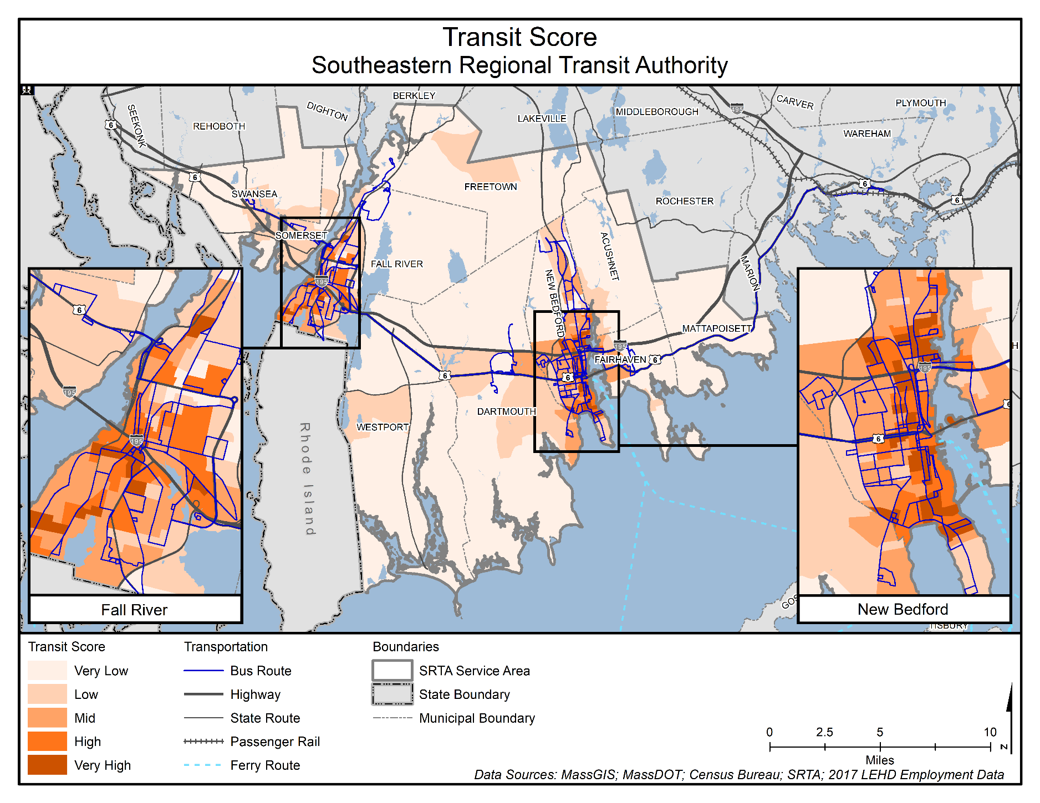

Performance
Performance-focused management is a critical priority for SRTA and the Commonwealth. The federal government has also led the transportation industry to become more performance-driven in the last decade by mandating that federally funded agencies implement a performance-based approach to planning and programming. This broad emphasis on the importance of having a strong enterprise-wide, data-driven and transparent performance management framework as the foundation for making decisions, particularly in the service planning and financial areas, is especially relevant to SRTA as it works to sustain success in the face of the challenges of COVID-19 and other market uncertainties.
The purpose of this chapter is to outline SRTA’s current performance practices, track performance results for the SRTA/MassDOT Bilateral MOU (which the Authority monitors quarterly) and make recommendations to enhance SRTA’s performance framework to support data-driven, performance-focused decision-making. These recommendations can either be implemented with SRTA’s current resources or require additional resources (in which case the recommendation is qualified). Historical performance information and a review of peer agencies are included in Appendix B.
As transit operations equipment has become more technologically sophisticated, vast amounts of operations data have become available to service providers. Providers should have data analysis strategies that ensure the data collected both inform operations planning and facilitate the RTA’s reporting requirements. When evaluating existing practices and developing recommendations for new metrics, it is important to keep in mind that performance measures should:
- Be easily measurable.
- Have a clear and intuitive meaning so that they are understandable to transit staff as well as non-transportation professionals.
- Be acceptable and useful to transportation professionals.
- Be comparable across time and between geographical areas.
- Be performed on either a monthly, quarterly, or annual basis, depending on state and federal requirements and the nature of the data.
- Have a strong functional relationship to actual system operations so that changes are reflected with minimal lag time in operating statistics.
- Provide the most cost-effective means of data collection.
- Where appropriate, be based on statistically sound measurement techniques.
- Be consistent with measures identified for other systems.
- Be readily available, when possible, to facilitate flexibility and agility in service planning.
- Include actionable language, setting thresholds when additional analysis or service changes are warranted.
These principles have informed the following analysis of performance recommendations and strategies, guiding the development of the recommendations at the end of this chapter.

Current Performance Measurement Practices
SRTA has developed a detailed and transparent performance measurement system guiding their decision-making processes. SRTA’s 2014 CSA outlined metrics that SRTA uses to evaluate route performance, including performance thresholds with actionable language that could lead to more detailed analysis and service changes. SRTA’s system for performance monitoring is described in the following sections.

Monthly and Annual Performance Monitoring
SRTA develops three publicly available performance reports: one annual report (“SRTA Year End Fixed Route Ridership Analysis”) for their fixed route service; a monthly performance dashboard that is posted on the SRTA website and updated annually; and an interactive performance dashboard displaying the metrics required by the MOU with MassDOT that is updated quarterly. They also submit data monthly, quarterly, and annually as required by MassDOT and FTA.

State and Federal Monitoring Requirements
SRTA reports a variety of performance metrics to both FTA and the Commonwealth on a monthly, quarterly, and annual basis as part of their funding agreements. FTA requires transit providers that receive federal funding to submit data (including service, financial, and asset inventory and condition) both monthly and annually to be posted on the National Transit Database (NTD).
The Commonwealth also requires SRTA and other RTAs to report service and asset data through the state’s GrantsPlus system. The Commonwealth has taken other steps in recent years to promote industry best practices, including a more data-driven approach to service planning. In 2019, MassDOT convened a stakeholder group, including RTA administrators, to develop a performance measurement strategy that could be tailored to each RTA’s needs and challenges. The results of this effort were laid out in individual MOUs signed by MassDOT and the RTA administrators.

Additional Monitoring Practices
In addition to reporting that meets federal and state requirements, SRTA uses Tableau Desktop 10.4 to organize and analyze performance data, producing interactive tables and charts found in the performance reporting section of their website (Figure 27). SRTA’s planning staff finds that the software helps them identify abnormalities and trends while being easy to use. This platform also allows SRTA to create interactive publicly available charts and tables, enhancing the transparency of SRTA’s operations.
SRTA posts monthly performance updates for their fixed route and demand response services on their website (https://www.srtabus.com/performance-measures), showing year-to-date operating statistics (broken down by quarter and month), baseline data, and targets on interactive charts and PDFs available for download. These interactive charts include the following metrics for both fixed route and demand response services:
- Systemwide metrics
- Total ridership
- Social media reach (quarterly and broken down by platform)
- Fixed route metrics
- Unlinked passenger trips
- On-time performance
- Passengers per revenue hour
- Farebox recovery ratio
- Passengers per revenue hour
- Operating expense per revenue hour
- Demand response metrics
- Unlinked passenger trips
- On-time performance
- Passengers per revenue hour
- Farebox recovery ratio
- Passengers per revenue hour
- Operating expense per revenue hour
SRTA also publishes a monthly performance dashboard, displayed in a PDF table on their website (https://www.srtabus.com/performance-measures). The dashboard includes the following metrics broken down by month:
- Fixed Route
- Total passengers
- Passengers per revenue hours
- Passengers per revenue mile
- Scheduled trips operated
- Missed trips
- Preventable accidents
- Breakdowns
- Valid complaints
- Demand Response
- Total passengers
- Passengers per revenue hours
- On-time performance
- Missed trips
- Preventable accidents
- Breakdowns
- Valid complaints

Figure 27. SRTA Website Interactive Dashboard
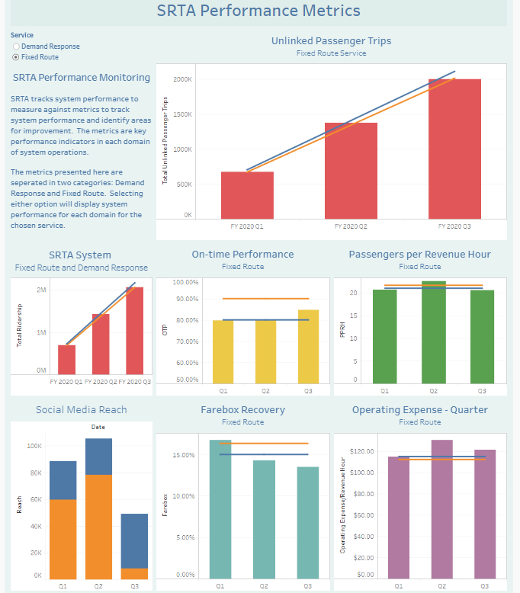
Source: SRTA
Additionally, SRTA posts an annual ridership report on their website (https://www.srtabus.com/performance-measures) that includes a detailed analysis of operations statistics using established performance standards by route. Route performance is measured against the systemwide average and falls into one of three categories:
- Pass: Productivity measure is greater than 50 percent of the systemwide average and no corrective action is necessary.
- Monitor: Productivity measure is less than 50 percent of the systemwide average but greater than 35 percent of the systemwide average; performance should be monitored, and a corrective plan is developed.
- Fail: Productivity is less than 35 percent of the systemwide average; the corrective plan is implemented. Finally, the report concludes by listing recommendations SRTA should work to implement over the next year.
Aside from Fall River Route 14, whose low ridership triggered a realignment in FY 2020 (see Section 4.2.1), one route that has consistently landed in the Fail category in SRTA’s annual ridership report is New Bedford’s North End Shuttle. SRTA acted on performance information gleaned from the ridership report and undertook a study examining the origins and destinations of North End Shuttle riders. The study showed that in order to provide comparable service using additonal service on other routes (eliminating the North End Shuttle service), SRTA would need to pay more in operating costs. SRTA decided to continue the route because shortly after the study was concluded, the Registry of Motor Vehicles moved to a location only served by the North End Shuttle.
The annual ridership report includes the following metrics:
- System-Level
- Ridership by garage
- Ridership by service schedule
- Fare payment by media
- Route-Level
- Passengers per revenue hour by route
- Passengers per revenue mile by route
- Passengers per trip by route

Performance Metrics and Targets from MassDOT Memorandum of Understanding
In August 2019, SRTA, along with the Commonwealth’s 14 other RTAs, entered into 2-year MOUs with MassDOT. This agreement is based on performance metrics established by MassDOT and the RTAs, and includes performance targets in the categories of ridership, customer service and satisfaction, asset management, and financial performance. The MOU states that SRTA’s performance is to be measured by comparing established baselines to FY 2020 and FY 2021 targets.
The performance measures included in the MOU, along with their baselines, targets, and SRTA’s progress (through the third quarter of FY 2020), are included in Table 9 and Table 10. Given that the COVID-19 pandemic didn’t significantly impact operations until the last two weeks of the third quarter, the data suggest that SRTA appeared to be on track to meet or exceed these goals before transit operations were interrupted.
When developing performance targets, it is typical to consider external factors that are influencing performance, but it is not common practice to consider unforeseen disruptions that have the potential to greatly upset the status quo, like COVID-19. When SRTA and MassDOT developed the performance targets in the MOU, they developed baselines to measure SRTA’s performance between FY 2019 and FY 2021. With few exceptions, these baselines are averages of data collected in FY 2016 to FY 2018. MOU targets reflected the reasonable expectation that SRTA could improve upon these baselines for the next 2 years. Since the outbreak of the pandemic, all parties acknowledge that meeting ridership and service efficiency goals will be very challenging.
As MassDOT notes in their July 2020 report Annual Report on the Regional Transit Authority Performance Management Program, the Performance Management Program will be a valuable tool in identifying progress, best practices, and innovative adaptations to the inevitable challenges the RTAs may face. In that report MassDOT states that, “the Q4 data submittal will provide MassDOT and the RTA stakeholders with a better understanding of the depth of impact the COVID-19 pandemic has had on public transportation in Massachusetts.” SRTA will use FY 2021 as a time to reevaluate targets and performance metrics as transit demand stabilizes and SRTA and MassDOT continue to discuss how to best reflect the impact of the pandemic on ridership, operations, and efficiency. This is discussed in greater detail in the following sections.

Service Effectiveness Measures
The following performance measures are included in the MOU with MassDOT (Table 9). They are calculated on a monthly and annual basis using farebox data, passes sold, bus driver tabulations, and schedules.
SRTA met some of their targets despite the COVID-19 pandemic. Otherwise they were on track to meet them before the pandemic struck toward the end of the third quarter. The fourth quarter saw greatly reduced ridership resulting from the stay-at-home order and service cuts.
- Total Ridership (Unlinked Passenger Trips): This metric is passenger trips taken on SRTA vehicles (transfers counted as individual trips, rather than one multi-segment trip). Ridership data are collected and reported by the Sheidt & Bachmann farebox system and stored in the central computing system. The farebox system records the details of each transaction at the fareboxes, ticket vending machines, and terminal ticket offices. The data are compiled through a series of reports available in the central computing system.
- Unlinked Passenger Trips per Vehicle Revenue Hour: This statistic is the number of total unlinked passenger trips divided by the corresponding revenue hours. Revenue hours are calculated by using trips scheduled on the published timetables. Scheduled values are used because detailed operational data are not currently available.
- On-Time Performance: This measures the percentage of fixed route trips that operate late or are missed. SRTA’s on-time performance policy allows for departures within a window of 1 minute prior to and five minutes after (-1/+5) the published time for routes with headways of 30 minutes or less. Routes with headways greater than 30 minutes have a standard of one minute prior to and 10 minutes after (-1/+10) scheduled departure times. SRTA has reduced their target for on-time performance in anticipation of the more accurate data they will be able to capture using their recently implemented AVL system. The new target will have progressively increasing goals as the system is calibrated. With the new AVL system, SRTA moved from relying on samples of on-time performance data to having it all available. SRTA is transitioning to tracking on-time performance using timepoints throughout the system rather than tracking from departure point only.

Table 9. MOU Service Effectiveness Measures
Operating Statistic | Baseline (FY 2016–FY 2018 Average) | Target FY 2020 | FY 2020 (First Quarter–Third Quarter) | FY 2020 (Full Year)
Total Ridership (Unlinked Passenger Trips)
Fixed Route | 2,678,000 | 2,687,760 | 1,997,177 | 2,225,259
Demand Response | 66,463 | 79,381 | 69,667 | 79,524
Systemwide | 2,744,465 | 2,767,141 | 2,066,844 | 2,304,783
Unlinked Passenger Trips per Revenue Hour
Fixed Route | 21.59 | 20.94 | 21.25 | 19.57
Demand Response | 1.99 | 1.93 | 1.92 | 2.15
On-Time Performance
Fixed Route | 90.00% | 80.00% | 81.53% | 83.58%
Demand Response | 97.00% | 90.00% | 98.17% | 98.20%
Source: SRTA and MassDOT MOU (2019), SRTA

Financial Efficiency Measures
Financial efficiency measures from the MOU are calculated on a monthly and/or annual basis using data from fare payment machines, fareboxes, pass sales, contracted service agreements, and schedules (Table 10).
- Farebox Recovery Ratio: This metric is the percentage of operating costs covered by fares, calculated by the fares collected divided by the cost to operate the route. This measure is only available by mode.
- Operating Expenses per Revenue Hour: This is the cost of service divided by the corresponding revenue hours.

Table 10. MOU Financial Efficiency Measures
Operating Statistic | Baseline (FY 2016–FY 2018 Average) | Target FY 2020 | FY 2020 (First Quarter–Third Quarter) | Target FY 2021
Farebox Recovery Ratio
Fixed Route | 16.35% | 15.48% | 14.50% | 10.58%
Demand Response | 5.04% | 5.31% | 6.07% | 4.40%
Operating Expenses per Vehicle Revenue Hour
Fixed Route | $112.40 | $115.21 | $124.63 | $143.48
Demand Response | $90.39 | $92.64 | $82.57 | $95.46
Source: SRTA and MassDOT MOU (2019), SRTA

Asset Measures
FTA has developed national standards for rating the condition of transit equipment and facilities. FTA categorizes vehicles, equipment, and facilities into asset classes and those classes have either a Useful Life Benchmark (ULB) or a condition rating on the Transit Economic Requirements Model (TERM) scale. While FTA has default ULBs for expected service years for vehicle classes, agencies are permitted to submit their own ULBs for approval from FTA if they choose. Although the MOU lists the following asset management metrics and targets, SRTA sets ULB goals for their rolling stock, equipment, and facilities in their Transit Asset Management (TAM) Plan, while the targets for the metrics in the sections above were set in the MOU. SRTA’s fleet and facilities are generally in good condition though some are nearing the end of their useful life (Table 11). SRTA is committed to upgrading their fleet and facilities over the next 5 years, funding permitting.
- FTA Reportable Revenue Vehicles Asset Class Meeting FTA TAM Plan ULB: This metric is the percentage of vehicles within a particular asset class that have met or exceed their ULB.
- FTA Reportable Equipment Asset Class Meeting FTA TAM Plan ULB: This metric is the percentage of equipment within a particular asset class that has met or exceed their ULB.
- FTA Reportable Facilities Asset Class Meeting FTA TAM Plan ULB: This metric is the percentage of facilities with a condition rating below 3.0 on the FTA TERM Scale.
Table 11. Condition of SRTA’s Vehicles and Facilities
Asset Type | FTA Standard
Vehicle | ULB
Bus (35 feet, 40 feet) | 27.72%
Bus (30 feet) | 70.97%
Van (Type E, Type E2) | 68.42%
Van (Type D) | 25.00%
Automobile | 47.62%
Facility | TERM Rating
New Bedford Terminal | 3
Fall River Terminal | 3
New Bedford Garage | 3
Fall River Garage | 2
Source: SRTA

How SRTA’s Market Has Been Affected by COVID-19
Months into the pandemic, Americans are still trying to understand what the “new normal” will look like. Transit providers are uncertain how many former customers will return (ridership has dropped as much as 80 percent in some systems) and what that timeline looks like. They are also grappling with how to ensure a safe workplace and retain employees as the risk associated with transit operations (and driving a vehicle in particular) has increased significantly since March 2020.
Since the outbreak became widespread in Massachusetts in mid-March 2020, many institutions and industries that fuel the region’s economy, and therefore SRTA’s ridership, have been severely altered for the foreseeable future. Some of the most significant include:
- Virtual classes at UMass Dartmouth, Bristol Community College, and the region’s public schools
- Decline in customers and workforce in the hospitality industry
- Decline in summer tourism industry jobs
These institutions and industries are not only major trip generators, but they also contribute significantly to area employment and the local budgets that comprise a significant portion of SRTA’s funding. As the timeline for eradicating the virus is extremely uncertain (social distancing may continue well into 2021), SRTA will need to be flexible in their ability to adjust service according to demand and funding availability. Access to ridership data that are detailed and readily available is imperative to SRTA’s ability to both maintain lifeline service and transport essential workers. SRTA and MassDOT will continue to review MOU performance results through the term of the agreement and will mutually utilize this data to inform agreements for FY 2022 and beyond.

Considerations for the Next 5 Years
Building on SRTA’s current performance management practices, there are some enhancements in the areas of data and performance measurement that the SRTA should adopt over the next 5 years. These changes will support enterprise-wide, data-driven decision making by SRTA, and aid in the navigation of the uncertainties brought on by COVID-19 and other market trends.

Principles for Data Collection and Evaluation
While the ability to access reliable up-to-date data was important prior to the pandemic, it is now essential that SRTA has the tools needed to make informed service changes in a nimble way. These tools include technology like automatic passenger counters (APC) and AVL, which, when combined, allow agencies to analyze ridership at the bus stop level, identifying new ridership patterns and adjusting service accordingly. Because these data are rich with information about a system’s travel patterns and are readily available, they are invaluable when considering service changes—particularly when those changes need to respond to a transit market in flux.
SRTA has had APC and AVL technology installed on their buses since FY 2019, activating the APC/AVL system in April 2019. SRTA currently uses the data collected for operations planning and has used it to analyze changes in ridership patterns since the pandemic outbreak in March 2020. SRTA is coordinating with their operators to fine tune the technology to enhance reliability. SRTA should continue using this technology to expand its post-pandemic analytical practices to fully understand the impact of COVID-19 on its transit market. More information on COVID-specific analysis can be found on the SRTA website (https://www.srtabus.com/covid19).

Additional Measures to Consider Including in Performance Reports (Technology Permitting)
SRTA’s monthly and quarterly performance reporting dashboards and annual ridership report already contain the majority of the industry-recommended performance measurement metrics. Depending on technology and staff capacity, SRTA should consider including the systemwide service cost data and route-level analyses listed below in performance reports.
- System-Level Performance
- Cost per Passenger: This metric is calculated by dividing the overall cost to operate a route by the number of passengers. This is recommended for annual reports.
- Subsidy per Passenger: This metric is calculated by subtracting total expenses from the fare revenue and dividing that total by ridership. This is recommended for annual reports.
- Route-Level Performance
- Ridership by Stop: This measure is typically limited to tracking passengers boarding and disembarking by stop. The technology associated with this type of data collection (APCs and AVLs) and supporting software can generate reports quickly for any time period requested and includes data that can assist in looking at the data spatially and by time of day. SRTA currently uses several additional criteria to monitor stop-level performance for service planning, including total on/off for the stop, average on/off passengers per day and week, and stop service frequency. It is recommended that SRTA include a simplified version of this analysis in annual reports.
- On-Time Performance by Route: This measure is the percentage of fixed route trips that operate late or are missed. SRTA’s on-time performance policy allows for departures within a window of 1 minute prior to and 5 minutes after (-1/+5) the published time for routes with headways of 30 minutes or less, and 1 minute prior to and 10 minutes after (-1/+10) for routes with headways greater than 30 minutes. It is recommended for annual reports.
- ADA Demand Response Percent No-Show: This measures cancellations made less than 1 hour prior to the pickup time or not being present for the pick-up. This is recommended for annual reports.
- ADA Demand Response Percent Cancellations: This measures same day cancellations made at least 1 hour prior to the start of the pick-up window. This is recommended for annual reports.
- Percent Denied Trips:
- Fixed Route: This measures the percentage of passengers left behind due to vehicle overload. This is recommended for annual reports.
- ADA Demand Response: This measures the denial of trip requested at least a day prior that the agency cannot provide or is outside the 1-hour negotiation window. This is recommended for annual reports.
- Average Phone Hold Time: This measures the average length of time a customer is on hold with customer service or with reservations for ADA and non-ADA service. This is recommended for annual reports.

Stakeholder Engagement
Engaging the public is an essential element of a successful 5-year plan. Planning efforts should be driven by the needs and preferences of transit customers, major regional employers, institutional partners (such as higher education), municipal officials, human service organizations, and other stakeholders. This chapter outlines the results of the online public outreach survey that was conducted as part of this 5-year CRTP update.

Stakeholder Survey
Outreach for this project was a stakeholder survey. The survey was available online on June 22, 2020 and was open through July 31, 2020. To promote the survey to its riders, SRTA sent email blasts with survey information to stakeholder groups, posted links on its social media accounts, set up paid advertising to target residents within the SRTA service area, and posted a link on SRTA’s website.

Survey Approach and Limitations
The survey approach was anchored in soliciting feedback from SRTA customers on how the service performs and identification of any additional needs. An unforeseeable challenge in executing the stakeholder strategy was the outbreak of COVID-19. Stakeholder engagement that was intended to primarily take place during the months of March and April 2020 had to be delayed as stay-at-home orders, social distancing guidelines, and closures of institutions such as colleges and universities took effect.
In order to comply with social distancing guidelines, in-person outreach was abandoned in favor of an all-online approach. To that end, the project team developed an online survey using the SurveyMonkey platform (Figure 28).
Figure 28. SRTA Online Survey
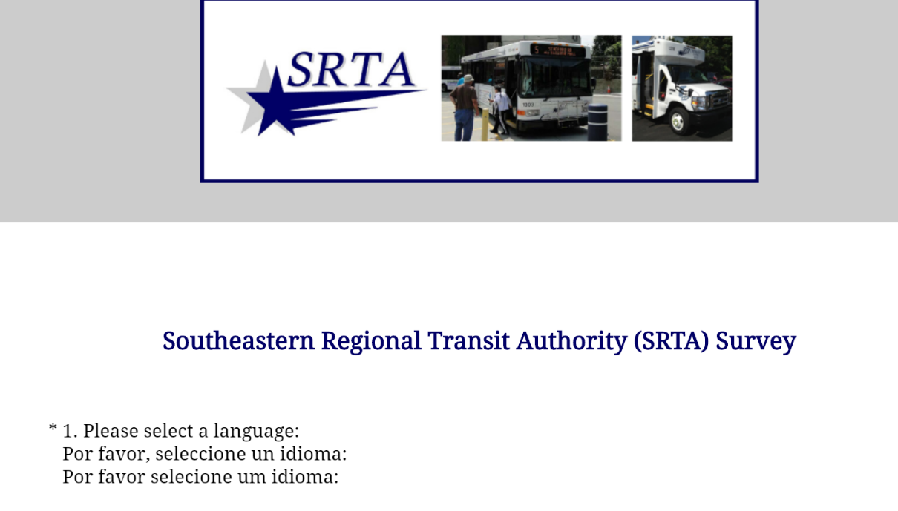
In order to gauge the impact an all-digital outreach approach had on the pool of respondents, the demographic data of this plan’s survey responses were compared to that of respondents to the survey results from SRTA’s 2019 Title VI Report. Compared to that effort, this plan’s survey yielded a less racially and ethnically diverse pool of survey respondents, with 74.4 percent of respondents identifying as Non-Hispanic White compared to 53 percent of respondents in the Title VI survey effort (Figure 29).
Figure 29. Race/Ethnicity (2020 CRTP versus 2019 Title VI Report)

(n=172, 2020 CRTP) (n=623, 2019 Title VI Report)
*NA means Not Applicable as this category was not offered in the corresponding report.
There was a similar discrepancy between surveys for the primary language respondents spoke at home. This survey effort saw more respondents who spoke English as their primary language at home (92 percent) than the 2019 Title VI Report survey (77 percent) (Figure 30).
Figure 30. Primary Language Spoken at Home (2020 CRTP versus 2019 Title VI Report)

(n=172, 2020 CRTP) (n=466, 2019 Title VI Report)
*NA means Not Applicable as this category was not offered in the corresponding report.
The ridership patterns of respondents also did not mirror SRTA’s ridership data. SRTA’s highest ridership route, New Bedford to Fall River, was only the seventh-most selected route for respondents’ initial trips of the day. This also suggests potential response bias in the survey results.
The project team worked to ensure that the broadest possible cross-section of SRTA’s stakeholders was represented. SRTA’s multi-pronged approach to promote the survey included:
- Sending email blasts with survey information to stakeholder groups, major employers, community partners, local chambers of commerce, and local municipalities to share with the public.
- Posting social media content on SRTA’s Facebook and Twitter accounts (Figure 31) encouraging visitors to participate in the survey.
- Advertising on Facebook to target residents within the SRTA service area, with the intent of reaching a larger audience.
- Posting the survey link on the SRTA website homepage for the entire length of the survey period.
- Using a mobile-friendly platform and promotional materials with the survey link accompanied by a QR code, enabling a quick scan using a smartphone to direct users immediately to the survey.
Figure 31. Survey Social Media Post
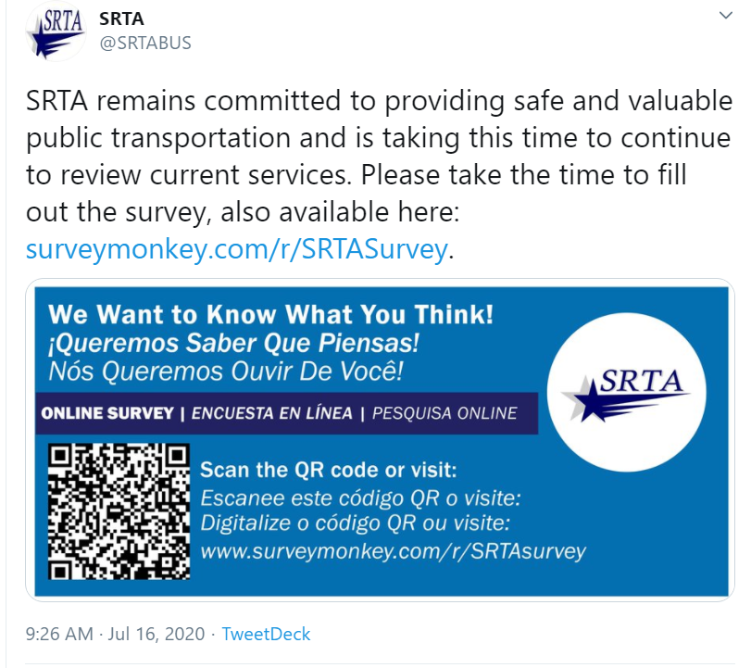
Despite these efforts, due to the limitations of the pandemic and the differences in demographics compared to the 2019 Title VI Program, it is important that the results of the 2020 survey be used in concert with previous plans and outreach efforts to inform planning decisions.

Limited English Proficiency
Special attention was paid to engaging with groups that serve LEP populations, not only fulfilling Title VI obligations, but also in an effort to represent the full diversity of SRTA’s ridership in the survey results. In addition to providing English, Portuguese, and Spanish versions of the survey, SRTA’s strategy to reach LEP populations involved targeted outreach to the organizations in Table 12.
Table 12. Partner Organizations Contacted for Survey Distribution
Organization | Organization
Atlantis Charter School | Mattapoisett COA
ATU - Fall River Local | Millstone Medical
ATU - New Bedford Local | New Bedford Career Center
Blount Foods | New Bedford COA
Bristol Community College; VP of Marketing & Communications | New Bedford Community Economic Development Corporation
CBRE/Amazon - Fall River | New Bedford Economic Development Corporation
City of Fall River | New Bedford Housing Authority
City of New Bedford Planning | New Bedford Neighborhood and Community Outreach
Coalition for Social Justice / Bus Riders United | Old Bedford Village Association
Coastline Elderly Services | One South Coast Chamber
Coastline Elderly Services - Tufts Grant Coordinator | One South Coast Chamber
Community Economic Development Center* | Parks, Recreation & Beaches
Community Foundation of Southeastern Massachusetts* | Southcoast Health
Fall River Career Center | UMass Dartmouth
Fall River COA | UMass Dartmouth Public Policy Center
Fall River Health and Human Services | United Neighbors of Fall River*
Fall River Planning Department | United Way of Greater Fall River*
Frequent Rider | United Way of Greater New Bedford
Immigrants’ Assistance Center, Inc.* | YMCA Southcoast*
Living Interdependently for Future Endeavors | Mattapoisett COA
*Indicates a community group that works with LEP populations

Additionally, a press release that included a link to the survey and information about this plan was sent to O Jornal, a local bi-lingual (English-Portuguese) publication serving 20 cities and towns in Massachusetts and Rhode Island. The press release was published on July 28, 2020.

Survey Results
Three-hundred and seventeen responses were collected using the online survey: 198 completed surveys and 119 partial responses. Partial responses were likely the result of immediate abandonment of the survey due to a time constraint, technical problem, or user error. Eighty-three percent of respondents (or 250 people) who responded to the question, “Do you currently use SRTA services?” identified as current riders and 17 percent of respondents (or 52 people) answered they did not currently use SRTA service (Figure 32).
The results of the survey are broken down into the following topic areas:
- Current Service/Ridership Profiles
- Needs or Opportunities for Future Improvements

Figure 32. Survey Respondents’ Rider Status

Current Service/Ridership Profiles
The majority of survey respondents began the first trip of their day in New Bedford (59 percent of respondents) or Fall River (35 percent of respondents). The remaining 6 percent of respondents began their first trips in a variety of communities including Dartmouth, Fairhaven, Mattapoisett, and Swansea. Most of these first trips also ended in New Bedford (44 percent) or Fall River (34 percent). Communities surrounding New Bedford and Fall River were more likely to see commuters traveling into their towns as opposed to trips originating from them. Twelve percent of riders ended their trip in Dartmouth, while 6 percent ended their trip in Fairhaven.
The majority of respondents who identified as current riders were transit dependent. When asked why they rode SRTA service (respondents were allowed multiple selections), 84 percent of respondents indicated that they used SRTA because they don’t own a car and 56 percent indicated that they did not have a driver’s license (Figure 33).
Figure 33. Current Riders’ Reasons for Using SRTA Service

n=167
Most current rider respondents used fixed route bus service at least three days a week (Figure 34) but only 22 percent used SRTA’s ADA demand response service, with 14 percent using it once a week or more.
Figure 34. Frequency of Fixed Route Use

n=164
The most popular trip purposes among respondents were travel to medical appointments (71 percent) and shopping (69 percent); respondents were allowed multiple selections (Figure 35).
Figure 35. Respondents' Primary Trip Purpose(s)

n=166
Survey responses indicate that riders made use of modes of travel outside of SRTA. When asked if they had used bikeshare, Uber or Lyft, or taxi service in the past year, 50 percent of respondents answered they had used Uber or Lyft and 55 percent answered they had used taxi service. Only 2 percent of respondents had used a bike share service in the past year, which is not surprising, given the absence of bike share services in SRTA’s service area. The question was asked to gauge interest as there are bike share programs in the region including a system in Providence.
Figure 36. Other Transportation Services Used in Past Year

n=166

Needs or Opportunities for Future Improvements
The survey was designed to capture feedback on SRTA’s service from current riders, in addition to those who stopped using the service or had never used the service. SRTA sought input on current service levels, destinations that respondents would like to see SRTA serve, fare media, and bus stop amenities.
SRTA also used the survey to gauge respondents’ comfort using the service during the COVID-19 pandemic. SRTA was interested in gaining insight into what measures could be taken to make riders feel safer on their vehicles and what could be done to attract former riders back to the service. Of the respondents who answered they did not currently use SRTA services, 15 out of 39 indicated that they had used the service prior to COVID-19 pandemic restrictions.
Of the 15 people who said the pandemic had caused them to stop using SRTA, 7 continued answering survey questions, 4 respondents said that they would use SRTA again after the restrictions were lifted, and 3 said they would not. One former rider commented that they had purchased a car and two former riders said they were worried about SRTA keeping the vehicles safely clean.
Below is a summary of how current rider respondents answered the question, “What measures can SRTA take to make you feel most comfortable while riding?”
- Vehicle Sanitizing and Cleanliness. Rider suggestions included increased bus cleaning and making the sanitizing process known to all riders. Respondents suggested that SRTA let the riders see the buses being cleaned and improve communications about what is being done to follow strict public health guidelines. Some riders reported dirty seats and requested the buses be cleaned more. Respondents also suggested providing hand sanitizer on the vehicles for passengers as they board the bus. One rider suggested adding a trash receptacle on the bus and noted seeing debris and other trash on the bus in the past.
- Social Distancing and Face Masks. Requests included reducing overcrowding on buses by reducing the number of passengers per vehicle. Some current riders requested bus drivers restrict passengers to sit in every other seat. Many current riders requested face masks be mandatory and enforced by the bus drivers.
- Communications. Respondents suggested SRTA increase the communications flow and utilize more methods other than the SRTA website. They indicated that SRTA should provide additional options to receive updates, important information, and schedule changes to stay informed.
- Safety. A few current riders reported feeling unsafe when passengers who appeared to be under the influence of alcohol were also on the bus. These riders requested SRTA refuse service to anyone who appears to be under the influence.
- Comfort. During the summer months, current riders said air conditioning on the vehicles should be turned on, in addition to reducing the number of passengers. Some riders suggested maximizing seating while enforcing social distancing.
- Schedules and Fares. One rider said GPS monitoring of the buses for real-time arrival and departure updates would help them plan trips better (this is currently planned to be implemented in early 2021). A number of responses included mention of a return to normal service and routes that run every 30 minutes. (Subsequent to the close of this survey, service returned to normal levels.) Additional suggestions included later evening services and Sunday service on multiple routes. Some riders said no fares or equivalent fares to those in Boston with weekend and night services would be more affordable.
The survey also asked respondents to prioritize service improvements that have either been brought up in past outreach efforts or investments that SRTA believes would benefit customers.
When asked whether they preferred more frequent service or extended service hours, 65 percent of current rider respondents selected extended service hours (Figure 37).
Figure 37. Riders’ Preference for Longer Service Hours or More Frequent Service

n=167
Respondents’ preference for longer service hours was echoed when they were asked, “What is the biggest improvement that SRTA should make over the next 5 years?” Forty-two percent of respondents selected “Increase service late at night” when presented with seven options (Figure 38). Respondents who selected “Other” wrote that they would like Sunday service, earlier morning buses, and a direct route to UMass Dartmouth.
Figure 38. Improvements that SRTA Could Make in the Next 5 years

n=167

Riders were also asked what new service they would like to see SRTA offer. The question was open-ended and received 139 responses. The responses are summarized in Table 13. Many respondents commented there was a need to extend existing service, either via earlier, later, or Sunday service. Thirty comments indicated that weekend service needed to be more robust, 29 of those mentioned the need for Sunday service specifically. Eleven comments requested later evening service specifically and six indicated there needed to be longer service hours generally.
Table 13. Service That Riders Would Like That SRTA Doesn't Currently Offer
Towns/Cities | Businesses | Attractions | Additional Days/Times | Other
Fairhaven, MA (before 7:00 AM)* | Industrial Park* | Church Street in New Bedford* | Sunday service | Hospital*
Wareham* | Seekonk Shopping Center* | Beaches* (weren’t served in 2020 due to COVID-19 but have been traditionally) | Bus service after 7:30 PM* (offered on some routes) | Mt. Pleasant bus route*
Providence | Dollar Tree on Orchard Street | Freetown State Forest | Bus service after 9:00 PM | Connection to MBTA station in Lakeville
Boston* | Mall* (SRTA offers service to several malls including the Fall River Shopping Center) | Direct route to UMass Dartmouth* | Extend all Fall River routes to later in the day | Route from Fall River to Boston*
Acushnet | Southcoast Marketplace* | Colt State Park | --- | ---
Taunton | Fall River Shopping Center* | Gillette Stadium | --- | ---
Raynham | Price Rite in New Bedford* (there is service to Price Rite on South Street but not Hathaway Road) | Battleship Cove* (wasn’t served in 2020 due to COVID-19 but has been traditionally) | --- | ---
Newport, RI | Registry of Motor Vehicles in New Bedford* | Fort Phoenix | --- | ---
Middleborough | Seekonk Speedway | East Beach* | --- | ---
Norton | --- | --- | --- | ---
Assonet | --- | --- | --- | ---
Somerset* | --- | --- | --- | ---
Swansea* | --- | --- | --- | ---
n=139
*Service already provided by regular, seasonal, or shuttle service.
SRTA saw this survey as an opportunity to inform service planning efforts, by improving service for existing customers and identifying strategies to attract new riders. In addition to asking existing customers to identify gaps in service, non-riders were asked why they didn’t use SRTA service in an open-ended question. Of the 24 respondents who left comments, 20 indicated that they didn’t use SRTA service because they had no need for it, either because they didn’t travel very much or because they had a car. Four respondents said they didn’t use SRTA service because it was inconvenient for them (due to current service levels and/or destinations).

Key Takeaways
While this effort yielded an array of valuable insights from riders and non-riders alike, a few key takeaways are areas of focus as the plan’s recommendations are developed:
- The majority of riders used the service due to a lack of car and the low cost of the fares, suggesting a strong customer base among those who ride for economic reasons and do not have alternative means of traveling.
- The majority of SRTA riders used ride hailing services. In the year before the survey, 50 percent of respondents answered they had used Uber or Lyft and 55 percent answered they had used taxi service.
- Many SRTA riders thought that additional service hours and increased weekend service should be prioritized over anything else.

Transportation Service Needs
Transportation needs were identified for the SRTA service area through discussions with SRTA leadership, review of previous studies and relevant documents, analysis of the transit service operations from FY 2015 to FY 2019, and an outreach effort conducted as part of this plan development process. The needs identified in this chapter reflect this extensive analysis undertaken as a part of the overall planning process and directly inform the recommendations provided in Chapter 9.

FY 2020 Service
A central challenge in identifying needs for this plan has been the unprecedented context in which the plan was prepared. As described in Chapter 2, the COVID-19 pandemic has had sweeping impacts on all aspects of life, including major implications on the operation of public transportation. Between the stay-at-home order in the spring and ongoing distance learning, business closures, telework, furloughs, layoffs, and reluctance to use public transportation, SRTA has had to quickly adapt to a rapidly shifting landscape. SRTA has had to incorporate new state guidelines and ridership expectations regarding safety, while operating a service with depressed ridership and transformed travel patterns (Figure 39).
Figure 39. SRTA Monthly Ridership (2017–2020)

Source: NTD
Of the pre-existing trends impacting the transit industry, the pandemic has accelerated some while disrupting others and leaving a few trends largely unaffected. Some issues, such as the demographic composition of a region, remain largely unchanged – for example, SRTA service area residents in suburban and rural areas remain on average older than the rest of the Commonwealth regardless of the pandemic. Other industry trends, such as the adoption of new touch-free fare technology, may be accelerated due to public health concerns. Meanwhile, some practices are severely disrupted, such as higher education, which has pivoted heavily toward distance learning.

Needs Identification Process
The impacts and limitations imposed by the COVID-19 pandemic required flexibility in the approach for identifying the needs for this plan. While some elements of the original process developed pre-pandemic remained viable, many had to be adapted to respond to the new realities of COVID-19. From the inability to conduct public outreach in person to a newly volatile ridership market, the pandemic fundamentally shaped the identification of SRTA’s needs for the next 5 years.

Review of Transit Services and Market Conditions
A review of service from the last 5 years and market demand analysis were conducted to identify performance trends as well as gaps and needs in SRTA’s service area. The analysis included a review of transit routes and other services, frequency and span of service, assets, technology, and policies. This planning process brought to light the importance of harnessing new technology to conduct ongoing analysis of real-time data rather than focusing primarily on historical trends.

Review of Previous Studies
In addition to the analysis of past operational data, the team reviewed previous studies and other relevant resources developed within the past 10 years, including the 2014 CSA, to identify transportation needs in the service area (Table 14).
Table 14. Review of Previous Studies
Study Name | Author | Year Completed
South Coast Rail Economic Development and Land Use Corridor Plan | MassDOT | 2009
Public Transit Needs & Perceptions: City of New Bedford, A Survey and Assessment | UMass Dartmouth Urban Initiative Center for Policy Analysis | 2011
New Bedford Transit Development Plan | Vanasse Hangen Brustlin, Inc. (VHB) | 2011
SRTA Comprehensive Service Assessment | SRPEDD | 2014
Coordinated Human Services Transportation Plan | SRPEDD | 2018
Southeastern Massachusetts Metropolitan Planning Organization (SMMPO) Regional Transportation Plan | SRPEDD | 2020
SRTA Year End Fixed Route Ridership Analysis: FY 2019 | SRTA | 2020

List of Identified Needs
Based on the information collected from public outreach, discussions with SRTA leadership, study of industry best practices, and prior plans, a list of identified needs has been developed. Needs are described in this section by category of need:
- Service
- Capital
- Performance
- Policy
- Coordination
- Studies
- Other
The needs directly inform the development of recommendations listed in Chapter 9 and include ID numbers that correspond with the associated recommendation. Importantly, some needs may be more pressing than others depending on how the transit market recovers from the COVID-19 pandemic, which is considered as recommendations were developed.

Service Needs
Several specific service-related needs were identified through public outreach and prior plans (Table 15). These requests range from providing service to specific regional destinations to more general needs such as extending hours. Some service needs are cross-listed in the Section 8.3.6 as SRTA would need to evaluate the feasibility of providing some services with a more in-depth analysis.
Table 15. Service Needs
ID | Need | Sources | Notes
1 | Expand service to Taunton | - Public Outreach  - CSA  - SMMPO Regional Transportation Plan  - SRPEDD Coordinated Human Services Transportation Plan | This connection would be made with MBTA’s South Coast Rail project.
2 | Include service to local beaches, attractions like Battleship Cove, and state parks | - Public Outreach | Battleship Cove has been served in the past seasonally on Route 7 but wasn't done in 2020 due to COVID-19. SRTA intends to resume this service in 2021, assuming an improvement in COVID-19.
3 | Provide service on more portions of Church Street in New Bedford | - Public Outreach | This is served by the North End Shuttle.
4 | Expand service to Acushnet | - Public Outreach  - Public Transit Needs & Perceptions: A Survey and Assessment | Acushnet is an extremely low-density community that would be hard to serve via fixed route transit. SRTA used to have a shuttle that operated and had very low ridership at the same time as the Somerset shuttle.

Capital Needs
Several needs were identified related to new technology or other capital investments that SRTA should consider (Table 16). SRTA is committed to expanding technological assets that improve the customer experience through fare system upgrades and transit signal prioritization. Previous studies and public feedback have also highlighted improvements to pedestrian infrastructure and bus stop amenities as an important need.
Table 16. Capital Needs
ID | Need | Sources | Notes
5 | Implement a contactless fare system with enhanced data collection capabilities (fare paid by location) | - Public Outreach  - Discussions with SRTA Leadership  - SRTA Year End Fixed Route Ridership Analysis  - SMMPO Regional Transportation Plan | Several RTAs have implemented mobile fare payment via the BusPlus mobile fare platform.
6 | Institute aesthetic improvements to buses, stations, and stops, including walkability enhancements and ADA accessibility improvements | - Public Outreach  - South Coast Rail Economic Development and Land Use Corridor Plan  - New Bedford Transit Development Plan  - SMMPO Regional Transportation Plan
7 | Address capacity constraints at the New Bedford Terminal | - Discussions with SRTA Leadership  - New Bedford Transit Development Plan | This is a long-documented need reflected in the TAM Plan.
8 | Study congested corridors for the implementation of transit signal prioritization | - SMMPO Regional Transportation Plan
9 | Implement an easy-to-use scheduling system for Dial-A-Ride and ADA service using technology that improves the customer experience | - RTA Task Force | In the process of implementing mobile data terminals and interactive voice response currently. Mobile booking would be a future step.
10 | Replace aging fleet | - Discussions with SRTA Leadership | SRTA’s current fleet of 30-foot buses were all purchased within a narrow window of time, making fleet replacement challenging.

Performance Needs
As outlined more fully in Chapter 6, SRTA is already adhering to industry best practices in using data to monitor service and drive decision-making. SRTA will continue to use their existing framework to make decisions regarding modifications to existing service (Table 17).
Table 17. Performance Needs
ID | Need | Sources | Notes
11 | Increase hours on service running to UMass Dartmouth | - Public Outreach  - CSA | UMass Dartmouth is currently served by the Intercity Route with morning and evening hourly service and half-hour service at peak times. SRTA is unclear what long-term impact the pandemic will have on distance learning and employment at UMass Dartmouth. Will continue to work with UMass shuttles to maximize service.

Policy Needs
The policy need identified in this planning process focuses on fare policies, specifically using fare policy to ensure that SRTA’s service is not financially prohibitive for customers (Table 18).
Table 18. Policy Needs
ID | Need | Sources | Notes
12 | Evaluate ways to make fares more affordable (via fare capping or other means) | - Public Outreach  - Discussions with SRTA leadership  - New Bedford Transit Development Plan  - Public Transit Needs & Perceptions: A Survey and Assessment

Coordination Needs
With the impending arrival of South Coast Rail to the region, SRTA will need to work closely with the MBTA to make sure that their services complement each other, making it easy for customers to use them jointly. SRTA also recognizes the need to continue working with social service providers and area institutions to meet the needs of the populations that rely on them (Table 19).
Table 19. Coordination Needs
ID | Need | Sources | Notes
13 | Provide Sunday service to different locations within the region | - Public Outreach  - CSA  - New Bedford Transit Development Plan  - Public Transit Needs & Perceptions: A Survey and Assessment  - SMMPO Regional Transportation Plan | Having Sunday service in place with improved connections between the campus and downtown New Bedford and Fall River could reopen opportunities for SRTA to negotiate with UMass Dartmouth.
14 | Run service from Fall River/New Bedford to communities along the South Coast Rail line and coordinate service with future commuter rail schedules | - Public Outreach  - Discussions with SRTA Leadership  - SMMPO Regional Transportation Plan  - RTA Task Force | Will be capital-intensive as it requires new buses, hiring new drivers, and other expenses
15 | Provide transportation from long‐term drug treatment facilities to required court appearances | - SRPEDD Coordinated Human Services Transportation Plan

Study Needs
In keeping with SRTA’s commitment to using data to drive decision making, requests for additional service must be studied for feasibility via performance and demographic data and public outreach (Table 20). At the same time, there is a need to maintain the service and infrastructure currently in place. Balancing these needs requires close study, particularly as SRTA moves into an uncertain future.
Table 20. Study Needs
ID | Need | Sources | Notes
16 | Expand service to Lakeville | - Public Outreach  - CSA | Unclear what level of demand exists; Depending on the schedule, could require rolling stock procurement.  This would also be served by South Coast Rail.
17 | Increase service to parts of Somerset beyond Route 6 | - Public Outreach | SRTA previously ran service that had very low ridership.
18 | Expand service to Assonet | - Public Outreach | There will be a South Coast Rail station in Freetown, close to Assonet. Stop and Shop distribution center is located in Assonet but that's already served by transit.
19 | Expand service to the Orchard Street Dollar Tree in New Bedford | - Public Outreach
20 | Increase operating hours in the morning and evening for routes serving industrial parks and other locations | - Public Outreach  - Discussions with SRTA Leadership  - CSA  - New Bedford Transit Development Plan  - Public Transit Needs & Perceptions: A Survey and Assessment  - SRPEDD Coordinated Human Services Transportation Plan | This requires additional driver hours, dispatch and supervisors, potentially has capital implications. SRTA is currently looking at some early trips and the needs for additional earlier loops to industrial parks.
21 | Run an evening schedule on the New Bedford Route 8 bus | - Public Outreach  - CSA | SRTA recently completed a pilot project for night service on Route 8 and decided to discontinue service due in part to low ridership and COVID-related declines. This service may be re-evaluated in the future.
22 | Upgrade Fall River Maintenance Facility | - Discussions with SRTA Leadership  - New Bedford Transit Development Plan | This is a long-standing need.
23 | Provide transportation to homeless shelters | - SRPEDD Coordinated Human Services Transportation Plan
24 | Make sure SRTA customers have access to the mode of transit that best suits their needs | - Discussions with SRTA Leadership | This could include taxis, ride hailing (Uber, Lyft), or other modes.

Other Needs
A few needs did not fit into the categories above. These included communications needs, adherence to environmental policies, and mobility management needs (Table 21).
Table 21. Other Needs
ID | Need | Sources | Notes
25 | Improve communications through using other channels, in addition to the website, to convey to service updates, important information, and schedule changes | - Public Outreach  - Discussions with SRTA Leadership  - New Bedford Transit Development Plan  - RTA Task Force | SRTA will be rolling out a new mobile app including bus tracking capabilities, as well as new LED signs in key locations for better communications.
26 | Pursue the Commonwealth’s environmental policies | - CSA
27 | Increase availability of mobility training for people to learn how to ride the bus | - SRPEDD Coordinated Human Services Transportation Plan

Recommendations
The recommendations for this 5-year plan are based on a holistic process that takes into account historical operational data, stakeholder input, industry best practices, Commonwealth-wide goals, and RTA priorities. The strategy for generating these recommendations embraces the uncertainty introduced by the COVID-19 pandemic and considers a spectrum of recommendations depending on ridership demand in the region. These recommendations provide a decision-making framework for pursuing strategic service changes, capital enhancements, and policy approaches, and prioritize maximizing mobility options for residents of the SRTA service area.

Guiding Principles
As SRTA prepares for the next 5 years, several looming questions face operators across the country: When will ridership return? How might the transit market be permanently changed by the pandemic? How can new technology be used to accommodate these changes to the transit market? How might new housing preferences impact transit demand?
Despite the uncertainty facing the transit industry due to the COVID-19 pandemic, several guiding principles remain steadfast despite the shifting transit landscape. These guiding principles must be considered as SRTA’s needs are analyzed and recommendations are made.
- Safety: The pandemic has underscored the importance of safety as the number one priority for SRTA. Before the pandemic, safety included considerations such as driver training, security systems, security guards at key locations, and enforcement of the Drug and Alcohol Program. In the context of the COVID-19 pandemic, safety considerations have been expanded to include issues such as routine cleaning, sanitizing, enforcing mask and social-distancing mandates, and removing benches and other amenities that may encourage congregation at transit facilities.
- Top-Notch Customer Experience: A primary guiding principle is the commitment to the best customer experience possible. The entire purpose of a transit agency is to move people efficiently to their desired destinations, and the efficiency of the system depends on robust ridership. Ensuring a high-quality customer experience is the best way to acquire and retain a loyal ridership base, especially during times of uncertainty.
- Equity Considerations/Title VI: Equity is an organizational priority for SRTA in addition to being a requirement of state and federal regulations. Federal guidance requires that service supported by federal funding not be provided in a way that places undue burdens on minority populations or those living in low-income households. Equity considerations are codified in SRTA’s Title VI Program (including the Language Access Plan and Public Participation Plan), which ensures that major service decisions are done in consultation with the public.
- Fiscal Responsibility: A key group that SRTA has responsibility to is the taxpayer, and as such SRTA pays close attention to the efficient use of public funding to meet local and statewide goals. While maximizing ridership is one metric for assessing efficient use of funding, there are numerous other goals expected of public transportation operators (many of which are listed elsewhere in this section).
- Environmental Stewardship: SRTA and the Commonwealth of Massachusetts have both made a commitment to environmental stewardship, and this commitment should guide decisions even in an uncertain future. This ongoing commitment to reducing environmental impacts should be reflected in the priorities of SRTA, with a recognition that one of the most meaningful environmental goals is shifting car trips to fixed route bus trips.
- Regional Land Use and Economic Development Goals: Numerous regional and local land use and economic development goals should guide SRTA’s decisions. This could be service to new 40R (Smart Growth) developments such as those in downtown New Bedford or Fall River, or service to the region’s business parks and other major commercial developments.
- Data-Driven, Performance-Based Decision Making: SRTA service and fiscal decisions should be made within a data-driven and performance-focused framework that is the foundation for management of the Authority and provides accountability and transparency.

Performance Monitoring
As outlined in Chapter 6, performance monitoring is the key strategy to navigate the extreme uncertainty facing SRTA in the context of this 5-year plan and to choosing a productive path forward. Since the pandemic began, ridership has declined sharply across the SRTA system, and it is unclear which routes and modes will bounce back more quickly and which will be compromised for a longer period.
Performance monitoring depends on three key ingredients that underpin the entire approach of this plan:
- Data Collection: A transit agency must have the data collection systems in place from which to draw the information for making decisions. These systems can be automated, such as APCs, or are drawn from manual observations or samples. Validation of the information collected is a crucial aspect of data-driven decision making.
- Data Analysis: More often than not, transit operators are overwhelmed with the data produced on a daily or even hourly basis from the systems used in delivering service. Information from AVLs, APCs, fareboxes, phone systems, and other technology can be voluminous, and having appropriate levels of data analysis capacity is essential for distilling the information into key decision-driving reports.
- Decision-making Processes: The final essential component of using data to drive decisions is developing as well as implementing the process by which key decision-making bodies, such as the Administrator, senior staff, and/or the oversight board, are presented with information for making choices. This can include regular reviews of summary reports and/or meetings to review key performance metrics with responsible staff.
Each step of the process for a data-driven decision-making framework is necessary but, in and of itself, insufficient to confront the volatility facing the transit industry. Taken together, they provide a powerful framework for navigating the uncertainty of the coming months and years. The recommendations provided in Chapter 6, and reiterated below, underscore this essential strategy SRTA is utilizing to ensure the best possible decisions are made in the context of the COVID-19 pandemic and thereafter.

Ridership Scenarios
The recommendations in this plan are structured around the uncertainty of how ridership could rebound in the SRTA service area. While other considerations, such as funding availability, are important when understanding what the future might hold, this plan’s approach focuses on ridership demand as the primary driving factor for these future scenarios.
In order to better understand how ridership might change in the coming months and years, SRTA used three qualitative ridership scenarios to sketch out the future of transit demand in potential futures through 2025. These include a high-ridership scenario (a return to 86 percent of pre-pandemic ridership), a medium-ridership scenario (between 60 and 85 percent of pre-pandemic ridership), and a low-ridership scenario (below 60 percent of pre-pandemic ridership). There is a consistent base ridership of transit-dependent people who rely on SRTA to get to work, medical appointments, and shopping in all scenarios.

High-Ridership Scenario
In the high-ridership scenario, this plan imagines what the world will look like when SRTA’s ridership hits 86 percent of pre-pandemic levels. Even though system ridership has returned to near 2019 levels, some specific markets might continue to be impacted. The conditions expected to have occurred in a high-ridership scenario are:
- There is an effective vaccine developed and widely available around the country. Vaccination rates are high enough to achieve “herd immunity.”
- There is continued federal support for small businesses and state and local governments to reduce layoffs resulting from the pandemic and prevent further workforce reductions due to lagging consumer spending and tax receipts.
- Major regional events restart with strong attendance, and local businesses are able to reopen with minimal permanent closures resulting from the pandemic.
As a result of this successful vaccination development and distribution effort, and ongoing federal support, ridership would be expected to return to levels seen in 2019. Specific aspects of this return of ridership demand include the following:
- Restaurants, museums, and beachside businesses open with strong sales as people return in record numbers after months of social distancing and deferred travel plans.
- UMass Dartmouth students return to campus for the 2021-2022 academic year, generally preferring in-person learning to online learning.
- Public schools reopen fully for the second half of the 2020-2021 school year.
- Unemployment drops to levels seen pre-pandemic, with people traveling to work on transit, in particular service-sector workers who depend on public transportation for mobility.
Importantly, the high-ridership scenario does not envision ridership rising above where it was pre-pandemic, but rather envisions a return to ridership at roughly the same levels in 2019.

Medium-Ridership Scenario
The medium-ridership scenario imagines a future in which ridership recovers somewhat from its lowest level in 2020 but does not exceed 60 to 86 percent of pre-pandemic ridership. This scenario would envision the following conditions:
- The COVID-19 vaccine is slow to be developed, has limited effectiveness, has distribution problems, or has low-uptake due to public skepticism about its safety. While many people would be vaccinated, this lack of widespread immunization means that many are still reluctant to be in public spaces for fear of infection.
- Federal support for small businesses and laid off workers is modest, and state and local governments are forced to reduce services and lay off staff due to significant funding shortfalls.
- Some economic activity returns as portions of the population are vaccinated and return to pre-pandemic activities, though unemployment still remains substantially higher than in 2019.
As a result of this middling performance on vaccination and economic support, the transit market remains depressed. Some specific transit market impacts are:
- Higher education sees some return of in-person instruction for those courses that benefit most from hands-on experience, such as trade schools and the sciences. Remote learning still dominates most departments.
- Those riders most sensitive to the risks of the pandemic (seniors, people with pre-existing conditions) tend to use demand response transit more often, which has higher fares than fixed route transit. The perceived risk of riding and prohibitive cost of fares reduces overall demand.
- Unemployment remains somewhat high and travel to service-sector places of work is depressed, reducing overall ridership.
These factors produce a scenario where there is some rebound from the lows of spring 2020 but keep overall system ridership below pre-pandemic numbers.

Low-Ridership Scenario
The low-ridership scenario imagines a future where the transit market is permanently compromised and transit demand has been structurally impacted, resulting in an indefinite plateau at or near ridership levels seen during the worst of the pandemic. There are some seasonal fluctuations, but overall ridership remains below 60 percent of the level seen in 2019. This scenario would envision the following conditions:
- The vaccine development effort proves to be more challenging than anyone thought, with vaccine trials showing limited or no effectiveness, or the need for annual vaccinations similar to flu shots.
- There is a strong shift in housing demand from urban areas (e.g., Boston) to auto-oriented suburban housing in the SRTA region as well as a move toward part- or full-time telework for computer-based professions.
- Higher education institutions explore all options for continued social distancing and remote learning, and the economic impacts result in fewer students with the financial means to pursue degrees.
- The national economy enters a period of extreme volatility, with unemployment rates spiking due to disruptions from recurring lockdown and social distancing orders.
- The federal government is stuck in gridlock and is unable to intervene effectively in addressing the ongoing economic crisis. Plummeting state and local revenues force layoffs, which exacerbates the economic turbulence.
This poor outcome on both the economic and public health fronts could impact the transit market in the following ways:
- Local business closures due to poor economic conditions and the ongoing cancellation or underattended public events severely depress ridership demand.
- Demand from higher education institutions, including students, faculty, and staff, is minimal due to the severe impacts of the pandemic.
- The severity of infection rates of the disease results in an ongoing hesitation to be in any public space, including transit vehicles, which diverts people to alternatives such as carpooling, active transportation, or lower-capacity shared rides (e.g., Uber/Lyft).
- The movement of people from more transit-oriented pre-war development into auto-oriented suburbs further erodes the market for fixed route transit and expands the need for demand response service.
The ongoing presence of high infection rates and the inability of the federal government to address the economic fallout result in volatility in the transit market, with ridership on average staying under 60 percent of pre-pandemic levels.

Key Recommendations
The needs outlined in Chapter 8 drove the development of recommendations presented in the following sections. The recommendations are broken down by service, capital, policy, performance, coordination, studies, and other needs. If a recommendation spans two or more categories, it is denoted with an icon to indicate that it is cross listed (Table 22).
Table 22. Recommendations Categories
Category | Icon | Description
Service |  | Service recommendations deal with specific routing or other operational considerations of day-to-day provision of service.
Capital |  | Capital recommendations deal with the purchase or management of equipment, rolling stock, facilities, or other assets.
Policy |  | Policy recommendations deal with practices and standards adopted by the transit agency to guide how the organization functions.
Performance |  | Performance recommendations deal with the systems and protocols for monitoring agency operations.
Coordination |  | Coordination recommendations deal with communications between the transit agency and other regional and statewide partners.
Studies |  | Studies recommendations deal with needs that require further examination in order to make an informed decision.
Other |  | Other recommendations deal with issues not handled by the other categories.

This breakdown of recommendations can be used to help inform funding priorities, with SRTA using it as a reference document for assembling future grant applications. It also serves to outline the approach that SRTA will be taking depending on the level of transit demand (described in Section 9.3), as well as listing core needs for SRTA.
Importantly, some recommendations respond to “Core Needs,” which exist independent of the level of ridership. These recommendations tend to relate to pre-existing industry trends, such as no-touch mobile ticketing, that should be pursued regardless of whether ridership is at 50 percent of pre-pandemic levels or 100 percent.

Service Recommendations
Service recommendations for SRTA center on improving transportation options for residents of the SRTA region. Due to the impending arrival of South Coast Rail to the region, coordination of service plays a key role in some of the recommendations laid out in Table 23. Some areas could use closer analysis to determine an appropriate level of service based on customer requests and prior planning processes.
Table 23. Service Recommendations
 | Recommendation | Need ID | Core Need | Low-Ridership Scenario | Medium-Ridership Scenario | High-Ridership Scenario | Complexity of Implementation (Low, Mid-Level, High) | Impact (Low, Mid-Level, High)
 | Pursue funding to run pilot service from Fall River to Taunton. | 1 |  |  | X |  | High | Low
 | Consider improved service to recreational areas once core ridership to employment and shopping has returned to pre-pandemic levels. | 2 |  |  |  | X | Mid-Level | Low
 | Plan for expanded service on Church Street with the implementation of South Coast Rail. | 3 | X |  |  |  | High | Mid-Level
 | Work with the Acushnet Public Housing Authority to implement a once a week shuttle for grocery shopping. | 4 |  |  |  | X | Mid-Level | Low
 | Assess opportunities for implementing targeted Sunday service as ridership rebounds, potentially on a pilot basis using grant funding. Increased opportunities to partner with UMass Dartmouth. | 13 |  |  |  | X | High | High
 | Better assess market demand for a Lakeville connection through community and rider surveys | 16 |  |  |  | X | High | Low
 | Better assess transit demand in Somerset through a community and rider survey. | 17 |  |  |  | X | High | Low
 | Better assess market demand with the introduction of South Coast Rail service. | 18 |  |  |  | X | Mid-Level | Low
 | Better assess improving service to Orchard Street in New Bedford depending on market demand. | 19 |  |  |  | X | High | Low
 | Assess opportunities for implementing expanded morning and evening operating hours as ridership rebounds, potentially on a pilot basis using grant funding. | 20 |  |  |  | X | High | High
 | Assess the opportunity for adding an additional trip at the end of the day on New Bedford Route 8. | 21 |  |  | X |  | Low | Low

Capital Recommendations
In order to provide much of the additional service addressed in public feedback and previous studies, and the service that will be needed to complement South Coast Rail service, SRTA will need to procure new vehicles and update their Fall River Maintenance Facility. Besides these critical procurements and infrastructure improvements, SRTA is interested in pursuing mobile fare payment options (Table 24).
Table 24. Capital Recommendations
 | Recommendation | Need ID | Core Need | Low-Ridership Scenario | Medium-Ridership Scenario | High-Ridership Scenario | Complexity of Implementation (Low, Mid-Level, High) | Impact (Low, Mid-Level, High)
05 | Pursue mobile fare payment options. | 5 | X |  |  |  | High | High
 | As funding opportunities for capital improvements such as new shelters, benches, and ADA improvements arise, SRTA should pursue these. | 6 | X |  |  |  | Mid-Level | High
 | Pursue grant funding for engineering and design for an upgraded or new terminal in New Bedford. | 7 | X |  |  |  | High | High
 | Work toward replacing aging fleet by prioritizing the procurement of 25 buses over the next 5 years | 10 | X |  |  |  | High | High
 | Work with the MPO to undertake future transit signal prioritization planning on congested corridors. | 8 | X |  |  |  | Low | Mid-Level
 | Explore options for offering online trip booking, mobile fare payment, and mobile/online "where's my ride" tracking. | 9 | X |  |  |  | High | High
 | Pursue funding to run pilot service from Fall River to Taunton. | 1 |  |  | X |  | High | Low
 | Plan for expanded service on Church Street with the implementation of South Coast Rail. | 3 | X |  |  |  | High | Mid-Level

Performance Recommendations
SRTA’s robust performance monitoring practices are detailed in Chapter 6. SRTA will rely on both performance monitoring and coordination with UMass Dartmouth to determine whether there is demand for additional service as requested by the public (Table 26).
Table 25. Performance Recommendations
 | Recommendation | Need ID | Core Need | Low-Ridership Scenario | Medium-Ridership Scenario | High-Ridership Scenario | Complexity of Implementation (Low, Mid-Level, High) | Impact (Low, Mid-Level, High)
 | Monitor demand closely to match service to transit ridership potential and coordinate with UMass shuttles to maximize service. | 11 |  |  |  | X | Low | Mid-Level

Policy Recommendations
SRTA is committed to keeping fares affordable for South Coast residents and will explore a range of options to do so (Table 25).
Table 26. Policy Recommendations
 | Recommendation | Need ID | Core Need | Low-Ridership Scenario | Medium-Ridership Scenario | High-Ridership Scenario | Complexity of Implementation (Low, Mid-Level, High) | Impact (Low, Mid-Level, High)
 | Undertake a comprehensive evaluation on understanding revenue sources and affordability issues with the ridership market on the South Coast and the best fare methods for that market. | 12 | X |  |  |  | High | High

Coordination Recommendations
Many of the requests for additional service that came out of this planning process involved institutions like UMass Dartmouth or health providers. SRTA will work closely with these partners to determine how best to provide service to riders who rely on SRTA to reach these destinations (Table 27).
Table 27. Coordination Recommendations
 | Recommendation | Need ID | Core Need | Low-Ridership Scenario | Medium-Ridership Scenario | High-Ridership Scenario | Complexity of Implementation (Low, Mid-Level, High) | Impact (Low, Mid-Level, High)
 | Assess opportunities for implementing targeted Sunday service as ridership rebounds, potentially on a pilot basis using grant funding. Increase opportunities to partner with UMass Dartmouth. | 13 |  |  |  | X | High | High
11 | Continue coordination with MBTA and MassDOT regarding South Coast Rail developments. | 14 | X |  |  |  | High | High
12 | Coordinate with MassHealth regarding efficient and effective transportation for NEMT purposes. | 15 | X |  |  |  | Mid-Level | Mid-Level
 | Work with the Acushnet Public Housing Authority to implement a once a week shuttle for grocery shopping. | 4 |  |  |  | X | Mid-Level | Low
 | Work with the MPO to undertake future transit signal prioritization planning on congested corridors. | 8 | X |  |  |  | Low | Mid-Level
 | Monitor demand closely to match service to transit ridership potential and coordinate with UMass shuttles to maximize service. | 11 |  |  |  | X | Low | Mid-Level

Studies Recommendations
SRTA relies on performance data to make decisions regarding service. SRTA plans to use this framework to make decisions regarding the service-related items in Table 28. Additionally, SRTA will undertake a study to look at potential sites for a new Fall River Maintenance Facility.
Table 28. Studies Recommendations
 | Recommendation | Need ID | Core Need | Low-Ridership Scenario | Medium-Ridership Scenario | High-Ridership Scenario | Complexity of Implementation (Low, Mid-Level, High) | Impact (Low, Mid-Level, High)
 | Better assess market demand for a Lakeville connection through community and rider surveys. | 16 |  |  |  | X | High | Low
 | Better assess transit demand in Somerset through a community and rider survey. | 17 |  |  |  | X | High | Low
 | Better assess market demand with the introduction of South Coast Rail service. | 18 |  |  |  | X | Mid-Level | Low
 | Better assess improving service to Orchard Street in New Bedford depending on market demand. | 19 |  |  |  | X | High | Low
 | Assess opportunities for implementing expanded morning and evening operating hours as ridership rebounds, potentially on a pilot basis using grant funding. | 20 |  |  |  | X | High | High
 | Assess the opportunity for adding an additional trip at the end of the day on New Bedford Route 8. | 21 |  |  | X |  | Low | Low
 | Undertake a study looking at potential sites for a new Fall River Maintenance Facility. | 22 | X |  |  |  | High | High
 | Undertake a comprehensive evaluation on understanding revenue sources and affordability issues with the ridership market on the South Coast and the best fare methods for that market. | 12 | X |  |  |  | High | High
 | SRTA will evaluate the mobility needs of the customers and invest in modes that best serves their needs. | 24 | X |  |  |  | High | High

Other Recommendations
Three recommendations did not fit into the categories outlined in Table 22. One involved developing a strategy for enhancing SRTA’s capacity for public communication, one strategy for expanding SRTA’s mobility management program, and one strategy for encouraging mode shift (Table 29).
Table 29. Other Recommendations
 | Recommendation | Need ID | Core Need | Low-Ridership Scenario | Medium-Ridership Scenario | High-Ridership Scenario | Complexity of Implementation (Low, Mid-Level, High) | Impact (Low, Mid-Level, High)
 | Communications: Pursue new communications platforms such as social media, multimedia information, and more frequent interactions with local news outlets. Consider bringing on additional staff capacity to focus on communications. | 25 | X |  |  |  | Low | High
 | Environment and Energy: Pursue opportunities for shifting trips from single occupancy vehicles to transit. Explore the possibility of adding solar panels above bus parking areas. | 26 | X |  |  |  | High | High
 | Mobility Management: Expand travel training capacity for residents of the SRTA service area. | 27 | X |  |  |  | Low | Mid-Level

- Fare Rates and Structure
A key responsibility of transit agencies is setting appropriate fare rates that balance maintaining an affordable transportation system with the financial needs of the organization. The RTA Task Force recommended that RTAs should periodically review fares to ensure that fare levels are appropriate, and this recommendation was subsequently included in the MOUs between the RTAs and MassDOT. This appendix outlines existing fare policies and collection methods and to describe future plans and needs of SRTA with regard to fares.

Collection Methods and Media
SRTA began using Scheidt & Bachmann fareboxes on their fixed route buses in 2013. The Scheidt & Bachmann system accepts cash, transfers, and MBTA CharlieCards, a smartcard to which customers can add value, including all types of passes. The SRTA fare policy describing fare levels and practices is shown on the following page.

Fare Policy
Placeholder for full one-page fare policy.

Fare Technology and Media
Scheidt & Bachmann fareboxes are widely used across the state, including the MBTA system. MBTA has been working on updating to a cash-free fare payment system since 2018 and there is still uncertainty surrounding what the new fare technology will be. With the arrival of South Coast Rail service, it is especially valuable for SRTA to have an interoperable fare payment system with MBTA.
SRTA has ticket vending machines at both of their terminals (Fall River and New Bedford) where customers can purchase new CharlieCards and load value onto already purchased CharlieCards. CharlieCards can also be purchased, along with passes, from ticket agents. Customers using SRTA’s demand response service must pay drivers exact fare at the time of boarding or pay with tickets from a 10-ride ticket book.
The most popular fare medium among SRTA riders is cash. In FY 2019, the number of fares paid with cash exceeded those paid with stored value and passes combined (Figure 40). One of SRTA’s principal administrative concerns is the cost associated with processing cash fares, particularly as ridership has dropped during the COVID-19 pandemic. SRTA currently offers financial incentives to encourage fixed route and demand response customers to pay fares using CharlieCards and passes rather than cash, but is considering options to cut cash fare processing costs moving forward.
Figure 40. Fare Media Usage (FY 2019)

Source: SRTA

Fare Structure
SRTA last raised fares in January 2013. Prior to this fare increase, SRTA’s service area had zones for both fixed route and demand response service. The zones were defined by town lines and other geographic points of reference. A fare equity analysis led SRTA to remove zones as they found they had a disparate impact on low income and minority communities.
Revisions to SRTA’s fare policy were adopted in November 20, 2020 to fulfill the requirement contained within its MOU with MassDOT, which stated:
“Fare modifications are subject to regular and recurring evaluations based on changes in rider demographics or needs of the service.”

Fixed Route Fares
SRTA’s current fare structure provides riders with various fares and pass types to meet their transportation needs (Table 30). Riders can purchase single rides with cash or use CharlieCards; SRTA encourages customers to use the latter by offering a small discount. SRTA also offers passengers one free transfer within 90 minutes of fare payment.
Half-price fares are available to those who meet ADA requirements, qualify for the Statewide Access Pass, or meet SRTA eligibility requirements. SRTA offers reduced fare rides to children ages 6 to 11 and Medicare card holders. If a rider is disabled or over 60 years of age, they can obtain a Statewide Access Pass in order to qualify for half-fare discounts for fixed route service. Riders must complete an application available from SRTA. Eligible riders must either (1) verify their disability from a licensed professional to receive ADA demand response services or (2) provide proof of date of birth to obtain a senior identification (ID) card. ID cards come preloaded with $3.00 in stored value when issued. Those who qualify for ADA demand response services are permitted to bring a personal care attendant on the bus who can ride for free.
SRTA offers four types of passes: 1-day pass, 7-day pass, 10-ride pass, and a 31-day pass. The 31-day pass is also available at a discounted rate to those who qualify for reduced fares. SRTA also accepts the UMass Pass as part of a partnership between UMass Dartmouth and SRTA, which enables students to ride SRTA’s system at no out-of-pocket cost to the student. The pass is funded by the University.

Demand Response Fares
SRTA demand response service has two fare zones, a base fare and trips outside a 2-mile radius of fixed route service. Riders can also purchase a 10-ride pass at a discounted rate. In order to qualify for demand response service, SRTA riders must fill out an application to prove eligibility.
Customers eligible for demand response service can also use SRTA’s weekly Boston Hospital Shuttle service, which travels between New Bedford and Fall River and hospitals in the Greater Boston area. Riders can either purchase tickets for this service in person or by mail or pay the exact fare the day of the ride; drivers do not provide change. The demand response structure is presented in Table 30.
Table 30. Fare Structure
Fare Type | Fare (in dollars)
Single Ride Cash
Full-Fare | $1.50
Half-Fare for Seniors age 60 and older, Disabled and/or Medicare Card Holders, and Children Ages 6 to 11 (UMass Dartmouth student trips are $0.75/trip, a student ID is required to board, and SRTA is reimbursed by the University) | $0.75
Children Under 6 | Free
Transfer (Issued from an inbound trip good for a single outbound trip within 90 minutes) | Free
Single Ride CharlieCard
Full-Fare | $1.40
Half-Fare for Seniors age 60 and older, Disabled and/or Medicare Card Holders, and Children Ages 6 to 11 | $0.70
1-Day Pass
Full-Fare | $4.00
Week Pass
Full-Fare | $14.00
31-Day Pass
Full-Fare | $40.00
Reduced-Fare for Seniors age 60 and older, Disabled and/or Medicare Card Holders, and Students | $28.00
10 Ride Pass
Full-Fare | $14.00
Reduced for Students | $7.50
Demand Response
Cash Fares | $3.00
10 Ride Pass | $25.00
Trips beyond 2-mile radius of fixed route | Add $1.00
Personal Care Attendant | Free
Special Services (eligibility-based)
Boston Hospital Shuttle | $12.50 each way
Source: SRTA Fares & Passes, https://www.srtabus.com/fares and https://www.srtabus.com/demand-response, August 2020.

Considerations for the Next 5 Years
On Saturday, March 21, 2020 SRTA suspended fare collection enforcement and began boarding passengers at the rear door of buses. The fare enforcement suspension was a measure taken to reduce the exposure the bus operators have with customers and to lower the risk of spread of the coronavirus. It was implemented as a temporary measure, similar to many other changes made to maintain operations and to keep operators and customers safe.
SRTA plans to reinstate fare collection enforcement on April 1, 2021 in phases:
- Phase I will provide a reduced fare rate on all products for a period of 6 months (Table 31).
- Phase II will restore most fare products to their pre-pandemic prices; however, multi-use products will be discounted to encourage more customers to convert from cash fares (63 percent of customers pay with cash). Nearly 80 percent of SRTA customers have a household income of less than $25,000. The phased approach and the reduced price in fare products will minimize the burden of cost on low-income riders since they have been disproportionately affected by a regional economy struggling to recover from the effects of the pandemic.
Table 31. Phase 1 Reduced Fare Structure
Fare Type | Current Fare | Step up for 6 months
Cash Fare
Full Fare | $1.50 | $1.00
Reduced Fare | $0.75 | $0.50
Transfers | 1 Free* | 1 Free*
Charlie Card Fare
Full Fare | $1.40 | $0.75
Reduced Fare | $0.70 | Free
Transfers | 1 Free* | 1 Free*
Passes
One Ride | $1.50 | $1.00
All Day | $4.00 | $2.00
Week Pass | $14.00 | $8.00
10 Ride | $14.00 | $10.00
10 Ride Student | $7.00 | $7.00
31 Day | $40.00 | $20.00
31 Day Senior, Disable and School Pass | $28.00 | $20.00
Demand Response
Demand Response-Cash | $3.00 | $2.00
Demand Response Premium - Cash | +$1.00 | +$1.00
Demand Response - 10 ticket book | $25.00 | $20.00
Source: SRTA
*90 minute transfer at time of boarding, from inbound bus to outbound bus
The suspension on fare collection enforcement provided SRTA with a unique opportunity to evaluate fare collection practices to better understand the impacts on system operations. When service was fully restored on August 24, 2020, SRTA sought to compare two fare collection environments: pre-pandemic period during which fares were collected and the pandemic period during which fares were not collected.
SRTA’s review of the costs associated with fare collection from FY 2019 revealed substantial costs, nearing $550,000 spent in pursuit of approximately $2,131,000 of collected fares; put differently, 25 percent of revenue supported just the cost of revenue collection. The costs incurred include:
- South Coast Transit Management employs a Revenue Clerk to count cash collected; a Revenue Analyst to maintain records of revenue collections; three mechanics to maintain fareboxes and ticket vending machines; and four Terminal Clerks to sell fare media to customers.
- An annual maintenance agreement and replacement parts provided by a sole-source vendor Scheidt & Bachmann (the fare collection system is proprietary technology with parts available only through the sole-source vendor).
- Secure data transmission lines to connect with MBTA CharlieCard servers where fare collection data are housed; armored vehicle contractor to securely transport cash for deposit; and fare box ticket inventory.
There are other changes, such as eliminating cash payments, that could be made to reduce fare collection costs (see discussion below).
In addition to reviewing the fiscal implications of fare collection, SRTA conducted an analysis of dwell times to understand how fare collection effects on-time performance. During the pandemic, on-time performance improved from approximately 80 percent to approximately 90 percent. This significant change in on-time performance was partially attributed to reduced passenger volumes and reduced traffic; however, a comparison of dwell times between the pre-pandemic and pandemic periods suggests that boarding times have been reduced by 12 to 26 seconds per stop during the pandemic period. The analysis of dwell times for passengers alighting was not observed to have changed significantly when pre-pandemic and pandemic alighting dwell times were compared.
The possible dwell time reductions may not appear significant; however, when aggregated over the course of a trip, the result is additional recovery time for each trip. This time savings could be used to shorten trip times to maintain the gains in on-time performance, save operating costs, and increase service availability. The analysis suggests that a return to normal operations would require a minimum 28 additional labor hours per service day to maintain the improved on-time performance experienced during the pandemic.
In addition to offering a longer-term discounted fare with incentives for multi-use fare media, SRTA is considering introducing fare capping to ease the financial burden on low-income riders. SRTA is using a data-driven process to develop its fare capping system based on the best technology available to inform their decision. Fare capping is when passengers who pay by single fares, perhaps because they cannot afford the upfront cost of a monthly pass, no longer have to pay fares once they reach the cost of a monthly pass. Cities like Portland, Oregon and Dallas, Texas have already implemented this equitable policy, as well as RIPTA.
A fare capping policy also offers a strong incentive for riders to abandon cash payment, reducing SRTA’s overhead costs for fare collection as cash processing is costly. Finally, although SRTA would like to be fare free, in the absence of replacement funding, a fare capping system would support the Authority’s fare equity goals. SRTA recognizes challenges associated with fare-free service beyond finding additional revenue to support its service – industry experience has also suggested a primary challenge to be an increase in ridership, which could increase costs due to the need for additional vehicles and staff to handle increased service demand. These expected costs and benefits should be planned for and weighed carefully against the service efficiency and general equity goals of a fare-free service.
In conjunction with their other fare system improvements, SRTA is also interested in modernizing their fare payment technology. A modernized fare system could offer more robust data collection, such as location tracking by fare paid. While the pandemic has proven to be extraordinarily disruptive to transit service and the typical processes supporting daily operations, it also has opened up new avenues for analysis and fare approaches. Exploring new fare technologies, policies, and practices are ways in which SRTA is proactively addressing the new normal of a post-pandemic world.

- Illustrative FY 2015–FY 2019 Performance Results and Peer Review
To provide historical context for SRTA’s performance since the 2014 CSA, this appendix provides information on SRTA’s systemwide performance for fixed route and demand response modes for FY 2015 through FY 2019. (FY 2020 results are covered under the Bilateral RTA/MassDOT MOU discussed in Chapter 6.) A brief performance comparison with peer transit systems is also included in this appendix.

Fixed Route Service Performance
SRTA, like many transit agencies, is currently not able to track revenue by route. With multiple pass options available at a variety of price points, it is challenging to pinpoint route revenue based on farebox data alone. Transit agencies often rely on fare allocation models to estimate revenue by route. In the absence of these fare allocation models, revenue by route cannot be calculated.

On-Time Performance
SRTA’s AVL system has been operational since 2019 but the Authority has been working with their operator to begin tracking their on-time performance using timepoints (rather than from the departure point) and does not have on-time performance available at the writing of this report.

Service Effectiveness
Productivity of transit service is measured based on two indicators: passengers per mile and passengers per hour. Passengers per mile is a measure of efficiency and trip length. Large numbers indicate shorter trips. Smaller numbers indicate either longer trips where passengers are traveling greater distances, or poorer performing routes.
Passengers per hour measures ridership as a function of the amount of service provided and will vary based on the geographic spread of the area and average operating speed. Higher numbers indicate a more efficient system.
SRTA’s passengers per mile totals for 2019 vary a great deal from route to route. Compared to the previous year (FY 2018), the system has become slightly more efficient. SRTA’s FY 2018 service data were analyzed as well as national data (NTD data not yet available for FY 2019). Overall, the system is more efficient than the Massachusetts average and the average of similar agencies (those with a comparable number of vehicles operated in annual maximum service [VOMS]) (Table 32).
Table 32. Fixed Route Productivity (FY 2018–FY 2019)
Route | Passengers/Mile | Passengers/Hour
System Average (FY 2019) | 1.72 | 24.36
System Average (FY 2018) | 1.69 | 21.23
Massachusetts Bus Average (FY 2018)* | 1.37 | 18.39
Agencies with Similar VOMs Average** (FY 2018) | 1.28 | 17.64
National Bus Average (FY 2018) | 2.26 | 27.21
Source: SRTA, NTD
*Does not include MBTA.
**Agencies nationwide with VOMS within one standard deviation of SRTA (1 SD = 130 vehicles).
The most efficient SRTA routes are the trippers as they serve limited hours with high student ridership. Other routes that perform well in the region do so for a variety of reasons, including route geometry, serving large trip generators like hospitals and large employers (Fall River Routes 3 and 10 and New Bedford Route 8), and serving higher density areas with a larger transit-dependent population (New Bedford Routes 1 and 8) (Table 33).
Table 33. Operating Statistics by Route (FY 2019)
Route | Ridership | Revenue Hours | Revenue Miles | Passenger Trips/Mile | Passenger Trips/Hour
Fall River Route 1 - South Main Street | 107,513 | 4,349 | 50,379 | 2.13 | 24.72
Fall River Route 2 - North Main Street | 173,414 | 8,293 | 160,147 | 1.08 | 20.91
Fall River Route 3 - Laurel Street | 125,646 | 3,581 | 40,669 | 3.09 | 35.09
Fall River Route 4 - Robeson Street | 90,925 | 4,614 | 58,307 | 1.56 | 19.70
Fall River Route 5 - Stafford Road | 131,468 | 4,848 | 55,813 | 2.36 | 27.12
Fall River Route 6 - Pleasant Street | 58,908 | 2,342 | 27,408 | 2.15 | 25.15
Fall River Route 7 - Bay Street | 59,596 | 2,535 | 26,272 | 2.27 | 23.51
Fall River Route 8 - Bristol Community College/Durfee High School | 234,370 | 6,634 | 76,345 | 3.07 | 35.33
Fall River Route 9 - Bedford Street | 64,562 | 4,040 | 47,629 | 1.36 | 15.98
Fall River Route 10 - Rodman Street | 53,147 | 1,724 | 20,896 | 2.54 | 30.83
Fall River Route 14 – Swansea Mall | 36,041 | 3,850 | 75,768 | 0.48 | 9.36
New Bedford Route 1 - Fort Rodman | 268,704 | 8,078 | 94,221 | 2.85 | 33.26
New Bedford Route 2 - Lund's Corner | 255,683 | 8,098 | 112,179 | 2.28 | 31.57
New Bedford Route 3 - Dartmouth Street | 102,772 | 6,938 | 75,753 | 1.36 | 14.81
New Bedford Route 4 - Ashley Boulevard | 163,681 | 5,660 | 94,121 | 1.74 | 28.92
New Bedford Route 5 - Rivet Street | 40,431 | 2,363 | 28,991 | 1.39 | 17.11
New Bedford Route 6 - Shawmut/Rockdale | 48,351 | 3,469 | 64,248 | 0.75 | 13.94
New Bedford Route 8 - Mt. Pleasant Street | 98,518 | 2,800 | 35,477 | 2.78 | 35.19
New Bedford Route 9 - New Bedford/Fall River Intercity | 323,727 | 12,820 | 216,658 | 1.49 | 25.25
New Bedford Route 10 - Dartmouth Mall | 63,007 | 3,040 | 43,411 | 1.45 | 20.73
New Bedford Route 11 - Fairhaven | 121,340 | 6,830 | 93,025 | 1.30 | 17.77
New Bedford High School North | 6,301 | 90 | 808 | 7.80 | 70.01
New Bedford High School South | 3,464 | 90 | 812 | 4.27 | 38.49
New Bedford Keith Middle School North | 9,137 | 90 | 812 | 11.26 | 101.52
New Bedford Keith Middle School South | 3,401 | 90 | 581 | 5.85 | 37.79
New Bedford North End Shuttle | 14,223 | 1,860 | 45,384 | 0.31 | 7.65
Total (Average) | 2,658,330 | 109,128 | 1,546,114 | (1.72) | (24.36)
Source: SRTA
The New Bedford North End Shuttle is the least efficient route in the system (Figure 41 and Figure 42). SRTA has researched implementing alternatives (see Section 4.2.1 Fixed Route Service) and found that found that replacing the service on its busiest sections by extending other existing routes was costlier than keeping the service as-is.
Figure 41. Fixed Route Passengers per Revenue Mile by Route (FY 2019)

Source: SRTA

Figure 42. Fixed Route Passengers per Revenue Hour by Route (FY 2019)

Source: SRTA

ADA Demand Response Service Performance
In the last 5 years, SRTA has expanded demand response service both to run on Sundays and to serve a ¾ mile radius around the newly launched New Bedford Wareham Shuttle, a joint effort with GATRA. It is important to consider that SRTA’s demand response service area exceeds the federally required ¾ mile buffer around fixed route service when comparing SRTA’s relatively low passenger trips per revenue mile to the national average and its similarity to the state average.

Demand Response On-Time Performance
In FY 2015, SRTA implemented guidelines for demand response service on-time performance. Trips that fall within a 20-minute pickup window (-5 minutes, +15 minutes) are considered on-time. SRTA’s on-time performance has consistently exceeded 95 percent over the past four years (Figure 43).
Figure 43. On-Time Performance – Demand Response (FY 2016–FY 2019)

Source: SRTA

Demand Response Service Effectiveness
SRTA’s demand response performance (as measured by passengers per revenue hour) is comparable to the Commonwealth and similar agencies but exceeds the national average (Table 34).
Table 34. Demand Response Productivity (FY 2018–FY 2019)
Route | Passenger Trips/Mile | Passenger Trips/Hour
Demand Response (FY 2019) | 0.13 | 2.14
Demand Response (FY 2018) | 0.14 | 2.14
Massachusetts Demand Response Average (FY 2018)* | 0.15 | 2.13
Agencies with Similar VOMs Average (FY 2018)** | 0.15 | 2.32
National Demand Response Average (FY 2018) | 0.13 | 1.97
Source: SRTA, NTD
*Does not include MBTA, CCRTA, or MART.
**Agencies nationwide with VOMS within one standard deviation of SRTA (1 SD = 54 vehicles).

Financial Performance
Cost effectiveness measures the effectiveness of the system from a financial standpoint – how efficiently the dollars put into the system are being used to produce passenger trips. The financial efficiency of the service depends on many factors including geography, ridership, and the cost of labor. The cost effectiveness indicators are cost per passenger, cost per mile, cost per hour, farebox recovery, and subsidy per passenger (Table 35 and Table 36).
- Cost per passenger is the overall cost to operate a route divided by the number of passengers. SRTA’s fixed route system is close to or exceeding national, similar agencies’, and state averages in terms of cost effectiveness, while its demand response service does not perform as well. SRTA does not have cost data available by route, so it is not possible to evaluate cost effectiveness at the route level.
- Cost per mile measures financial efficiency of providing service and varies based on the average operating speed. A smaller number indicates more financially efficient routes and/or faster operating speeds. SRTA’s demand response service costs more than the Commonwealth, similar agencies’, and national averages (Table 36).
- Cost per hour measures the financial efficiency of providing service. A smaller cost per hour indicates more financially efficient routes and/or faster operating speeds. SRTA’s fixed route service costs roughly 20 percent more per mile and hour than the averages of similar agencies and the Massachusetts average but less than the national average (Table 35).
- Farebox recovery measures the percentage of operating cost covered by fares and is a metric heavily influenced by the ridership productivity of a route against its total operating cost, as well as the fare policy of the system. It is calculated by dividing fare revenue by operating cost. SRTA’s fixed route farebox recovery ratio is higher than the Massachusetts average and similar agencies. Demand response service’s farebox recovery ratio is lower than national, similar agencies’, and state averages.
- Subsidy per passenger measures how much it costs to operate a route on a “per passenger” basis. It is calculated by subtracting passenger revenue from operating cost and dividing by the total number of passengers. It is the cost to operate after taking into account fare revenue and represents the required operating subsidy to run the service. SRTA’s fixed route service has a lower subsidy per passenger than Massachusetts, is nearly identical to the peer group average but higher than the national average. SRTA’s subsidy for demand response passengers exceeds national, similar agencies’, and state averages.
SRTA offers demand response service to all the communities in its service area and to eligible customers in the ¾ mile buffer around its shared service with GATRA. This is above and beyond typical ADA demand response, which just offers service to a ¾ mile buffer area around fixed route service.
Table 35. Fixed Route Financial Efficiency (FY 2018–FY 2019)
Average | Cost/Mile | Cost/Hour | Cost/ Passenger | Subsidy/ Passenger | Farebox Recovery
Fixed Route Average (FY 2019) | $9.21 | $131.17 | $5.43 | $4.50 | 17.0%
Fixed Route Average (FY 2018) | $9.34 | $117.41 | $5.53 | $4.69 | 15%
Massachusetts Bus Average (FY 2018)* | $7.24 | $97.20 | $5.29 | $4.47 | 15.4%
Agencies with Similar VOMs Average (FY 2018)** | $7.35 | $101.13 | $5.73 | $4.87 | 15.1%
National Bus Average (FY 2018) | $11.15 | $133.99 | $4.92 | $3.84 | 22%
Source: SRTA, NTD
*Does not include MBTA.
**Agencies nationwide with VOMS within one standard deviation of SRTA (1 SD = 130 vehicles).

Table 36. Demand Response Financial Efficiency (FY 2018–FY 2019)
Average | Cost/Mile | Cost/Hour | Cost/ Passenger | Subsidy/ Passenger | Farebox Recovery
Demand Response Average (FY 2019) | $7.09 | $113.63 | $53.00 | $50.58 | 4.6%
Demand Response Average (FY 2018) | $5.86 | $90.91 | $42.44 | $40.17 | 5%
Massachusetts Demand Response Average (FY 2018)* | $4.38 | $59.86 | $28.28 | $25.95 | 8.3%
Agencies with Similar VOMs Average (FY 2018)** | $3.80 | $59.16 | $25.50 | $23.54 | 8%
National Demand Response Average (FY 2018) | $4.33 | $64.93 | $32.92 | $30.46 | 7.5%
Source: SRTA, NTD
*Does not include MBTA, CCRTA, or MART.
**Agencies nationwide with VOMS within one standard deviation of SRTA (1 SD = 54 vehicles).

As expected, the farebox recovery ratio is higher for fixed route than demand response (Figure 44).
Figure 44. Farebox Recovery Ratio by Mode (2019)

Source: SRTA
Fare media usage by route shows that cash fares are the most common fare type, though some routes show a high percentage of student passes (Figure 45).
Figure 45. Fare Media Usage by Route (FY 2019)

Source: SRTA
*Other includes one ride magnetic ticket, overpayment ticket, and promotional fares.

Capacity
SRTA’s demand response service has data from as far back as FY 2017 for denied trips, missed trips, no-shows, late cancellations, and same-day cancellations; there were no data for the number of active passengers (Table 37). SRTA uses the following definitions for each:
- No show: Passenger not at designated pick-up spot.
- Missed trip: SRTA failed to provide trip appropriately.
- Late cancellation: Anything less than one-hour notice.
- Same day cancellation: Passengers call and cancel up to an hour before on the day of the trip.
Table 37. Demand Response Capacity (FY 2017–FY 2019)
Demand Response Capacity | FY 2017 | FY 2018 | FY 2019
% Denied Trips | 0% | 0% | 0%
% Missed Trips | 0% | 0% | 0%
% No-show | 1% | 1% | 1%
% Late Cancellation | 0% | 0% | 1%
% Same Day Cancellation | 9% | 10% | 10%
Source: SRTA
SRTA’s data show there are no capacity issues with their demand response service. There were no denied trips between FY 2017 and FY 2019. The only values over 1 percent were same day cancellations, which varied between 9 percent and 10 percent of customers over the past 3 years (Figure 46).
Figure 46. Percent Scheduled Trips Operated Systemwide (FY 2015–FY 2019)

Source: MassDOT

Customer Service
Transit providers typically have a target number for complaints per 100,000 passenger trips to normalize complaints across fluctuating ridership. SRTA statistics showed a peak of complaints per 100,000 trips in FY 2018, with the lowest number in FY 2015 for fixed route (Figure 47).
Figure 47. Valid Complaints per 100,000 Passenger Trips – Fixed Route (FY 2015–FY 2019)

Source: SRTA
Demand response complaints also had a peak in FY 2018 but were the lowest in FY 2017 (Figure 48). There are far more complaints from demand response passengers than fixed route passengers. This is typical as demand response trips are more complicated than fixed route trips (e.g., more one-on-one interaction with drivers and trip scheduling through customer service).
Phone hold time is not available. Phone hold time data collection is done at random by the operator throughout the year.
Figure 48. Valid Complaints per 100,000 Passenger Trips – Demand Response (FY 2015–FY 2019)

Source: SRTA

Safety and Security
FTA rule 49 CFR 673 requires transit operators who are recipients or sub-recipients of Section 5307 funding to develop safety plans (PTASP) that include the processes and procedures to implement Safety Management Systems by December 31, 2020 (the original deadline of July 20, 2020 was delayed due to the COVID-19 pandemic). As part of the PTASP, performance targets are based on safety performance measures (fatalities, injuries, safety events, system reliability) established in FTA’s National Public Transportation Safety Plan (NSP). SRTA adopted their PTASP on December 16, 2020; the plan includes targets for their fixed route and demand response services (Table 38).
Table 38. PTASP Safety and Security Targets (Adopted December 2020)
Mode of Transit Service | Fatalities (Total) | Fatalities (Rate) | Injuries (Total) | Injuries (Rate) | Non-Major Safety Events (Total) | Non-Major Safety Events (Rate) | System Reliability (Miles between Major Failure)
Fixed Route | 0 | 0 | 8 | 5.2 | 8 | 5.2 | 35,000
Demand Response | 0 | 0 | 1 | 1.9 | 1 | 1.9 | 250,000

Systemwide, SRTA operates a safe service with few safety events (Table 39). The number of major mechanical failures is relatively high, which may be related to the number of SRTA vehicles that have exceeded their useful life (see Section 6.1.2.3).
Table 39. Safety and Security (FY 2019)
Mode of Service | Fatalities | Injuries | Safety Events | System Reliability (Major Mechanical Failures)
Fixed Route | 0 | 2 | 2 | 128
Demand Response | 0 | 0 | 0 | 1

Asset Management
SRTA has maintenance facilities in Fall River and New Bedford (Table 40). The Fall River facility’s TERM rating is 2, on a scale of 1 (lowest) to 5 (highest), indicating the building is not considered to be in a state of good repair. This standard of reporting is required by FTA. SRTA commissioned a feasibility study focused on evaluating both the projected upfront and annual operations costs of three options: (1) modernizing the existing Fall River Maintenance Facility; (2) constructing a new facility (two sites were evaluated); and (3) combining the New Bedford and Fall River Maintenance Facilities in 2016.
The study also detailed possible impacts each location would have on day-to-day operations. Consolidating the facilities would cost SRTA an estimated $590,534 annually and was the most expensive option in terms of construction costs. SRTA maintains that the facilities should not be consolidated, and a replacement facility should be located in Fall River, ideally close to their existing facility.
Table 40. Facility Inventory Summary
Facility Name | Type | Location | Direct Capital Responsibility | Operator | TERM Rating
New Bedford Terminal | Passenger - Bus transfer center | 134 Elm Street, New Bedford, MA | SRTA | SRTA | 3
Fall River Terminal | Passenger - Bus transfer center | 118 4th Street, Fall River, MA | SRTA | SRTA | 3
New Bedford Garage | Maintenance facility (service and inspection) | 65 Potomska Street, New Bedford, MA | SRTA | SRTA | 3
Fall River Garage | Maintenance facility (service and inspection) | 601 Brayton Avenue, Fall River, MA | SRTA | SRTA | 2
Source: SRTA

Two bus terminals are located in Fall River and New Bedford. The Fall River Terminal (also known as the Louis D. Pettine Transportation Center) opened in 2013. SRTA recently completed a feasibility study focused on upgrading or constructing a new New Bedford Terminal. The study is pending finalization as of the drafting of this report, and its findings are dependent on the state’s plan to expand commuter rail to New Bedford via the South Coast Rail.
SRTA’s vehicle fleet includes 64 buses, 31 vans, and 21 automobiles (non-revenue vehicles) (Table 41). A significant number of SRTA’s buses and vans are at or past their useful life benchmark. SRTA plans to purchase 25 buses over the next 5 years if funding permits. All revenue and non-revenue vehicles are equipped with AVL technology.
Table 41. Equipment Inventory Summary
Vehicle Type | Total Number | Average Age | Average Mileage | ULB | % at or past ULB
Bus (35 feet, 40 feet) | 33 | 6.61 | 203,912.29 | 12 | 27.72%
Bus (30 feet) | 31 | 9.74 | 262,232.77 | 10 | 70.97%
Van (Type E, Type E2) | 19 | 5.89 | 134,240.05 | 5 | 68.42%
Van (Type D) | 12 | 5.92 | 109,869.98 | 7 | 25.00%
Automobile* | 21 | 7.76 | 58,273.01 | 8 | 47.62%
Source: SRTA
*Non-revenue vehicles
Maintenance costs per revenue mile increased over the 5-year period of analysis (Figure 49). SRTA does not track spare ratio as they consider all vehicles “Active” until they are disposed of, meaning no vehicles are classified as “Spare.”
Figure 49. Maintenance Cost per Revenue Mile (FY 2015–FY 2019)

Source: SRTA, NTD
Miles between road calls due to major mechanical failures across the system had improved in FY 2017 and FY 2018 (there was only one road call each year), but increased in FY 2019 with 11 road calls (Figure 50). SRTA changed the way it defined road calls in FY 2019, classifying road calls using the following definitions, the last of which is used to measure miles between road calls:
- Road Call (Farebox): Any road call due to an issue related to farebox.
- Road Call (Other): Any on-the-road issue that is (1) not related to farebox and (2) does not require a non-revenue (i.e., maintenance) vehicle to assist the bus or van.
- Road Call (Major Mechanical): Any on-the-road issue that requires a non-revenue (i.e., maintenance) vehicle to assist the bus or van. This would be a direct impediment to service, meaning that the next scheduled trip would be missed or canceled.
Figure 50. Miles Between Road Calls (FY 2015–FY 2019)

Source: SRTA, NTD
Preventable accidents per 100,000 miles increased in FY 2019 after reductions in each of the prior four years. However, the number of accidents per 100,000 miles is still relatively low (Figure 51). Currently SRTA does not have a target for this metric.
Figure 51. Preventable Accidents per 100,00 Miles (FY 2015–FY 2019)

Source: MassDOT SRTA, NTD

Peer Evaluation
As part of this plan, a peer review was prepared to gain an understanding of how similar systems operate transit service. This peer review explores five transit services that operate in similar conditions. Although each transit system and its routes are unique, the general similarities provide useful insight into how transit service is provided and operated throughout the country and how SRTA compares.
SRTA developed a group of peer agencies for performance reporting and policy review. Peers were chosen based on similarity in service area size, service area population density, and size of their fixed route vehicle fleet. All data are from FY 2017 (Table 42 and Table 43), the most recent year for which comprehensive and comparable data are available from NTD.
Table 42. Peer Systems Census Data (FY 2017)
System | Town | State | Population | Population Density (Population/ Square Mile) | Population Growth Rate | Percent Poverty
Eastern Contra Costa Transit Authority | Antioch | CA | 306,000 | 3,851 | 18.8% | 13%
Santa Clarita Transit | Santa Clarita | CA | 252,271 | 3,400 | 31.2% | 9%
Kanawha Valley Regional Transportation Authority | Charleston | WV | 191,275 | 1,504 | −15.7% | 20%
Chittenden County Transportation Authority | Burlington | VT | 93,656 | 1,818 | 1.1% | 15%
Denton County Transportation Authority | Lewisville | TX | 608,520 | 2,873 | 10.3% | 9%
Southeastern Regional Transit Authority | New Bedford | MA | 308,614 | 2,730 | 1.5% | 14%
Source: NTD

Table 43. Peer Systems Operating Data (FY 2017)
System | Ridership | % Demand Response* | Operating Budget | Revenue Miles Operated | Revenue Hours Operated | Farebox Revenue
The Eastern Contra Costa Transit Authority | 2,478,391 | 33% | $20,235,509 | 2,788,204 | 197,967 | $3,023,214
Santa Clarita Transit | 2,864,351 | 24% | $22,849,623 | 3,431,206 | 219,065 | $3,448,211
Kanawha Valley Regional Transportation Authority | 153,199 | 23% | $12,065,501 | 2,463,504 | 154,242 | $1,901,247
Chittenden County Transportation Authority | 450,506 | 28% | $6,539,905 | 1,919,243 | 112,053 | $122,221
Denton County Transportation Authority | 3,110,314 | 11% | $28,211,227 | 3,220,169 | 196,580 | $5,296,029
Southeastern Regional Transit Authority | 2,734,062 | 30% | $17,159,460 | 2,045,367 | 158,424 | $2,414,218
Source: NTD
* Percentage of VOMS that are demand response vehicles.

The following figures provide comparisons between SRTA and its peers for a range of major performance indicators generated from the data in Table 43. They show that SRTA outperforms peers in efficiency measures except farebox recovery ratio. SRTA has the lowest cost and subsidy per passenger and the highest passengers per mile of any of its peers (Figure 52 to Figure 57). This indicates that the system is generating excellent ridership for its population area and for its expenditure on transit. SRTA’s cost per hour was at the average for the group.
Figure 52. SRTA Peer Comparison – Trips per Mile (FY 2017)

Source: NTD

Figure 53. SRTA Peer Comparison – Trips per Hour (FY 2017)

Source: NTD
Figure 54. SRTA Peer Comparison – Cost per Hour (FY 2017)

Source: NTD

Figure 55. SRTA Peer Comparison – Cost per Passenger (FY 2017)

Source: NTD
Figure 56. SRTA Peer Comparison – Subsidy per Passenger (FY 2017)

Source: NTD

Figure 57. SRTA Peer Comparison – Farebox Recovery Ratio

Source: NTD

- Commonwealth Environmental Policies
Transportation is a leading producer of greenhouse gas emissions (GHG) in the Commonwealth, and the only sector identified through the Global Warming Solutions Act of 2006 (GWSA) with a volumetric increase in GHG emissions; meaning that any effort to reduce emissions must significantly target the transportation system. In 2008, through the passage of the GWSA, Massachusetts committed to reduce its GHG emissions by 80 percent below 1990 baseline levels by 2050. Commonwealth policies and action on environmental sustainability in the transportation sector can be summarized by a series of executive orders, regulations, and recommendations to achieve the Commonwealth’s goal of reducing transportation-related emissions by 40 percent over the next 20 years, helping to meet the emissions reduction goals of the GWSA.
Massachusetts is establishing an integrated climate change strategy for the Commonwealth through the implementation of Executive Order 569, which was issued in 2017 and had major elements codified in 2018. It aims to develop a roadmap for climate mitigation and adaptation for the Commonwealth.
Sustainability requirements for transportation are summarized in 310 CMR 60.05, where the Climate Protection and Green Economy Advisory Committee advises the Executive Office of Energy and Environmental Affairs on measures to reduce GHG emissions in accordance with the GWSA. The purpose of 310 CMR 60.05 is to assist the Commonwealth in achieving the GHG emissions reduction goals, and to establish an annually declining aggregate GHG emissions limit for MassDOT, as well as general requirements for determining aggregate transportation GHG emissions in the transportation planning process.
To be in line with this regulation, RTAs in particular must conduct comprehensive service reviews; identify service enhancements to increase passenger ridership; identify vehicle technology and operational improvements that can reduce aggregate transportation GHG emissions; and work within the MPO process to prioritize and fund GHG reduction projects and investments.
In Executive Order 579: Establishing the Commission on the Future of Transportation in the Commonwealth, the goal is to determine “how to ensure that transportation planning, forecasting, operations, and investments for the period from 2020 through 2040 can best account for likely demographic, technological, climate, and other changes in future mobility and transportation behaviors, needs and options.” This will be accomplished by further investigating topics such as climate and resiliency, transportation electrification, autonomous and connected vehicles, transit and mobility services, and land use and demographics. In 2019, the Commission on the Future of Transportation released their report, Choices for Stewardship: Recommendations to Meet the Transportation Future.
The report provides five recommendations with a planning horizon of year 2040. The recommendations include (1) modernizing existing transportation assets; (2) creating a 21st Century “mobility infrastructure” to prepare the Commonwealth for emerging changes in transportation technology and behavior; (3) substantially reducing GHG emissions from the transportation sector; (4) coordinating and modernizing land use, economic development, housing, and transportation policies and investment in order to support resilient and dynamic regions and communities throughout the Commonwealth; and (5) changing current transportation governance and financial structures in order to better position Massachusetts for the transportation system that it needs in the next years and decades.
Current RTA-specific sustainable practices are described in Chapter 4 and recommendations for future sustainable practices are described in Chapter 9.

- Community and Stakeholder Outreach Results

Survey Instrument
Figure 58. SRTA Survey Heading
Please select a language:
- English
- Portuguese
- Spanish
We want to know what you think! SRTA is updating their Regional Transit Plan in order to create a vision for the next five years and prioritize service improvements. As a valued SRTA customer, your feedback is essential to our service and is a key ingredient in our recipe for success. Please take five minutes to complete this survey to help us make SRTA the best service it can be!
Do you currently use SRTA services?
- Yes
- No
* THE FOLLOWING ARE THE CURRENT RIDER QUESTIONS
Thank you for taking the time to fill out this short survey. SRTA is always striving to best serve each and every rider with the utmost care and we want to know how you feel. Please answer the following question to help us understand your level of comfort for riding with SRTA as the state begins to reopen.
- What measures can SRTA take to make you feel most comfortable while riding?
- In what town do you begin you first SRTA trip?
- In what town do you typically end your first SRTA trip of the day?
- What SRTA service do you typically use to make this trip? (Choose all that apply)
- New Bedford Route 1 - Fort Rodman
- New Bedford Route 2 – Lund’s Corner
- New Bedford Route 3 - Dartmouth Street
- New Bedford Route 4 - Ashley Blvd.
- New Bedford Route 5 - Rivet St.
- New Bedford Route 8 - Mt. Pleasant
- New Bedford Route 11 - Fairhaven
- New Bedford North End Shuttle
- Fall River Route 1 - South Main
- Fall River Route 2 - North Main
- Fall River Route 3 - Laurel
- Fall River Route 4 - Robeson St.
- Fall River Route 5 - Stafford Rd.
- Fall River Route 6 - Pleasant St.
- Fall River Route 7 - Bay St.
- Fall River Route 8 - BCC/Durfee
- Fall River Route 9 - Bedford
- Fall River Route 10 - Rodman St.
- Fall River Route 14 - Swansea Mall
- New Bedford to Fall River
- Fall River to New Bedford
- Wareham-New Bedford Connection
- SRTA Wheelchair Accessible Van
- How often do you use SRTA wheelchair accessible vans?
- Every day
- 3 or more days a week
- 1-2 days a week
- 1-2 days per month
- Rarely
- I don’t use the SRTA wheelchair accessible vans
- How often do you use SRTA fixed route bus service?
- Every day
- 3 or more days a week
- 1-2 days a week
- 1-2 days per month
- Rarely
- I don’t use the SRTA fixed route bus service
- If the bus service did not exist, how would you travel?
- Walk
- Taxi
- Drive myself
- Get a ride
- Bicycle
- SRTA Demand Response Service
- Council on Aging
- I do not have another way to travel
- Other (please specify)
- How long have you been riding SRTA service?
- Less than 1 year
- 1-2 years
- 2+ years
- What is your primary trip purpose when you use SRTA services?
- Work School
- Shopping
- Recreation/Entertainment
- Medical Appointments
- Family Visits
- Other (please specify)
- Have you used the following service(s) in the past year?
- Uber/Lyft
- Bikeshare
- Taxi
- Why do you ride SRTA service?
- I don’t own a car
- I don’t have a driver’s license
- Low cost fares
- There is a bus stop near my house
- Transfer service to other public transportation
- The bus schedule matches my schedule
- It is better for the environment
- Other (please specify)
- Where would you like to go that you currently cannot using SRTA service (including times when service doesn’t run)?
- Do you prefer bus routes that come more often or run earlier in the morning/later at night?
- Bus routes that come more often
- Buses run earlier in the morning/later at night
- What is the biggest improvement that SRTA should make over the next 5 years? (Choose one)
- Increase service late at night
- Increase service on weekends
- Increase frequency of buses
- Transit tickets on smart phones
- More benches, bus shelters, and other bus stop items
- Connect the bus to more places outside of Fall River and New Bedford
- Other (please specify)
- Do you feel that SRTA public transportation services are valuable to the area?
- Yes
- No
- What is your age?
- What is your gender?
- What is your race/ethnicity? (Select all that apply)
- White/Caucasian
- Black or African American
- Hispanic or Latino
- Asian or Asian American
- American Indian or Alaska Native
- Native Hawaiian or other Pacific Islander
- Other (please specify)
- What is the primary language spoken in your home?
- What is your highest level of educational attainment?
- Less than a high school diploma
- High school diploma or equivalent (e.g. GED)
- Some college, no degree
- Associate degree (e.g. AA, AS)
- Bachelor’s degree (e.g. BA, BS)
- Higher than bachelor’s degree
[END OF SURVEY FOR CURRENT RIDERS]
* THE FOLLOWING ARE THE FORMER RIDER QUESTIONS
Thank you for taking the time to fill out this short survey. SRTA is always striving to best serve each and every rider with the utmost care and we want to know how you feel. Please answer the following questions to help us understand your level of comfort for riding with SRTA as the state begins to reopen.
Did you use SRTA services prior to the COVID-19 pandemic restrictions?
- Yes
- No (please explain why)
[END OF SURVEY FOR NON-RIDERS]
- Which SRTA services did you use?
- Fixed Route Bus
- Wheelchair Accessible Van
- Both
- Do you plan to use SRTA services again after the COVID-19 pandemic restrictions are lifted?
- Yes
- No (please describe)
- What would make you feel more comfortable to ride with SRTA again?
- In what town did you begin you first SRTA trip?
- In what town did you typically end your first SRTA trip of the day?
- What SRTA service did you typically use to make this trip? (Choose all that apply)
- New Bedford Route 1 - Fort Rodman
- New Bedford Route 2 - Lunds Corner
- New Bedford Route 3 - Dartmouth Street
- New Bedford Route 4 - Ashley Blvd.
- New Bedford Route 5 - Rivet St.
- New Bedford Route 8 - Mt. Pleasant
- New Bedford Route 11 - Fairhaven
- New Bedford North End Shuttle
- Fall River Route 1 - South Main
- Fall River Route 2 - North Main
- Fall River Route 3 - Laurel
- Fall River Route 4 - Robeson St.
- Fall River Route 5 - Stafford Rd.
- Fall River Route 6 - Pleasant St.
- Fall River Route 7 - Bay St.
- Fall River Route 8 - BCC/Durfee
- Fall River Route 9 - Bedford
- Fall River Route 10 - Rodman St.
- Fall River Route 14 - Swansea Mall
- New Bedford to Fall River
- Fall River to New Bedford
- Wareham-New Bedford Connection
- SRTA Wheelchair Accessible Van
- How often did you use SRTA wheelchair accessible vans?
- Every day
- 3 or more days a week
- 1-2 days a week
- 1-2 days per month
- Rarely
- I didn’t use the SRTA wheelchair accessible vans
- How often did you use SRTA fixed route bus service?
- Every day
- 3 or more days a week
- 1-2 days a week
- 1-2 days per month
- Rarely
- I didn’t use the SRTA fixed route bus service
- If the bus service did not exist, how would you have travelled to your destinations?
- Walk
- Taxi
- Drive myself
- Get a ride
- Bicycle
- SRTA Demand Response Service
- Council on Aging
- I do not have another way to travel
- Other (please specify)
- How long had you been riding SRTA service?
- Less than 1 year
- 1-2 years
- 2+ years
- What was your primary trip purpose when you used SRTA services?
- Work
- School
- Shopping
- Recreation/Entertainment
- Medical Appointments
- Family Visits
- Other (please specify)
- Have you used the following service(s) in the past year?
- Uber/Lyft
- Bikeshare
- Taxi
- Why did you ride SRTA service?
- I don’t own a car
- I don’t have a driver’s license
- Low cost fares
- There is a bus stop near my house
- Transfer service to other public transportation
- The bus schedule matches my schedule
- It is better for the environment
- Other (please specify)
- Where would you like to go that you couldn’t go using SRTA service (including times when service doesn’t run)?
- Do you prefer bus routes that come more often or run earlier in the morning/later at night?
- Bus routes that come more often
- Buses run earlier in the morning/later at night
- What is the biggest improvement that SRTA should make over the next 5 years? (Choose one)
- Increase service late at night
- Increase service on weekends
- Increase frequency of buses
- Transit tickets on smart phones
- More benches, bus shelters, and other bus stop items
- Connect the bus to more places outside of Fall River and New Bedford
- Other (please specify)
- Do you feel that SRTA public transportation services are valuable to the area?
- Yes
- No
- What is your age?
- What is your gender?
- What is your race/ethnicity? (Select all that apply)
- White/Caucasian
- Black or African American
- Hispanic or Latino
- Asian or Asian American
- American Indian or Alaska Native
- Native Hawaiian or other Pacific Islander
- Other (please specify)
- What is the primary language spoken in your home?
- What is your highest level of educational attainment?
- Less than a high school diploma
- High school diploma or equivalent (e.g. GED)
- Some college, no degree
- Associate degree (e.g. AA, AS)
- Bachelor’s degree (e.g. BA, BS)
- Higher than bachelor’s degree
- Why did you stop using SRTA service?
- Furloughed/laid off from job
- Began working from home
- Closed businesses/offices due to social distancing guidelines
- Safety concerns of using the bus
- Other
[END OF SURVEY FOR FORMER RIDERS]

Survey Comments
Table 44. Open Ended Survey Comments
ID | Question | Comment
1 | Q3. What measures can SRTA take to make you feel most comfortable while riding? | Comfortable seats and being able to get one the front of the bus as i stand under 5 ft and have to wear a leg brace and most of the bus drivers don't care and make me get on the back band I have to struggle to get on the bus without hurting myself
2 | Q3. What measures can SRTA take to make you feel most comfortable while riding? | Get rid of rude drivers, stop pretending their Boston T drivers. They have no clue how to act in New Bedford and Fall River
3 | Q3. What measures can SRTA take to make you feel most comfortable while riding? | Continue cleaning regularly and wearing masks
4 | Q3. What measures can SRTA take to make you feel most comfortable while riding? | They are doing a great job. They can add hand sanitizer on the bus. A push one
5 | Q3. What measures can SRTA take to make you feel most comfortable while riding? | More number 2 bus, it is usually crowded and when the driver ask people to move to the front side it's because the back side is already full
6 | Q3. What measures can SRTA take to make you feel most comfortable while riding? | I’m good
7 | Q3. What measures can SRTA take to make you feel most comfortable while riding? | Make sure sanitation is kept up
8 | Q3. What measures can SRTA take to make you feel most comfortable while riding? | Dont let drunk people on the bus
9 | Q3. What measures can SRTA take to make you feel most comfortable while riding? | I am very comfortable riding the SRTA and the drivers are kind and helpful
10 | Q3. What measures can SRTA take to make you feel most comfortable while riding? | Ice cold buses are not needed
11 | Q3. What measures can SRTA take to make you feel most comfortable while riding? | I feel SRTA is doing a great job
12 | Q3. What measures can SRTA take to make you feel most comfortable while riding? | Cleaner bus
13 | Q3. What measures can SRTA take to make you feel most comfortable while riding? | Go back to Normal
14 | Q3. What measures can SRTA take to make you feel most comfortable while riding? | I don't experience any problems.
15 | Q3. What measures can SRTA take to make you feel most comfortable while riding? | That all people riding the bus keep their face coverings on at all times.
16 | Q3. What measures can SRTA take to make you feel most comfortable while riding? | Don't let intoxicated people ride the bus and use of cell phones
17 | Q3. What measures can SRTA take to make you feel most comfortable while riding? | Continue having every one wear mask not to crowded in the bus and clean then good
18 | Q3. What measures can SRTA take to make you feel most comfortable while riding? | I've been on the bus and I they are safe to be on
19 | Q3. What measures can SRTA take to make you feel most comfortable while riding? | Make sure everyone has a mask on
20 | Q3. What measures can SRTA take to make you feel most comfortable while riding? | Nothing! The bus driver's are all ready friendly
21 | Q3. What measures can SRTA take to make you feel most comfortable while riding? | Continue to provide and mandate masks. Sanitize more often.
22 | Q3. What measures can SRTA take to make you feel most comfortable while riding? | Keep buses clean
23 | Q3. What measures can SRTA take to make you feel most comfortable while riding? | If the drivers were more personal..and professional
24 | Q3. What measures can SRTA take to make you feel most comfortable while riding? | Limit amount of people on bus. Masks. Sanitize.
25 | Q3. What measures can SRTA take to make you feel most comfortable while riding? | Riding for my things i need to do
26 | Q3. What measures can SRTA take to make you feel most comfortable while riding? | Being on time so that im not anxious & stressed about getting to my destination the whole ride
27 | Q3. What measures can SRTA take to make you feel most comfortable while riding? | Provide Sunday service
28 | Q3. What measures can SRTA take to make you feel most comfortable while riding? | I do feel comfortable while ridding.
29 | Q3. What measures can SRTA take to make you feel most comfortable while riding? | Think as of everything is comfortable for me
30 | Q3. What measures can SRTA take to make you feel most comfortable while riding? | Band anyone who refuse to have masks and maybe put a Hand sanitizer unit so everyone needs/ has to come in all buses.
31 | Q3. What measures can SRTA take to make you feel most comfortable while riding? | make masks mandatory and say something if people are not using them properly
32 | Q3. What measures can SRTA take to make you feel most comfortable while riding? | I feel safe
33 | Q3. What measures can SRTA take to make you feel most comfortable while riding? | Stop wearing masks..espicially in 90°weather..i have asthma and copd..its not healthy
34 | Q3. What measures can SRTA take to make you feel most comfortable while riding? | Clean the buses nightly when done being uesed for the day
35 | Q3. What measures can SRTA take to make you feel most comfortable while riding? | Sunday service and earlier busses for those who work
36 | Q3. What measures can SRTA take to make you feel most comfortable while riding? | Extend bus service and put extra busses on the schedule, so bus #’s like 9Dartmouth/Fall River wouldn’t be so packed.
37 | Q3. What measures can SRTA take to make you feel most comfortable while riding? | Continued PPE and longer hours
38 | Q3. What measures can SRTA take to make you feel most comfortable while riding? | I'm satisfied great job
39 | Q3. What measures can SRTA take to make you feel most comfortable while riding? | Most drivers are great but there are a couple of I’ll mannered ones but you obviously could care less🤷🏻‍♀️
40 | Q3. What measures can SRTA take to make you feel most comfortable while riding? | Nothing I’m fine
41 | Q3. What measures can SRTA take to make you feel most comfortable while riding? | Keep adhering to the essential rides policy and also keep.the social distancing enforced!
42 | Q3. What measures can SRTA take to make you feel most comfortable while riding? | Keep disinfecting, thank you.
43 | Q3. What measures can SRTA take to make you feel most comfortable while riding? | Clean seat! No nasty smelling people! No B.O.
44 | Q3. What measures can SRTA take to make you feel most comfortable while riding? | make sure people wear masks
45 | Q3. What measures can SRTA take to make you feel most comfortable while riding? | Have riders continue to wear masks while on board the bus
46 | Q3. What measures can SRTA take to make you feel most comfortable while riding? | People continue wearing masks
47 | Q3. What measures can SRTA take to make you feel most comfortable while riding? | Thoroughly sanitize busses
48 | Q3. What measures can SRTA take to make you feel most comfortable while riding? | Live gps data for real time bus location for arrival and departure.
49 | Q3. What measures can SRTA take to make you feel most comfortable while riding? | No masks
50 | Q3. What measures can SRTA take to make you feel most comfortable while riding? | Masks and distance
51 | Q3. What measures can SRTA take to make you feel most comfortable while riding? | Cleaning is not being done in Fall River in between every trip. More frequency in buses during the day. Run on a weekday schedule on weekends and holidays.
52 | Q3. What measures can SRTA take to make you feel most comfortable while riding? | Disinfection needs to be done every trip and Fall River is not doing anything. There is absolutely no social distancing. Fall River drivers are even letting more than the recommended amount of passengers on the bus. People are within inches of each other. People are not keeping masks on and the drivers are not enforcing it. Even some drivers are not wearing masks.
53 | Q3. What measures can SRTA take to make you feel most comfortable while riding? | Better a/c. Night routes
54 | Q3. What measures can SRTA take to make you feel most comfortable while riding? | Air conditioning
55 | Q3. What measures can SRTA take to make you feel most comfortable while riding? | It feels safe... this is regional transit, not a private limousine.
56 | Q3. What measures can SRTA take to make you feel most comfortable while riding? | Go back to every half hour
57 | Q3. What measures can SRTA take to make you feel most comfortable while riding? | i think there doing fine withevery thing
58 | Q3. What measures can SRTA take to make you feel most comfortable while riding? | Reiterate mask rules. I rode today and people did not have masks on at all. I Also have not seen the buses cleaned before boarding at the station like they were doing.
59 | Q3. What measures can SRTA take to make you feel most comfortable while riding? | Better seats that don't make my legs go numb
60 | Q3. What measures can SRTA take to make you feel most comfortable while riding? | better cleaning at night
61 | Q3. What measures can SRTA take to make you feel most comfortable while riding? | Good service
62 | Q3. What measures can SRTA take to make you feel most comfortable while riding? | Keep the Drivers safer
63 | Q3. What measures can SRTA take to make you feel most comfortable while riding? | Night service and weekend service
64 | Q3. What measures can SRTA take to make you feel most comfortable while riding? | More cleaning between runs, fewer people aloud per trip
65 | Q3. What measures can SRTA take to make you feel most comfortable while riding? | Return to weekday service would be nice.
66 | Q3. What measures can SRTA take to make you feel most comfortable while riding? | Longer hours and days and more places to go to.
67 | Q3. What measures can SRTA take to make you feel most comfortable while riding? | a fare system like Boston and service that is equal to the Boston area with nights and weekends. Have seating n bus removed to maintain social distanciing and require use of masks
68 | Q3. What measures can SRTA take to make you feel most comfortable while riding? | Make sure there is at least one seat between riders. Set a limit on the amount of people that are allowed on a bus at a time. Therefore setting up more bus runs for each route.
69 | Q3. What measures can SRTA take to make you feel most comfortable while riding? | I think the way things are going now is good. I see no need for change.
70 | Q3. What measures can SRTA take to make you feel most comfortable while riding? | Make it so the people who uses a scooter (like a wheelchair) so we can go places instead of depending on others to do our shopping .
71 | Q3. What measures can SRTA take to make you feel most comfortable while riding? | Constant sanitation of all equipment on the buses.
72 | Q3. What measures can SRTA take to make you feel most comfortable while riding? | Make it easier for those who uses a scooter (like a wheelchair) so we can do our own errands and get the feeling we are not a burden /depended upon others.
73 | Q3. What measures can SRTA take to make you feel most comfortable while riding? | Return the seating to normal
74 | Q3. What measures can SRTA take to make you feel most comfortable while riding? | back to normal schedule so its less crowded
75 | Q3. What measures can SRTA take to make you feel most comfortable while riding? | Never felt uncomfortable
76 | Q3. What measures can SRTA take to make you feel most comfortable while riding? | I am comfortable riding it already!
77 | Q3. What measures can SRTA take to make you feel most comfortable while riding? | masks, sanitization throughout the day, sneeze guards between seats
78 | Q3. What measures can SRTA take to make you feel most comfortable while riding? | I'm good so far
79 | Q3. What measures can SRTA take to make you feel most comfortable while riding? | They already do it cleaning after every trip and making riders distance
80 | Q3. What measures can SRTA take to make you feel most comfortable while riding? | Everyone should wear a mask
81 | Q3. What measures can SRTA take to make you feel most comfortable while riding? | Nice bus drivers who smile and do the job properly
82 | Q3. What measures can SRTA take to make you feel most comfortable while riding? | Require people sit every other seat from someone.
83 | Q3. What measures can SRTA take to make you feel most comfortable while riding? | Making sure that the bus isn’t full it’s scary Not knowing who is sick this passes are packed they should have a back up bus waiting
84 | Q3. What measures can SRTA take to make you feel most comfortable while riding? | Curdosey training for the driver cause some of them are rude as all hell
85 | Q3. What measures can SRTA take to make you feel most comfortable while riding? | Drivers need to stop driving right by me!
86 | Q3. What measures can SRTA take to make you feel most comfortable while riding? | Trash bin, some discarded bottles roll around the bus, cause a safety hazard.
87 | Q3. What measures can SRTA take to make you feel most comfortable while riding? | i have always felt comfortable .
88 | Q3. What measures can SRTA take to make you feel most comfortable while riding? | Later buses
89 | Q3. What measures can SRTA take to make you feel most comfortable while riding? | Limit the number of passager, and add more times. Make Ashley blvd run just Ashley blvd, like Dartmouth st and Mt pleasant
90 | Q3. What measures can SRTA take to make you feel most comfortable while riding? | No more masks
91 | Q3. What measures can SRTA take to make you feel most comfortable while riding? | riding is fine
92 | Q3. What measures can SRTA take to make you feel most comfortable while riding? | friendlier drivers
93 | Q3. What measures can SRTA take to make you feel most comfortable while riding? | Mask
94 | Q3. What measures can SRTA take to make you feel most comfortable while riding? | While in this pandemic it is great that no contact is being done, as in driver-rider rider-cash
95 | Q3. What measures can SRTA take to make you feel most comfortable while riding? | Have later service runs.
96 | Q3. What measures can SRTA take to make you feel most comfortable while riding? | Sanitizing inside of bus every night.
97 | Q3. What measures can SRTA take to make you feel most comfortable while riding? | Be on time for once in your life 🤷‍♂️
98 | Q3. What measures can SRTA take to make you feel most comfortable while riding? | I feel comfortable with the service as it stands now
99 | Q3. What measures can SRTA take to make you feel most comfortable while riding? | Drivers that wear masks when needed
100 | Q3. What measures can SRTA take to make you feel most comfortable while riding? | Having drivers follow the same protocols as the passengers (wearing masks, as some do not) .
101 | Q3. What measures can SRTA take to make you feel most comfortable while riding? | For bus drivers not to communicate with passengers on a social matter. I feel speaking with customers ( people taking the bus) takes away some focus on driving.
102 | Q3. What measures can SRTA take to make you feel most comfortable while riding? | They have been doing well with that.
103 | Q3. What measures can SRTA take to make you feel most comfortable while riding? | Improved communications. I've noticed a delay before SRTA finally updating the newly updated schedule on the website, which made me a few minutes late to work on the first day it was rolled out because it came out late and I didn't know what time the bus was. Now the site displays a "404 not found" message when clicking on the one link that's supposed to have all route times on one page, further hindering my efforts to get to work on time. I can take care of my own safety, SRTA is messing with my livelihood for not being as upfront as they could be.
104 | Q3. What measures can SRTA take to make you feel most comfortable while riding? | I rely on the route 6 bus. It would be better if the bus ran at its regular times and if it ran later than 6pm regular times and 430pm on Saturday times.
105 | Q3. What measures can SRTA take to make you feel most comfortable while riding? | No changes. an extra run of North End Shuttle would be good.
106 | Q3. What measures can SRTA take to make you feel most comfortable while riding? | I miss mt pleasant running later.
107 | Q3. What measures can SRTA take to make you feel most comfortable while riding? | Be friendlier
108 | Q3. What measures can SRTA take to make you feel most comfortable while riding? | Monitor loud players and talkers!
109 | Q3. What measures can SRTA take to make you feel most comfortable while riding? | Masks off
110 | Q3. What measures can SRTA take to make you feel most comfortable while riding? | Please continue safe service practices until we clear this virus. Teach drivers to pull to the curb, just because someone isn't old or in a wheelchair doesn't mean they aren't disabled.
111 | Q3. What measures can SRTA take to make you feel most comfortable while riding? | I would like the buses to go back to regular hours no more Saturday schedule
112 | Q3. What measures can SRTA take to make you feel most comfortable while riding? | Keep the riders wearing masks and ENFORCE SOCIAL DISTANCING
113 | Q3. What measures can SRTA take to make you feel most comfortable while riding? | Sunday service
114 | Q3. What measures can SRTA take to make you feel most comfortable while riding? | Sunday service
115 | Q3. What measures can SRTA take to make you feel most comfortable while riding? | doing good job now
116 | Q3. What measures can SRTA take to make you feel most comfortable while riding? | at this time masks should be worn and if u refuse to wear one u should be denied access to the bus
117 | Q3. What measures can SRTA take to make you feel most comfortable while riding? | Better understanding of the schedule.
118 | Q3. What measures can SRTA take to make you feel most comfortable while riding? | Nothing about being comfortable. But how about service on sundays. Some of us do work on sundays.
119 | Q3. What measures can SRTA take to make you feel most comfortable while riding? | Keep going as you are.
120 | Q3. What measures can SRTA take to make you feel most comfortable while riding? | I’d like to know the bus is regularly cleaned to protect the passengers as well as the driver. Maybe even offer a hand sanitizer pump.
121 | Q3. What measures can SRTA take to make you feel most comfortable while riding? | Use of the whole bus instead of half for better social distancing
122 | Q3. What measures can SRTA take to make you feel most comfortable while riding? | Start at 6:00a.m.  Stop at 9:00p.m.-10:00p.m.  Monday through Friday.  Then do Saturday schedule for Saturday and Sunday.
123 | Q3. What measures can SRTA take to make you feel most comfortable while riding? | I travel in a wheelchair and use the Demand Response service. I would like to see that the restraints and buckles are sanitized after their previous use and before I'm buckled in.
124 | Q3. What measures can SRTA take to make you feel most comfortable while riding? | available hand sanitizer /cleaner for seats & surfaces
125 | Q3. What measures can SRTA take to make you feel most comfortable while riding? | We are seniors and have problems when drivers do not pull up to curbs and have to ask drivers to lower the bus to enter or depart the bus.
126 | Q3. What measures can SRTA take to make you feel most comfortable while riding? | Masks and appropriate social distancing
127 | Q3. What measures can SRTA take to make you feel most comfortable while riding? | If you lower your prices and have the buses run all day every day and bring back Sunday service and everything will be OK
128 | Q3. What measures can SRTA take to make you feel most comfortable while riding? | keeping buses clean & sanitized.
129 | Q3. What measures can SRTA take to make you feel most comfortable while riding? | clean bus sanitizer sprays mask distancing and informational and educational signage posters materials pick up
130 | Q3. What measures can SRTA take to make you feel most comfortable while riding? | Make ever one wear their mask, or walk.
131 | Q3. What measures can SRTA take to make you feel most comfortable while riding? | Stop asking me about masks. I don't wear one because I have medical conditions.
132 | Q3. What measures can SRTA take to make you feel most comfortable while riding? | Clean the interior of the buses and continue to clean them. The buses appear to be poorly cleaned. In attempting to open a window in the last 3 to 4 weeks, when trying to open a window, I got a black oily substance on my hand.......very unhealthy. Why are the drivers provided a 10 foot or more social distance from the passenger public, but the public has no space to socially distance (6 feet). The public is being forced to sit side by side or with only a seat between them. This is unhealthy, not according to CDC guidelines, and a disregard for the safety of the public.
133 | Q3. What measures can SRTA take to make you feel most comfortable while riding? | If transportation was available from 6:00 a.m - 9:00p.m or 10:00  Monday through Friday  Saturday and Sunday on Saturday schedule.  Bring back Wareham bus
134 | Q3. What measures can SRTA take to make you feel most comfortable while riding? | Cleaner buses
135 | Q3. What measures can SRTA take to make you feel most comfortable while riding? | I use the Demand Response service, so I would like to see evidence that the restraints and their buckles are sanitized before they are strapped around me. The driver could wipe down these high-touch items with a disinfectant wipe before strapping me in.
136 | Q3. What measures can SRTA take to make you feel most comfortable while riding? | Masks  Social distancing  Regular sanitation  Hand sanitizer when boarding buses
137 | Q3. What measures can SRTA take to make you feel most comfortable while riding? | Have buses go back to every half hour and when school starts back up, have Durfee students ride on their own buses cause people aren’t comfortable with them on the city buses
138 | Q3. What measures can SRTA take to make you feel most comfortable while riding? | Enforce mask wearing.
139 | Q3. What measures can SRTA take to make you feel most comfortable while riding? | I know it's summer and air conditioning is great but I think it's really important for the most of the windows to be open to circulate the air so that any germs can leave the bus.
140 | Q3. What measures can SRTA take to make you feel most comfortable while riding? | Add Sunday Service and make Saturday every 15 minutes as well
141 | Q3. What measures can SRTA take to make you feel most comfortable while riding? | The bus driver being patient and not rude
142 | Q3. What measures can SRTA take to make you feel most comfortable while riding? | Clean bus, quiet passengers and efficient service.
143 | Q3. What measures can SRTA take to make you feel most comfortable while riding? | Add more buses and go back to weekday schedule.
144 | Q3. What measures can SRTA take to make you feel most comfortable while riding? | Its good the way it is.
145 | Q3. What measures can SRTA take to make you feel most comfortable while riding? | Nothing. I feel comfortable when riding.
146 | Q3. What measures can SRTA take to make you feel most comfortable while riding? | ensure drivers don't speed. some of the drivers drive like a bat outta hell, speeding and slamming on brakes at stops. Also, a real time bus tracker is severely needed. sometimes there are detours that one cannot know about unless one calls the srta phone number and the menu tree is convoluted and confusing. drivers don't all adhere to the same detour route either. it can be unsafe to ne standing by the road waiting for a bus that may never show. a live tracker will resolve this.
147 | Q3. What measures can SRTA take to make you feel most comfortable while riding? | No fair
148 | Q3. What measures can SRTA take to make you feel most comfortable while riding? | Limit people on the buses and enforce mask wearing.
149 | Q3. What measures can SRTA take to make you feel most comfortable while riding? | Providing masks - if you don't have one and later buses to the mall
150 | Q3. What measures can SRTA take to make you feel most comfortable while riding? | Regularly cleaned buses and terminals
151 | Q3. What measures can SRTA take to make you feel most comfortable while riding? | Cleaner line buses... besides the sanitizing during epidemic.. these buses are not cleaned at best!
152 | Q3. What measures can SRTA take to make you feel most comfortable while riding? | I'm fine with it now. Due to medical conditions I cannot wear a mask.
153 | Q3. What measures can SRTA take to make you feel most comfortable while riding? | Go back to its normal schedule
154 | Q3. What measures can SRTA take to make you feel most comfortable while riding? | Space to spread out a bit
155 | Q3. What measures can SRTA take to make you feel most comfortable while riding? | The SRTA is doing what they can, and I appreciate it. honestly, a lot of the problems come from other riders. I can be on an empty bus and have someone sit directly next to me. maybe crack down on some of the people that hang around the train station. I have been approached by many maskless people trying to talk to me within 2 ft asking for money or not respecting the fact that I keep backing away to ensure social distancing.
156 | Q3. What measures can SRTA take to make you feel most comfortable while riding? | Not having many people on the bus at once
157 | Q3. What measures can SRTA take to make you feel most comfortable while riding? | I feel safe riding the buses there are nice drivers for SRTA
158 | Q3. What measures can SRTA take to make you feel most comfortable while riding? | More buses to crowned in the back everybody gets to close to you.
159 | Q3. What measures can SRTA take to make you feel most comfortable while riding? | Stop having crowded buses define North Main (N- 2) bus I have a hard time getting in and out of the back door with my legs.
160 | Q3. What measures can SRTA take to make you feel most comfortable while riding? | Clean vehicles, safe and reliable service
161 | Q3. What measures can SRTA take to make you feel most comfortable while riding? | Go back to the regular weekday schedule so the buses are less crowded
162 | Q9. If the bus service did not exist, how would you travel? (Select all that apply) | Uber
163 | Q9. If the bus service did not exist, how would you travel? (Select all that apply) | Feet
164 | Q9. If the bus service did not exist, how would you travel? (Select all that apply) | my wheelchair
165 | Q9. If the bus service did not exist, how would you travel? (Select all that apply) | i would stay home
166 | Q9. If the bus service did not exist, how would you travel? (Select all that apply) | or would not be able to visit my sister in another city . she in a group home so she cant come to me
167 | Q9. If the bus service did not exist, how would you travel? (Select all that apply) | Uber/Lyft - although a lot pricer
168 | Q9. If the bus service did not exist, how would you travel? (Select all that apply) | Uber
169 | Q9. If the bus service did not exist, how would you travel? (Select all that apply) | Call Lyft
170 | Q9. If the bus service did not exist, how would you travel? (Select all that apply) | hitch hike
171 | Q9. If the bus service did not exist, how would you travel? (Select all that apply) | hitch hike
172 | Q9. If the bus service did not exist, how would you travel? (Select all that apply) | Uber
173 | Q9. If the bus service did not exist, how would you travel? (Select all that apply) | Lyft or uber
174 | Q9. If the bus service did not exist, how would you travel? (Select all that apply) | Not travel sometimes
175 | Q9. If the bus service did not exist, how would you travel? (Select all that apply) | Uber
176 | Q9. If the bus service did not exist, how would you travel? (Select all that apply) | Lyft, uber
177 | Q11. What are your primary trip purpose(s) when you use SRTA services? (Select all that apply) | AA meeting
178 | Q11. What are your primary trip purpose(s) when you use SRTA services? (Select all that apply) | Food shopping
179 | Q11. What are your primary trip purpose(s) when you use SRTA services? (Select all that apply) | Gym is medical and recreational.
180 | Q11. What are your primary trip purpose(s) when you use SRTA services? (Select all that apply) | Friends
181 | Q11. What are your primary trip purpose(s) when you use SRTA services? (Select all that apply) | Church
182 | Q11. What are your primary trip purpose(s) when you use SRTA services? (Select all that apply) | fun site seeing
183 | Q13. Why do you ride SRTA service? (Select all that apply) | Car Broke Down
184 | Q13. Why do you ride SRTA service? (Select all that apply) | Disabled
185 | Q13. Why do you ride SRTA service? (Select all that apply) | Too expensive for taxi, Uber
186 | Q13. Why do you ride SRTA service? (Select all that apply) | Ride free with student id
187 | Q13. Why do you ride SRTA service? (Select all that apply) | Can travel to almost anywhere in the city limits witout having to walk great distances from the stops
188 | Q13. Why do you ride SRTA service? (Select all that apply) | I use the Demand Response service.
189 | Q13. Why do you ride SRTA service? (Select all that apply) | to and from school
190 | Q13. Why do you ride SRTA service? (Select all that apply) | convenence
191 | Q13. Why do you ride SRTA service? (Select all that apply) | Public Transportation is a good concept only if the service being provided is good...in a few different categories.....more than a few drivers are rude and do not understand the concept of customer service & retention, there is limited or no input allowed by the public, none of the SRTA Administration utilize the service so how would they know what happens on the bus or routes.......There should be a public riders advisor board or the public should have at least 1 to 2 seats on the SRTA Advisory Board.......The Mayor doesn't ride the bus, so why does he occupy a seat...not does his designee, etc.....the SRTA Advisor Board should also have at least one seat designated for a SRTA bus driver or designee.
192 | Q13. Why do you ride SRTA service? (Select all that apply) | I actually come from Quincy, there is no coach service to the South Coast in the morning.
193 | Q14. Where would you like to go that you currently cannot using SRTA service (including times when service doesn’t run)? | Would like an early am bus to fairhaven. Preferably before 7 am.
194 | Q14. Where would you like to go that you currently cannot using SRTA service (including times when service doesn’t run)? | Wareham (pm times)
195 | Q14. Where would you like to go that you currently cannot using SRTA service (including times when service doesn’t run)? | Boston
196 | Q14. Where would you like to go that you currently cannot using SRTA service (including times when service doesn’t run)? | I would like services to run on sundays cuz i also work on the weekend.
197 | Q14. Where would you like to go that you currently cannot using SRTA service (including times when service doesn’t run)? | Boston
198 | Q14. Where would you like to go that you currently cannot using SRTA service (including times when service doesn’t run)? | industrial park i know bus goes their but i unfortunately can't use it because of the times it goes
199 | Q14. Where would you like to go that you currently cannot using SRTA service (including times when service doesn’t run)? | Beaches
200 | Q14. Where would you like to go that you currently cannot using SRTA service (including times when service doesn’t run)? | Church st in New Bedford needs a bus route.
201 | Q14. Where would you like to go that you currently cannot using SRTA service (including times when service doesn’t run)? | Seekonk shopping center
202 | Q14. Where would you like to go that you currently cannot using SRTA service (including times when service doesn’t run)? | Hospital
203 | Q14. Where would you like to go that you currently cannot using SRTA service (including times when service doesn’t run)? | Lake vill
204 | Q14. Where would you like to go that you currently cannot using SRTA service (including times when service doesn’t run)? | Freetown state forest. Use the bus on Sundays.
205 | Q14. Where would you like to go that you currently cannot using SRTA service (including times when service doesn’t run)? | Buses on weekends to mall and fall river stop running earlier than weekdays which I work. I only gave weekend off but limited transportation
206 | Q14. Where would you like to go that you currently cannot using SRTA service (including times when service doesn’t run)? | Achusent
207 | Q14. Where would you like to go that you currently cannot using SRTA service (including times when service doesn’t run)? | Sunday service. And I also with #8 my Pleasant would go back to having evening schedule
208 | Q14. Where would you like to go that you currently cannot using SRTA service (including times when service doesn’t run)? | wareham
209 | Q14. Where would you like to go that you currently cannot using SRTA service (including times when service doesn’t run)? | My parents house
210 | Q14. Where would you like to go that you currently cannot using SRTA service (including times when service doesn’t run)? | Everywhere on Sundays..there is no service
211 | Q14. Where would you like to go that you currently cannot using SRTA service (including times when service doesn’t run)? | Shopping need sunday buses
212 | Q14. Where would you like to go that you currently cannot using SRTA service (including times when service doesn’t run)? | Back and fourth 2 work in the mornings for 7 and at night at 9
213 | Q14. Where would you like to go that you currently cannot using SRTA service (including times when service doesn’t run)? | Sunday service to Grocery stores, work, movies, etc.
214 | Q14. Where would you like to go that you currently cannot using SRTA service (including times when service doesn’t run)? | Home from work at 7:30pm
215 | Q14. Where would you like to go that you currently cannot using SRTA service (including times when service doesn’t run)? | Wa eham
216 | Q14. Where would you like to go that you currently cannot using SRTA service (including times when service doesn’t run)? | Seekonk Speedway
217 | Q14. Where would you like to go that you currently cannot using SRTA service (including times when service doesn’t run)? | Acushnet
218 | Q14. Where would you like to go that you currently cannot using SRTA service (including times when service doesn’t run)? | Boston
219 | Q14. Where would you like to go that you currently cannot using SRTA service (including times when service doesn’t run)? | Umass Dartmouth directly from Terminal or route 3
220 | Q14. Where would you like to go that you currently cannot using SRTA service (including times when service doesn’t run)? | Nights and Sunday
221 | Q14. Where would you like to go that you currently cannot using SRTA service (including times when service doesn’t run)? | Shopping and entertainment
222 | Q14. Where would you like to go that you currently cannot using SRTA service (including times when service doesn’t run)? | Work and shopping and church
223 | Q14. Where would you like to go that you currently cannot using SRTA service (including times when service doesn’t run)? | Portsmouth
224 | Q14. Where would you like to go that you currently cannot using SRTA service (including times when service doesn’t run)? | Tauton
225 | Q14. Where would you like to go that you currently cannot using SRTA service (including times when service doesn’t run)? | Lakeville, MA
226 | Q14. Where would you like to go that you currently cannot using SRTA service (including times when service doesn’t run)? | Museums and aquariums
227 | Q14. Where would you like to go that you currently cannot using SRTA service (including times when service doesn’t run)? | coat state park
228 | Q14. Where would you like to go that you currently cannot using SRTA service (including times when service doesn’t run)? | I would like to be able to ride to work on Sundays.
229 | Q14. Where would you like to go that you currently cannot using SRTA service (including times when service doesn’t run)? | Taunton, raynham. Also you forgot to add the New Bedford bus 6 route and New Bedford BUS 10 route that i take everyday
230 | Q14. Where would you like to go that you currently cannot using SRTA service (including times when service doesn’t run)? | On sundays I think buses should run
231 | Q14. Where would you like to go that you currently cannot using SRTA service (including times when service doesn’t run)? | Norton
232 | Q14. Where would you like to go that you currently cannot using SRTA service (including times when service doesn’t run)? | Store on Sunday.
233 | Q14. Where would you like to go that you currently cannot using SRTA service (including times when service doesn’t run)? | Ride through Fairhaven center would be nice.
234 | Q14. Where would you like to go that you currently cannot using SRTA service (including times when service doesn’t run)? | Newport or beavhes in RI.Seekonk.
235 | Q14. Where would you like to go that you currently cannot using SRTA service (including times when service doesn’t run)? | Newport Middleboro Taunton
236 | Q14. Where would you like to go that you currently cannot using SRTA service (including times when service doesn’t run)? | Acushnet
237 | Q14. Where would you like to go that you currently cannot using SRTA service (including times when service doesn’t run)? | Taunton  New Bedford on weekends
238 | Q14. Where would you like to go that you currently cannot using SRTA service (including times when service doesn’t run)? | SouthCoast Marketplace, Fall River Shopping Center
239 | Q14. Where would you like to go that you currently cannot using SRTA service (including times when service doesn’t run)? | Regular weekend service (including Sunday), Freetown, Providence, Cape Cod (beyond Wareham), Taunton, Boston
240 | Q14. Where would you like to go that you currently cannot using SRTA service (including times when service doesn’t run)? | food shopping
241 | Q14. Where would you like to go that you currently cannot using SRTA service (including times when service doesn’t run)? | Would like Sunday service for work
242 | Q14. Where would you like to go that you currently cannot using SRTA service (including times when service doesn’t run)? | Include a connection service to the MBTA Station in Lakeville from Fall River until the South Coast Rail Project becomes operational. One per hour, not just a few times in the morning adafternoon.
243 | Q14. Where would you like to go that you currently cannot using SRTA service (including times when service doesn’t run)? | Shopping on Sunday it’s hard to walk so far to market basket
244 | Q14. Where would you like to go that you currently cannot using SRTA service (including times when service doesn’t run)? | Work. No sunday buses and saturday trips end too early.
245 | Q14. Where would you like to go that you currently cannot using SRTA service (including times when service doesn’t run)? | Shuttle from terminal to umassd. Route 9 bus adds excess time. My 30 min round trip commute by car. Is a 4 hour round trip by bus.
246 | Q14. Where would you like to go that you currently cannot using SRTA service (including times when service doesn’t run)? | The beach and mall on Sunday
247 | Q14. Where would you like to go that you currently cannot using SRTA service (including times when service doesn’t run)? | Although it's RIPTA territory, Gray's Ice Cream in Tiverton.
248 | Q14. Where would you like to go that you currently cannot using SRTA service (including times when service doesn’t run)? | sundays
249 | Q14. Where would you like to go that you currently cannot using SRTA service (including times when service doesn’t run)? | I would love a bus to run again servicing somerset and Swansea.
250 | Q14. Where would you like to go that you currently cannot using SRTA service (including times when service doesn’t run)? | Fall River to Boston
251 | Q14. Where would you like to go that you currently cannot using SRTA service (including times when service doesn’t run)? | PriceRite in the North end of New Bedford on Hathaway Rd.
252 | Q14. Where would you like to go that you currently cannot using SRTA service (including times when service doesn’t run)? | Taunton
253 | Q14. Where would you like to go that you currently cannot using SRTA service (including times when service doesn’t run)? | Battleship Cove
254 | Q14. Where would you like to go that you currently cannot using SRTA service (including times when service doesn’t run)? | I would like to see a route that goes into Somerset, not just Route 6, but Route 138 to the Dighton area and have all routes run from 6 AM until 9:30 PM every day (including Sundays).
255 | Q14. Where would you like to go that you currently cannot using SRTA service (including times when service doesn’t run)? | Main st in Acushnet
256 | Q14. Where would you like to go that you currently cannot using SRTA service (including times when service doesn’t run)? | Work on sunday
257 | Q14. Where would you like to go that you currently cannot using SRTA service (including times when service doesn’t run)? | Taunton,raynham.
258 | Q14. Where would you like to go that you currently cannot using SRTA service (including times when service doesn’t run)? | New Bedford later in the day. I can’t get a ride back to Fall River at the times I need to.
259 | Q14. Where would you like to go that you currently cannot using SRTA service (including times when service doesn’t run)? | North end shuttle if later and I don't have to leave Dartmouth at 2, so I can catch the 4:05 route 8 or try to walk home. (BTW, asking local pizza places if they can deliver me if I order a pizza - chains say "Our insurance won't let us" is an alternative.)
260 | Q14. Where would you like to go that you currently cannot using SRTA service (including times when service doesn’t run)? | Assonet.  And I wish that Mt Pleasant ran longer. I already have to walk 3 miles to and from my destination, then to get back to New Bedford and walk home, because #8 isnt running, is tough.
261 | Q14. Where would you like to go that you currently cannot using SRTA service (including times when service doesn’t run)? | Mall in Fall River and no Dartmouth
262 | Q14. Where would you like to go that you currently cannot using SRTA service (including times when service doesn’t run)? | All Fall River fixed routes with the exception of 9-Bedford St.
263 | Q14. Where would you like to go that you currently cannot using SRTA service (including times when service doesn’t run)? | Warham from fall river and fall river to Boston and the zoo
264 | Q14. Where would you like to go that you currently cannot using SRTA service (including times when service doesn’t run)? | Seekonk Speedway
265 | Q14. Where would you like to go that you currently cannot using SRTA service (including times when service doesn’t run)? | Taunton, Gillette Stadium
266 | Q14. Where would you like to go that you currently cannot using SRTA service (including times when service doesn’t run)? | Sunday
267 | Q14. Where would you like to go that you currently cannot using SRTA service (including times when service doesn’t run)? | Sundays service
268 | Q14. Where would you like to go that you currently cannot using SRTA service (including times when service doesn’t run)? | costco
269 | Q14. Where would you like to go that you currently cannot using SRTA service (including times when service doesn’t run)? | I woulf like longer times in the day so I won't be stranded when I have to get back home.
270 | Q14. Where would you like to go that you currently cannot using SRTA service (including times when service doesn’t run)? | Sunday service.
271 | Q14. Where would you like to go that you currently cannot using SRTA service (including times when service doesn’t run)? | Bus to the south end. Ends at 505pm needs to be till 6 at least.
272 | Q14. Where would you like to go that you currently cannot using SRTA service (including times when service doesn’t run)? | Areas in Somerset and Swansea that are not on rt. 6
273 | Q14. Where would you like to go that you currently cannot using SRTA service (including times when service doesn’t run)? | Shopping, friends on Sundays specifically route 9 bedford st fall river running past 6pm
274 | Q14. Where would you like to go that you currently cannot using SRTA service (including times when service doesn’t run)? | Seekonk, Providence, Boston
275 | Q14. Where would you like to go that you currently cannot using SRTA service (including times when service doesn’t run)? | direct route from FR industrial park to New Bedford
276 | Q14. Where would you like to go that you currently cannot using SRTA service (including times when service doesn’t run)? | My chiropractor on comfort lane Dartmouth ma bus doesn’t run early enough to get me to my 8 am appointment
277 | Q14. Where would you like to go that you currently cannot using SRTA service (including times when service doesn’t run)? | Fort Phoenix, Fairhaven (summer/fall)
278 | Q14. Where would you like to go that you currently cannot using SRTA service (including times when service doesn’t run)? | Traveling to Boston or Providence.
279 | Q14. Where would you like to go that you currently cannot using SRTA service (including times when service doesn’t run)? | RMV in New Bedford, Fort Phoenix in Fairhaven, more beach access.
280 | Q14. Where would you like to go that you currently cannot using SRTA service (including times when service doesn’t run)? | East beach . And Sunday for church.
281 | Q14. Where would you like to go that you currently cannot using SRTA service (including times when service doesn’t run)? | Taunton, The Mall on Sunday, UMass-D on Sunday, Taunton on Sunday or any day of the week, the East and West Beach, The East and West Hurricane Dike Walks, Fairhaven on Sunday, Wareham on Sunday, Fall River on Sunday
282 | Q14. Where would you like to go that you currently cannot using SRTA service (including times when service doesn’t run)? | Home from work the bus doesn’t run past 5 on the Rodman route.
283 | Q14. Where would you like to go that you currently cannot using SRTA service (including times when service doesn’t run)? | A direct connection from New Bedford to the Lakeville commuter rail station is ideal.
284 | Q14. Where would you like to go that you currently cannot using SRTA service (including times when service doesn’t run)? | Sunday service
285 | Q14. Where would you like to go that you currently cannot using SRTA service (including times when service doesn’t run)? | I’d like to see a Sunday service, it’d make getting places easier.
286 | Q14. Where would you like to go that you currently cannot using SRTA service (including times when service doesn’t run)? | Boston
287 | Q14. Where would you like to go that you currently cannot using SRTA service (including times when service doesn’t run)? | Fall River shuttle was long overdue.
288 | Q14. Where would you like to go that you currently cannot using SRTA service (including times when service doesn’t run)? | Beach
289 | Q14. Where would you like to go that you currently cannot using SRTA service (including times when service doesn’t run)? | They did extend UMASS Dartmouth, but extending the hours would not hurt on other routes due to work.
290 | Q14. Where would you like to go that you currently cannot using SRTA service (including times when service doesn’t run)? | the buses don't run frequently enough. some buses have cutoff times earlier in the evening which really sucks. like if i have to get food, i may not be able to get home because the last bus from the store is at 5pm. also, no Sunday service? why??
291 | Q14. Where would you like to go that you currently cannot using SRTA service (including times when service doesn’t run)? | Taunton
292 | Q14. Where would you like to go that you currently cannot using SRTA service (including times when service doesn’t run)? | The schedule in Fall River is shameful and hours should be expanded. Whose life stops at 630?
293 | Q14. Where would you like to go that you currently cannot using SRTA service (including times when service doesn’t run)? | Wareham and Westport area and Seekonk and Taunton
294 | Q14. Where would you like to go that you currently cannot using SRTA service (including times when service doesn’t run)? | Downtown, the mall, and shopping/dining in Fairhaven on Saturday nights and Sundays
295 | Q14. Where would you like to go that you currently cannot using SRTA service (including times when service doesn’t run)? | ALL Fall River routes need to be extended. We also desperately need Sunday bus service.
296 | Q14. Where would you like to go that you currently cannot using SRTA service (including times when service doesn’t run)? | Would love service to run later on Sat night .
297 | Q14. Where would you like to go that you currently cannot using SRTA service (including times when service doesn’t run)? | Mainly my trip home from work. There's no buses after 10pm.
298 | Q14. Where would you like to go that you currently cannot using SRTA service (including times when service doesn’t run)? | Providence
299 | Q14. Where would you like to go that you currently cannot using SRTA service (including times when service doesn’t run)? | Boston and Cambridge
300 | Q14. Where would you like to go that you currently cannot using SRTA service (including times when service doesn’t run)? | Boston
301 | Q14. Where would you like to go that you currently cannot using SRTA service (including times when service doesn’t run)? | Taunton
302 | Q14. Where would you like to go that you currently cannot using SRTA service (including times when service doesn’t run)? | I'd like to go to my usual stops in the evening/night, but the buses don't run then.
303 | Q16. What is the biggest improvement that SRTA should make over the next 5 years? (Choose one) | Increase early am buses for workers
304 | Q16. What is the biggest improvement that SRTA should make over the next 5 years? (Choose one) | Direct route to Umass Dartmouth
305 | Q16. What is the biggest improvement that SRTA should make over the next 5 years? (Choose one) | Route from terminal to umass.
306 | Q16. What is the biggest improvement that SRTA should make over the next 5 years? (Choose one) | Sunday service
307 | Q16. What is the biggest improvement that SRTA should make over the next 5 years? (Choose one) | Clean all windows with sanitizer
308 | Q16. What is the biggest improvement that SRTA should make over the next 5 years? (Choose one) | Retrain Terminal staff to communicate and engage with the riders rather than hiding from and being abusive to public. Retrain drivers to be much more customer friendly and focused, rather than being abusive. The SRTA staff seem to think the service operates just because, not because the service is here to serve as a mode of safe and reliable public transportation for Southeastern MA.
309 | Q16. What is the biggest improvement that SRTA should make over the next 5 years? (Choose one) | SUNDAY SERVICE
310 | Q23. Did you use SRTA services prior to the COVID-19 pandemic restrictions? | Limited route and schedule availability
311 | Q23. Did you use SRTA services prior to the COVID-19 pandemic restrictions? | I haven’t used your service in years because I have a vehicle
312 | Q23. Did you use SRTA services prior to the COVID-19 pandemic restrictions? | Not readily available in my area of Dartmouth
313 | Q23. Did you use SRTA services prior to the COVID-19 pandemic restrictions? | Have car
314 | Q23. Did you use SRTA services prior to the COVID-19 pandemic restrictions? | Don’t use public transportation
315 | Q23. Did you use SRTA services prior to the COVID-19 pandemic restrictions? | I have a car!
316 | Q23. Did you use SRTA services prior to the COVID-19 pandemic restrictions? | It is too easy to drive everywhere in the SouthCoast.
317 | Q23. Did you use SRTA services prior to the COVID-19 pandemic restrictions? | I have access to a vehicle.
318 | Q23. Did you use SRTA services prior to the COVID-19 pandemic restrictions? | Wasn’t convenient to my needs.
319 | Q23. Did you use SRTA services prior to the COVID-19 pandemic restrictions? | own a car
320 | Q23. Did you use SRTA services prior to the COVID-19 pandemic restrictions? | I have not had a need to utilize public transportation due to utilization of other modes (personal vehicle, walking).
321 | Q23. Did you use SRTA services prior to the COVID-19 pandemic restrictions? | I do not live in New Bedford
322 | Q23. Did you use SRTA services prior to the COVID-19 pandemic restrictions? | I have my own transportation.
323 | Q23. Did you use SRTA services prior to the COVID-19 pandemic restrictions? | I have always had my on vehicle. When I was a student at UMass Dartmouth, I would take the loop shuttle from downtown to save on gas.
324 | Q23. Did you use SRTA services prior to the COVID-19 pandemic restrictions? | No need to as i walk or drive to destinations.
325 | Q23. Did you use SRTA services prior to the COVID-19 pandemic restrictions? | No stop where I work
326 | Q23. Did you use SRTA services prior to the COVID-19 pandemic restrictions? | I utilize my vehicle for transportation
327 | Q23. Did you use SRTA services prior to the COVID-19 pandemic restrictions? | Just didn't need to.
328 | Q23. Did you use SRTA services prior to the COVID-19 pandemic restrictions? | Have a car
329 | Q23. Did you use SRTA services prior to the COVID-19 pandemic restrictions? | inconvenient time/schedule/locations
330 | Q25. Do you plan to use SRTA services again after the COVID-19 pandemic restrictions are lifted? | Got a car
331 | Q25. Do you plan to use SRTA services again after the COVID-19 pandemic restrictions are lifted? | Still worried about SRTA being able to safely clean and sanitize
332 | Q26. What would make you feel more comfortable to ride with SRTA again? | vaccine
333 | Q26. What would make you feel more comfortable to ride with SRTA again? | A vaccine for Covid-19
334 | Q26. What would make you feel more comfortable to ride with SRTA again? | To know the process used for cleaning between rides, mandatory masks for staff
335 | Q32. If the bus service did not exist, how would you have travelled to your destinations? | uber
336 | Q32. If the bus service did not exist, how would you have travelled to your destinations? | kick scooter and walking
337 | Q37. Where would you like to go that you couldn’t go using SRTA service (including times when service doesn’t run)? | Sundays, urgent care. It costs $24 ONE WAY to Hawthorne medical urgent care by taxi
338 | Q37. Where would you like to go that you couldn’t go using SRTA service (including times when service doesn’t run)? | During these restricted hours times you no longer make it able for me to get to and from work, you start too late and end too soon. Also anything on Sunday is unavailable since you do not provide ANY Sunday service.
339 | Q46. Why did you stop using SRTA service? (Select all that apply) | Got a car
340 | Q46. Why did you stop using SRTA service? (Select all that apply) | I stopped when furloughed and then when I was brought back to work, your service was not available for the times I needed. So not only are you no longer able to get me to and from work, but I am unable to use you for any errands after work.
341 | Q48. ¿Qué medidas puede tomar SRTA para que se sienta más cómodo mientras utiliza los servicios de SRTA? | Translated from Spanish: Keep the buses clean.
342 | Q48. ¿Qué medidas puede tomar SRTA para que se sienta más cómodo mientras utiliza los servicios de SRTA? | Translated from Spanish: Drivers that are friendlier
343 | Q48. ¿Qué medidas puede tomar SRTA para que se sienta más cómodo mientras utiliza los servicios de SRTA? | Translated from Spanish: Continue to be kind and treat everyone with the same respect.
344 | Q48. ¿Qué medidas puede tomar SRTA para que se sienta más cómodo mientras utiliza los servicios de SRTA? | Translated from Spanish: Clean and safe
345 | Q48. ¿Qué medidas puede tomar SRTA para que se sienta más cómodo mientras utiliza los servicios de SRTA? | Translated from Spanish: Masks
346 | Q48. ¿Qué medidas puede tomar SRTA para que se sienta más cómodo mientras utiliza los servicios de SRTA? | Translated from Spanish: Always use a mask and it is very important to have people keep distant and talk less on the bus.
347 | Q48. ¿Qué medidas puede tomar SRTA para que se sienta más cómodo mientras utiliza los servicios de SRTA? | Translated from Spanish: It's very good that we have to use a mask for protection.
348 | Q48. ¿Qué medidas puede tomar SRTA para que se sienta más cómodo mientras utiliza los servicios de SRTA? | Translated from Spanish: Always use a mask.
349 | Q48. ¿Qué medidas puede tomar SRTA para que se sienta más cómodo mientras utiliza los servicios de SRTA? | Translated from Spanish: There should be an 'X' between seats so no one can sit next and infect you if they have COVID-19.
350 | Q59. ¿A dónde le gustaría ir que actualmente no puede usar el servicio SRTA (incluidos los momentos en que el servicio no se ejecuta)? | Industrial Park and warehan
351 | Q59. ¿A dónde le gustaría ir que actualmente no puede usar el servicio SRTA (incluidos los momentos en que el servicio no se ejecuta)? | Providence
352 | Q59. ¿A dónde le gustaría ir que actualmente no puede usar el servicio SRTA (incluidos los momentos en que el servicio no se ejecuta)? | Translated from Spanish: If service isn't offered I have to take a taxi but it costs a lot of money. I like the Bible bus service.
353 | Q59. ¿A dónde le gustaría ir que actualmente no puede usar el servicio SRTA (incluidos los momentos en que el servicio no se ejecuta)? | Translated from Spanish: I would like to go to the Dollar Tree that is on Orchard St.
354 | Q61. ¿Cuál es la mayor mejora que SRTA debería hacer en los próximos 5 años? (Elige uno) | Translated from Spanish: Sunday service
355 | Q70. ¿Planea usar los servicios SRTA nuevamente después de que se levanten las restricciones de la pandemia COVID-19? | Translated from Spanish: I have a car
356 | Q71. ¿Qué te haría sentir más cómodo para volver a utilizar los servicios SRTA? | Translated from Spanish: When there is not so much disease, obviously.
357 | Q82. ¿A dónde le gustaría ir que no podría ir utilizando el servicio SRTA (incluidas las veces en que el servicio no se ejecuta)? | Translated from Spanish: Service to other states
358 | Q82. ¿A dónde le gustaría ir que no podría ir utilizando el servicio SRTA (incluidas las veces en que el servicio no se ejecuta)? | Translated from Spanish: To the mall
359 | Q91. ¿Por qué dejó de usar el servicio SRTA? | Translated from Spanish: I bought a car

Commonwealth of Massachusetts, “General Laws Chapter 161B: Transportation Facilities, Highway Systems, and Urban Development Plans,” https://malegislature.gov/Laws/GeneralLaws/PartI/TitleXXII/Chapter161B.
Commission on the Future of Transportation, Choices for Stewardship: Recommendations to Meet the Transportation Future, 2018, https://www.mass.gov/orgs/commission-on-the-future-of-transportation.
Task Force on Regional Transit Authority Performance and Funding, A Vision for the Future of Massachusetts’ Regional Transit Authorities, April 2019, https://malegislature.gov/Reports/7917/SD2385_RTAtaskforceReport.pdf.
Transportation and Climate Initiative, accessed 2020, https://www.transportationandclimate.org/.
Massachusetts Bay Transportation Authority, accessed 2020, https://www.mbta.com/projects/fare-transformation.
Task Force on Regional Transit Authority Performance and Funding, A Vision for the Future of Massachusetts’ Regional Transit Authorities, April 2019, https://malegislature.gov/Reports/7917/SD2385_RTAtaskforceReport.pdf.
Commonwealth of Massachusetts, “Budget Summary FY2019,” https://budget.digital.mass.gov/bb/gaa/fy2019/os_19/houtexp.htm.
Task Force on Regional Transit Authority Performance and Funding, A Vision for the Future of Massachusetts’ Regional Transit Authorities, April 2019, https://malegislature.gov/Reports/7917/SD2385_RTAtaskforceReport.pdf.
Transportation and Climate Initiative, “Massachusetts, Connecticut, Rhode Island, D.C. are First to Launch Groundbreaking Program to Cut Transportation Pollution, Invest in Communities,” December 2020, https://www.transportationandclimate.org/final-mou-122020.
As of the drafting of this report, fare collection is expected to resume on April 1, 2021.
National Academy of Science, Transportation Research Board, Transportation Cooperative Research Program, “TCRP Research Report 209: Analysis of Recent Public Transit Ridership Trends,” http://www.trb.org/TCRP/Blurbs/179912.aspx.
American Public Transportation Association, “Understanding Recent Ridership Changes,” https://www.apta.com/research-technical-resources/research-reports/understanding-recent-ridership-changes/.
Fares are discussed further in Appendix A.
SRTA has made several long-term service changes such as route alignments due to the COVID-19 pandemic. Changes include the suspension of Fall River Route 6; the suspension of Fall River Route 9’s service to Diman Regional Vocational High School; a service realignment on New Bedford Route 2 (travels on Purchase Street instead of Acushnet Avenue); New Bedford Route 5 (now called Route 5 – South Central) is no longer serving Rivet Street and now terminates at Price Rite; New Bedford Route 6 (now called Route 6 – Shawmut Avenue) was realigned and no longer serves Rockdale Avenue south of Parker Street and does not intersect with Routes 3, 5, 9, or 10, the pilot to Hathaway Road was discontinued due to low ridership, and the deviated flex service to the Buttonwood Senior Center was discontinued; New Bedford Route 11 was realigned and no longer serves Herman Melville Boulevard and travels on Acushnet Avenue rather than Route 2.
SRTA has made several long-term service frequency changes due to the COVID-19 pandemic. Changes include Fall River Route 2 now has 30 minute headways on Saturday; Fall River Route 6 now only operates a single AM trip and a single PM trip to maintain service to Durfee High School; New Bedford Routes 5 and 6 now have 60 minute headways.
Note that the federal definition of senior as aged 65 or over is used in this case, but age in relation to transportation need is more nuanced than a strict age cutoff implies. In 2017, Governor Baker signed Executive Order 576 establishing the Governor’s Council to Address Aging in Massachusetts. As part of this effort, the Council looked at different methods and solutions to create an age-friendly Commonwealth and conducted research and listening sessions across the state, during which transportation was identified as a key challenge facing older adults. Additionally, research presented from this effort showed a trend toward people staying in the workforce longer than previous generations. This research shows that the topic of transportation for older adults is one that is evolving and will require more attention in transportation planning in the future.
https://www.mass.gov/doc/a-vision-for-the-future-of-massachusetts-regional-transit-authorities/download.
https://www.mass.gov/executive-orders/no-569-establishing-an-integrated-climate-change-strategy-for-the-commonwealth.
https://www.mass.gov/doc/final-regulation-4/download.
https://www.mass.gov/executive-orders/no-579-establishing-the-commission-on-the-future-of-transportation-in-the.
https://www.mass.gov/executive-orders/no-579-establishing-the-commission-on-the-future-of-transportation-in-the.
https://www.mass.gov/doc/choices-for-stewardship-recommendations-to-meet-the-transportation-future-volume-1/download.

