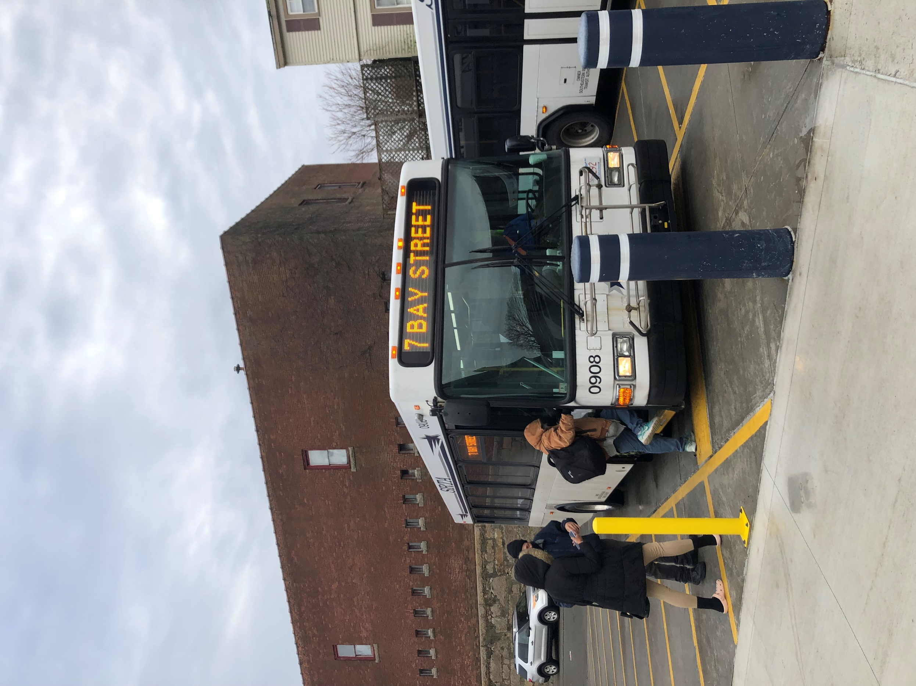
Southeastern Regional Transit Authority
Title VI Program
February 2022
Adopted by the Southeastern Regional Transit Authority Advisory Board on x/xx/22.
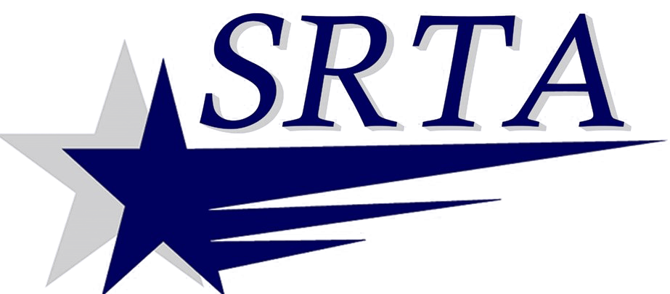

Cover image source: Nelson\Nygaard Consulting Associates, Inc.

Table of Contents
Page
1 Introduction 1-1
1.1 About Title VI 1-1
1.2 About SRTA 1-2
1.3 About This Title VI Program 1-7
2 General Reporting Requirements 2-1
2.1 Title VI Notice to the Public 2-1
2.2 Title VI Complaint Procedures and Forms 2-3
2.3 Prior Complaints and Investigations 2-9
2.4 Other Title VI Requirements 2-11
3 Public Participation Plan 3-1
3.1 Overview 3-1
3.2 Public Engagement Methods 3-1
3.3 Public Participation Procedures 3-6
3.4 Plan to Engage Minority and Limited-English Proficient Populations 3-9
3.5 Summary of Public Outreach Activities 3-11
4 Language Assistance Plan 4-1
4.1 Four-Factor Analysis 4-1
4.2 Implementation Plan 4-21
5 Demographic Data and Maps 5-1
5.1 Service Area Demographic Profile 5-1
5.2 Demographic Maps 5-3
5.3 Route Classification 5-9
5.4 Demographic Profile of Customers 5-11
6 Systemwide Service Standards and Policies 6-1
6.1 Service Standards 6-1
6.2 Service Policies 6-4
7 Service Monitoring Program and Results 7-1
7.1 Monitoring Program Summary 7-1
7.2 Vehicle Load 7-2
7.3 Vehicle Headway 7-4
7.4 On-Time Performance 7-6
7.5 Service Availability 7-8
7.6 Distribution of Transit Amenities 7-9
7.7 Vehicle Assignment 7-9
8 Service and Fare Changes 8-1
8.1 Major Service Change Policy 8-1
8.2 Adverse Effects 8-2
8.3 Disparate Impact Policy 8-3
8.4 Disproportionate Burden Policy 8-4
8.5 Findings of Service Equity Analyses 8-5
8.6 Findings of Fare Equity Analyses 8-5

Introduction
This Title VI report has been prepared by the Southeastern Regional Transit Authority (SRTA) in compliance with the Federal Transit Administration (FTA) of the United States Department of Transportation’s (USDOT’s) Title VI guidance. The purpose of this report is to ensure the SRTA’s policies and programs meet the civil rights guidelines and obligations established by FTA’s current Title VI circular (FTA C 4702.1B) to provide equitable transit services and benefits across the SRTA’s service area.

1.1 About Title VI
Title VI of the Civil Rights Act of 1964 requires that “no person in the United States shall, on the ground of race, color, or national origin, be excluded from participation in, be denied the benefits of, or be subjected to discrimination under any program or activity receiving federal financial assistance”. This provision of the Civil Rights Act is followed by agencies that receive federal financial assistance.
The FTA maintains a guiding document that describes the requirements of the Title VI program and establishes rules federal funding recipients must follow. This document, called a ‘circular’, was first published by the FTA on May 26, 1988, as FTA C 4701.1. The circular was updated on May 13, 2007 as FTA C 4701.1A, and again on October 1, 2012 as FTA C 4702.1B. The 2012 circular is the current guidance that this report follows. Appendix A of this document includes a checklist demonstrating this Title VI Program’s compliance with the circular.

1.2 About SRTA

Authorization and Origins
SRTA was established under Massachusetts General Law (MGL) 161B in 1974. The SRTA service area covers 289 square miles, 322,845 residents, and serves Acushnet, Dartmouth, Fairhaven, Freetown, Mattapoisett, New Bedford, Somerset, Swansea, and Westport with fixed-route and demand-response public transit.

Service Area Overview
SRTA’s fixed-route and demand-response systems are dispatched from two garages: one in Fall River and one in New Bedford. Fall River fixed-route service originates from the Fall River Terminal on 4th Street. New Bedford fixed-route service originates from the New Bedford Terminal on Elm Street. The two terminals are connected via the New Bedford/Fall River intercity local and express routes. SRTA provides approximately 2.7 million fixed-route passenger trips and 83,000 demand-response passenger trips annually.
Maps showing SRTA’s service area, fixed routes, facilities, and key service area destinations are in Figure 1 through Figure 3.
Figure 1 Map of SRTA Service Area with SRTA Facilities and Key Trip Generators
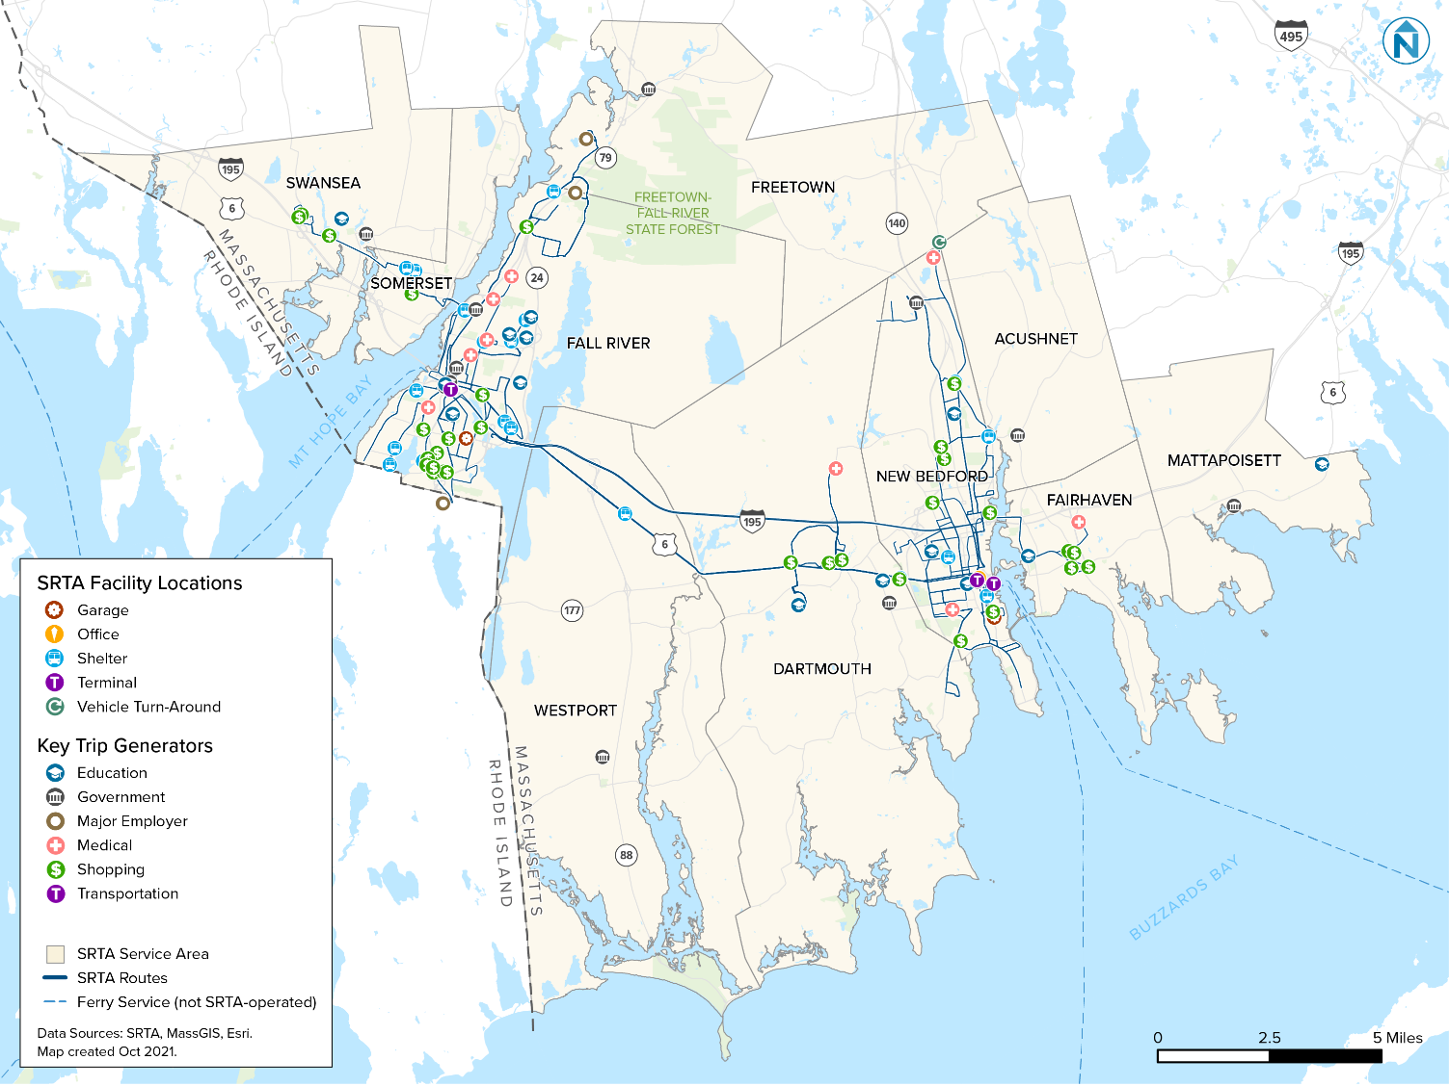
Figure 2 Map of New Bedford with SRTA Facilities and Key Trip Generators
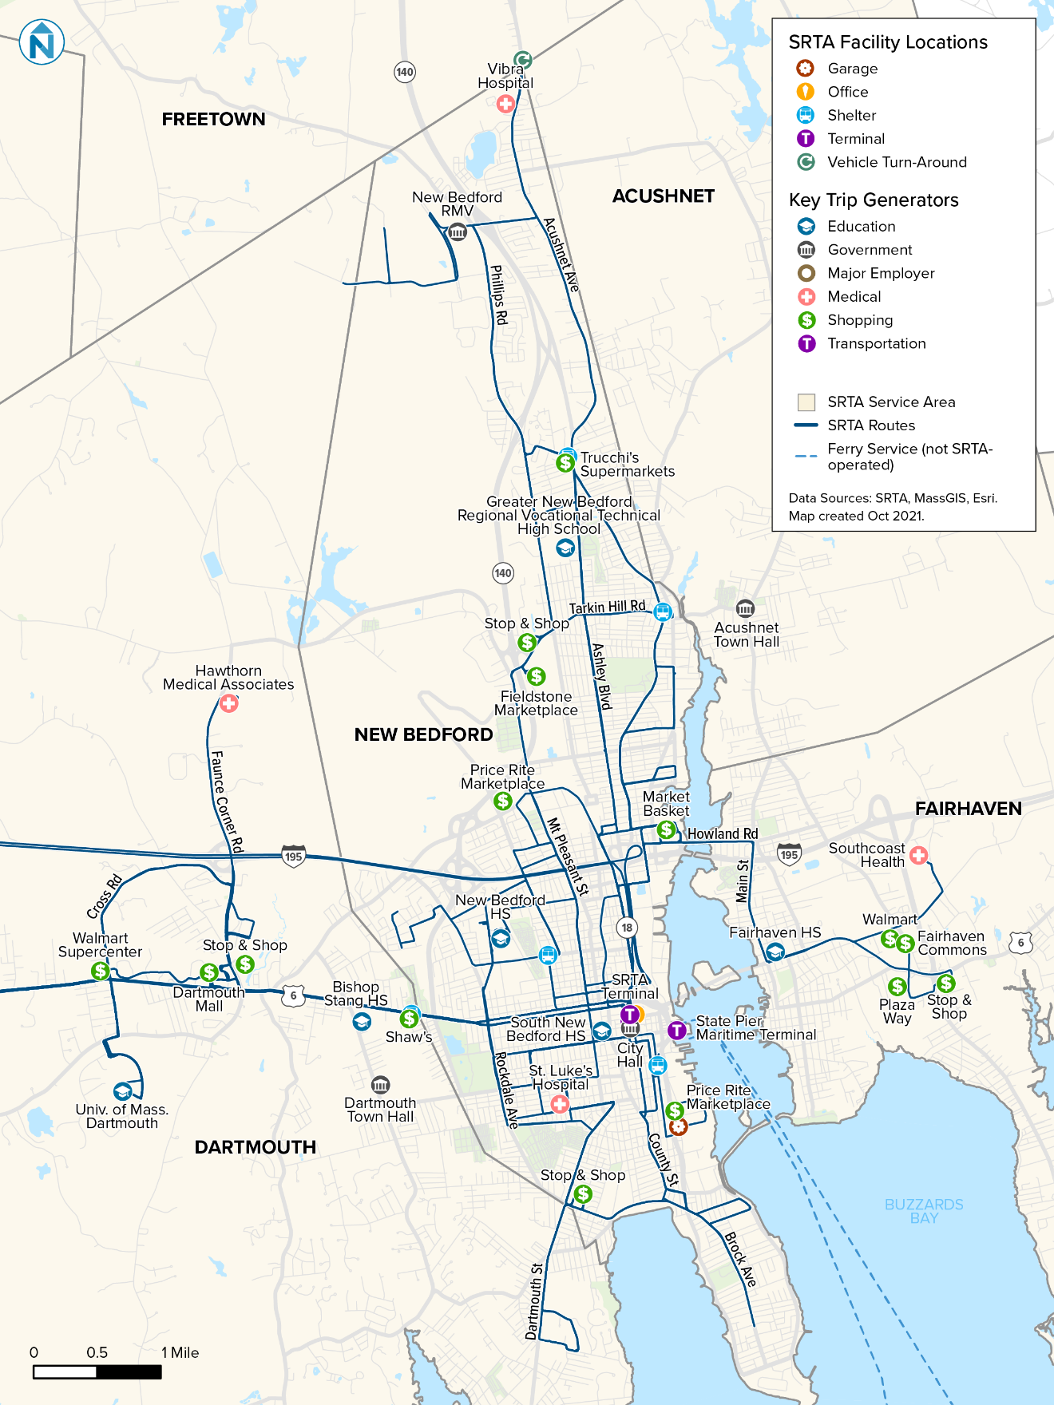
Figure 3 Map of Fall River with SRTA Facilities and Key Trip Generators
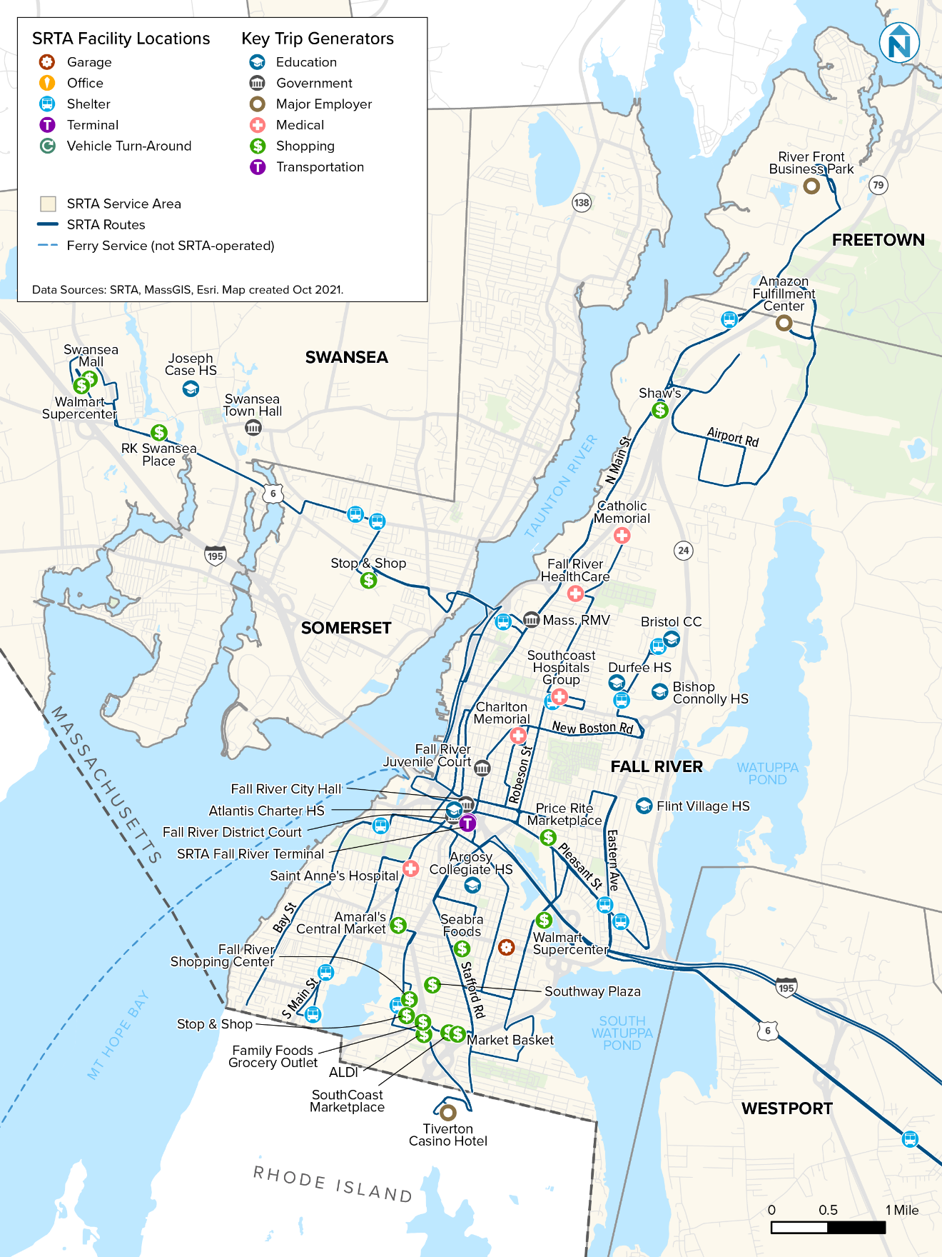

Service Overview
SRTA fixed-route service is provided on 24 routes with a weekday span of service from approximately 6:00 a.m. to 10:00 p.m. Saturday fixed-route service operates from approximately 6:00 a.m. to 8:00 p.m. There is no fixed-route service on Sundays and holiday service follows a Saturday schedule. Demand-response service is available in all ten service-area communities on every day of the week, and exceeds the minimum coverage prescribed by the Americans with Disabilities Act (ADA) of 1990.

Budget, Governance, and Operations
The SRTA annual operating budget is approximately $19 million, and revenue is earned through rider fares, advertising on physical assets, assessments to service area communities, Commonwealth contract and capital assistance grants, and federal grants for capital and operating expenses. SRTA is governed by an advisory board of chief elected officials from each service area community, a disabled community representative, and a rider representative. The advisory board appoints the administrator, approves the annual budget, establishes levels of service and fares, and approves the purchase and sale of real property.
In accordance with MGL 161B, fixed-route and demand-response transit operations must be contracted with an operating company. SRTA’s current operating company, South Coast Transit Management (SCTM), is a wholly owned subsidiary of First Transit. SCTM is responsible for providing operators and maintenance staff, operating fixed-route and demand-response service, maintaining capital assets, and reporting system performance to SRTA. The operating contract with SCTM was renewed in 2021, with SCTM providing a general manager and an assistant general manager of operations.

Mission Statement
SRTA’s mission is to provide safe, convenient, and economical transportation opportunities for people that supports economic development and improved quality of life for South Coast residents.

Title VI Program Update
This Title VI Program is an update of SRTA’s 2019 Title VI Program, and was prepared by SRTA and its consultant, Nelson\Nygaard Consulting Associates, Inc. SRTA is responsible for the final layout and contents of the report. Questions or comments about the content of this report can be addressed to:
Shayne M. Trimbell, AICP
Director of Transit Planning
Southeastern Regional Transit Authority
700 Pleasant Street, Suite 530
New Bedford, MA 02740

1.3 About This Title VI Program
This Title VI Program has been prepared in accordance with FTA C 4702.1B. In the Title VI Program, FTA guidance is addressed using various analytical methods (e.g., maps, charts, tables), using quantitative and qualitative data.
- Chapter 1 introduces federal Title VI law, SRTA, and this Title VI Program.
- Chapter 2 includes SRTA’s general Title VI compliance documents and procedures and summarizes Title VI complaints lodged since SRTA’s last Title VI Program was submitted.
- Chapter 3 summarizes SRTA’s public participation plan (PPP), including tactics for engaging with minority and limited-English proficient (LEP) people. This chapter also lists outreach activities conducted by SRTA since submission of the agency’s last Title VI Program.
- Chapter 4 includes SRTA’s Language Assistance Plan (LEP Plan), which includes the four-factor analysis that describes the number of LEP people likely to be encountered by SRTA. This chapter also describes how SRTA engages with these populations.
- Chapter 5 describes SRTA’s service area demographic profile and distribution of low-income and minority people. This chapter classifies SRTA routes based on the area they serve as minority or non-minority.
- Chapter 6 describes SRTA’s service standards and policies, including those for vehicle load, vehicle headway, on-time performance, service availability, distribution of transit amenities, and vehicle assignment.
- Chapter 7 reports the results of SRTA’s service monitoring program, identifying routes that do or do not meet standard, and applying the disparate impact policy to route performance.
- Chapter 8 defines SRTA’s major service change policy, and the agency’s disparate impact and disproportionate burden policies, which may be applied if a major service change adversely affects low-income or minority populations. This chapter also includes any equity analyses that were completed since SRTA’s last Title VI Program submission.

General Reporting Requirements

2.1 Title VI Notice to the Public
The Title VI Notice to the Public is an essential document that indicates SRTA complies with Title VI and informs the public of their Title VI protections against discrimination. The English version of this document is in Figure 4, and translated versions of this document are in Appendix B. This notice is posted in the following locations:
- Driver’s lobby
- Fall River Terminal lobby
- Maintenance office
- New Bedford Terminal lobby
- Onboard all demand-response vehicles
- Onboard all fixed-route vehicles
- Public areas of SRTA’s administrative office, including at the reception desk and in meeting rooms
- SRTA website (www.srtabus.com)
Figure 4 Title VI Notice to the Public
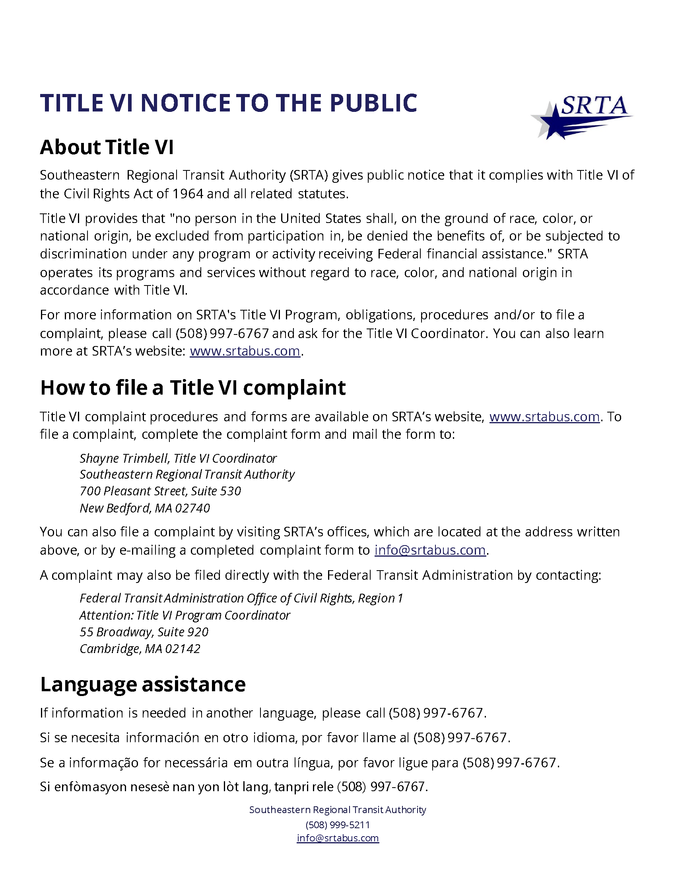

2.2 Title VI Complaint Procedures and Forms
Community members have the right to file a Title VI complain with SRTA. Community members also have the right to file a complaint with an external entity such as USDOT, a federal or state agency, or a federal or state court.
The Title VI complaint procedure is described below.
- When a complaint is received by SRTA, the Title VI Coordinator will acknowledge the complaint within ten days by a phone call or mail, depending on contact information provided. If a complaint is incomplete, additional information will be requested, and the complainant will have 30 business days to submit the required information. If the information is not received within 30 business days, the case can be administratively closed by SRTA. A case can also be administratively closed if the complainant no longer wishes to pursue their case.
- Should a complaint be filed with SRTA and an external entity simultaneously, the external complaint shall supersede the SRTA complaint and SRTA's complaint procedures will be suspended, pending the external entity's findings.
- Within 15 business days from receipt of a complete complaint to SRTA, a determination will be made if the complaint has sufficient merit to warrant investigation as a Title VI complaint. The complainant will be notified of the decision within five days of the date the decision is made. If the decision is not to investigate the complaint as a Title VI complaint, the notification shall specifically state the reason for the decision.
- Investigation:
  - The investigation will address complaints against SRTA and be conducted in conjunction with and under the advice of the Title VI Coordinator.
  - The investigation may include discussion of the complaint with all affected parties to determine the problem. The complainant may be represented by an attorney or other representative of his/her own choosing and may bring witnesses and present testimony and evidence during the investigation.
  - The investigation will be conducted and completed within 60 days of the acceptance of the formal complaint.
  - Based on all the information received, an investigation report will be written by the Title VI Coordinator for submittal to the SRTA Administrator.
- The complainant will receive a letter stating the final decision of the Administrator by the end of the 60-day limit. The complainant shall be notified of their right to appeal the decision.
The public is made aware of their right to file a complaint through the SRTA Title VI Complaint Instructions and Procedures document, which is available at the SRTA administrative offices and on SRTA’s website (www.srtabus.com). This document is shown below in Figure 5, and translated versions are in Appendix C.

Figure 5 Title VI Complaint Instructions and Procedure
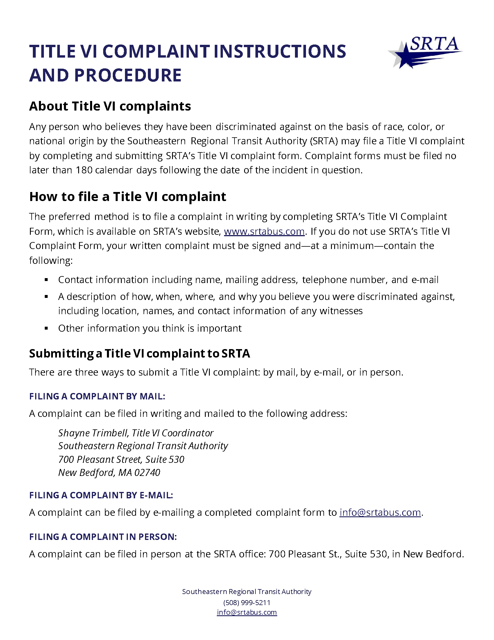

Although a Title VI complaint can be filed verbally by calling the SRTA Title VI Coordinator at (508) 997-6767, x3312, SRTA’s preferred method for receiving complaints is through the complaint form. Complaint forms are on the SRTA website (www.srtabus.com), in SRTA’s New Bedford offices, and can be requested by phone or mail. The English version of the complaint form is in Figure 6 and translated versions are in Appendix C.

Figure 6 Title VI Complaint Form
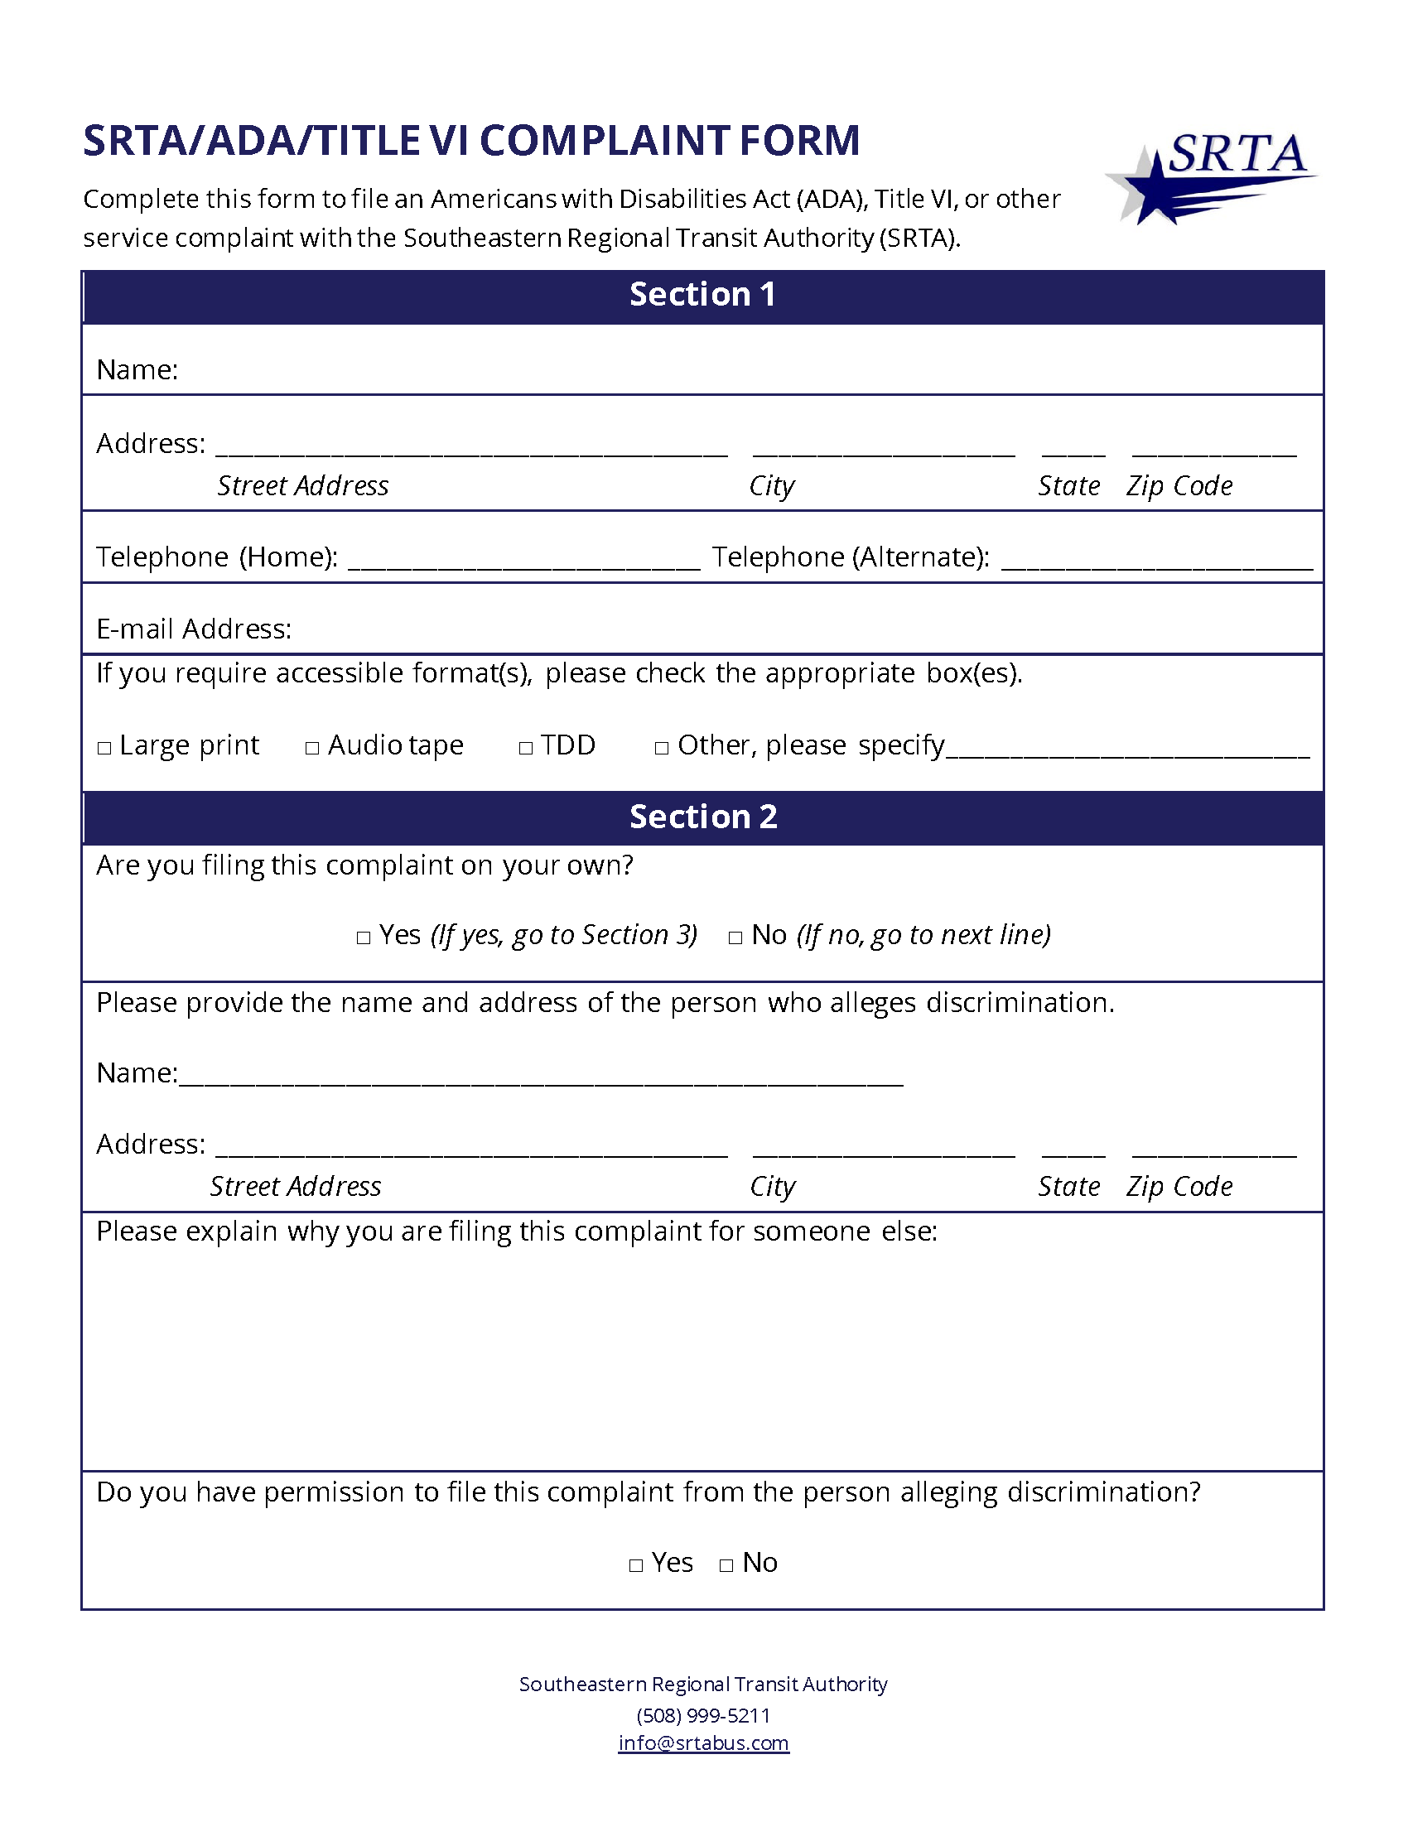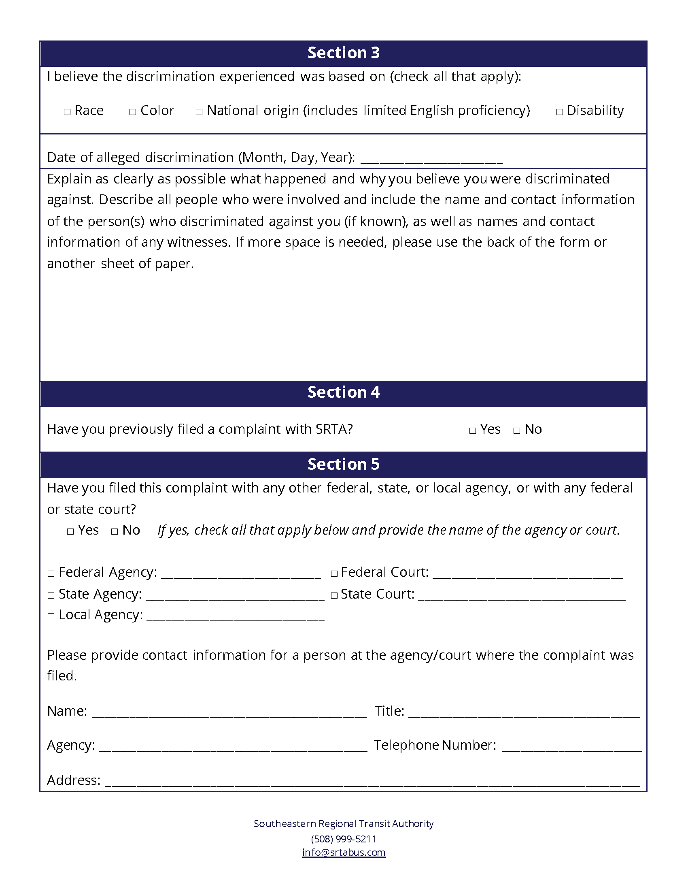
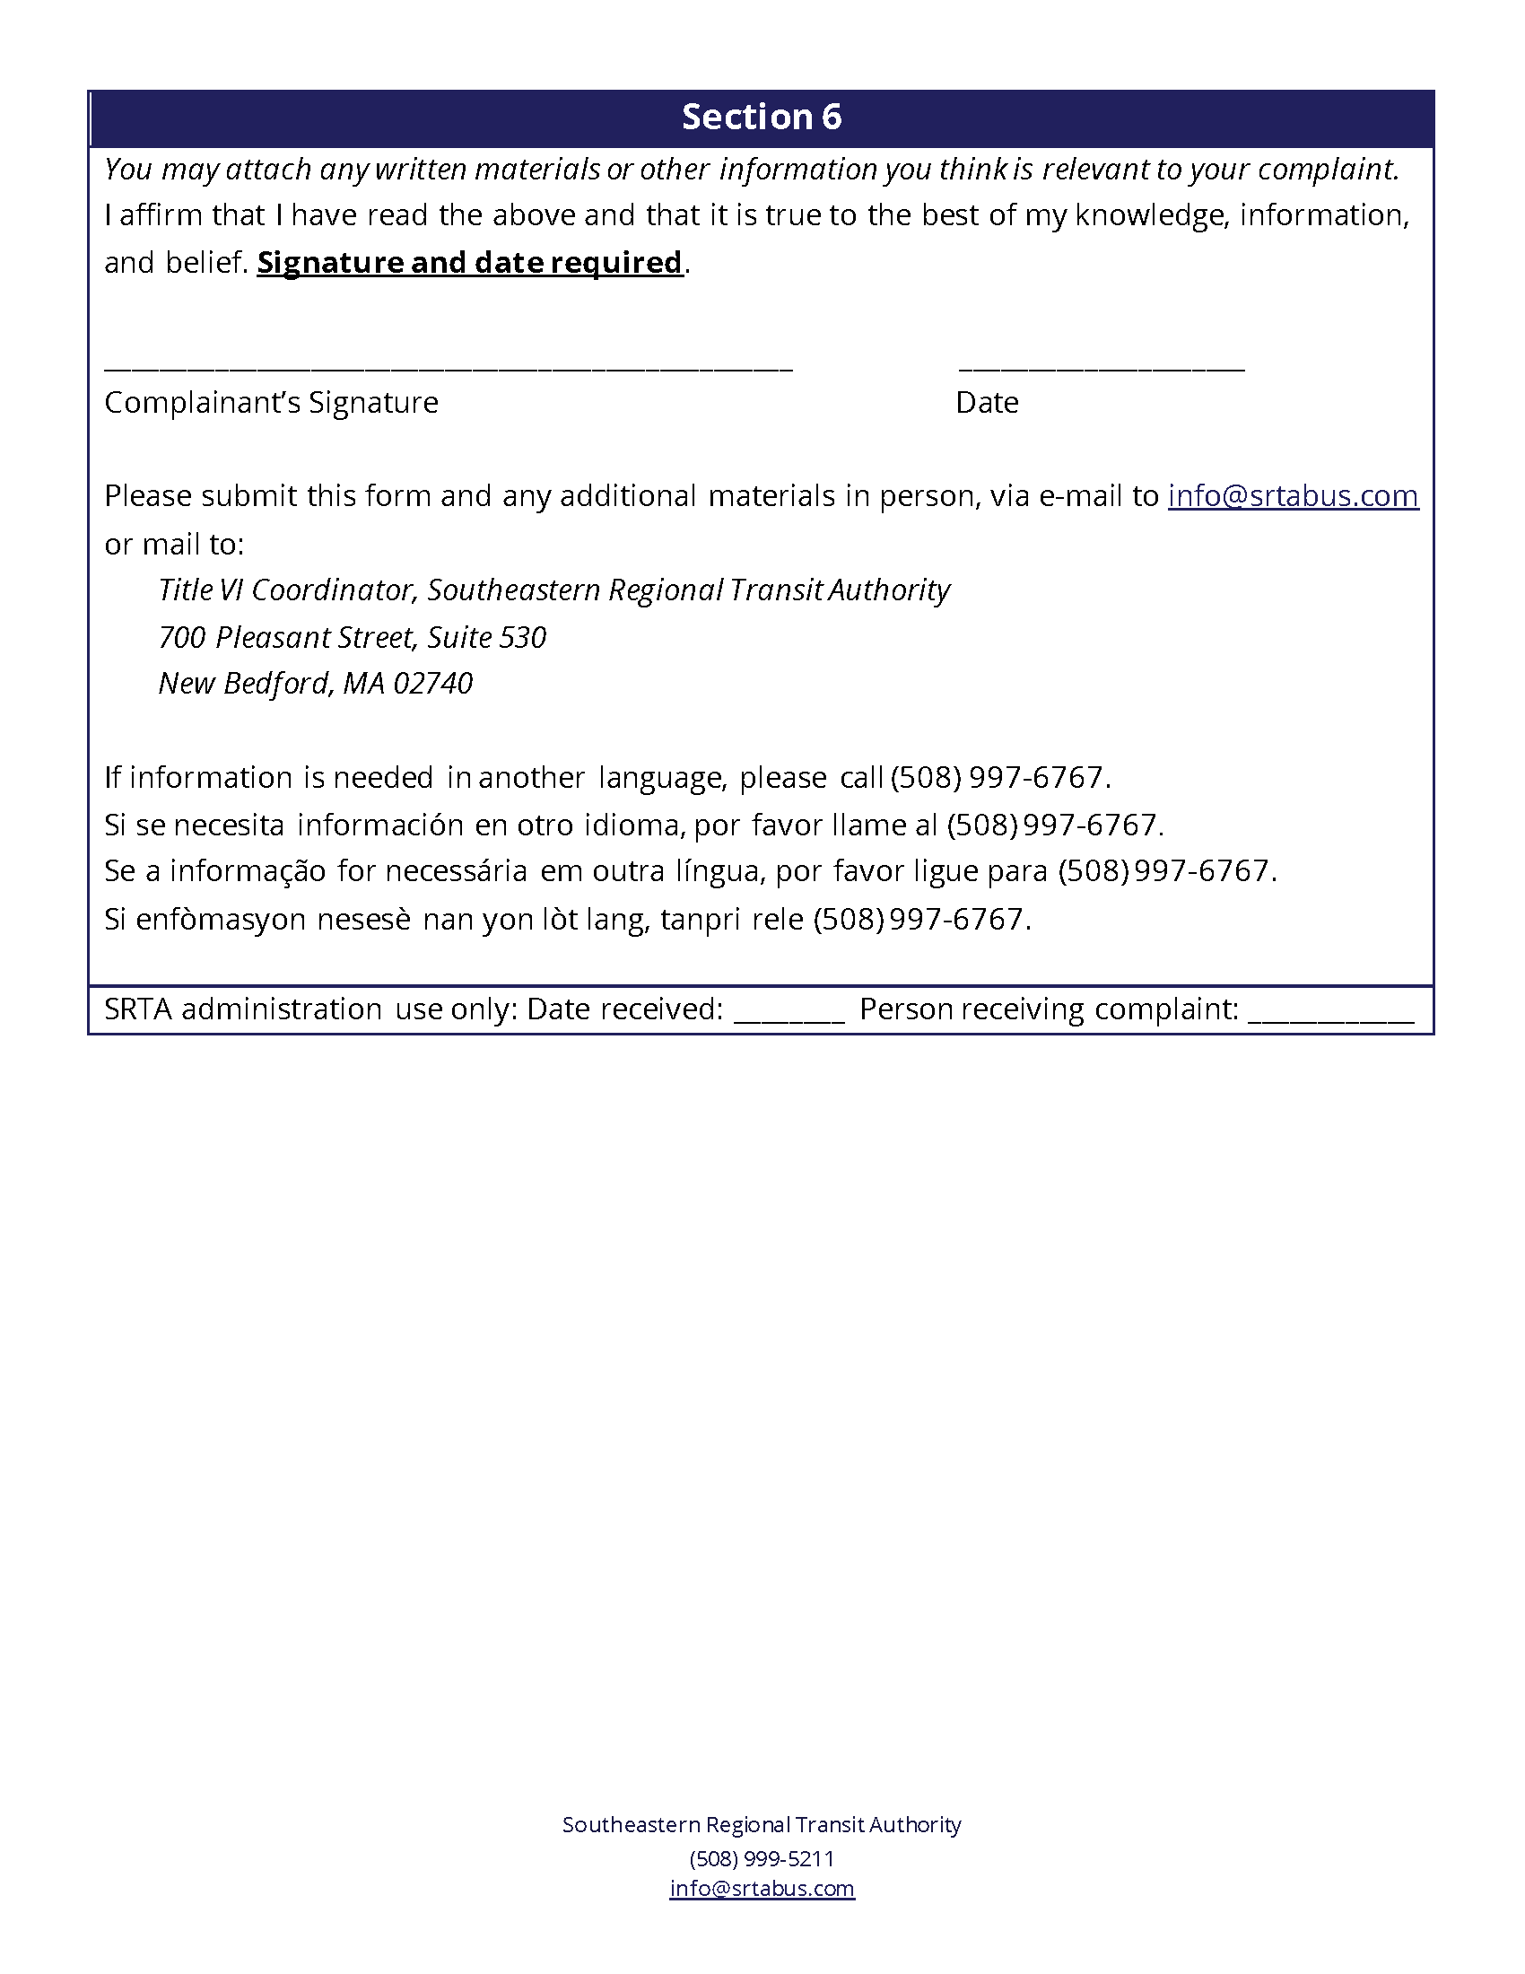

2.3 Prior Complaints and Investigations
SRTA tracks Title VI investigations, lawsuits, and complaints. The SRTA Title VI Coordinator is responsible for maintaining this list, which records complaints using the following fields:

- Case number
- Case type (investigation, lawsuit, complaint)
- Name
- Address
- Basis of complaint (race, color, and/or national origin)
- Summary of complaint
- Date submitted
- Date of alleged incident
- Complaint complete
- Acknowledgement due date
- Acknowledgement sent date
- Decision to investigate
- Complainant notification due date
- Complainant notification date
- Investigation completion due date
- Investigation completion date
- Action taken
- Complaint status

SRTA acknowledged and investigated two Title VI complaints between February 1, 2019 and February 1, 2022 (Figure 7). Only one of the complaints was determined to be a valid Title VI complaint and is under investigation as of the date of this Title VI Program.
Figure 7 Summary Table of Acknowledged and Investigated Title VI Complaints
Complaint Basis and Date Submitted | Date of Alleged Incident | Complaint Summary | Comments | Actions Taken | Status
National Origin,  2/20/20 | 2/20/20 | Operator engaged in argument with complainant as they were boarding and during argument made a rude, national-origin based comment to complainant. Complainant was denied service. | Customer could not be reached to confirm complaint and gather more details needed to investigate under the Title VI policy. | N/A | Closed
Race,  7/1/21 | Specific dates identified in complaint | Former employee alleges racial discrimination on the job. Complainant filed a complaint through the Massachusetts Commission Against Discrimination (MCAD). | MCAD will investigate this complaint. Under SRTA Title VI policy, the MCAD investigation supersedes SRTA’s and the outcome will be accepted and placed on file. | MCAD investigation is ongoing. | Open

2.4 Other Title VI Requirements
This section includes documentation of the relevant Title VI guidance that is not applicable to SRTA.

Minority Representation on Appointed Committees
SRTA does not have any non-elected planning boards, advisory councils, or committees for which the membership is selected by SRTA. SRTA Advisory Board members are appointed by member communities.

Subrecipient Monitoring
SRTA does not have any sub-recipients.

Equity Analysis for Constructed Facilities
SRTA has not constructed any facilities since the previous Title VI Program was submitted to the FTA on February 21, 2019.

Public Participation Plan

3.1 Overview
Public participation is integral to the planning process for SRTA service and occurs before major changes to service and fares. Including the public in the decision-making process is the right thing to do and required by statute under 49 U.S.C. sections 5307(b) and 5307(c)(1)(I).
This chapter describes SRTA’s public participation plan (PPP), which includes outreach methods and tactics for engaging minority and LEP people. The chapter also summarizes public engagement activities since February 21, 2019, when the previous Title VI Program was submitted.
Public participation is most effective when it includes all people, regardless of race, color, national origin, or their ability to speak and understand English. Moreover, it is important that community members have confidence they will be heard, that their input will be valued, and that their input will be considered properly when decisions are made. There may be times when a decision is unpopular, just as there are times when a decision is lauded by the community. Regardless of a decision’s popularity, the public should always have ample opportunity to participate in the decision-making process.

3.2 Public Engagement Methods
In accordance with 49 U.S.C. Sections 5307(b) and 5307(c)(1)(I), public participation is required prior to raising fares or implementing a major service change. SRTA defines a major service change as one in which an individual fixed route’s, or the full fixed-route system’s daily revenue mileage is permanently increased or decreased by more than 25%, or in which a demand-response service area’s size or daily span of service is permanently increased or decreased by more than 25%. Public participation is also required prior to constructing transit facilities.
In addition to statutory requirements for public participation, SRTA uses several methods for public engagement, which are described below.

Open Forum
The open forum is the most open, least structured form of public engagement employed by SRTA; the first open forum was held in June 2017. Open forums are held periodically and without a specific topic to be addressed but rather as a way for the public to speak directly with SRTA planning and administrative staff and provide ideas for improvement, share experiences with the service, and communicate directly to SRTA. The forums are held in the Fall River and New Bedford terminals with staff on hand to speak with customers. Open forums are scheduled during times of the day when passenger volumes are greatest in the terminals and held on multiple days to provide ample opportunities for engagement.

Public Meeting
Public meetings are more formal than open forums and are held when a specific issue is being addressed. Public meetings are the first point of contact with the public to present proposed service or fare changes. Public meetings include large-format visualizations of proposals, staff to speak with members of the public, a formal presentation at scheduled times, surveys, and other methods to record public input.
Public meetings are held as close to potentially impacted communities as possible so members of the impacted community do not need to travel far to participate. Meetings are publicly accessible and ADA-compliant. When applicable, meetings are scheduled for times when the affected route or service operates.
Visualizations are an important element of public meetings. Visualizations are typically large-format posters with descriptions, maps, or design concepts. Posters can be used to describe the issue being discussed and can also collect input by providing community members an opportunity to interact with the display. Interactive visualizations ask meeting participants to mark areas of importance, provide prioritization of concepts, and provide feedback on areas of concern.
Notices of public meetings are made no less than two weeks prior to the meeting date. Notices are posted in the SRTA terminal and buses that serve the affected area (i.e., meetings held in Fall River are posted in the Fall River Terminal and buses; meetings held in New Bedford are posted in the New Bedford Terminal and buses). Meeting notices are posted online via Facebook, Twitter, and on SRTA’s website. Notices are also sent to local agencies that may serve affected populations, for distribution to their networks.
Public meetings are staffed with people able to interpret Portuguese, Spanish, and Haitian Creole, and language assistance information is included on the posted meeting notice. Meeting notices are prepared in English, Portuguese, Spanish, and Haitian Creole, the four most prevalent languages spoken in the SRTA service area.
During public meetings, attendees are asked to provide optional basic personal information, such as name, address, phone number, and e-mail address. The record of attendees is kept on file, along with a summary of the meeting and issues discussed.

Public Hearing
Public hearings are the most formal method of public involvement and are held to receive public comment on a specific service change or fare change. The testimony provided during the hearing is recorded and transcribed verbatim and kept on file as part of the project record. The hearing testimony is reviewed and an assessment of whether the public comment supports or refutes the proposal is provided with the hearing record.
Public hearings are held in places accessible by the SRTA fixed-route system and in buildings with access for people with disabilities. Public hearings are scheduled at times that allow the public to use the SRTA system as a means of transportation to and from the hearing. Hearings are staffed with people able to interpret Portuguese, Spanish, and Haitian Creole, and language assistance information is included on the posted meeting notice. Hearing notices are prepared in English, Portuguese, Spanish, and Haitian Creole, the four most prevalent languages spoken in the SRTA service area.
Notices of public hearings are made no less than two weeks prior to the hearing date. Notices are posted in the SRTA terminal and buses that serve the affected area. Hearing notices are posted online via Facebook, Twitter, and on SRTA’s website. Notices are also sent to local agencies that may serve affected populations, for distribution to their networks.
During public hearings, attendees are asked to provide a name and city of residence before starting their testimony. This information is included in the hearing record so comments can be properly attributed.
Public hearings are held on the last day of the 30-day public comment period for service and fare change proposals. Public comment periods extend no fewer than thirty days from the date of the public hearing; written comments are accepted by SRTA via mail, e-mail, or in-person delivery, and are given equal consideration to verbal testimony.
All comments received prior to the hearing will be entered into the record at the hearing and considered with the same weight and value as those presented during the hearing. The decision to implement a proposed service or fare change occurs after the public comment period is closed, comments are recorded to the project file, and an assessment of public comments is complete. Public comments are considered as part of the decision to implement a service or fare change; some circumstances, however, require a change is implemented despite public opposition.
Public comments are an important part of the decision-making process, and in most cases, a decision is supported by public comments. There are rare cases where a decision may not be supported by public comment, yet circumstances dictate a change is necessary. These instances are rare and generally driven by SRTA resource availability. Changes that are not supported by public comments are implemented so long as measures are in place to mitigate any disparate impact on minority populations or disproportionate burden on low-income populations.

Advisory Board Meetings
SRTA is governed by a twelve-member advisory board, with one representative from each of the service area communities, one representative of the disabled community, and one rider representative. The Advisory Board meets periodically throughout the year with an annual minimum requirement of six meetings. Meetings alternate between Fall River and New Bedford city halls. Advisory Board meetings are public and subject to public meeting laws.
Advisory Board agendas include time for the public to testify to the board on any subject. Comments received during this period are recorded in the meeting minutes and, when relevant to an ongoing project, the minutes are retained with the project file.

Customer Survey
Customer surveys are a way to collect and record passenger data in a uniform manner that allows for analysis and reporting of results. Surveys are used for specific issues or proposals, such as a service or fare change, or for developing a customer demographic profile, identifying changes in customer opinions and riding trends, or understanding transit demand in unserved areas. Surveys are conducted in terminals, on buses, at the sites of proposed service changes, or any relevant location. Surveys are generally distributed, completed, and collected in-person. When appropriate, a digital survey is administered either in-person with a tablet computer or remotely, as an internet survey. SRTA prepares surveys in English, Portuguese, Spanish, and Haitian Creole.

Demand-Response Consumer Advisory Meetings
SRTA hosts quarterly Demand-Response Consumer Advisory meetings in which demand-response riders are encouraged to participate and provide feedback on their experience with the service. The meetings bring together customers, operations managers, and customer service staff for the purpose of discussing the service and identifying areas for improvement. These meetings are held as roundtable discussions and are important opportunities for demand-response riders to speak candidly about their service experiences, raise complaints and commendations, and discuss ideas to improve the service.
Consumer advisory meetings are open to the public and advertised on demand-response vehicles. An e-mail meeting notice is also sent to demand-response customers that have registered their e-mail address with SRTA. Demand-response customers that wish to attend a meeting in person receive a zero-fare ride to and from the meeting. A meeting summary is prepared, distributed via e-mail to those that attended, and kept on file.

Ad Hoc Meetings with Social Service Agencies and Business Groups
SRTA staff sometimes meet with social service agencies and business groups to understand how potential changes may affect demand for service. Engagement with various stakeholders differs and is typically issue-specific. As such, these meetings and engagement do not generally occur on a regular basis.

Social Media and Online Engagement
SRTA recognizes the ubiquity of social media and has accounts on Facebook, Twitter, and Instagram. These accounts allow SRTA to share information directly with customers.
Social media platforms include translation tools that let users translate SRTA communications into a language of their choosing. These translation tools reduce the translation burden on both SRTA and users, enabling better access to information for LEP people.
Social media also lets customers provide feedback by posting comments or sending messages that are then reviewed by SRTA staff. Post comments are kept private because commenters occasionally use obscene language and SRTA does not have the staff resources to review each comment.

3.3 Public Participation Procedures
The public engagement methods described above are used differently, depending on the type(s) of engagement needed. The public participation procedures below show how SRTA determines the appropriate engagement method(s) and ensures community members and SRTA riders can participate meaningfully and substantially. The procedures below are guidelines that can be followed for most SRTA projects or initiatives.

Step 1: Determine if public participation is required or appropriate
The first step in engaging the public is to determine if the topic or issue requires public participation. SRTA engages the public for all fare changes and for any service change that is considered a major service change. Public participation is also required prior to constructing transit facilities. This standard ensures the public is engaged for service or fare changes that will affect a substantial portion of the service they use, and also gives SRTA the ability to make minor changes (such as adding a stop on a route or changing a trip departure time slightly) without engaging the public.

Step 2: Identify the affected population
If the results of Step 1 indicate public participation is appropriate, the next step is to identify the likely population affected by the proposed change. For fare changes, the affected population is all riders and residents of the SRTA service area, however smaller service changes are likely to affect only a subset of the service area population. SRTA keeps demographic information in a geographic information system (GIS), organized by route. As part of developing the proposed service change, SRTA will analyze demographic information to identify the affected population, determine the minority and low-income status of the affected population, and determine the languages likely spoken by the affected population.

Step 3: Determine the appropriate method of engagement
The method of engagement is largely determined by the scope of the project and the intended outcome. The choice of method is also determined by the extent of the affected population and the demographic composition of the population. Good public engagement requires considerable staff resources, so it is important that engagement methods properly match the project scope. The following guidelines help choose the appropriate method of engagement:
- Is SRTA fact-finding, or learning about topic before developing plans? If so, appropriate engagement methods may be:
  - Customer surveys, online and in-person
  - Ad-hoc meetings with groups representing the affected population
  - An open forum
  - A public meeting
- Is SRTA presenting service or fare change proposals? If so, appropriate engagement methods may be:
  - Customer surveys on affected routes and at affected stops
  - Ad-hoc meetings
  - A public meeting in the affected area
  - A demand-response consumer advisory meeting
- Is SRTA making a final decision on service or fare change? If so, appropriate engagement methods may be:
  - A public hearing
Public participation needs vary by project and should match a project’s scope and scale. Service changes that only affect a small area or population require less engagement than projects that affect several routes or larger portions of the service area population. Affected population demographics also guide engagement method selection. If the people being engaged fall under LEP Plan guidance, engagement methods should include translation of materials and having interpreters present during the meeting.

Step 4: Choose an appropriate time and location for public participation events
The time and location of meetings are important to ensuring the public can participate. Meetings are held as close to the affected area as possible to reduce the travel burden for the affected population, and are located on a SRTA fixed route that is in service before and after the meeting. Meeting places are accessible for people with disabilities, have enough space for the anticipated number of attendees, are well lit, and have reasonable acoustics so attendees can clearly hear any presentation or dialogue. SRTA will accommodate the hearing impaired by providing assistive listening devices, if requested. Requests for assistive listening devices need to be acknowledged by SRTA seven days in advance of the event, to provide time for devices to be procured for the meeting.
Meeting days and times are scheduled to accommodate community needs and are typically scheduled during weekday late afternoon or early evening hours. Times are chosen to allow participation by people that work during the day. Sometimes, public outreach is conducted on weekends; the type of outreach most commonly done on weekends is passenger surveying. Open forums are typically scheduled for the busiest times in the SRTA terminals, to include as many customers as possible.

Step 5: Advertise the public participation event
Once public engagement methods have been chosen, locations identified, and times selected, the public must be made aware of the opportunity to participate. SRTA posts notices of public participation no later than two weeks in advance of the event date. These postings include the date, time, and location of the meeting, with directions to the location. The postings include information about the event purpose, any proposals, and a reminder that the public is encouraged to participate. All notices include information in English, Portuguese, Spanish, and Haitian Creole, and are posted on all SRTA fixed-route buses (and demand-response vehicles, if demand-response riders are likely to be affected) and in SRTA terminals. SRTA also uses social media to promote events.
In the case of customer surveys, notices explain when and where surveyors will conduct the survey and generally include a link to an online version of the survey.

Step 6: Hold the event
The event is held at the location and the time advertised. Participants are asked to provide basic personal information upon entry (e.g., name, place of residence, phone number, e-mail address). The space is arranged according to the purpose:
- Open Forums: Tables are set up in the direct line of sight of people in the terminal. Visualizations are large format and generally interactive. Staff are available to speak with customers. No sign-in is requested.
- Public Meetings: Visualizations (e.g., posters) are set up in stations to allow for one-on-one conversation between SRTA staff and participants. Seating is available in the meeting space, and is oriented towards the podium and presentation screen, if a presentation is planned. Upon entry, attendees are asked to provide basic personal information and are given any print materials relevant to the topic of discussion; print materials are prepared in English, Portuguese, Spanish, and Haitian Creole.
- Public Hearing: The room is set up with seating facing the front of the room. A table and chairs are placed at the front of the room for SRTA staff to sit at while receiving testimony. A space is provided for attendees to stand and address SRTA. The attendees that provide testimony are asked to give their name and place of residence. Any visualizations or printed material is given to attendees when they enter. The hearing is opened by SRTA with a description of the change for which comment is sought.

Step 7: Summary Report
At the conclusion of the public input event and after the written comment period closes, a summary report is prepared to document public participation. The summary report describes the event that was held, the process followed (steps 1 through 6), and comments received. The report is placed on file with the project and is included as an appendix to the final project report. If a decision is made to implement the proposed change, the summary report is used as a reference document in the decision. All public participation efforts are reported to the advisory board and recorded in board meeting minutes.

3.4 Plan to Engage Minority and Limited-English Proficient Populations
The events and outreach described in SRTA’s PPP are applicable to all people living in SRTA’s service area, including low-income, minority, and LEP populations. In addition to this inclusive outreach, SRTA has specific plans for engaging minority and LEP populations, per FTA guidance. Some of the methods SRTA uses to ensure high-quality engagement with minority and LEP people are:
- Planning events for times and at locations that are accessible to minorities and LEP people.
- Ensuring vital documents, visualizations, presentations, and other engagement materials are translated into languages spoken in the community that is being engaged with.
- Engaging with community-based organizations (CBOs) to ensure SRTA is reaching minority and LEP populations with outreach and, if needed, conduct more targeted outreach based on input from these CBOs.

3.5 Summary of Public Outreach Activities
SRTA has conducted many public outreach activities since submission of its last Title VI Program. Figure 8 summarizes these events.
Figure 8 SRTA Public Outreach Activities
Outreach Activity | Dates
Open Forum | October 28, 2019  October 29, 2019
Public Meeting | July 10, 2019: Tripp Towers Shoppers Shuttle Meeting
Public Hearing | September 17, 2020: Route Change Public Hearing  June 17, 2021: Route Change Public Hearing
Advisory Board Meetings | March 28, 2019  May 23, 2019  September 26, 2019  October 21, 2019  November 21, 2019  January 16, 2020  February 27, 2020  April 22, 2020  May 28, 2020  December 16, 2020  February 25, 2021  March 31, 2021  April 29, 2021  May 27, 2021  June 14, 2021
Customer Survey | Fare Equity Analysis Customer Survey  Comprehensive Regional Transit Plan Customer Survey  New Bedford Industrial Park Customer Survey
Demand-Response Consumer Advisory Meetings | September 5, 2019  March 3, 2020: Scheduled but cancelled due to COVID-19  October 29, 2020  May 20, 2021: Held in-person with dial-in option  November 10, 2021
Non-SRTA Events  (SRTA was invited to share information) | June 15, 2019: NB Resilient Plan Public Meeting  July 1, 2019: New Bedford School District Kindergarten Registration Event  August 4, 2021: New Bedford School District Kindergarten Registration Event
Ad Hoc Meetings with Social Service Agencies and Business Groups (listed by group as meeting dates are numerous) | Atlantis Charter School  Blount Fine Foods  City of New Bedford Mobility Planning Committee  Coastal Foodshed  Fall River Amazon Fulfillment Center  Fall River Public Housing Authority  Fall River Public Schools  Freetown Stop & Shop Distribution Center  Millstone Medical  New Bedford Feast of the Blessed Sacrament  New Bedford Public Schools  Old Bedford Village Community Meeting  US Census Bureau
Social Media and Online Engagement | 2019: 50+ social media posts with more than 24,000 views  2020: 50+ social media posts with more than 52,000 views  2021: 60+ social media posts with more than 42,000 views

Language Assistance Plan
As established by Executive Order 13166, “Improving Access to Services for Persons with Limited English Proficiency”, the SRTA Language Assistance Plan (LEP Plan) describes how SRTA will address the language needs of limited-English proficient (LEP) people the agency serves, to ensure LEP people have meaningful access to benefits, services, information, and other important portions of SRTA programs and activities. The Language Assistance Plan has two sections:
- The Four-Factor Analysis determines what language services are appropriate for SRTA to provide. This analysis informs the Implementation Plan.
- The Implementation Plan establishes the framework by which SRTA ensures language assistance is available to LEP people.

4.1 Four-Factor Analysis
The FTA’s Title VI guidance requires use of the Four-Factor Analysis to help determine the specific language services that are appropriate for the recipient to provide. The Four-Factor Analysis is an individualized assessment that balances the following factors:
- The number or proportion of LEP people eligible to be served or likely to be encountered by SRTA.
- The frequency with which LEP persons come in to contact with the programs or activities provided by SRTA.
- The nature and importance of the program, activity, or services provided by SRTA to people’s lives.
- The resources available to SRTA for LEP outreach, as well as the costs associated with that outreach.

Factor 1: The number and proportion of LEP people served

LEP People Presence in SRTA Service Area
To document the presence of LEP people in the service area, SRTA uses American Community Survey (ACS) data that estimate the percent of a given population that speaks a different language at home and the percent of the population considered LEP. The ACS data used in this analysis are from 2015 five-year estimates and are analyzed at the census tract level (shown in Figure 9). Data from 2015 are used because this is the last year that this table was made available at the tract level.
Figure 9 through Figure 11 map the distribution of LEP people in SRTA’s service area, showing that LEP people live most densely in Fall River and New Bedford.
Figure 9 Map Showing the Distribution of LEP People in the SRTA Service Area
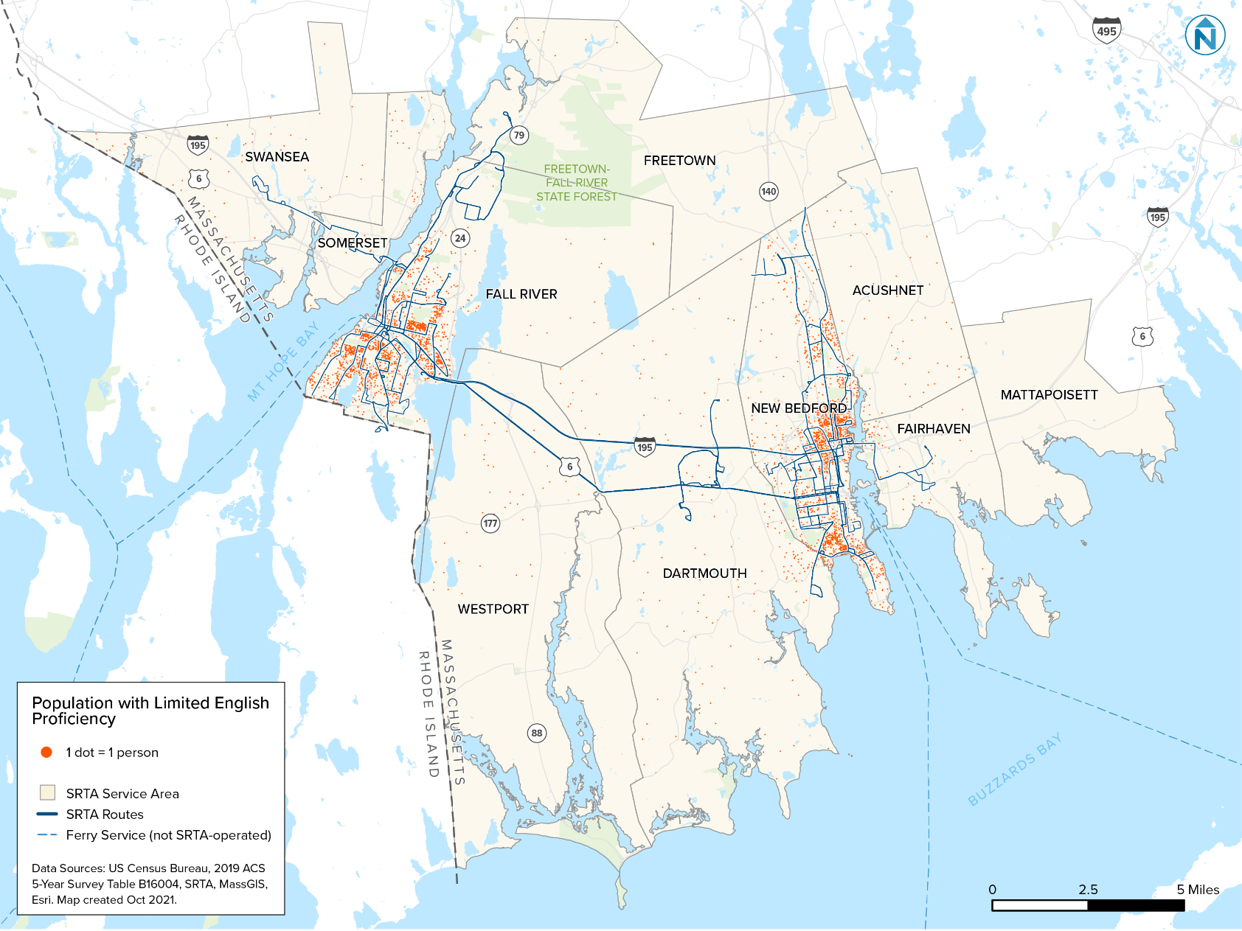

Figure 10 Map Showing the Distribution of LEP People in New Bedford
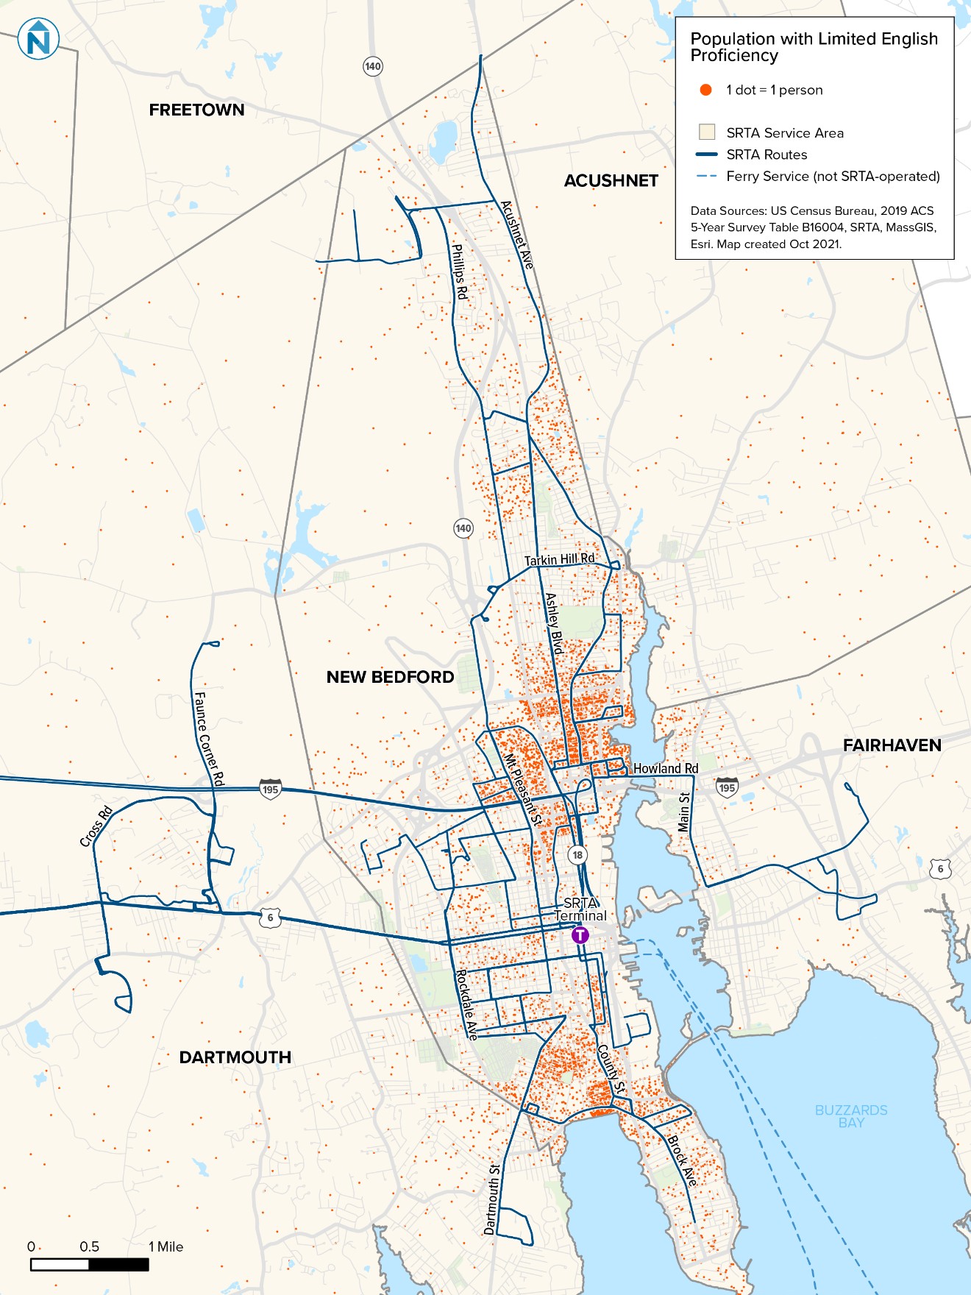
Figure 11 Map Showing the Distribution of LEP People in Fall River
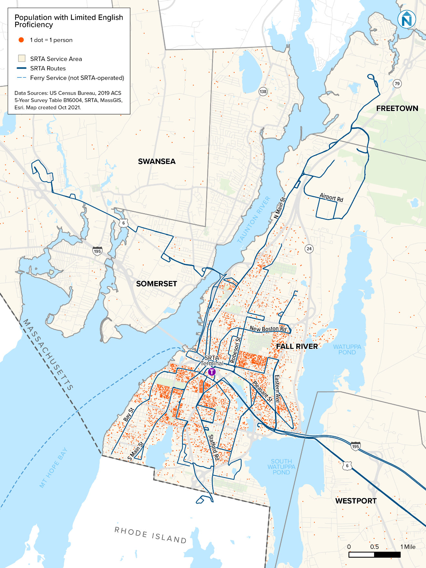

SRTA has identified 26 distinct languages spoken by LEP residents within the agency’s service area (Figure 12). The range in the number of people speaking each language varies dramatically, from about 19,000 people speaking Portuguese to approximately seven people speaking Laotian.
To assist transit agencies in determining which languages should be considered for translation or interpretation, the USDOT has adopted the DOJ Safe Harbor Provision. This provision requires written translation of vital documents for each eligible LEP language group that constitutes 5% or 1,000 people—whichever is less—of the total population. The three languages spoken in SRTA’s service area that quality as ‘Safe Harbor’ languages are bolded in Figure 12.
Figure 12 Estimated Number of LEP Residents in SRTA Service Area by Language Spoken at Home
Language | LEP Residents Speaking Language | Percent of Total Population
Portuguese or Portuguese Creole | 19,451 | 6.61%
Spanish or Spanish Creole | 8,461 | 2.88%
French Creole | 1,237 | 0.42%
Chinese | 710 | 0.24%
Mon-Khmer, Cambodian | 626 | 0.21%
French (incl. Patois, Cajun) | 441 | 0.15%
Vietnamese | 303 | 0.10%
Arabic | 191 | 0.06%
Greek | 180 | 0.06%
Polish | 149 | 0.05%
Other Asian languages | 104 | 0.04%
Korean | 96 | 0.03%
Persian | 95 | 0.03%
Other Indo-European languages | 87 | 0.03%
Russian | 74 | 0.03%
Urdu | 70 | 0.02%
Other and unspecified languages | 32 | 0.01%
Gujarati | 31 | 0.01%
Other Indic languages | 29 | 0.01%
Tagalog | 29 | 0.01%
African languages | 28 | 0.01%
Italian | 19 | 0.01%
Japanese | 12 | 0.00%
German | 8 | 0.00%
Hindi | 8 | 0.00%
Laotian | 7 | 0.00%
Total LEP Population | 32,478 | 11%
Total Population | 291,276 | 100%
Source: ACS 2015 five-year estimates. Table B16001.
These Safe Harbor languages are unchanged from the previous Title VI Program (2019), which also identified Portuguese, Spanish, and French Creole.
The presence of Portuguese- and Spanish-speaking people is well-understood by SRTA, as communities speaking these languages have a long history in SRTA’s service area. French Creole became a Safe Harbor language during the last Title VI program update, and SRTA continues to work to better understand the French Creole-speaking community in the service area.
More information on the relationship between SRTA and Safe Harbor language-speaking residents of SRTA’s service area is below, as well as maps showing where these people live (Figure 13 through Figure 15).
Figure 13 Map of Portuguese-, Spanish-, and French-Speaking Residents in SRTA Service Area
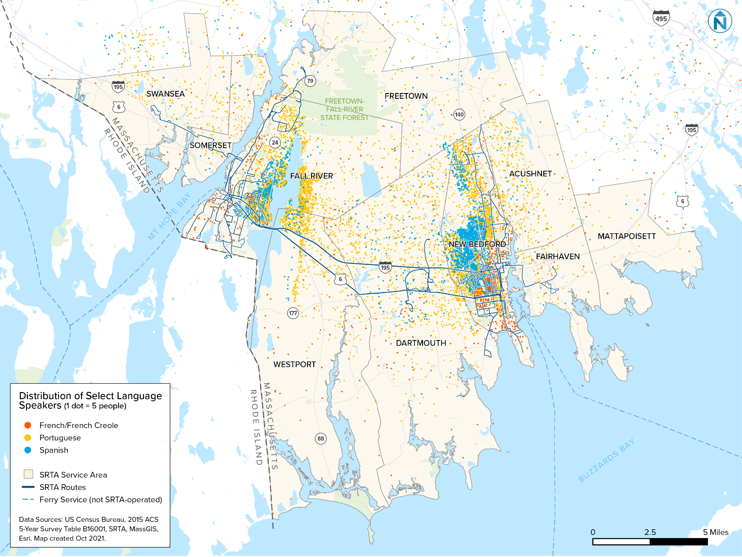

Figure 14 Map of Portuguese-, Spanish-, and French-Speaking Residents in Fall River
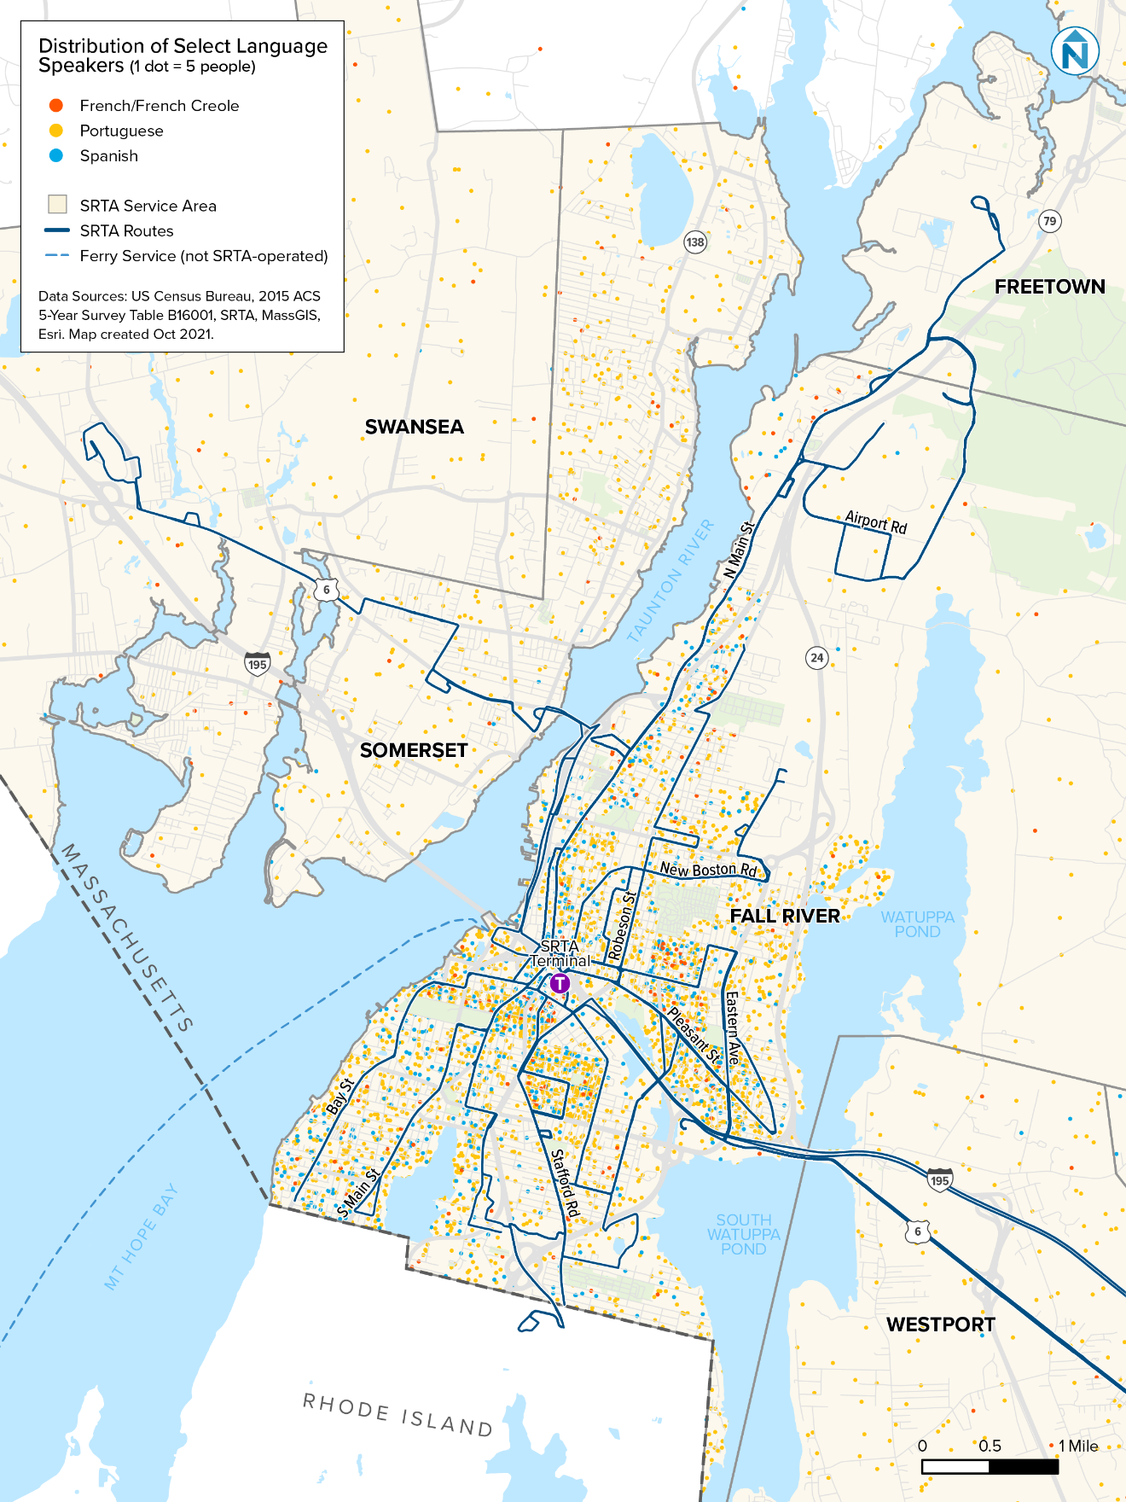
Figure 15 Map of Portuguese-, Spanish-, and French-Speaking Residents in New Bedford
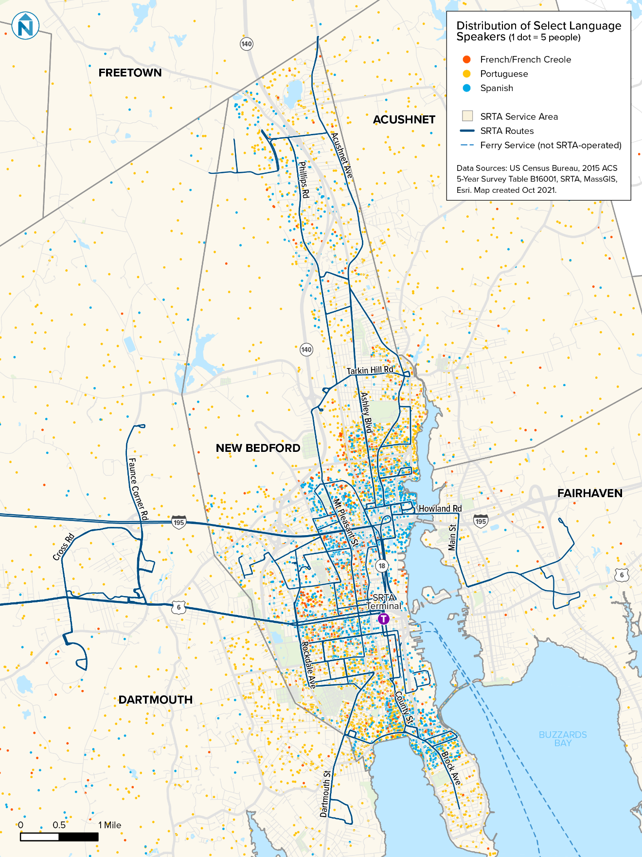

French
It is estimated that most French-speaking residents of SRTA’s service area are Haitian and Haitian-American people that speak Haitian Creole. Based on ACS data, it appears French-speaking people are most densely concentrated in New Bedford and in parts of Fall River near downtown.
During development of SRTA’s previous Title VI Program, outreach was conducted in the Haitian community, but little evidence was collected about Haitian Creole-speaking people’s use of SRTA services, so it is assumed this community does not interact with SRTA services as commonly as other Safe Harbor language-speaking people. The French Creole-speaking community’s literacy skills and transit service status are not well understood, due to challenges reaching the population.

Portuguese
Portuguese-speaking residents of SRTA’s area have a long history in the region and their relationship to public transit is well understood. Portuguese speakers often ride SRTA services and literacy among this population is estimated to be widespread. SRTA does not believe Portuguese-speaking residents of the agency’s service area are underserved.

Spanish
Spanish-speaking residents of SRTA’s area have a long history in the region and their relationship to public transit is well understood. Spanish speakers often ride SRTA services and literacy among this population is estimated to be widespread. SRTA does not believe Spanish-speaking residents of the agency’s service area are underserved.

Common Languages Among LEP People
Of people living in the SRTA service area that speak English less than very well, Portuguese is by far the most common language spoken, followed by Spanish (Figure 16). This highlights the importance of providing language assistance for Spanish and Portuguese speakers engaging with SRTA service.
Figure 16 SRTA Service Area Residents’ Languages Spoken at Home for Residents that Speak English Less Than Very Well

Source: 2015 ACS five-year estimates. Table B16001.

LEP People’s Use of SRTA Service
The demographics or SRTA riders are different from the demographics of people that live in SRTA’s service area. In June 2018, the Southeastern Regional Planning Economic and Development District (SRPEDD) conducted an on-board passenger survey to develop a demographic profile of SRTA riders; language proficiency was included as a question on the survey. Surveys were distributed in English, Portuguese, and Spanish. There were two questions about language, one of which asked the respondent to indicate their proficiency in English, and the other to indicate their language spoken at home.

Most SRTA riders can speak some English; 90% of respondents that answered the English proficiency question indicated they speak English well, 8% indicated they speak English not well, and 2% indicated they do not speak English (Figure 17).
Figure 17 SRTA Riders’ English Proficiency Status

Source: 2018 SPREDD onboard survey.
Among limited-English proficient SRTA riders, Spanish is the dominant language spoken, at 72% (Figure 18). Other LEP riders primarily speak French and Portuguese languages.
Figure 18 Percent of Riders That Reported Speaking English Less Than Well by Language Spoken

Source: 2018 SPREDD Rider Survey
In addition to the 2018 SPREDD onboard survey, SRTA conducted a Title VI Program LEP employee survey during development of this Title VI Program (more detail regarding this survey is in the Factor 2 section of this chapter). Results from this survey show Spanish and Portuguese are by far the most common language that LEP populations interacting with SCTM employees speak (Figure 19). These data also show that Fall River-based employees are somewhat more likely to encounter Spanish- and Portuguese-speaking LEP people than New Bedford-based employees.
Figure 19 Languages Encountered by SRTA Employees When Working with LEP People, by SRTA Base

Source: 2021 SRTA Title VI Employee Survey
About 20% of SCTM employees also reported encountering K’iche’ speakers. Although the ACS does not collect data on K’iche’, there is a documented presence of people speaking the language in New Bedford, where the public school district translates some documents into K’iche’.

Factor 2: The frequency with which LEP people come in contact with the program
To assess the frequency with which LEP people come into contact with SRTA’s service, an employee survey was conducted during development of this Title VI Program. Overall, 85% of SCTM employee respondents reported encountering LEP people at least once each week, and 39% of respondents reported encountering LEP people at least once every day (Figure 20). New Bedford-based employees were more likely to report encountering LEP people than Fall River-based employees. New Bedford-based employees were also more likely to report encountering LEP people on a more frequent basis. This suggests SRTA may benefit from greater language assistance in New Bedford than in Fall River.
Figure 20 Number of Times per Week SRTA Employees Interact with LEP People

Source: 2021 SRTA Title VI Employee Survey
There are five primary ways LEP people encounter SRTA service and programming:
- Riding SRTA buses: This is the most common way LEP people encounter SRTA service.
- Ticket purchases: Tickets for fixed-route service can be purchased in person, and demand-response tickets can be purchased in person and by telephone. Fixed-route ticket sales occur at both SRTA terminals at the sales windows and ticket vending machines (TVMs). SCTM employs ticket agents and supervisors that are fluent in Portuguese and Spanish, and TVMs provide both language options. Eligible customers can schedule demand-response trips by telephone. Demand-response call centers are staffed with Spanish- and Portuguese-speakers that book trips.
- Main office interactions: SRTA riders interact with main office staff when filing complaints in person, applying for demand-response service, and applying for discounted fare cards. Some SRTA office staff are fluent in Spanish. If Portuguese translation is necessary, SCTM can provide a fluent staff person on short notice.
- Onboard surveys: SRTA and its partners periodically conduct onboard surveys during planning and other outreach efforts. These surveys are translated into Spanish and Portuguese.
- Public outreach events: SRTA and its partners periodically hold outreach events to inform and solicit input from the public. When these events are in person or via videoconference, Spanish and Portuguese interpreters are included. Materials shared at these events are also translated into Spanish and Portuguese.

Factor 3: Nature and importance of the program
Fixed-route and demand-response public transit plays a vital role in the lives of SRTA riders. For many riders, public transit is their only option for local travel and provides their transportation for work, learning, medical needs, shopping, and social visits. Because SRTA’s services are so important to riders, it is critical that the language needs of riders are accommodated to the fullest extent possible.

Fixed-Route Bus
Fixed-route bus is the most widely used SRTA service, providing more than 2.6 million passenger trips per year. Ticket vending machines for fixed-route bus service offer Spanish and Portuguese options, and terminal staff are fluent in both languages. Several operators are fluent in either Spanish or Portuguese, and all vehicles are equipped with two-way radios so operators and dispatchers can communicate about rider language assistance needs.
SRTA has recently implemented technology that makes audio announcements on all fixed-route vehicles and provides real-time information signs in the terminals. This technology makes announcements in both English and Spanish. SRTA has also implemented a web-based application that provides customers real-time arrival information in a web browser or smart phone. This mobile application offers translation in Spanish and Portuguese.

Demand-Response Bus
Demand-response bus is SRTA’s curb-to-curb service for eligible riders, providing over 80,000 passenger trips each year. Once approved for the service, customers can call one day before a needed trip and schedule a ride. The demand-response call center is staffed with Spanish and Portuguese speakers.

Filing Complaints
Customer complaints are an important way to identify needed customer service improvements. Customer complaints are typically received by SRTA administrative staff and addressed by SCTM. Complaints are classified as a civil rights discrimination, disability discrimination, or general customer service complaint. Customer service complaints are generally submitted by telephone, however civil rights and disability discrimination complaints are generally submitted via complaint form. The civil rights and disability discrimination complaint forms are translated in all Safe Harbor languages, with additional translation available upon request. If language assistance is needed for a telephone complaint, the caller is connected with a staff person fluent in either Spanish or Portuguese.

Public Outreach
SRTA periodically conducts service planning initiatives to better align service with customer needs. Effective planning includes the public during the decision-making process, maintains transparency, and is responsive to input. Language access is integral to this inclusive planning. All planning-event advertisements are provided in English, Spanish, and Portuguese, and posted at bus terminals and on buses in the community or communities affected by planning process. All advertisements indicate translation services are available upon request, and all public meetings include staff that speak either Spanish or Portuguese.

Factor 4: Resources available for LEP outreach
SRTA provides translation and interpretive services to the fullest extent possible, given available language assistance resources. Although these resources are limited, SRTA incorporates language assistance in its operating budget without undue burden on other essential transit activities.

Multi-Lingual Staff
SRTA has found that the most effective and cost-efficient way to provide language assistance is hiring multilingual staff. Nearly 90% of non-English speakers in the SRTA service area speak Portuguese and/or Spanish, and both SCTM and SRTA employ staff fluent in both languages. These staff are available to speak with riders if language assistance is needed. In partnership with the regional planning agency, SRPEDD, SRTA translates demand-response applications, customer complaint forms, and public notices into Portuguese and Spanish.

Translation at Public Meetings
SRTA staff fluent in Portuguese and Spanish are available at all public meetings.

Translation Technology
SRTA uses technology to provide language assistance where feasible and cost-effective. The SRTA website uses a translator application that allows much of the site content to be translated into dozens of languages. The translation application uses Google translation, which is less accurate than translation provided by a human, but allows SRTA to provide basic language assistance in almost any language likely to be encountered. Fixed-route vehicles and terminals have a technology system that makes audio announcements in Spanish, the language spoken by most non-English speaking customers.

Additional Resources
Language assistance for languages other than Portuguese or Spanish is infrequently requested, although SRTA has the budgetary capacity to address requests on an as-needed basis.

Determination of Language Services Needed
Based on the Four-Factor Analysis results described above, SRTA has determined that several language services should be provided to LEP people that interact with SRTA programs and services. Figure 21 describes the services needed and the following Implementation Plan describes how these services are provided.
Figure 21 Summary of Language Services Needed by Language
Language | Language Services Needed
French | This is a relatively new Safe Harbor language for SRTA. SCTM employees report that most French-speaking SRTA riders speak Haitian Creole. SRTA will translate vital documents into Haitian Creole and, when resources allow, provide translation services in Haitian Creole.
Portuguese | This is the second-most common language spoken by LEP people interacting with SRTA. SRTA will continue to translate vital documents into Portuguese and provide Portuguese translation. SRTA will also encourage SCTM to hire qualified workers that speak Portuguese fluently.
Spanish | This is the most common language spoken by LEP people interacting with SRTA. SRTA will continue to translate vital documents into Spanish and provide Spanish translation. SRTA will also encourage SCTM to hire qualified workers that speak Spanish fluently.
Other languages | Although other languages and language groups (such as K’iche’, Chinese, and Mon-Khmer) in the SRTA service area are not considered Safe Harbor languages, SRTA strives to provide the most accessible service possible for people speaking all languages. To achieve this goal, SRTA will provide translation services on an as-needed basis to people speaking non-Safe Harbor languages, as resources allow.

4.2 Implementation Plan
The Four-Factor Analysis established the languages and extent to which assistance should be provided in Safe Harbor languages. Implementing the assistance and monitoring the implementation is how SRTA ensures language assistance is provided in a meaningful and effective manner. This Implementation Plan is a working document and reference that is formally updated every three years, as part of the Title VI Program.

Provision of Language Services by Language
Language services are provided for SRTA Safe Harbor languages, as well as for some non-Safe Harbor languages, when resources allow. The language services provided, by language, are shown in Figure 22.
Figure 22 Summary of SRTA Language Services Provided by Language
Language Service Provided | French | Portuguese | Spanish | Other Languages
Employees fluent in language |  | 🗸 | 🗸 | When available
Public outreach translation |  | 🗸 | 🗸 | When available
Survey translation |  | 🗸 | 🗸 | When available
Translation of vital documents | 🗸 | 🗸 | 🗸 | Upon request
TVM translation |  | 🗸 | 🗸
Website translation | 🗸 | 🗸 | 🗸 | 🗸

Translation of Vital Documents
Vital documents are key written notices that allow people to understand essential aspects of SRTA’s service and programs. These documents, which are translated into SRTA’s three Safe Harbor languages, are listed below.
- Demand-response informational brochure
- Demand-response application
- Public hearing notices
- SRTA/American with Disabilities Act (ADA)/Title VI Complaint Form
- Title VI Complaint Instructions and Procedure
- Title VI Notice to the Public

Provision of Notice of Language Assistance Availability
If LEP riders are not aware language assistance is available, these services may go unused. To ensure LEP riders are aware of language assistance services, a statement indicating that language assistance is available is included in the Title VI Notice to the Public, which is displayed in SRTA’s public spaces, including in terminals, on fixed-route buses, in demand-response vehicles, and in the reception area of the SRTA administrative office.
In addition, notices posted for service changes or public meetings are prepared in English, Portuguese, Spanish, and Haitian Creole, and posted in public spaces pertinent to the meeting being held. The notices are posted in conspicuous locations and prepared in a size and font that are easy to read.

Monitoring, Evaluating, and Updating LEP Plan
The SRTA LEP Plan is monitored, evaluated, and updated triennially as part of the Title VI Program.

Monitoring
LEP Plan performance is monitored in several ways:
- Collecting demographic data and conducting surveys to document the presence of LEP people likely to be served by SRTA.
- Maintaining records that indicate where language assistance beyond what is normally provided was requested by and/or provided to customers.
- Reviewing language assistance policies.
- Reviewing staff training procedures.
- Checking vehicles and terminals for language assistance notices and ensuring these locations have the latest English and non-English version of these notices.
Informal LEP Plan monitoring occurs on an ongoing basis, as SRTA staff observe SCTM operations to ensure compliance with LEP Plan policies.

Evaluating
Evaluation of SRTA’s LEP Plan includes:
- Analyzing demographic data and comparing against historic data to identify changes in the presence of LEP people in the SRTA service area.
- Understanding how LEP populations are changing.
- Analyzing survey data to identify how the LEP customer base is changing.
- Evaluating the frequency of contact with LEP people and the nature of that contact.

Updating
The results of LEP Plan monitoring and evaluation are used to develop and update the LEP Plan, policies, and procedures. The LEP Plan is updated triennially with the Title VI Program. LEP Plan policies and procedures are updated if the results of a complaint investigation identify a deficiency. Since the last LEP Plan update, neither SRTA or SCTM have had complaint investigations result in modification to LEP Plan policies or procedures.

Training Staff to Provide Language Assistance
Training staff to properly address the needs of LEP riders is an ongoing effort that begins with new hires and continues through the entirety of an employee’s tenure with SRTA and with SCTM. All new hires receive LEP training to ensure they understand SRTA’s LEP policies. Tenured employees receive LEP training when LEP policies change. Employees also receive training when a valid complaint regarding LEP-related issues is submitted by a customer.
Special training is provided to dispatchers and employees fielding calls from the public, since staff coordinating demand-response service typically have the most language skill-dependent interactions with riders.

Demographic Data and Maps

5.1 Service Area Demographic Profile
According to the 2020 U.S. Census, 322,845 people live in the SRTA service area. This population is concentrated in the cities of Fall River and New Bedford. Of these residents, 76,632 (24%) identify as minorities and 69,221 (22%) are considered low-income (Figure 23).
Figure 23 Percent of SRTA Service Area Population that is Minority or Low-Income

Sources: 2020 U.S. Census Table P1 (minority data), 2019 ACS five-year estimates Table DP05 (income data).

Minority and Low-Income Classification
SRTA follows guidance from FTA C 4702.1B to define low-income and minority people, geographies, and fixed transit routes. These definitions and analytical methods are described in Figure 24.
Figure 24 Low-Income and Minority Definitions and Methods
Demographic Group | Category | Definition | Guidance Source
Low-Income | Person | A person is considered low-income if their median household income is at or below the US Department of Health and Human Services (DHHS). The 2021 DHHS poverty guideline for a four-person household is $26,500. Additional household size poverty guidelines are in Appendix D. | FTA C 4702.1B, Chap. I-3
 | Census block group | A block group is considered low-income if the low-income population of the block group is greater than SRTA’s service area average. | FTA C 4702.1B, Chap. IV-8
Minority | Person | A person is considered minority if they identify as any race/ethnicity other than white, or as Hispanic or Latino. | FTA C 4702.1B, Chap. I-4
 | Census block group | A block group is considered a minority block group if the minority population of the block group is greater than SRTA’s service area average. | FTA C 4702.1B, Chap. IV-9
 | Fixed transit route | A transit route is considered a minority transit route if at least 1/3 of its total revenue mileage occurs in a minority census block group or groups. | FTA C 4702.1B, Chap. I-4

In accordance with federal guidance referenced in Figure 25, SRTA identifies census block groups in its service area that are considered low-income and minority block groups. Based on the latest U.S. Census and ACS data, block groups are considered minority block groups if more than 23.7% of residents identify as minority and are considered low-income block groups if more than 21.4% of residents are considered low-income. Nearly half of all 251 block groups in the SRTA service area are either low-income or minority block groups, and one-third of block groups are both low-income and minority (Figure 25).
Figure 25 Block Groups in SRTA Service Area that Meet Demographic Criteria
Demographic Criteria | Number of Census Block Groups Meeting Criterion | Percent of Census Block Groups Meeting Criterion
Low-Income | 106 | 42%
Minority | 121 | 48%
Low-Income and Minority | 83 | 33%
Sources: 2019 ACS five-year estimates, Table DP05.

5.2 Demographic Maps
Figure 26 through Figure 29 show the location of low-income and minority block groups in the SRTA service area, along with SRTA facilities and routes.
Minority populations are concentrated in New Bedford and Fall River. In New Bedford, minority populations are primarily concentrated in the more urbanized parts of the city. In Fall River, minority populations are concentrated downtown, as well as in the southwestern part of the city. Smaller concentrations of minority populations live in Dartmouth, Fairhaven, and Acushnet.
Low-income people are concentrated in the urban areas of New Bedford and central Fall River. Other concentrations of low-income populations live in northern Freetown, western Dartmouth, southern Acushnet, and parts of Swansea.
Figure 26 Map Showing Minority and Low-Income Block Groups in the SRTA Service Area
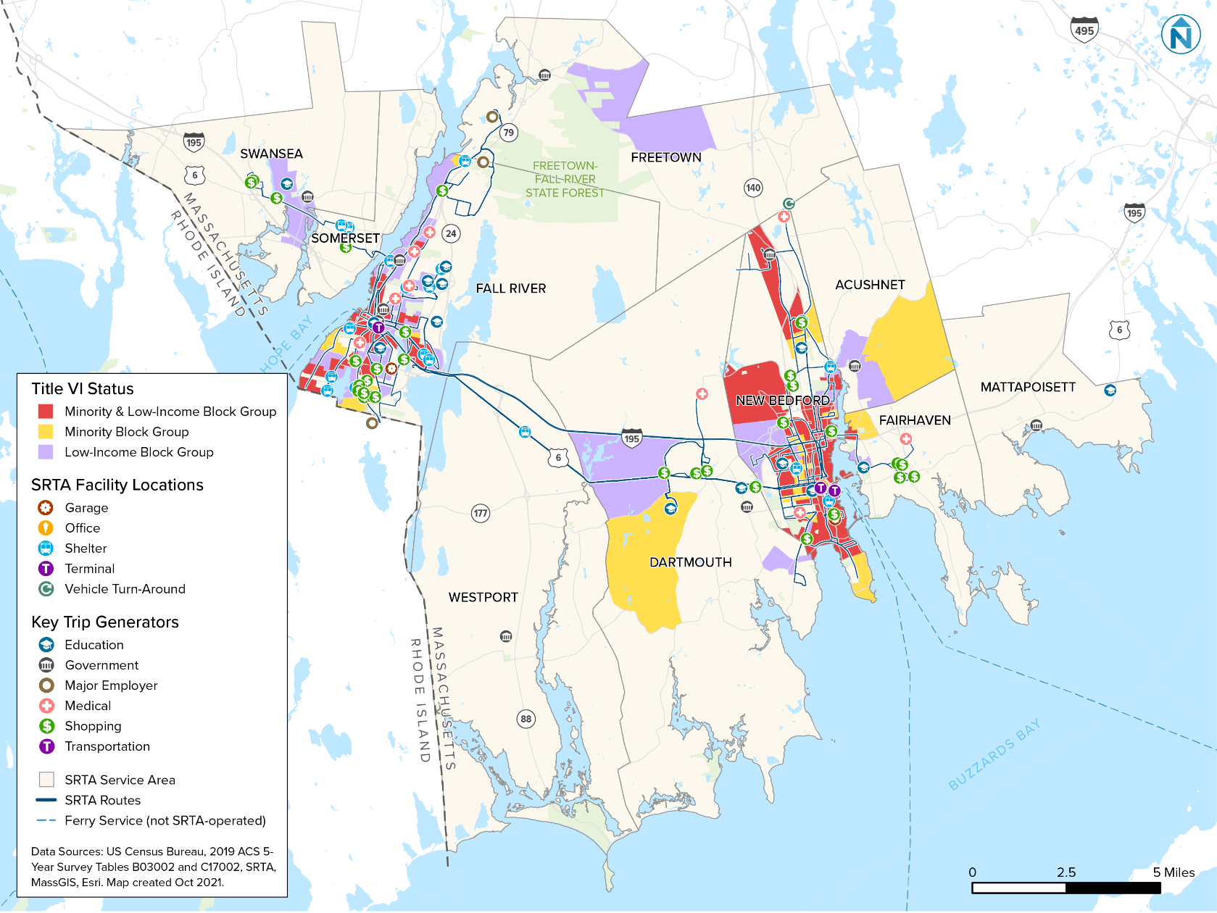

Figure 27 Map Showing Minority and Low-Income Block Groups in Fall River
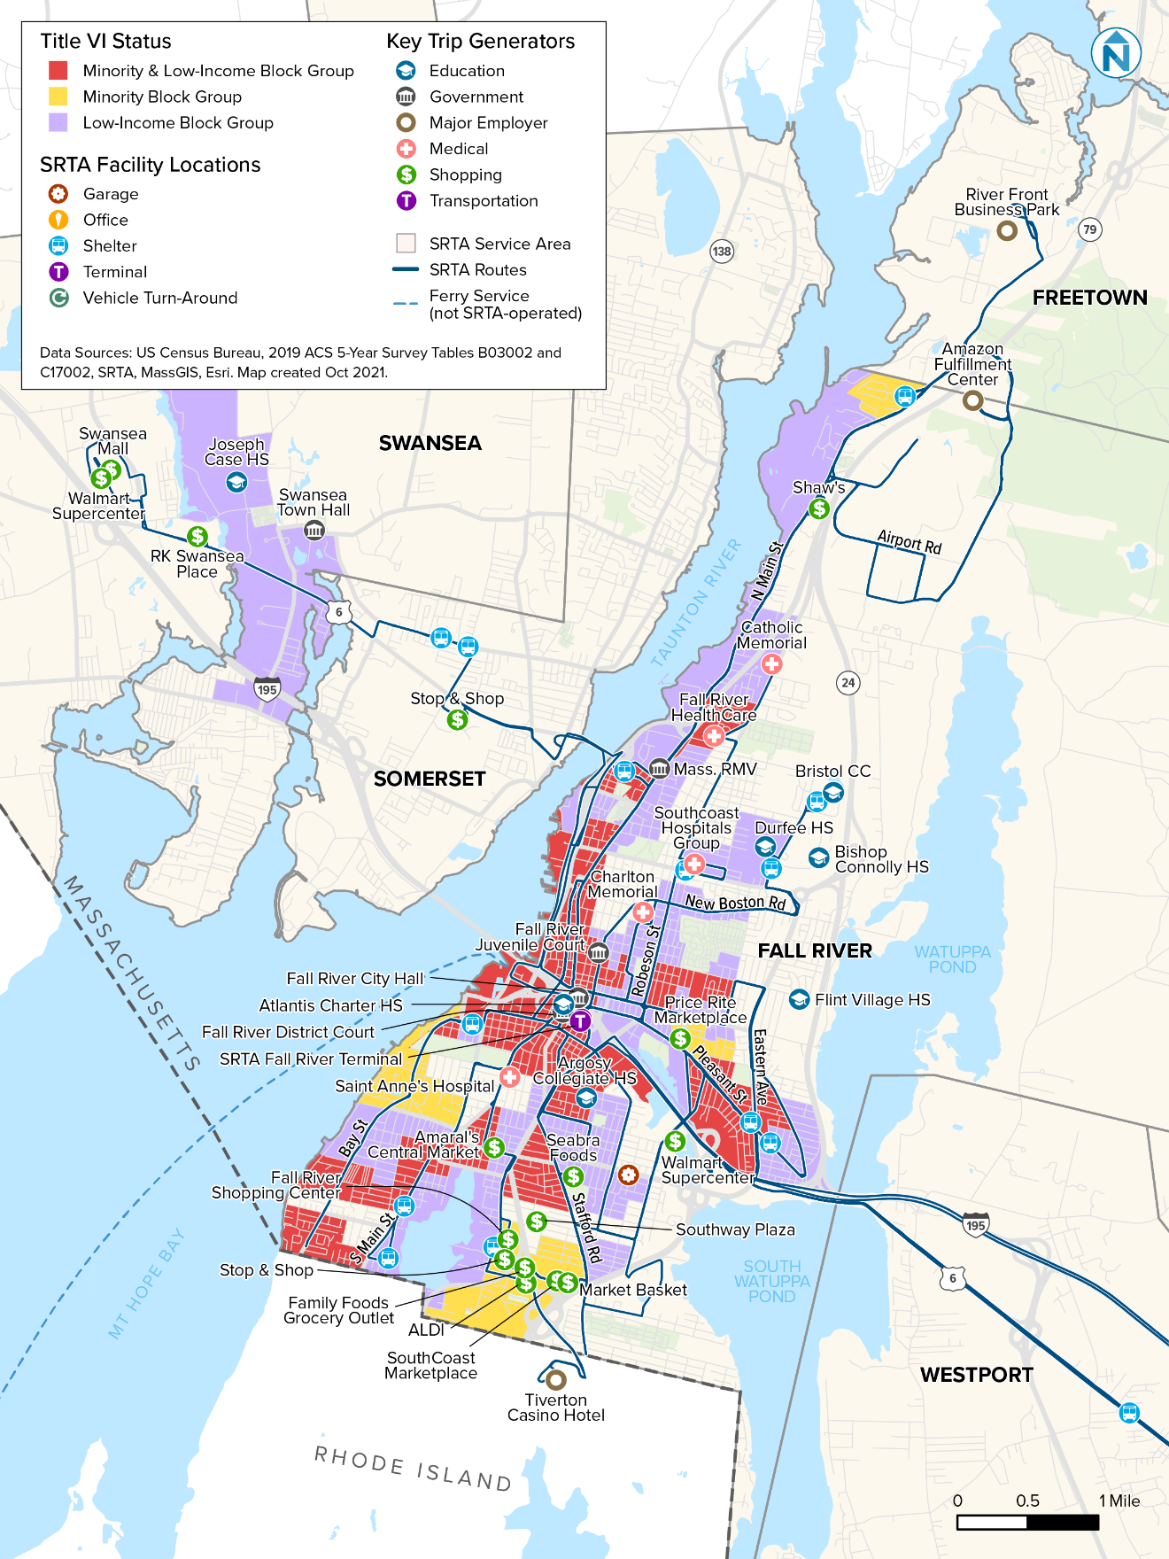
Figure 28 Map Showing Minority and Low-Income Block Groups in New Bedford
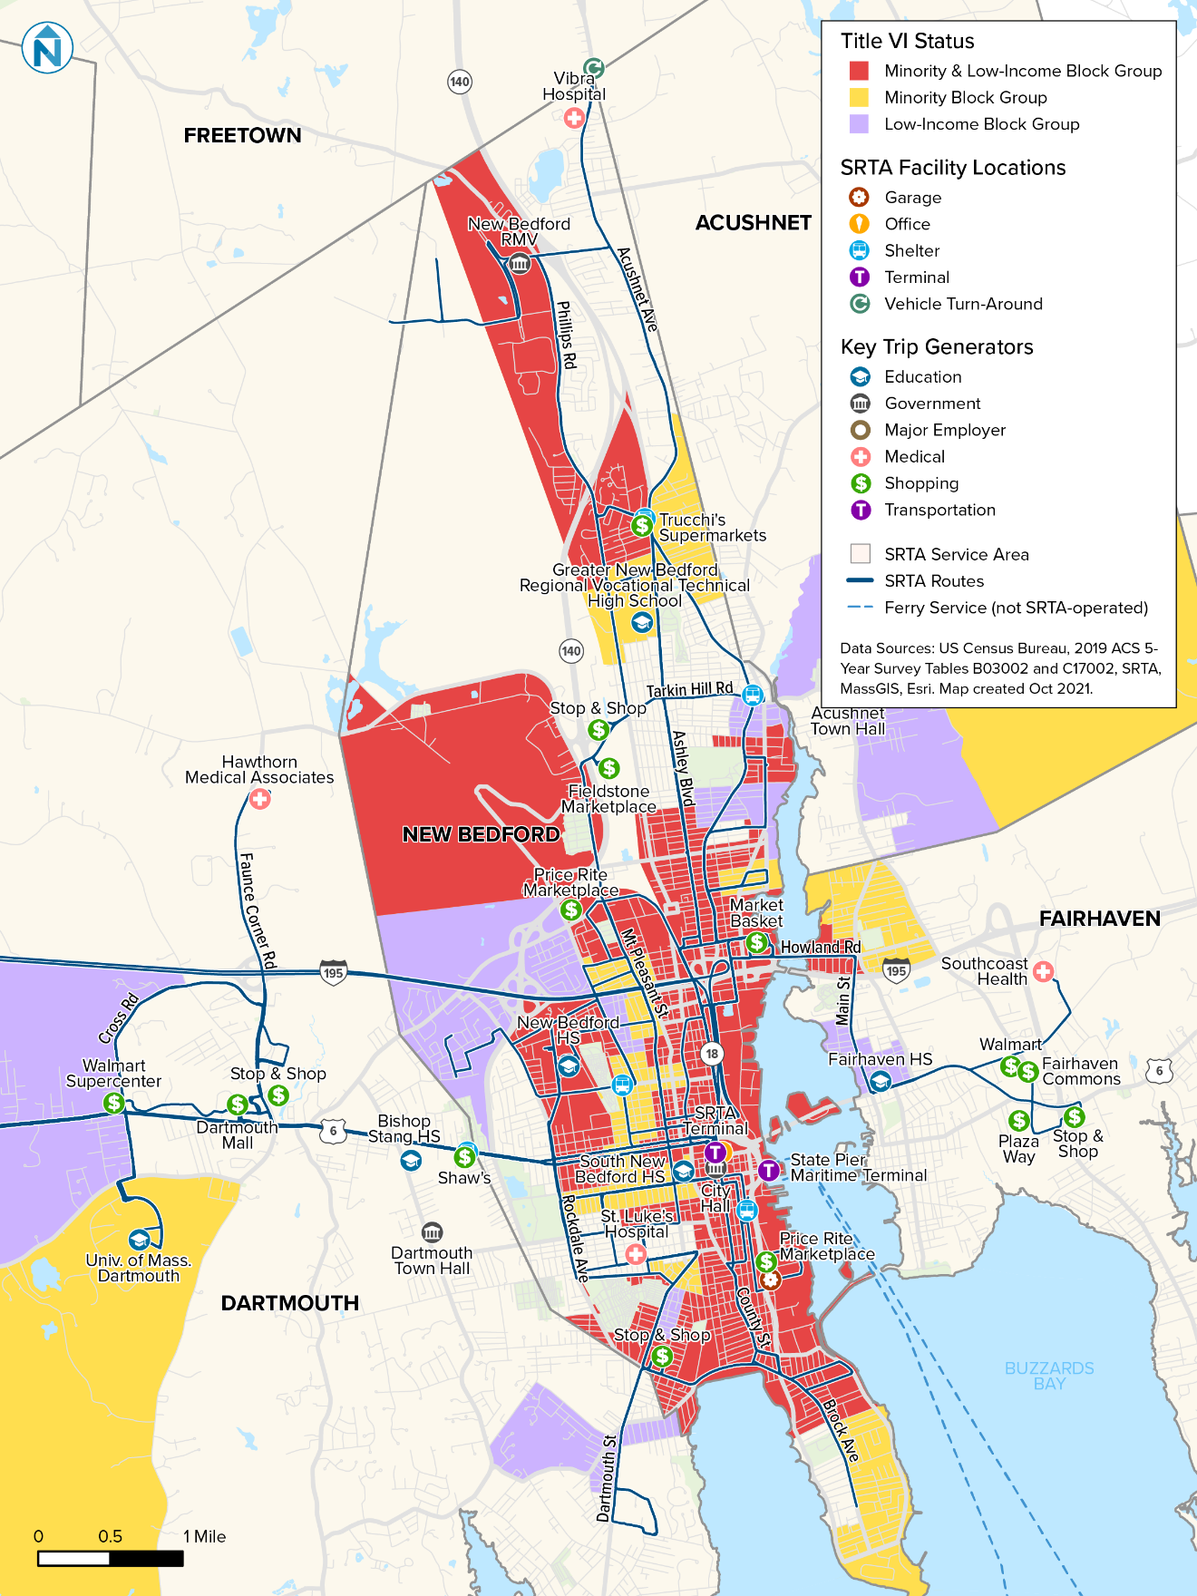

SRTA plans to upgrade its Fall River garage/maintenance facility and New Bedford Terminal in the coming years, although funding has not been identified for these projects. A map showing these facilities’ locations, with minority and low-income demographic data, is in Figure 29.
Figure 29 Map Showing Planned Facility Upgrade Locations with Low-Income and Minority Census Block Groups
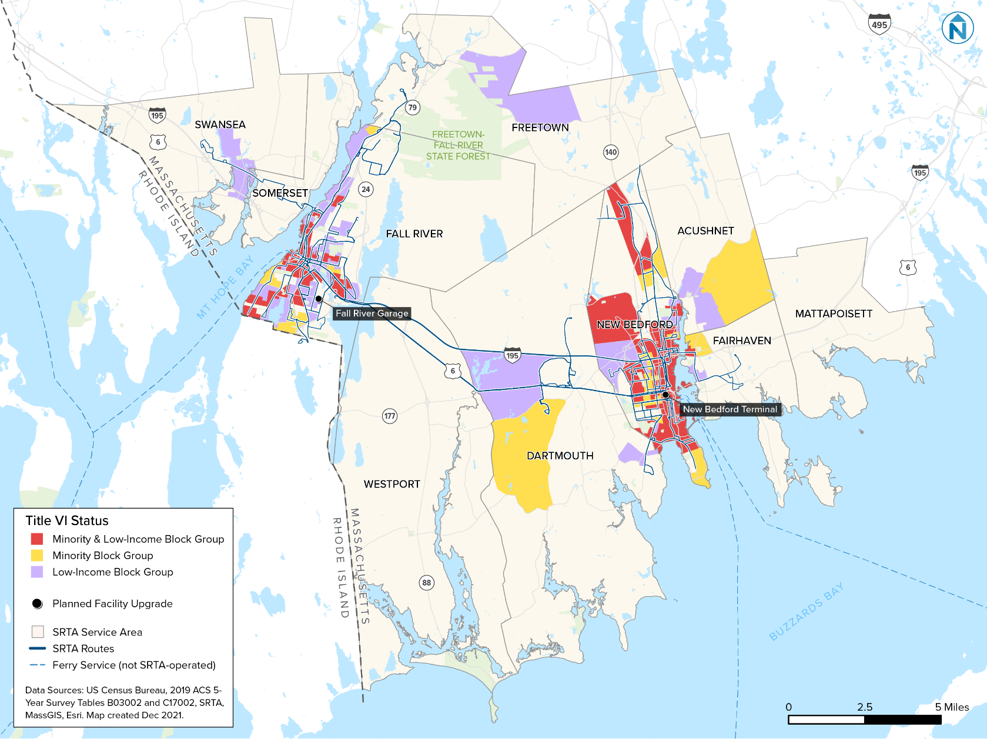

5.3 Route Classification
Based on the FTA C 4702.1B definition above, SRTA has identified ‘minority routes’ (Figure 30). These routes are also classified as either urban or suburban, where urban routes operate most of their revenue miles within either the City of Fall River or New Bedford, and suburban routes do not.
Figure 30 SRTA Route Classification
Route Name | Minority Status | Route Type
New Bedford Routes
NB1 – Fort Rodman | Minority Route | Urban
NB2 – Lund’s Corner | Minority Route | Urban
NB3 – Dartmouth St. | Minority Route | Urban
NB4 – Ashley Blvd. | Minority Route | Urban
NB5 – South Central | Minority Route | Urban
NB6 – Shawmut | Minority Route | Urban
NB8 – Mt. Pleasant | Minority Route | Suburban
NB9 – Fall River-New Bedford | Non-Minority Route | Suburban
NB9X – Fall River-New Bedford Express | Minority Route | Suburban
NB10 – Dartmouth Mall | Non-Minority Route | Suburban
NB11 – Fairhaven | Minority Route | Suburban
North End Shuttle | Non-Minority Route | Urban
New Bedford School Routes
Roosevelt Middle School | Minority Route | Urban
Keith Middle School | Minority Route | Urban
New Bedford High School | Minority Route | Urban
Fall River Routes
FR1 – South Main | Minority Route | Urban
FR2 – North Main | Minority Route | Urban
FR3 – Laurel | Minority Route | Urban
FR4 – Robeson St. | Minority Route | Urban
FR5 – Stafford Rd. | Minority Route | Urban
FR6 – Pleasant St. | Minority Route | Urban
FR7 – Bay St. | Minority Route | Urban
FR8 – BCC/Durfee | Minority Route | Urban
FR9 – Bedford | Minority Route | Urban
FR10 – Rodman St./Walmart | Minority Route | Urban
FR14 – Swansea Mall | Non-Minority Route | Suburban

5.4 Demographic Profile of Customers
In addition to analyzing service area demographic data from the U.S. Census and ACS, SRTA collects demographic information on SRTA riders, and uses this information to develop a demographic profile to analyze the minority and low-income status of riders. These data are important because SRTA rider demographics do not always reflect the demographics of the service area; this information provides valuable information for analyzing potential service and fare changes.
The most recent customer data were collected in a survey conducted by the Southeastern Regional Planning and Economic Development District (SRPEDD) on-board SRTA buses as part of a 2019 fare equity analysis. The survey was conducted over the course of several days in 2019 and produced a statistically significant sample of SRTA customers, providing a 95% confidence interval with a 4.8% margin of error. The survey was distributed and collected on all SRTA routes and resulted in a sample representing all routes, times of the day, and schedule types. Surveys were provided in English, Portuguese, and Spanish.
The results of the survey indicated that 52% of passengers identify as minorities and 80% identified as low-income (Figure 31 and Figure 32). This shows that SRTA’s ridership consists of proportionally more minority and low-income people than the service area.
Figure 31 SRTA Riders’ Minority and Low-Income Status

Source: 2019 SPREDD Fare Equity Survey

Figure 32 SRTA Riders’ Minority and Low-Income Status
Minority and Low-Income Status | Responses | Percent
Minority | 250 | 52%
Low-Income | 321 | 80%
Minority and Low-Income | 160 | 33%
Source: 2019 SPREDD Fare Equity Survey
In addition to understanding the demographic profile of riders, it is important to understand how and why SRTA riders use SRTA’s fixed-route system. To understand this, SRTA uses information collected from a 2018 rider survey. The SRTA rider survey was conducted by SRPEDD at the New Bedford Terminal from June 12, 2018, until June 16, 2018; and at the Fall River Terminal from June 19, 2018, until June 23, 2018. The survey was available in English, Portuguese, and Spanish. 623 surveys responses were collected, providing a 95% confidence interval with a 4% margin of error.
Results from this survey show that minority and non-minority trip purposes on SRTA’s fixed-route services are relatively similar, but minority riders are twice as likely to use SRTA service for school trips than non-minority riders (Figure 33 and Figure 34).
Figure 33 SRTA Riders’ Trip Purpose by Minority Status

Source: 2018 SPREDD Rider Survey
Figure 34 SRTA Riders’ Trip Purpose as a Percent of All Trips, by Minority Status
Trip Purpose | Minority | Non-Minority
Work | 24% | 23%
Home | 23% | 24%
Shopping | 18% | 16%
School | 8% | 4%
Medical | 9% | 9%
Other | 14% | 16%
Source: 2018 SPREDD Rider Survey
It is also important to understand how fare payment may differ among low-income and minority riders, relative to non-low-income and non-minority riders. To understand this, SRTA uses data from the 2019 SPREDD fare equity survey.
Figure 35 and Figure 36 show how low-income and minority riders pay their fares on SRTA fixed routes. Although all demographic groups are similarly likely to use CharlieCards, non-low-income riders are more likely than low-income riders to use paper tickets, and low-income riders are considerably more likely to pay fares with cash. There is little difference between fare media use of non-minority and minority riders. A complete analysis of the 2019 Fare Equity survey is provided in Appendix E.
Figure 35 Fare Media Used Most Frequently by SRTA Riders, by Income and Minority Status

Source: 2019 SPREDD Fare Equity Survey
Figure 36 Fare Media Used Most Frequently by SRTA Riders, by Income and Minority Status
Fare Media | All Riders | Minority | Non-Minority | Low-Income | Non- Low Income
Paper Tickets | 8% | 8% | 8% | 5% | 11%
Cash | 41% | 42% | 40% | 43% | 35%
CharlieCard | 51% | 50% | 52% | 52% | 53%
Source: 2019 SPREDD Fare Equity Survey
Figure 37 and Figure 38 show how the fare type that SRTA riders most commonly use varies by income and minority status. Although all demographic groups are roughly equally as likely to pay full fare, low-income riders are more likely to pay with a reduced fare. Non-low-income riders are also more likely than low-income riders to pay with a student pass.
Figure 37 Fare Type Used Most Frequently by SRTA Riders, by Income and Minority Status

Source: 2019 SPREDD Fare Equity Survey
Figure 38 Fare Type Used Most Frequently by SRTA Riders, by Income and Minority Status
Fare Type | All Riders | Minority | Non-Minority | Low-Income | Non- Low Income
Pass (e.g., 10-ride) | 17% | 16% | 19% | 16% | 19%
Reduced Fare (all types) | 29% | 28% | 29% | 29% | 25%
Full Fare | 51% | 52% | 50% | 53% | 51%
Student | 1% | 2% | 0% | 1% | 4%
Transfer | 2% | 2% | 2% | 2% | 1%
Source: 2019 SPREDD Fare Equity Survey

Systemwide Service Standards and Policies
SRTA maintains service standards and service policies that guide the agency’s levels and quality of service for fixed-route bus service. These standards and policies are used by SRTA to monitor transit service, in compliance with the agency’s Title VI obligations.

6.1 Service Standards
SRTA’s fixed-route service standards are summarized here and described in more detail below:
- Vehicle load: A route’s average maximum passenger load should not exceed 150% of a vehicle’s seated capacity, where the maximum passenger load is measured at the trip level. This standard applies to both peak and off-peak trips.
- Vehicle headway: A route’s headways should be no greater than 60 minutes.
- On-time performance: A route’s on-time performance should be 85% or greater, where on-time performance is measured as the percent of departures from trip origins that are on time. Departures are considered on time if they occur less than one minute earlier or less than five minutes later than the scheduled departure time.
- Service availability: 90% of households in the SRTA service area that don’t have access to a vehicle should be within ½-mile of a fixed-route bus stop.

Vehicle Load
SRTA maintains a fixed-route vehicle load standard to ensure vehicles are not overcrowded. Vehicle load is the number of passengers on board a vehicle, and vehicle load ratio is the ratio of vehicle load to seated capacity of the vehicle. The vehicle load ratio is recorded at each stop, after all passengers on board are counted.
SRTA considers a vehicle’s maximum passenger capacity to be 150% of the number of seats, which represents a very crowded condition, with many passengers forced to stand. The seated and maximum passenger capacities for the three vehicle types SRTA operates are in Figure 39.
Figure 39 SRTA Fixed-Route Passenger Seated and Maximum Capacity by Vehicle Size
Vehicle Type | Seated Capacity | Maximum Capacity
30-Foot Bus | 30 | 45
35-Foot Bus | 35 | 53
40-Foot Bus | 38 | 57
SRTA’s vehicle load service standard is for a route’s average maximum vehicle load ratio to not exceed the maximum capacity ratio (i.e., 150%), where the vehicle load ratio is measured at the trip level. This standard applies to both peak and off-peak trips.

Vehicle Headway
SRTA maintains vehicle headway standards to ensure service is provided at a reasonable frequency throughout the service area. Vehicle headway is measured at the route level and is the time between bus departures at the same stop, on the same route. Vehicle headways on a route can vary, depending on the time of day.
SRTA’s vehicle headway standard sets maximum headways by route type, day type, and time of day. Figure 40 shows SRTA’s vehicle headway standards, where the standard is the maximum headway that should be operated. For example, an urban route in the a.m. peak period should not operate with headways greater than every 60 minutes. For example, headways of every 40 or 35 minutes would meet the standard.
Figure 40 SRTA Fixed-Route Vehicle Headway Standards
Day Type | Peak Period Standard | Off-Peak Period Standard
Weekday | 60 mins. | 60 mins.
Saturday | 60 mins. | 60 mins.

On-Time Performance
SRTA maintains a fixed-route on-time performance standard to ensure service is reliable for riders. On-time performance is the percentage of departures from trip origins that are on time, where departures are considered on time if they occur less than one minute earlier or less than five minutes later than the scheduled departure time. For example, a bus that leaves a trip origin two minutes early is not on-time; likewise, if that bus were to leave the trip origin six minutes late, it would not be on time.
SRTA’s standard is for a route to have 85% or greater on-time performance.

Service Availability
SRTA maintains a fixed-route service availability standard to ensure service is provided to as many service area residents as is reasonably possible.
SRTA’s service availability standard is for 90% of households in the SRTA service area that do not have access to a vehicle to be within a half-mile walking distance of a SRTA bus stop.

6.2 Service Policies

Distribution of Transit Amenities
SRTA maintains transit amenity provision standards to guide its capital investments at transit stops and facilities. These standards are described below and shown in Figure 41.
Figure 41 SRTA Fixed-Route Distribution of Transit Amenities Policy Guidelines
Transit Amenity | Provision Policy
Elevators | N/A
Escalators | N/A
Printed route schedules | Available on request at Fall River Terminal, New Bedford Terminal, and SRTA offices.
Seating | Prioritized at stops with higher numbers of average daily boardings and with higher numbers of riders that cannot comfortably stand for long periods of time (e.g., stops at senior living facilities).
Shelter | Prioritized at stops where average daily boardings exceed 20 and/or where transfers are possible among different routes.
Waste receptacles | Prioritized at stops with higher numbers of average daily boardings and/or with high numbers of complaints about littering.

Elevators and Escalators
There are SRTA-owned and -operated elevators at the Fall River Terminal and New Bedford Terminal, and a third-party operated elevator at SRTA offices. SRTA does not plan to add elevators at any transit facilities in the future, and the current SRTA-owned elevators are not used to access transit (only to access the SRTA-owned parking garage). SRTA does not own or operate any escalators and does not plan to add escalators at any transit facilities in the future. Because of this, SRTA does not have a provision policy for elevators or escalators.

Printed Route Schedules
SRTA provides printed route schedules for each route, on request, at the Fall River and New Bedford terminals, and at SRTA’s offices.

Seating and Shelter
SRTA provides seating at the Fall River and New Bedford terminals but does not plan to provide seating at any other locations, due to resource limitations. If resources are made available in the future, SRTA will prioritize stops with higher numbers of average daily boardings and with higher numbers of riders that cannot comfortably stand for long periods of time.
SRTA maintains 20 bus shelters, 11 of which are in either a minority or low-income census tract. No new shelters have been installed by SRTA since the agency’s last Title VI Program was updated in 2019. Shelters are considered for stops that exceed 20 boardings per day or where multiple routes intersect and transfers among the routes are possible. SRTA has limited jurisdiction to install shelters without the approval of the property owner that controls the site (site control can generally be defined as private or government ownership) and is subject to municipal review and approval. SRTA prefers to site shelters in publicly controlled right-of-way to ensure the shelter will remain in place for the entirety of its useable life. SRTA encourages private property owners to install and maintain shelters.

Waste Receptacles
SRTA provides waste receptacles at the Fall River and New Bedford terminals but does not plan to provide receptacles at any other locations. If resources are made available in the future, SRTA will prioritize stops with higher numbers of average daily boardings and/or with high numbers of complaints about littering.

Vehicle Assignment
SRTA assigns vehicles to routes based on the route’s geometry and anticipated passenger volumes. Current fixed-route bus fleet vehicles are comparably equipped with technology and comfort features, and all vehicles are accessible by people with disabilities. Vehicles are kept in a state of good repair and are only used in service if all equipment is functioning properly.
SRTA’s vehicle assignment policy is for the average age of fixed-route vehicles at the Fall River Garage and New Bedford Garage to be within two years of one another. Because vehicles are assigned to garages, and not specific routes, SRTA considers this a reasonable approach to ensuring the quality of vehicles is roughly equivalent throughout the network.

Service Monitoring Program and Results

7.1 Monitoring Program Summary
SRTA's systemwide service standards and policies establish minimum thresholds for system performance. This chapter of the Title VI Program documents how SRTA’s current service compares to those standards, as well as how minority routes perform relative to non-minority routes on these standards.
The data used to monitor system performance were collected between June 1, 2021 and October 30, 2021. These data were from fixed-route automatic passenger counters (APCs) and automatic vehicle location (AVL) systems, which are installed on all SRTA fixed-route vehicles. Software used to assess these data were Ridecheck Plus Version 8.1, Tableau Desktop 2020.4.10, and Microsoft Excel.
Overall monitoring results show that SRTA meets its standards and policies in all categories except for on-time performance. There are no discrepancies between minority and non-minority outcomes. A summary table of the monitoring program results is in Figure 42.
Figure 42 Summary Table of Monitoring Program Results
Standard or Policy | Is Standard or Policy Met Systemwide? | Discrepancy between Minority and Non-Minority Standard or Policy Performance?
Vehicle load | Yes | Standard Met for All Routes
Vehicle headway | Yes | Standard Met for All Routes
On-time performance | No | No Discrepancy
Distribution of transit amenities | N/A | No Discrepancy
Vehicle assignment | Yes | N/A
Service availability | Yes | N/A
The SRTA board was made aware of these monitoring results and approved of the changes when approving this Title VI Program. Minutes showing the board’s approval of the monitoring results are in Appendix F.

7.2 Vehicle Load
Vehicle load is the number of passengers on board a vehicle, and a vehicle load ratio is the ratio of passengers on board a vehicle to the seated capacity of the vehicle.
SRTA’s vehicle load service standard is for a route’s average maximum vehicle load ratio to not exceed the maximum capacity ratio of 150%, where the maximum vehicle load ratio is measured at the trip level (i.e., the maximum number of passengers onboard a vehicle at any time during a trip is the ‘maximum vehicle load’ for that trip).
Although SRTA’s standard allows for standees on some trips, this is likely to only occur during periods of peak demand, on some trips, on some routes. Most of the time, SRTA riders should expect to find a seat upon boarding. In the monitoring data used for this analysis, standing-room-only trips did not occur.
Figure 43 shows the average maximum vehicle load ratio recorded during the 2021 data collection period. The average maximum ratio did not exceed the standard for any routes, with non-minority routes showing a higher average maximum vehicle load (and therefore more crowding) than minority routes. Likewise, the systemwide average maximum vehicle load ratio did not exceed the standard. These results do not suggest a disparate impact in terms of vehicle load.

Figure 43 Average Route Maximum Vehicle Load Ratio, by Minority Status and Time Period
Minority Status | Route | Off-Peak | Peak | Meets Standard?
Minority | FR1 – South Main | 0.33 | 0.31 | Yes
 | FR2 – North Main | 0.32 | 0.40 | Yes
 | FR3 – Laurel | 0.42 | 0.33 | Yes
 | FR4 – Robeson St. | 0.31 | 0.30 | Yes
 | FR5 – Stafford Rd. | 0.36 | 0.33 | Yes
 | FR6 – Pleasant St. | 0.32 | 0.23 | Yes
 | FR7 – Bay St. | 0.30 | 0.25 | Yes
 | FR8 – BCC/Durfee | 0.32 | 0.33 | Yes
 | FR9 – Bedford | 0.30 | 0.25 | Yes
 | FR10 – Rodman St./Walmart | 0.35 | 0.26 | Yes
 | NB1 – Fort Rodman | 0.51 | 0.52 | Yes
 | NB2 – Lund’s Corner | 0.49 | 0.47 | Yes
 | NB3 – Dartmouth St. | 0.35 | 0.33 | Yes
 | NB4 – Ashley Blvd. | 0.34 | 0.30 | Yes
 | NB5 – South Central | 0.17 | 0.15 | Yes
 | NB6 – Shawmut | 0.21 | 0.19 | Yes
 | NB8 – Mt. Pleasant | 0.41 | 0.36 | Yes
 | NB9X – Fall River-New Bedford Express | 0.33 | 0.34 | Yes
 | NB11 – Fairhaven | 0.42 | 0.36 | Yes
 | New Bedford School Trips | 0.55 | 0.41 | Yes
 | Minority Route Average | 0.37 | 0.34 | Yes
Non-minority | FR14 – Swansea Mall | 0.25 | 0.28 | Yes
 | NB9 – Fall River-New Bedford | 0.62 | 0.55 | Yes
 | NB10 – Dartmouth Mall | 0.42 | 0.39 | Yes
 | North End Shuttle | 0.26 | 0.31 | Yes
 | Non-Minority Route Average | 0.43 | 0.42 | Yes
Systemwide Average |  | 0.37 | 0.34 | Yes
SRTA Standard |  | 1.5 | 1.5 | -
Source: SRTA APC data from between June 1, 2021 and October 30, 2021.

7.3 Vehicle Headway
Vehicle headway is the time between bus departures at the same stop, on the same route; it measures the frequency of vehicle arrivals. SRTA headways are set based on route length, service demand, and available resources, and vary by service schedule. Because school ridership increases demand for service, several routes have additional service in the a.m. and p.m. when school is in session, to provide additional capacity during peak periods.
SRTA’s vehicle headway standard is to operate all fixed-route service with headways no greater than 60 minutes on weekdays and Saturdays. All routes in the SRTA system meet SRTA’s service standard for Weekday and Saturday service, so there is no disparate impact (Figure 44).
Figure 44 SRTA Route Headways
Route Name | Minority  Status | Route Type | Weekday Headway | Saturday Headway | Meets  Standard?
New Bedford Routes
NB1 – Fort Rodman | Minority Route | Urban | 20-30 mins. | 30 mins. | Yes
NB2 – Lund’s Corner | Minority Route | Urban | 20-30 mins. | 30 mins. | Yes
NB3 – Dartmouth St. | Minority Route | Urban | 30 mins. | 60 mins. | Yes
NB4 – Ashley Blvd. | Minority Route | Urban | 25-45 mins. | 30 mins. | Yes
NB5 – South Central | Minority Route | Urban | 60 mins. | 60 mins. | Yes
NB6 – Shawmut | Minority Route | Urban | 60 mins. | 60 mins. | Yes
NB8 – Mt. Pleasant | Minority Route | Suburban | 40 mins. | 40 mins. | Yes
NB9 – Fall River-New Bedford | Non-Minority Route | Suburban | 30-60 mins. | 60 mins. | Yes
NB9X – Fall River-New Bedford Express | Minority Route | Suburban | 60 mins. | 60 mins. | Yes
NB10 – Dartmouth Mall | Non-Minority Route | Suburban | 60 mins. | 60 mins. | Yes
NB11 – Fairhaven | Minority Route | Suburban | 30 mins. | 30 mins. | Yes
North End Shuttle | Non-Minority Route | Urban | 40 mins. | 40 mins. | Yes
New Bedford School Routes
Roosevelt Middle School | Minority Route | Urban | N/A
Keith Middle School | Minority Route | Urban
New Bedford High School | Minority Route | Urban
Fall River Routes
FR1 – South Main | Minority Route | Urban | 15-30 mins. | 30-35 mins. | Yes
FR2 – North Main | Minority Route | Urban | 25-30 mins. | 30 mins. | Yes
FR3 – Laurel | Minority Route | Urban | 25-30 mins. | 30-40 mins. | Yes
FR4 – Robeson St. | Minority Route | Urban | 30 mins. | 60 mins. | Yes
FR5 – Stafford Rd. | Minority Route | Urban | 5-30mins. | 30 mins. | Yes
FR6 – Pleasant St. | Minority Route | Urban | 10-60 mins. | 60 mins. | Yes
FR7 – Bay St. | Minority Route | Urban | 25-60 mins. | 60 mins. | Yes
FR8 – BCC/Durfee | Minority Route | Urban | 10-30 mins. | 60 mins. | Yes
FR9 – Bedford | Minority Route | Urban | 5-30mins. | 60 mins. | Yes
FR10 – Rodman St./Walmart | Minority Route | Urban | 10-60 mins. | 60 mins. | Yes
FR14 – Swansea Mall | Non-Minority Route | Suburban | 60 mins. | 60 mins. | Yes

7.4 On-Time Performance
On-time performance is the percent of departures from trip origins that are on time, where departures are considered on time if they occur less than one minute earlier or less than five minutes later than the schedule departure time. SRTA’s standard is for a route to have 85% or greater on-time performance.
Using AVL data from the program monitoring period, it was determined that systemwide on-time performance was 83%, which does not meet SRTA’s standard. Among trip departures, 3% were early and 14% were late. SRTA plans to address on-time performance issues by reviewing AVL calibration to ensure stop times are being recorded accurately, and by adjusting schedules to ensure schedule stop times match realistic running times for routes. Operators that regularly depart prior to the scheduled departure time will also be identified for additional training.
Using the same AVL data, minority routes achieved an 83% on-time performance and non-minority routes achieved an 80% on-time performance, indicating very little discrepancy (there was a 5% difference, in favor of minority routes) in route on-time performance by minority status (Figure 45). Likewise, 47% of all minority routes did not meet OTP standards, while 50% of non-minority routes did not meet OTP standards. This is not considered a minority status-based discrepancy (there was a 6% difference, in favor of minority routes) or disparate impact.

Figure 45 On-Time Performance by Route
Route | Minority Status | Early | Late | On-Time | Standard | Meets Standard?
FR1 – South Main | Minority | 1% | 9% | 90% | 85% | Yes
FR2 – North Main | Minority | 2% | 15% | 83% | 85% | No
FR3 – Laurel | Minority | 3% | 23% | 75% | 85% | No
FR4 – Robeson St. | Minority | 0% | 13% | 87% | 85% | Yes
FR5 – Stafford Rd. | Minority | 7% | 13% | 80% | 85% | No
FR7 – Bay St. | Minority | 1% | 17% | 82% | 85% | No
FR8 – BCC/Durfee | Minority | 1% | 14% | 85% | 85% | Yes
FR9 – Bedford | Minority | 8% | 25% | 67% | 85% | No
FR10 – Rodman St./Walmart | Minority | 3% | 31% | 66% | 85% | No
NB1 – Fort Rodman | Minority | 4% | 14% | 83% | 85% | No
NB2 – Lund’s Corner | Minority | 2% | 16% | 82% | 85% | No
NB3 – Dartmouth St. | Minority | 3% | 7% | 90% | 85% | Yes
NB4 – Ashley Blvd. | Minority | 4% | 6% | 90% | 85% | Yes
NB5 – South Central | Minority | 2% | 11% | 87% | 85% | Yes
NB6 – Shawmut | Minority | 9% | 7% | 84% | 85% | No
NB8 – Mt. Pleasant | Minority | 5% | 9% | 86% | 85% | Yes
NB9X – FR-NB Express | Minority | 3% | 3% | 94% | 85% | Yes
NB11 – Fairhaven | Minority | 2% | 11% | 86% | 85% | Yes
New Bedford School Trips | Minority | 13% | 34% | 52% | 85% | No
Minority Route Total |  | 3% | 13% | 83% | 85% | No
FR14 – Swansea Mall | Non-Minority | 8% | 6% | 86% | 85% | Yes
NB9 – Fall River-New Bedford | Non-Minority | 1% | 21% | 78% | 85% | No
NB10 – Dartmouth Mall | Non-Minority | 9% | 17% | 74% | 85% | No
North End Shuttle | Non-Minority | 3% | 5% | 92% | 85% | Yes
Non-Minority Route Total |  | 5% | 16% | 80% | 85% | No
Systemwide Total |  | 3% | 14% | 83% | 85% | No
Source: SRTA AVL data from between June 1, 2021 and October 30, 2021.
Note: FR6 was not completely in service at the time these data were collected, so is excluded from this table.

7.5 Service Availability
Service availability measures the population that has access to the transit system. SRTA’s current standard is for 90% of households in the SRTA service area without access to a vehicle to be within ½-mile walking distance of a SRTA fixed-route bus stop.
SRTA staff conducted a GIS analysis to assess the agency’s performance against this standard. The analysis created a ½-mile walking distance buffer from each SRTA fixed-route bus stop to establish a service area. To estimate the number of households in the service area, the area of the buffer was multiplied by the ratio of households to area for the census tracts intersected by the buffer. The results produced an estimate of the number of households, which was then multiplied by the proportion of households without an available vehicle in the intersecting census tracts.
According to the latest ACS data, there are 125,145 households in SRTA’s service area, 17,674 (14%) of which have zero vehicles available. The results of the analysis described above estimate that 79,850 (64%) of service area households are within a half-mile of the fixed-route system, and 16,071 of those households (20%) do not have an available vehicle. Based on these results, 91% of households without an available vehicle live within ½-mile walking distance of a SRTA fixed-route bus stop, meeting SRTA’s standard. This information in displayed in Figure 46.
Figure 46 SRTA Household Service Availability
Geography | Total  Households | Households w/o Vehicle Available | Percent of Households w/o Vehicle Available
SRTA service area | 125,145 | 17,674 | 14%
½-mile walking distance of SRTA fixed-route bus stop | 79,850 | 16,071 | 20%
Percent withing ½-mile walking distance of SRTA fixed-route bus stop | 64% | 91% | -

7.6 Distribution of Transit Amenities
SRTA’s policies for distribution of transit amenities are largely prioritization-based, as SRTA does not systemically provide seating, shelters, and waste receptacles. Monitoring results related to SRTA’s current policies are discussed below.

Elevators and Escalators
SRTA does not plan to provide elevators outside of its parking garages, and so does not have a standard for provision of this amenity. SRTA has no plans to provide escalators.

Printed Route Schedules
SRTA’s policy is for route schedules to be available at its Fall River Terminal, New Bedford Terminal, and New Bedford offices. Schedules are available at these locations, so SRTA is meetings its policy for provision of this amenity.

Seating and Shelters
SRTA does not provide seating outside of its transit facilities, and so does not have a policy for provision of this amenity.
Eleven of 20 (55%) SRTA shelters are in minority census tracts and nine (45%) are located in non-minority tracts; this is 10% more shelters in minority tracts than non-minority tracts, and which does not represent a discrepancy in amenity provision based on race/ethnicity, under SRTA’s disparate impact policy.

Waste Receptacles
SRTA does not plan to provide waste receptacles outside of its transit facilities, and so does not have a policy for provision of this amenity.

7.7 Vehicle Assignment
SRTA’s standard to ensure vehicles are of roughly equivalent quality throughout the network is for the average fixed-route vehicle age at each garage to be within two years of one another. Meeting this standard requires fleet balancing, as New Bedford vehicles typically accrue more mileage per year than Fall River vehicles, and SRTA’s current Fall River Garage does not have space to store many 40-foot vehicles.
The current difference in average age between the Fall River Garage and New Bedford Garage fleets is 1.05 years, which meets SRTA’s standard. SRTA constantly rebalances vehicles across garages to maintain a roughly equivalent average age, working within garage capacity and other operational limitations.
Figure 47 Average Vehicle Age at SRTA Garages
SRTA Garage | Average Vehicle Age (years)
Fall River | 7.9
New Bedford | 6.9
Difference | 1.05
Source: SRTA fleet roster as of December 23, 2021.

Service and Fare Changes
Per FTA C 4702.1B, SRTA conducts equity analyses for all permanent fare changes and service changes that exceed the major service change threshold. This chapter of the Title VI Program describes the major service change policy, adverse effects, and the disparate impact and disproportionate burden policies. This chapter also includes summaries and findings from service and fare equity analyses conducted by SRTA since submission of the last Title VI Program.

8.1 Major Service Change Policy
A major service change is defined as one in which an individual fixed route’s or the full fixed-route system’s daily revenue mileage is permanently increased or decreased by more than 25%, or in which a demand-response service area’s size or daily span of service is permanently increased or decreased by more than 25%. A permanent change is considered one that lasts for longer than 12 months or is made with the intention of being in place for more than 12 months, or until the next regularly scheduled service change.
In the case of a major service change that is intended to be permanent, SRTA will conduct a service equity analysis prior to the change occurring. In the case of a major service change that is initially meant to be temporary but becomes permanent by lasting more than 12 months, SRTA will conduct a service equity analysis immediately after determining the service change is permanent.
In conducting a service or fare equity analysis, SRTA will use the best available data, including but not limited to: ACS estimates, U.S. Census data, SRTA ridership data, or SRTA survey data.
It is SRTA policy to engage the public during development of a major service change, conduct a service equity analysis, and address potential adverse disparate impacts or disproportionate burdens caused by those changes.
Service changes that have potential for adverse effects include route elimination, shortlining, rerouting, headway changes, or span of service changes. Prior to making a service change, SRTA conducts the following steps, which allow agency staff to determine if a service equity analysis is necessary and, if a service equity analysis is required, what analysis results will allow the agency to implement the service change.
Figure 48 SRTA Service Change and Title VI Service Equity Analysis Flowchart
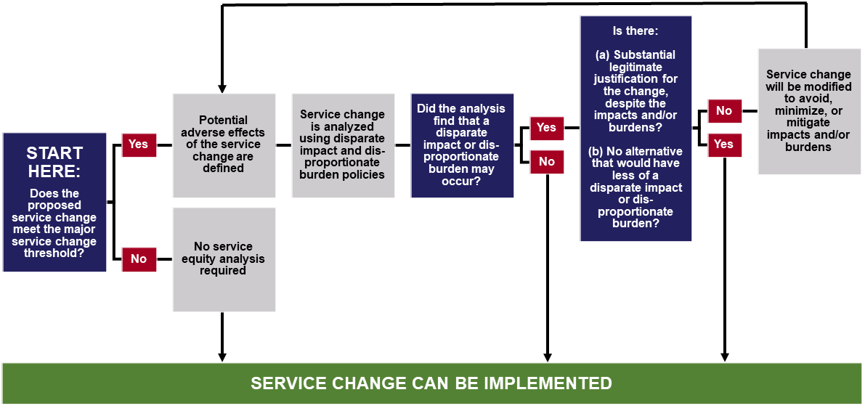
The major service change policy described in this document was revised from SRTA’s previous Title VI Program to be clearer, but substantial changes were not made. To ensure the public was aware of these changes and had an opportunity to provide input, SRTA held one Title VI open forum at the Fall River Terminal and another at the New Bedford Terminal in January 2022. For three weeks following these open forums, the public was able to comment on the proposed changes. The SRTA board was made aware of these proposed changes at their January 27, 2022 board meeting and approved of the changes when approving this Title VI Program. Minutes showing the board’s approval of the major service change policy are in Appendix F.

8.2 Adverse Effects
Because major service changes can either increase or decrease the amount of transit service available, it must be determined if they have adverse effects. SRTA considers the degree of adverse effects in its service equity analyses. Adverse effects include:
- Loss of access to transit (i.e., a route no longer operates in a certain place)
- Loss of frequency (i.e., a route comes less often)
- Loss of span of service (i.e., a route doesn’t come as early or late in the day)

8.3 Disparate Impact Policy
A disparate impact occurs when a proposed fare or major service change produces adverse effects on a population that is 60% or more minority. The definition of the population impacted may vary, depending on the type of change or result being examined. In some cases the population may be the riders affected and in other cases the population may be potential riders affected (i.e., the service area population). Staff conducting the equity analysis will use their best judgement when determining the population. Examples of how this policy may be used are:
- A route is proposed to be eliminated, reducing access to transit in a neighborhood of 6,000 people. All these people would lose access to transit in this proposal, so they are considered the ‘population’ for the analysis. This population consists of 5,000 minorities and 1,000 non-minorities, which is 83% minority and 17% non-minority. This population is more than 60% minority, so there is a disparate impact in this example.
- Cash fares are proposed to be increased systemwide, increasing the cost of transit for riders paying with cash. In this example, the ‘population’ bearing the adverse effects is riders paying cash. Survey data show that 55% of cash riders are minorities and 45% of cash riders are non-minorities. Because less than 60% of the affected population is minority, there is no disparate impact in this example.
The disparate impact policy can also be applied to SRTA’s service monitoring results. In the case of examining a population of minority routes and non-minority routes, the disparate impact threshold is when minority routes experience adverse effects at a rate that is 20 percentage points higher than non-minority routes. An example of this is:
- There is a discrepancy in on-time performance on minority and non-minority routes. Non-minority routes have an on-time performance of 90% and minority routes have an on-time performance of 80%. This means that minority routes have 10 percentage-point worse on-time performance than non-minority routes, which does not meet the 20 percentage-point disparate impact threshold. There is no disparate impact in this example.
It is the goal of SRTA to avoid, minimize, or mitigate adverse effects of service changes. Changes may proceed with a documented disparate impact if a substantial legitimate justification is demonstrated and there are no comparably effective alternative practices that would result in a lesser disparate impact.
The disparate impact policy described in this document was revised from SRTA’s previous Title VI Program to clearly indicate that the disparate impact policy was 20 percentage points and not a 20 percent difference. To ensure the public was aware of these changes and had an opportunity to provide input, SRTA held one Title VI open forum at the Fall River Terminal and another at the New Bedford Terminal in January 2022. For three weeks following these open forums, the public was able to comment on the proposed changes. The SRTA board was made aware of these proposed changes at their January 27, 2022 board meeting and approved of the changes when approving this Title VI Program. Minutes showing the board’s approval of the disparate impact policy are in Appendix F.

8.4 Disproportionate Burden Policy
A disproportionate burden occurs when a proposed fare or major service change produces adverse effects on a population that is 60% or more low-income. The definition of the population impacted may vary, depending on the type of change or result being examined. In some cases the population may be the riders affected and in other cases the population may be potential riders affected (i.e., the service area population). Staff conducting the equity analysis will use their best judgement when determining the population. Examples of how this policy may be used are:
- A route is proposed to be eliminated, reducing access to transit in a neighborhood of 6,000 people. All these people would lose access to transit in this proposal, so they are considered the ‘population’ for the analysis. This population consists of 5,000 low-income people and 1,000 non-low-income people, which is 83% low-income and 17% non-low-income. This population is more than 60% low-income, so there is a disproportionate burden in this example.
- Cash fares are proposed to be increased systemwide, increasing the cost of transit for riders paying with cash. In this example, the ‘population’ bearing the adverse effects is riders paying cash. Survey data show that 55% of cash riders are low-income and 45% of cash riders are non-low-income. Because less than 60% of the affected population is low-income, there is no disproportionate burden in this example.
It is the goal of SRTA to avoid, minimize, or mitigate adverse effects of service changes. Changes may proceed with a documented disproportionate burden if a substantial legitimate justification is demonstrated and there are no comparably effective alternative practices that would result in a lesser disproportionate burden.
The disproportionate burden policy described in this document was revised from SRTA’s previous Title VI Program to clearly indicate that the disproportionate burden policy was 20 percentage points and not a 20 percent difference. To ensure the public was aware of these changes and had an opportunity to provide input, SRTA held one Title VI open forum at the Fall River Terminal and another at the New Bedford Terminal in January 2022. For three weeks following these open forums, the public was able to comment on the proposed changes. The SRTA board was made aware of these proposed changes at their January 27, 2022 board meeting and approved of the changes when approving this Title VI Program. Minutes showing the board’s approval of the disproportionate burden policy are in Appendix F.

8.5 Findings of Service Equity Analyses
Since the submission of SRTA’s previous Title VI Program, SRTA has not implemented any service changes that required an equity analysis.

8.6 Findings of Fare Equity Analyses
Since the submission of SRTA’s previous Title VI Program, SRTA implemented one fare change that required a fare equity analysis. A description of the change and the results of the analysis are below, and the full fare equity analysis is included as Appendix G of this document.

January 2020 Fare Equity Analysis
This fare equity analysis was conducted to assess the potential impacts of a systemwide SRTA fare increase. The fare equity analysis, which is in Appendix G, analyzed the potential impacts of four fare change scenarios to low-income and minority SRTA riders, finding that none of the scenarios would produce a disparate impact or disproportionate burden on minority or low-income riders, respectively.
This equity analysis was presented to SRTA’s Advisory Board on February 27, 2020. Meeting notes showing the Board’s consideration of the analysis are in Appendix H. The fare change assessed in this equity analysis did not occur.

September 2021 Fare Equity Analysis
This fare equity analysis was conducted to assess the potential impacts of reduction in CharlieCard and pass fares. These fare reductions were proposed as a tool to help restore ridership that was lost due to the COVID-19 pandemic. The analysis, which is in Appendix I, found that there would be no disparate impact or disproportionate burden due to these fare changes.
The proposed fare changes were put into effect October 1, 2021.
This equity analysis was presented to SRTA’s Advisory Board on September 30, 2021. Meeting notes showing the Board’s consideration of the analysis are in Appendix J.

Federal Transit Administration. Southeastern Regional Transit Authority 2019 Annual Agency Profile. <https://www7.fta.dot.gov/sites/fta.dot.gov/files/transit_agency_profile_doc/2019/10006.pdf>
Ibid.
Ibid.
65 FR 50121, Aug. 11, 2000
LEP people are defined in ACS data as those that “speak English less than very well”.
The survey was distributed on paper to operators and staff from October 18 through October 22, 2021. There was a total of 112 respondents.
Federal Transit Administration. Southeastern Regional Transit Authority 2019 Annual Agency Profile. <https://www7.fta.dot.gov/sites/fta.dot.gov/files/transit_agency_profile_doc/2019/10006.pdf>
Ibid.
Source: 2015 ACS five-year estimates, Table B16001.
Source: 2020 U.S. Census. Table P1.
U.S. DHHS. 2021 Poverty Guidelines. <https://aspe.hhs.gov/topics/poverty-economic-mobility/poverty-guidelines/prior-hhs-poverty-guidelines-federal-register-references/2021-poverty-guidelines#guidelines>
For example, if Route X makes three trips where the maximum vehicle load ratios are 175%, 150%, and 100%, the average maximum vehicle load ratio for Route X is 142% ([175%+150%+100%]/3). This does not exceed SRTA’s standard.
SRTA operates two service schedules: weekday and Saturday. Holiday service operates on a Saturday schedule.
2019 ACS five-year estimate, Table B08203.
For any day (i.e., weekday or weekend).
60% or more minority is the percentage at which the population is 20 percentage points more minority than non-minority. The prior SRTA Title VI Program used a 20% threshold in its disparate impact and disproportionate burden policies; this threshold is an evolution of that method.
60% or more low-income is the percentage at which the population is 20 percentage points more low-income than non-low-income. The prior SRTA Title VI Program used a 20% threshold in its disparate impact and disproportionate burden policies; this threshold is an evolution of that method.

